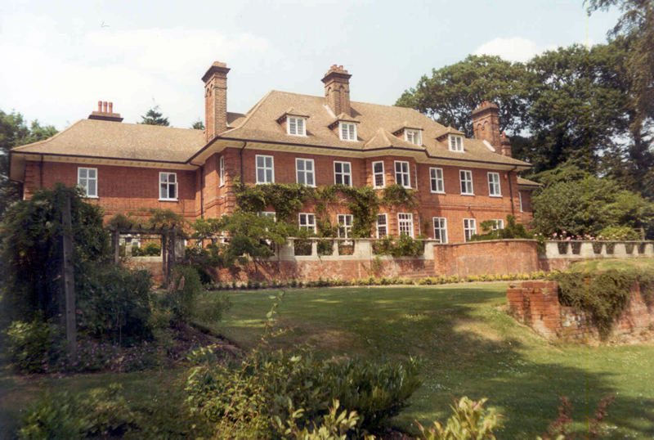
- Admiralty House (Grade II Listed)
by M Macartney c1898

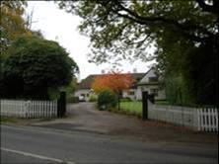
3. The Glade (Grade II Listed).
Attributed to CF Voysey c1912.

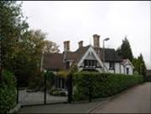
4. Frith Lodge (Locally Listed)
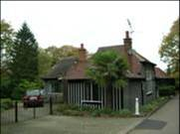

5. Frith Cottage (Locally Listed)
Frith Lodge and Frith Cottage c1860 are linked to Eastbury, the mansion that eventually became the Officers’ Mess at Coastal Command, HMS Warrior

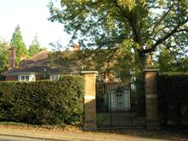

6. Frithcote c1900

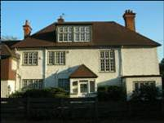

7. White House c1900

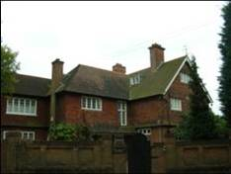

8. Breaside
Previously “Chudderton” c1890

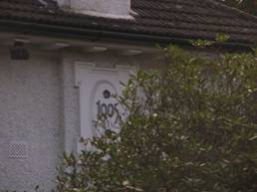

9. Garlands 1905

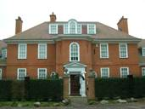

10. Gatehouse
On the site of 17th Century Gate House Farm which was demolished in 1905. An “abbey Piece” relating to St Albans Monks of the 13th Century was found in the orchard.

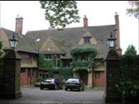

11. Sandyhurst c1900

