EXECUTIVE COMMITTEE

30 JANUARY 2012



STRATEGIC, SERVICE AND FINANCIAL PLANNING

EXECUTIVE COMMITTEE – 30 JANUARY 2012

PART I - NOT DELEGATED

9. STRATEGIC, SERVICE AND FINANCIAL PLANNING – INTRODUCTION
(DCRG)

1. Summary

1.1 This report is an introduction to the six agenda items that follow.

2. Details

Background

2.1 At its meeting on 5 September 2011 (Minute EX19/11 refers) this Committee agreed the process that was to be used for setting the strategic, service and financial plans. The process complies with the Council’s ‘Budget and Policy Framework Procedure Rules’ and means that the Council can demonstrate clear links between its Strategic Plan, its Service Plans and the allocation of resources to achieve the outputs and outcomes contained in them.

2.2 Following on from this item are six reports:-

Agenda  Item No. | Title
10 | Strategic Planning – The Strategic Plan 2012-2015
11 | Service Planning – Service Plans 2012-2015
12 | Financial Planning – Revenue Services
13 | Financial Planning – Capital Investment Programme
14 | Financial Planning – Treasury Management
15 | Strategic, Service & Financial Planning – Recommendations

Strategic Planning – The Strategic Plan 2012-2015

2.3 The purpose of this report is to allow consideration of the Council’s Strategic Plan for the period 2012-2015.

Service Planning – Service Plans 2012-2015

2.4 The purpose of this report is to allow consideration of the service plans for the period 2012-2015.

Financial Planning – Revenue Services

2.5 The Council’s activities are funded either from the council tax – these are (General Fund) revenue accounts that include the day to day income and expenditure of the council – or from capital sources which are used to create assets benefitting the community over the longer term.

2.6 The purpose of this report is to allow the Executive Committee to recommend to the Council the service levels and outputs it wishes to see and the associated revenue budget. This budget is a component part of the 2012/2013 council tax calculations.

Financial Planning – Capital Investment Programme

2.7 The purpose of this report is to allow the Executive Committee to recommend to the Council its capital investment programme, in the light of the available funding.

Financial Planning – Treasury Management

2.8 This report presents to members:-

a) the Annual Treasury Management Report and Prudential Indicators for 2010/11;
b) a mid year review of the Treasury Management function 2011/12; and,
c) the Treasury Management Strategy for 2012/13 – 2014/15.

Strategic, Service & Financial Planning – Recommendations

2.9 This report enables the Executive Committee to make its recommendations on the Strategic, Service and Financial Plans to the Council on 21 February 2012.

2.10 In the recent past the Committee has resolved to delay final decisions until the Council meeting. The recommendations at Item 15 provide a framework by which recommendations can be formulated whichever course of action is taken. In either case, it is suggested that decisions are not taken until all of the previous reports have been considered.

2.11 This is because:-

- Strategic, Service and Financial Planning is an iterative process. A change in one plan is likely to have an effect in another. The outputs described in the strategic and service plans are dependent upon the resources allocated to them and may have to be altered in the light of any rationing of available resources.

- The reports considering revenue budgets and the capital investment programme are inter-related. For example, it will be important to include in the revenue budgets the revenue implications of capital expenditure. Similarly, it may not be possible to determine the level of the capital investment programme without considering any revenue contributions to it.

2.12 A Budget Setting Model (Spreadsheet) can be made available electronically to members if requested with instructions as to how it can be used.

Policy and Scrutiny Committees’ Advice

2.13 Under the Council’s Constitution, only the full Council can approve or adopt the budget (Article 4). The Budget and Policy Framework Procedure Rules (Part 4 Rules of Procedure) set out the process for developing the budget framework which includes consulting the Council’s policy and scrutiny committees. The advice of policy and scrutiny committees has been sought and is included in the appropriate reports.

3. Options/Reasons for Recommendation

3.1 The recommendation below is to note this report.

4. Policy/Budget Reference and Implications

4.1 The recommendations in this report contribute to the process whereby the Council will approve and adopt its strategic, service and financial plans under Article 4 of the Council’s Constitution.

5. Staffing, Environmental, Community Safety, Customer Services Centre, Communications & Website Implications

5.1 Included in the reports that follow where appropriate.

6. Financial Implications

6.1 There are no changes to the budget or the efficiency gains already agreed by Members as a result of this report.

6.2 Members are welcome to raise questions on the budget prior to any discussion at the meeting. Indeed, it would be helpful if questions could be notified in advance to ensure that comprehensive responses are available. Any queries should be addressed in the first instance to the Finance Section (Shared Services) (accountancy.practice@threerivers.gov.uk) who will ensure an answer is provided by the responsible budget holder. Confidential advice can be obtained prior to the meeting in accordance with the “Conventions between Political Groups and Officers”.

7. Legal Implications

7.1 The Council is required to set its budget before 9 March 2012, although it is intended that it should do this on 21 February 2012.

7.2 The Localism Act includes powers to abolish Whitehall capping and instead allow local residents to veto excessive council tax rises through a referendum. The Council will have to determine whether its council tax increase is excessive in relation to principles set out by the Secretary of State. The Government is ‘minded’ to propose that increases greater than 3.5% will be excessive for district councils.

7.3 The Council’s Chief Finance Officer (Director of Corporate Resources and Governance) has a statutory duty to report to the Council if it is likely to incur expenditure that is unlawful or likely to exceed its resources. Section 25 of the Local Government Act 2003 places a duty on the Chief Finance Officer to report on the robustness of the estimates and the adequacy of the financial reserves.

8. Equal Opportunities Implications

8.1 See Agenda Item 15.

9. Risk Management and Health & Safety Implications

9.1 There are no risks to the Council in agreeing the recommendation in this report.

10. Recommendation

10.1 That this report be noted.

Report prepared by:
David Gardner – Director of Corporate Resources and Governance

Background Papers
None

The recommendations contained in this report DO NOT constitute a KEY DECISION but contribute to the process whereby the Council will approve and adopt its Strategic, Service and Financial Plans under Article 4 of the Council’s Constitution
EXECUTIVE COMMITTEE – 30 JANUARY 2012

PART I - NOT DELEGATED

10. STRATEGIC PLANNING – THE STRATEGIC PLAN 2012-2015
(DCRG)

1. Summary

1.1 The purpose of this report is to allow consideration of the Council’s Strategic Plan for the period 2012-2015.

2. Details

Background

2.1 The Council’s draft Strategic Plan 2012-2015 was considered by the Executive Committee on 5 September 2011 (Minute EX19/11 refers). The Plan has been prepared in consultation with the Local Strategic Partnership and the public and takes into account both local and national priorities. It sets out the Council’s contribution to the Community Plan and the priorities it has for its own service delivery.

2.2 Since last year, the themes within the plan have been amended. The ‘Safer Communities’ theme has been changed to ‘Safety and Well-being’ to support the healthier communities agenda. ‘Sustainable Communities’ is now termed ‘Clean and Green’ as a better description of the services provided. An additional theme, ‘Economic Opportunities’ has been added to reflect the increased importance of partnership work in regeneration, training and access to benefits in the current economic climate. The ‘Customer Service’ theme remains to reflect the Council’s standards and governance arrangements.

2.3 Since the Executive Committee met, targets have been included in the Plan. Achievement of the outcomes and outputs is measured through a performance management framework.

2.4 The Resources Policy and Scrutiny Committee on 10 November 2011 (Minute R.PS24/11 refers) recommended that Paragraph 3.13 of the Plan be amended to read ‘…or more GCSEs at Grades A* to C’. This change has been incorporated.

2.5 The Draft Plan assumes no change to the resources available for its implementation and may therefore need amending as a result of the budget set at Agenda Item 15. The draft Strategic Plan is attached at Appendix 1.

2.6 Responsibility for delivering the Strategic Plan has been delegated to service heads each of whom includes their element of it in their Service Plan. Service plans also include operational matters and are considered at the next agenda item. Resources required to achieve the Strategic Plan are also included in the service plans.

3. Options/Reasons for Recommendation

3.1 The recommendation below is to note this report.

3.2 The recommendations at Agenda Item 15, because of the inter-relationship between outputs and resources, enable the Committee to make consistent recommendations to the Council on 21 February 2012 concerning the Council’s strategic, service and financial plans.

4. Policy/Budget Reference and Implications

4.1 The recommendations in this report are within the Council’s agreed policy and budgets. They contribute to the process whereby the Council will approve and adopt its strategic, service and financial plans under Article 4 of the Council’s Constitution.

5. Legal, Staffing, Environmental, Community Safety, Customer Services Centre, Communications & Website, Risk Management and Health & Safety Implications

5.1 Included in the strategic and service plans where appropriate.

6. Financial Implications

6.1 Financial implications are included in service plans and in the reports that follow.

7. Equal Opportunities Implications

7.1 A statement on equalities is included in the Strategic Plan. See also Agenda item 15.

8. Risk Management and Health & Safety Implications

8.1 On the advice of the Audit Committee held on 16 June 2011 (Minute AC07/11 refers), the Executive Committee reviewed the Risk Management Strategy at its meeting on 20 June 2011 (Minute EX11/11 refers). The Risk Management Strategy can be found on the website at http://www.threerivers.gov.uk .

8.2 This Committee has also considered, on a quarterly basis, reports giving details of progress against the Risk Treatment Plans for the Strategic Risks identified in the Strategic Plan 2011-14 and any subsequently identified strategic risks. Strategic risks are those which, were they to come about, would seriously prejudice the achievement of the Strategic Plan.

8.3 The Strategic Risk Register is attached at Appendix 2. Risk Assessment and Treatment Plans are attached at Appendix 3.

8.4 The risks have been plotted on a risk matrix depending on the scored assessments of impact and likelihood, detailed definitions of which are included in the risk management strategy. The Council has determined its aversion to risk and is prepared to tolerate risks where the combination of impact and likelihood are plotted in the shaded area of the matrix. The remaining risks require a treatment plan.

9. Recommendation

9.1 That this report be noted.

Report prepared by:
David Gardner – Director of Corporate Resources and Governance

Background Papers
None

The recommendations contained in this report DO NOT constitute a KEY DECISION but contribute to the process whereby the Council will approve and adopt its Strategic, Service and Financial Plans under Article 4 of the Council’s Constitution

APPENDICES / ATTACHMENTS

1. Draft Strategic Plan 2012-2015 - Three Rivers District Council
2. Strategic Risk Register
3. Risk Assessment & Treatment Plans

APPENDIX 1
THREE RIVERS DISTRICT COUNCIL
STRATEGIC PLAN 2012-2015

Introduction
Each year, Three Rivers District Council updates its Strategic Plan. This document identifies the Council’s priorities, and the measures it will use to assess their delivery. It focuses on those areas where the Council has a lead role, or can play a key part in delivering or influencing the outcomes.

The Vision and our Priorities
Three Rivers District Council’s long-held vision is that the district should remain a prosperous, safe and healthy place where people want and are able, to live and work. We recognise that Three Rivers District is a mixture of beautiful countryside, villages and small towns, and the majority of its inhabitants are relatively healthy, well educated, affluent, articulate and able to access our public services. Not surprisingly, people want this state of affairs to improve further, or at least to stay the same, and the Council’s plans must pay careful heed to this point of view, without slipping into complacency.

However, deprived communities do exist in the District, often side by side with more affluent areas, where disadvantaged individuals and groups find difficulty in accessing the full range of services and facilities many of us take for granted. The Council has therefore made a conscious decision to concentrate on improving services and access to services for all people, particularly the people in deprived communities.

We recognise our increasing duty to promote “greener” ways of delivering services, reducing the carbon footprint of the district, and creating cohesive communities that enable people to live in harmony with each other and with their environment. We also recognise that the people of Three Rivers need and expect from an excellent Council a high standard of customer service. Finally, we know that our residents have had a fear of crime and anti-social behaviour disproportionate to the crime statistics that show the district is exceptionally safe.

Our objectives have emerged from what you, the public, tell us. We have undertaken surveys and focus groups with local residents and partner agencies. We receive regular feedback through your elected councillors. We are not isolated, however and our plans influence and are influenced by national, regional and county considerations. Where the delivery of local priorities falls to Three Rivers District Council in partnership with other agencies, these are reflected in our Community Strategy which is developed by the Local Strategic Partnership. This is made up of members from the NHS, Police Constabulary, Police Authority, County Council, Parish Councils, Thrive Homes, the Voluntary Sector and Business Sector. The Community Strategy 2006-12 identifies 5 shared priority objectives for to accomplish over that period:

1. Reducing anti-social behaviour, crime, and fear of crime
2. Reducing inequalities, (including health, poverty, access to services and employment)
3. Improving the environment
4. Improving children’s and young people's access to education, skills and training
5. Improving the supply and standard of affordable housing

Whilst we play a major role in the LSP’s work programme, Three Rivers District Council’s Strategic Plan focuses (as stated above) on those areas where the Council has a lead role, or can play a key part in delivering or influencing the outcomes. Thus, out of the above five objectives, we have decided to concentrate our energies on three major thematic areas of activity: safety and well-being, clean and green, economic opportunities and customer service, and our aims for these are set out below.

1) Safety and well-being - We shall work with partners to make the district a safer place and we shall provide a safe and healthy environment.

2) Clean and green - We want to provide equal access to services and facilities for the public within the district and surrounding area and in particular address the needs of vulnerable residents such as elderly, disabled and young people. In addition, we want to maintain a high quality local environment and reduce the eco-footprint of the district.

3) Economic opportunities – We shall work in partnership to promote the economic prospects for all our communities.

4) Customer Service - We shall deliver services to a standard that meets the needs and expectations of all of our customers and provides exemplary value for money.

 | Cllr. Ann Shaw OBE  Leader of the Council |  | Dr Steven Halls  Chief Executive

Key to the Grid set out overleaf: Themes, Aims and Objectives

As explained above, the Three Rivers vision is that the district should remain a prosperous, safe and healthy place where people want and are able to live and work. This is our aspirational statement describing the future and the grids reflect the thematic areas of safety and well-being, clean and green, economic opportunities and customer service, subdivided into the relevant aims. These describe what we want to have achieved by 2015.

For each aim the tables set out our objectives, which are all the things we need to achieve in order to realise our aims, with how these will be measured, their targets and the lead Council service and/or Partnership that will support or monitor delivery.

1. Safety and Well-being

  - We will work with partners to make the district a safer place.
Objectives | Measures | Target setting | Lead Service / Partnership
1.1.1 Reduce anti-social behaviour and crime. | Community Safety Partnership measures.  LC14 – No of ASB incidents (reported to the Police)  LC22 – Reduce No of Violent crimes  LC15 – No of domestic violence crimes (reported to independent DV advisor), repeat victimisations  LC19 – Reduce No of household burglaries  LC17 – Reduce No of ‘other’ burglaries  LC21 – Reduce No of vehicle crimes  LC12 – No of hate crimes (reported to the police, inc, graffiti) | 3061  505  14  281  304  518  75 | Community & Leisure Services

1.2 We will provide a safe and healthy environment.
1.2.1 Ensure the safety of people in the district. | EH11 – Number of successful prosecutions / sanctions against food business operators and other employers who fail to comply with hygiene and occupation health law.  EH12 – Year on year reduction in number of serious accidents and incidents reported.  NI184 – Percentage annual increase in the number of food premises that are broadly compliant with food safety law  EH04 & EH05 – All medium and high risk premises inspected within prescribed timescales  LC23 – Implement the District Safeguarding plan  LC07 – The percentage of people who agree that local public services are working to make the area safer | 10  48  96.005  100.00%  TBA  77.00% | Environmental Health  Community & Leisure Services
1.3 We will reduce health inequalities, promote healthy lifestyles, support learning and community organisations
1.3.1 Improve and facilitate access to leisure and recreational activities for adults | LC31 – Attendances by adults at leisure venues and activities.  LC02 – Satisfaction with quality/provision of parks and open spaces  New LC24 – Sheltered Housing Scheme: Percentage of older people reporting specific health benefits  New LC25 – Cardiac Rehabilitation Programme: Annual attendance | 364,209  78.00%  75.00%  3,550 | Community & Leisure Services
1.3.2 Contribute to partnership working to reduce health inequalities | New – LC XX – No of people completing the GP referral scheme  New – LC XX – No people completing the ‘2 month quitters’, stop smoking programme  New – LC XX – No of people accessing MIND services in Three Rivers | Target is draft, subject to approval by LSP in March 2012 | The Local Strategic Partnership (LSP) supported by Leisure & Community Services.
1.3.3 Provide a range of supervised leisure activities and facilities for young people. | LC33 – Attendances by young people at leisure venues and activities.  LC28 – Children's play activities will be termed as good by Ofsted  LC29 – No of attendances by children from low income families at Easter and summer play schemes  LC30 – Vulnerable children's satisfaction with leisure projects | 97,456  Achieved  630  90.00% | Community & Leisure Services
1.2.4 Work in partnership to improve access to learning opportunities | New – LC XX – No of new clients beginning learning courses in areas of deprivation | Target is draft, subject to approval by LSP in March 2012 | The Local Strategic Partnership (LSP) supported by Leisure & Community Services.
1.2.5 Work with the Community and Voluntary sector to meet the needs of local communities | New LC26 – Percentage increase in funding to the Community and Voluntary Sector, through leverage, match funding and grants | TBA | Community & Leisure Services

2. Clean and green

Objectives | Measures | Target | Lead Service / Partnership
2.1 We want to maintain a high quality local environment and reduce the eco-footprint of the district
2.1.1 Maintain the number of accredited open spaces, parks and woodland areas. | LC34 – Parks and open spaces with Green Flag accreditation.  LC32 – UK Woodlands Assurance Scheme (UKWAS) accreditation.  LC08 – The percentage of people who agree that local public services are working to make the area cleaner and greener | 3  Maintained  77.00% | Community & Leisure Services  The Local Strategic Partnership (LSP) supported by Leisure & Community Services.
2.1.2 Minimise waste and optimise recycling. | EP10 – Increase the percentage of household waste sent for reuse, recycling and composting.  EP06 – Decrease the tonnage of Household waste collected and sent to landfill  LC03 – The percentage of respondents who are satisfied with refuse collection  LC04 – The percentage of respondents who are satisfied with doorstep recycling  LC05 – The percentage of respondents who are satisfied with local tips/household waste recycling centres. | 60.00%  16,000 tonnes  92.00%  88.00%  89.00% | Environmental Protection

2.1.3 Preserve the green belt. | DP04 – Percentage of new homes built on previously developed (brownfield) land. | 95.00% | Development Plans
2.1.4 Maintain clean streets. | LC01 – Satisfaction with ‘keeping public land clear of litter and refuse’ | 100.00% | Community & Leisure Services
2.1.5 Minimise energy and water consumption, reduce CO2 emissions and increase the use of renewable energy. | New SU06 – Reduce Green House Gas emissions  SU05 – Achievement of ISO 14001 Environmental Management standard. | Reduce emissions by 6% (120 tonnes) in 2011/12.  Yes, Achieved | Sustainability

3. Economic opportunities

Objectives | Measures | Target | Lead Service / Partnership
3.1 Economic prosperity – support for business and the local economy
3.1.1 Encouragement for business | Measures to be confirmed:  New – DP07 – New business floor space available (from current year baseline)  New – DP08 – New business registrations  (Indicators support delivery of the Local Development Framework). | TBA  TBA | Development Plans
3.1.2 Champion the local economy | Measures to be confirmed:  New – DP09 – Economically active people in employment  New – DP10 – Vacancy rate for town and district centres | TBA  TBA | Development Plans

3.1.3 Work in partnership to encourage training, skills and access to employment | Measures to be confirmed:  New - Percentage of 15 Yr old pupils, in schools maintained by the local education authority, achieving 5 or more GCSEs at grades A* to C  New – LC XX – Targets from Step-Up Project | TBA  Target is draft, subject to approval by LSP in March 2012 | The Local Strategic Partnership (LSP) supported by Leisure & Community Services.
3.2 Prosperity for all and access to opportunities
3.2.1 Improve access to benefits. | New – Extend the number of Benefit Surgeries to include Watford Town Hall  New – Implement Self Service System for Benefit Claimants | 3  New system adopted and working by June 2012 | Revenues and Benefits
3.2.2 Improve or facilitate access to housing. | DP01 – Net additional homes provided.  DP02 – Number of affordable homes delivered (gross).  HN05 – Provide additional lettings through partnerships with social landlords, using ‘chain moves’ and local lettings plan  HN06 – Enable lettings in private rental sector using the Council’s rent deposit guarantee scheme, to people in priority housing need.  HN04 – Cases where positive action was successful in preventing/relieving homelessness | 180  54  15  40  110 | Development Plans  Housing Needs

4. Customer Service

Objectives | Measures | Target | Lead Service / Partnership
4.1 Customers – We will deliver our services to a standard that meet the needs and expectations of all of our customers.
4.1.1 We will strive to improve and maintain service standards for all services. | A basket of performance indicators for customer-facing services will be monitored against targets:  CSC01 – Percentage of calls answered  CSC02 – Percentage of calls answered within 20 seconds  DM01 – Processing major planning applications within 13 weeks  DM02 – Processing minor planning applications within 8 weeks  DM03 – Processing other planning applications within 8 weeks  EH01 – Respond to all requests for service within 24 hours (no.) – Pollution  EH06 – Respond to all requests for service within 24 hours (animal control)  EH07 – Respond to all requests for service within 14 days (pest control)  EP07 – Number of household waste collections missed per 100,000 collections  HN07 – The percentage of housing applications registered within 10 working days  RB03 – Speed of processing new claims  RB04 – Speed of processing changes of circumstances. | 97.00%  85.00%  60.00%  65.00%  85.00%  98.00%  98.00%  98.00%  60  90.00%  25 Days  15 Days | Customer Service Centre  Development Management  Environmental Health  Environmental Protection  Housing Needs & Strategy  Revenues & Benefits
4.1.2 We will strive to improve and monitor customer satisfaction. | LC06 – The average customer satisfaction with public-facing Council services  New LC27 – The percentage of priority indicators showing ‘Maintained or improved’. | 91.00%  TBA | All Services, monitored by Leisure & Community Services.
4.1.3 We will inform and update customers about the Council’s work and services. | The percentage of people who feel informed about local public services overall. | 49.00% | Monitored by Corporate Services (Communications)
4.2 Governance – We will manage our resources to deliver our strategic priorities and service needs.
4.2.1 We will manage our financial resources to deliver value for money. | LC46 – The perception to which local people agree the council provides value for money  The percentage of people who agree that local public services:  …promote the interests of local residents (LC09)  …act on the concerns of local residents (LC10)  …treat all types of people fairly (LC11) | 51.00%  55.00%  56.00%  79.00% | Dept. for Corporate Resources and Governance  The Local Strategic Partnership (LSP) supported by Leisure & Community Services.
4.2.2 We will ensure employees are properly trained, developed and motivated. | HR01 – Reduce sickness absence  CSC03 – How satisfied or dissatisfied are you with the overall quality of the service you received from the customer service centre staff? | 7.6 days  95.00% | All Services, supported Human Resources and Customer Service Centre

The Council’s Commitment to Data Quality – A Policy Statement

Statutory and local performance indicators as well as a range of financial and non-financial information are used throughout the organisation to aid the decision making process as well as assess the efficiency and effectiveness of service delivery.

The purpose of this policy is to outline Three Rivers District Council’s approach to improving data quality. Accurate, high-quality, timely and comprehensive information underpins the Council’s performance management system, and is vital to support good decision-making and improved service outcomes.

The Council also needs reliable, accurate and timely information with which to manage services, account for our performance and to keep residents and service users informed of our progress. The information we produce needs to be accessible to enable service users, the general public, and our partners to make informed decisions.

To help us make decisions about our priorities and use of resources, we actively encourage a performance management culture to:

✓ Manage resources effectively to achieve our ambitions and priorities

✓ Facilitate timely access to performance reports for service managers, Members and Senior Management

✓ Ensure that performance information is used to drive improvement leading to better services for local people

✓ Monitor and review our performance.

We will implement the Standards for Better Data Quality though our Data Quality Strategy.

Risk Management Implications
The following table shows the risks that have been identified and gives an assessment of their impact and likelihood in accordance with the Council’s Risk Management Strategy:-

Description of Risk |  | Impact | Likelihood
1 | Failure to secure improvements to services | III | E
2 | Failure to tell residents about improvements | III | E
3 | Failure to make progress on the Sustainability Action Plan | IV | E
4 | Failure to engage the community in the Strategic Plan | III | E
5 | Failure to achieve Community Safety targets | III | E
6 | Failure to achieve the priorities of the Community Strategy through the LSP | III | E

(Note: the defined impacts are set out overleaf.)

Likelihood | A |  |  |  |  |  | Impact | Likelihood
Likelihood | B |  |  |  |  |  | V = Catastrophic | A = ≥98%
Likelihood | C |  |  |  |  |  | IV = Critical | B = 75% - 97%
Likelihood | D |  |  |  |  |  | III = Significant | C = 50% - 74%
Likelihood | E |  |  | 1,2,4,5,6,7 | 3 |  | II = Marginal | D = 25% - 49%
Likelihood | F |  |  |  |  |  | I = Negligible | E = 3% - 24%
Likelihood |  | I | II | III | IV | V |  | F = ≤2%
Likelihood | Impact

The above risks are plotted on the matrix below depending on the scored assessments of impact and likelihood, detailed definitions of which are included in the risk management strategy. The Council has determined its aversion to risk and is prepared to tolerate risks where the combination of impact and likelihood are plotted in the shaded area of the matrix. The remaining risks require a treatment plan. All the risks that require management and monitoring are included in the appropriate service plans.

Impact Classification | Service Disruption | Financial Loss | Reputation | Failure to provide statutory service/meet legal obligations | People
V  Catastrophic | Total failure of service | >£1m | National Publicity. Resignation of leading member or chief officer | Litigation, claim or fine >£500k | Fatality of one or more clients/staff
IV  Critical | Serious disruption to service | £500k - £1m | Local media criticism | Litigation, claim or fine £250k - £500k | Serious injury, permanent disablement of one or more clients/staff
III  Significant | Disruption to service | £100k - £500k | Local public interest and complaints | Litigation, claim or fine £100k - £250k | Major injury to individual
II  Marginal | Some minor impact on service | £10k -£100k | Contained within service | Litigation, claim or fine £10k - £100k | Minor injuries to several people
I  Negligible | Annoyance but does not disrupt service | <£10k | Contained within section | Litigation, claim or fine <£10k | Minor injury to an individual

APPENDIX 2

STRATEGIC RISK REGISTER

Risk  Ref | Risk | Impact | Impact  Classification | Likelihood  Classification | Reason for Assessment
Risk  Ref | Brief Description – Title of Risk | See Impact Table | See Impact Table | See Likelihood Table | Use this box to describe how the score has been derived
1 | Failure to secure improvements to services | Service Disruption | II | E | Data fails to be captured due to decrease in resources and outcomes cannot be demonstrated to residents or members. | Requires Treatment | Yes
1 | Failure to secure improvements to services | Financial Loss | I | E |  | Last Review Date | 21/09/11
1 | Failure to secure improvements to services | Reputation | III | E |  | Next Milestone Date | 30/01/12
1 | Failure to secure improvements to services | Legal Implications | I | E |  | Next Review Date | 31/03/12
1 | Failure to secure improvements to services | People | I | E |  | Date Closed | --
2 | Failure to tell residents about improvements | Service Disruption | I | E | The Council’s reputation might suffer if residents weren’t informed of the Council’s successes. The measure in place to inform residents of improvements (e.g. Three Rivers Times) reduces the likelihood of residents not being informed | Requires Treatment | Yes
2 | Failure to tell residents about improvements | Financial Loss | I | E |  | Last Review Date | 04/10/11
2 | Failure to tell residents about improvements | Reputation | III | E |  | Next Milestone Date | 30/01/12
2 | Failure to tell residents about improvements | Legal Implications | I | E |  | Next Review Date | 31/03/12
2 | Failure to tell residents about improvements | People | I | E |  | Date Closed | --
3 | Failure to make progress on the sustainability action plan | Service Disruption | I | E | Having made sustainability one of the two ‘outward’ looking themes of the Strategic Plan, the Council’s reputation might suffer if the outcomes were not achieved. | Requires Treatment | Yes
3 | Failure to make progress on the sustainability action plan | Financial Loss | II | E |  | Last Review Date | 04/05/11
3 | Failure to make progress on the sustainability action plan | Reputation | IV | E |  | Next Milestone Date | 30/01/12
3 | Failure to make progress on the sustainability action plan | Legal Implications | II | E |  | Next Review Date | 31/03/12
3 | Failure to make progress on the sustainability action plan | People | I | E |  | Date Closed | --
4 | Failure to engage the community in the Strategic Plan | Service Disruption | I | E | Data fails to be captured due to decrease in resources and outcomes cannot be demonstrated to residents or members | Requires Treatment | Yes
4 | Failure to engage the community in the Strategic Plan | Financial Loss | I | E |  | Last Review Date | 21/09/11
4 | Failure to engage the community in the Strategic Plan | Reputation | III | E |  | Next Milestone Date | 30/01/12
4 | Failure to engage the community in the Strategic Plan | Legal Implications | I | E |  | Next Review Date | 31/03/12
4 | Failure to engage the community in the Strategic Plan | People | I | E |  | Date Closed | --
5 | Failure to achieve Community Safety targets | Service Disruption | II | E | Strategy continues to meet majority of targets. Individual targets not met are being addressed by local action plans. | Requires Treatment | Yes
5 | Failure to achieve Community Safety targets | Financial Loss | I | E |  | Last Review Date | 21/09/11
5 | Failure to achieve Community Safety targets | Reputation | III | E |  | Next Milestone Date | 30/01/12
5 | Failure to achieve Community Safety targets | Legal Implications | I | E |  | Next Review Date | 31/03/12
5 | Failure to achieve Community Safety targets | People | I | E |  | Date Closed | --

Risk  Ref | Risk | Impact | Impact  Classification | Likelihood  Classification | Reason for Assessment
Risk  Ref | Brief Description – Title of Risk | See Impact Table | See Impact Table | See Likelihood Table | Use this box to describe how the score has been derived
6 | Failure to achieve the priorities of the Community Strategy through the LSP | Service Disruption | I | E | Loss of 50% of the Performance Reward Grant reduces capacity for local projects. | Requires Treatment | Yes
6 |  | Financial Loss | I | E |  | Last Review Date | 21/09/11
6 |  | Reputation | III | E |  | Next Milestone Date | 30/01/12
6 |  | Legal Implications | I | E |  | Next Review Date | 31/03/12
6 |  | People | I | E |  | Date Closed | --

Likelihood | A |  |  |  |  |  |  | Impact |  | Likelihood
Likelihood | B |  |  |  |  |  |  | V = | Catastrophic | A = ≥98%
Likelihood | C |  |  |  |  |  |  | IV = | Critical | B = 75% - 97%
Likelihood | D |  |  |  |  |  |  | III = | Significant | C = 50% - 74%
Likelihood | E |  |  | 1, 2, 4, 5, 6 | 3 |  |  | II = | Marginal | D = 25% - 49%
Likelihood | F |  |  |  |  |  |  | I = | Negligible | E = 3% - 24%
Likelihood |  | I | II | III | IV | V |  |  |  | F = ≤2%
Likelihood | Impact

APPENDIX 3
RISK ASSESSMENT AND TREATMENT PLANS

Risk Ref: | 1 | Risk Title: | Failure to secure improvements to services
Responsibility |  | Who is managing the risk? |  | Community Partnerships Manager
Consequence |  | What can go wrong?  How can it go wrong?  Has it gone wrong before? |  | - Management fail to monitor performance and address under performance and targets not met.  - Some service areas have failed.
Cause / Trigger |  | What happens to bring the risk into being? |  | - Data fails to be captured to assess achievement of the Strategic Plan.  - Services fail to input data into performance management system.  - No action taken to address poor performance.  - Management and Members only monitoring performance.
Existing Control |  | What controls exist now to minimise the risk? |  | - Performance monitoring system in place.  - Quarterly reports to MBd and 6 monthly reports to Policy and Scrutiny Committees.  - Performance Improvement Officer.  - Performance plus has been replaced.  - New procedure notes in place to manage performance data
Adequacy of Control |  | What evidence is there that the existing  Controls are working? What would the Risk  Rating be without the existing controls? |  | - Majority of corporate targets are on track. Or being over achieved. | Impact | Likelihood
 |  |  |  |  | III | D
Further Action / Controls Required |  | What gaps have been identified?  What can be done to reduce the likelihood of  something going wrong and/or reduce the  Impact if something does go wrong? |  | - Annual review of targets with Heads of Service.  - Improvements to shared services performance management systems in collaboration with Watford Borough Council.
Cost / Resources |  | Are there cost / resource implications in achieving the further action above? |  | Staff time. | £ 0
Current Status |  | What is the current position on introducing  additional controls? What is the current  Risk Rating |  | - New system has been developed and implemented.  - Strategic plan reviewed bu Service Heads & Management Board.  - Improvement measured in corporate customer satisfaction through the Omnibus Survey. | Impact | Likelihood
 |  |  |  |  | III | E
Critical Success Factor |  | How will you know that the action taken has  worked? What will be the Risk Rating  outcome with the new controls? |  | - Strategic plan targets achieved – report produced for quarter 1  - Customer satisfaction has improved. | Impact | Likelihood
 |  |  |  |  | II | F

Risk Ref: | 2 | Risk Title: | Failure to tell residents about improvements
Responsibility |  | Who is managing the risk? |  | Communications Manager
Consequence |  | What can go wrong?  How can it go wrong?  Has it gone wrong before? |  | - Poor response rates from hard to reach groups  - Stakeholders not understanding/valuing the services the Council provides  - Low levels of public satisfaction with the Council  - Residents do not feel well informed  - Vulnerable residents are not sufficiently informed about local service improvements
Cause / Trigger |  | What happens to bring the risk into being? |  | - Citizen’s Panel not representative of community  - Consultation methods fail to engage hard to reach groups  - Insufficient resources to engage hard to reach groups  - Messages unclear or garbled  - Responsive rather than proactive  - Distribution failures (Three Rivers Times)  - Prolonged staff absence
Existing Control |  | What controls exist now to minimise the risk? |  | - Corporate consultation data analysed by race, gender and disability  - Regularly updated strategy and action plan with increased emphasis on quality controls  - Editorial Working Party reviews TRT and A-Z  - TRT distributor provides GPS tracking of delivery teams and delivery quality checked with staff who live in the district  - TRT delivery reminder service implemented  - TRT delivery and comment feedback log implemented and reviewed  - Annual focus groups for TRT, A-Z and priority communications issues  - Press release output and coverage targets in place  - Feedback mechanisms include Pensioners’ Forum, Youth Council, prize draw survey in democracy packs, welcome packs for new residents, surveys in TRT and at key points of contact.  - Communications team action plan produced annually and reviewed twice a year  - Communications and engagement plans for sustainability, community safety, democracy and citizenship and South Oxhey Initiative include targets and evaluation  - Herts Omnibus survey provides annual data on communications performance, including breakdowns for deprived and minority groups  - Review of Residents Association network in place  - Staff marketing and press release workshops held three times a year  - Web development workshops implemented and web editors now expected to attend cross-department communications group  - Audio version of Three Rivers Times actively distributed for visually impaired or those with reading difficulties  - Use of web analytics tools  - Internal Communications survey completed annually  - Monthly “What’s On” poster placed on noticeboards and distributed to community venues  - Service e-newsletter introduced for news of service disruptions/changes. Includes feedback mechanisms.  - E-newsletters in place for Environment, Planning, Leisure and South Oxhey include feedback mechanisms  - Facebook news pages introduced for key areas included those with significant deprivation and integrated with Twitter. Social media is monitored and responded to.  - Regular attendance at the county communications managers group
Adequacy of Control |  | What evidence is there that the existing  Controls are working? What would the Risk  Rating be without the existing controls? |  | - Customer Service Excellence accreditation  - Council recognised as good communicator by LGA  - Herts omnibus survey (wave 1 & 2) shows 77% of respondents felt they were well informed or fairly well informed about Council services and overall satisfaction is 79% (71% average for county) | Impact | Likelihood
 |  |  |  |  | III | B
Further Action / Controls Required |  | What gaps have been identified?  What can be done to reduce the likelihood of  something going wrong and/or reduce the  Impact if something does go wrong? |  | - Scope of communications work is limited by below national average staffing level  - Below average staffing level weakens resilience
Cost / Resources |  | Are there cost / resource implications in achieving the further action above? |  |  | £
Current Status |  | What is the current position on introducing  additional controls? What is the current  Risk Rating |  | - Controls to be reviewed as part of periodic communications reviews during 2011/12. | Impact | Likelihood
 |  |  |  |  | III | E
Critical Success Factor |  | How will you know that the action taken has  worked? What will be the Risk Rating  outcome with the new controls? |  | - All key groups will be represented in consultation feedback.  - Satisfaction with information provision and overall satisfaction  with the Council would increase | Impact | Likelihood
 |  |  |  |  | II | E

Risk Ref: | 3 | Risk Title: | Failure to make progress on the sustainability action plan
Responsibility |  | Who is managing the risk? |  | Head of Sustainability
Consequence |  | What can go wrong?  How can it go wrong?  Has it gone wrong before? |  | - The authority fails to lead by example on sustainable initiatives and does not provide the opportunities for residents to take advantage of, for example, energy saving measures  - Failure to resource the plan properly  - Lack of awareness of current initiatives  - National Indicators have been abolished. The Council is at a high level already and a high base line may prove difficult to improve on if new Indicators are introduced.
Cause / Trigger |  | What happens to bring the risk into being? |  | - Monitoring reveals that the actions are not taking place and targets are not being achieved  - Withdrawal of Government funding for sustainable initiative subsidies
Existing Control |  | What controls exist now to minimise the risk? |  | - Action Plan for the development of Climate Change Strategy agreed  - Sustainability team has been set up  - Regular progress reports on strategy development reported to SEPSC  - Standing items for Cabinet/Management Board and Management Board meetings  - Partnership arrangements have been set up with the LSP and Energy Savings Trust  - Membership of the University of Herts Climate Change Group with bi-monthly meetings  - Information is provided via the “Our Climate Is Changing” website  - Local Climate Impacts Profile has been submitted to DEFRA  - ISO14001 accreditation achieved (excluding Batchworth Depot)
Adequacy of Control |  | What evidence is there that the existing  Controls are working? What would the Risk  Rating be without the existing controls? |  | - Stakeholders are kept up to date on progress via regular reports  - Internal audits  - Submissions to DEFRA | Impact | Likelihood
 |  |  |  |  | IV | D
Further Action / Controls Required |  | What gaps have been identified?  What can be done to reduce the likelihood of  something going wrong and/or reduce the  Impact if something does go wrong? |  | - Continued local monitoring of ex NI186 via Climate Change Partnership  - Annual audit and re-accreditation of ISO14001 – Due October, 2011  - Seeking accreditation for ISO14001 for Batchworth Depot by early 2012  - Continued promotion of Government (CERT) funding, whilst available  - Continued development and promotion of the “Our Climate Is Changing” website
Cost / Resources |  | Are there cost / resource implications in achieving the further action above? |  | No additional resource requirements identified | £
Current Status |  | What is the current position on introducing  additional controls? What is the current  Risk Rating |  | - Additional controls to be completed during 2010/11.  - Impact and probability have not changed since last review | Impact | Likelihood
 |  |  |  |  | IV | E
Critical Success Factor |  | How will you know that the action taken has  worked? What will be the Risk Rating  outcome with the new controls? |  | - Successful ISO14001 accreditation for Batchworth Depot  - Successful ISO14001 re-accreditation | Impact | Likelihood
 |  |  |  |  | IV | F
Risk Ref: | 4 | Risk Title: | Failure to engage the community in the Strategic Plan
Responsibility |  | Who is managing the risk? |  | Community Partnerships Manager
Consequence |  | What can go wrong?  How can it go wrong?  Has it gone wrong before? |  | - Poor engagement with hard to reach groups results in lack of evidence base to meet vulnerable group needs.  - Recent consultation has seen increase in engagement of key hard to reach groups.  - Loss of funding for engagement work.
Cause / Trigger |  | What happens to bring the risk into being? |  | - Citizen’s panel becomes unrepresentative.  - Consultation methods fail to engage hard to reach groups.  - Insufficient resources to engage groups.  - Hard to reach groups fail to remain engaged due to lack of TRDC response to needs.
Existing Control |  | What controls exist now to minimise the risk? |  | - Corporate consultation budget in place to support work.  - Panel membership updated each year.  - Response rates to surveys monitored.  - Joint work developed across county and locally with partners to reduce costs and increase overall engagement outcomes.  - Engagement in public engagement partnership.  - Diversity group with Thrive NHS HCC and Police in District.  - LGBT Partnership.  - County Omnibus survey.
Adequacy of Control |  | What evidence is there that the existing  Controls are working? What would the Risk  Rating be without the existing controls? |  | - Improvement to joint working e.g. LGBT consultation.  - Follow up work with BME communities.  - New projects with people with mental health problems.  - Increased participation of people with learning disabilities. | Impact | Likelihood
 |  |  |  |  | III | D
Further Action / Controls Required |  | What gaps have been identified?  What can be done to reduce the likelihood of  something going wrong and/or reduce the  Impact if something does go wrong? |  | - Further joint work to engage low income groups and those with low literacy on area basis with partners’ agencies.
Cost / Resources |  | Are there cost / resource implications in achieving the further action above? |  | Staff time | £
Current Status |  | What is the current position on introducing  additional controls? What is the current  Risk Rating |  | - Plans to increase joint working developed to reduce costs.  - Contractor in place for Herts Omnibus.  - Improvement in public perception that services are acting on the concerns of residents.  - Maintained Herts Omnibus under new Market Research call out contract | Impact | Likelihood
 |  |  |  |  | III | E

Critical Success Factor | How will you know that the action taken has  worked? What will be the Risk Rating  outcome with the new controls? | - Increase in residents’ view that they can influence local decision making.  - Increase in residents satisfaction  - Increased understanding of the needs of hard to reach groups | Impact | Likelihood
Critical Success Factor |  |  | III | F

Risk Ref: | 5 | Risk Title: | Failure to achieve Community Safety targets
Responsibility |  | Who is managing the risk? |  | Community Safety Manager
Consequence |  | What can go wrong?  How can it go wrong?  Has it gone wrong before? |  | - Ineffective target setting  - Resources not allocated to address actions  - Changes in recording systems  - Initiatives fail to meet targets  - Public do not understand what work is being achieved  - Overall strategy has met strategic targets
Cause / Trigger |  | What happens to bring the risk into being? |  | - Strategy not translated into plans for each partners’ agency  - Action Plan not monitored for impact and corrective action  - MIDAS / monitoring systems fail  - Poor practice and enforcement by partners  - Residents misinformed by national media  - Reduction in funding for partnership  - No joint risk management  - Lack of commitment of staffing resources from partners  - Lack of equality monitoring  - No business continuity or disaster recovery plans
Existing Control |  | What controls exist now to minimise the risk? |  | - Quarterly reports to Community Safety Board and Co-ordination Group,  - Six monthly reports to Leisure and Community Safety Policy and Scrutiny Committee  - Briefings with CEO and portfolio holder  - Participation in Family Intervention Project, Offender Management Group and ASB Action Group  - Equality impact monitored
Adequacy of Control |  | What evidence is there that the existing  Controls are working? What would the Risk  Rating be without the existing controls? |  | - Strategy overall is on target. Where individual targets not met new action plans have been put in place and targets revised annually. | Impact | Likelihood
 |  |  |  |  | III | D
Further Action / Controls Required |  | What gaps have been identified?  What can be done to reduce the likelihood of  something going wrong and/or reduce the  Impact if something does go wrong? |  | - Review all bids for sustainability.  - Assess risks of all partnership projects.  - Request clarity of staffing commitments from all partners through annual action plan.  - Request CRB checks for partnership funded projects where relevant.  - Request equality impact on all funding proposals. Health and safety terms to be given to all grants.  - Review data protection arrangements for non-statutory partners.  - Assess business continuity needs for all partnership projects.  - Implement shared ASB management system.  - Seek county clarity on funding sources.
Cost / Resources |  | Are there cost / resource implications in achieving the further action above? |  | Staff time. ICT support to implement new ASB system. | £ tbc
Current Status |  | What is the current position on introducing  additional controls? What is the current  Risk Rating |  | - Grants reviewed, and sustainability proposals being reviewed.  - Dialogue started with LSP regarding funding sources.  - CRB checks requested where relevant.  - County funding cuts identified  - Health and safety terms provided with all grants  - Equality data gathered where relevant. | Impact | Likelihood
 |  |  |  |  | III | E
Critical Success Factor |  | How will you know that the action taken has  worked? What will be the Risk Rating  outcome with the new controls? |  | - Targets of strategy met for year.  - Review new risks at that point. | Impact | Likelihood
 |  |  |  |  | III | F

Risk Ref: | 6 | Risk Title: | Failure to achieve the priorities of the Community Strategy through the LSP
Responsibility |  | Who is managing the risk? |  | Community Partnerships Manager
Consequence |  | What can go wrong?  How can it go wrong?  Has it gone wrong before? |  | - Failure to deliver on the strategy by some partners  - Loss of resources to support achievement of the priorities.  - Action Plans not effectively implemented
Cause / Trigger |  | What happens to bring the risk into being? |  | - Loss of national targets and funding streams.  - Changes in priorities of individual partners.  - Budget limitations.  - Poor development of action plans.  - Limited buy in to strategy by partners.
Existing Control |  | What controls exist now to minimise the risk? |  | - Action Plan updates provided to board from all sub-partnerships.  - Key performance indicators being tracked.  - Regular briefings with Leader.  - Regular meeting of LSP Board.
Adequacy of Control |  | What evidence is there that the existing  Controls are working? What would the Risk  Rating be without the existing controls? |  | - Progress made on key projects in the District.  - Challenge provided to poor performance.  - Board reviewing impact of CSR and new changes.  - Sustainability key decision element to project funding. | Impact | Likelihood
 |  |  |  |  | III | C
Further Action / Controls Required |  | What gaps have been identified?  What can be done to reduce the likelihood of  something going wrong and/or reduce the  Impact if something does go wrong? |  | - Complete review of LSP post CSR.  - Assess new sources of potential shared funding for local priorities.  - Maintain risk assessment of all proposals for funding and joint action.
Cost / Resources |  | Are there cost / resource implications in achieving the further action above? |  | Staff time. Partners funding and commitment. | £0
Current Status |  | What is the current position on introducing  additional controls? What is the current  Risk Rating |  | - Review of partnership has started to risk address future needs.  - Community Strategy being reviewed.  - Potential sources of funding identified by some LSP Partners for different projects.  - Risk assessment framework maintained.  - Public perception data demonstrates achievements in key priority areas of crime and sustainability. | Impact | Likelihood
 |  |  |  |  | III | E
Critical Success Factor |  | How will you know that the action taken has  worked? What will be the Risk Rating  outcome with the new controls? |  | Partnership achieves further progress on priorities in areas of deprivation in sustainable manor. | Impact | Likelihood
 |  |  |  |  | III | E

EXECUTIVE COMMITTEE – 30 JANUARY 2012

PART I - NOT DELEGATED

11. SERVICE PLANNING – SERVICE PLANS 2012-2015
(DCRG)

1. Summary

1.1 The purpose of this report is to allow consideration of the service plans for the period 2012-2015.

2. Details

2.1 In order to achieve the Council’s key objectives it is organised into a number of services. Each service has the responsibility for delivering part of the Strategic Plan, including operational services.

2.2 There are twelve services provided directly by the Council. The policy and scrutiny committees considered their service plans during November and recommended their content to the Executive Committee.

2.3 Service plans for the services shared with Watford Borough Council – Human Resources, ICT, Finance, Revenues & Benefits – were approved by the Joint Committee on 21 November 2011.

2.4 Each of the Council’s service plans include:-

 | Item
1 | Key Purpose of the Service
1.1 | Scope of the Service
1.2 | Service Standards
2 | Inputs
2.1 | People
2.2 | Workforce Planning
2.3 | Partnerships & Contracts
2.4 | Service Level Agreements
2.5 | Assets and Technology
2.6 | Current Budgets
2.7 | Potential Revenue Growth
2.8 | Revenue & Capital Budgets
2.9 | Efficiency Gains
2.10 | Capital Investment
3 | Outputs and Outcomes
3.1 | Customer Insight and Consultation
3.2 | Performance Management
3.3 | External Accreditation and Assessment
3.4 | Benchmarking Information
3.5 | Projects
3.6 | Equalities
3.7 | Risk Management

2.5 Appendix 1 shows the links between the strategic plan, the service plans and financial cost centres. It is produced to ensure that all budgets will be included in a service plan and that all proposed services have a budget. It can also be used to determine what activities are discretionary and which mandatory. The list has been analysed by strategic plan theme, and although some cost centres support more than one aim in the strategic plan each cost centre has been allocated to its principal theme to give members an indication as to how resources are being allocated to priorities.

3. Options/Reasons for Recommendation

3.1 The recommendation below is to note this report.

3.2 The recommendations at Agenda Item 15, because of the inter-relationship between outputs and resources, enable the Committee to make consistent recommendations to the Council on 21 February 2012 concerning the Council’s strategic, service and financial plans.

4. Policy/Budget Reference and Implications

4.1 The recommendations in this report are within the Council’s agreed policy and budgets and contribute to the process whereby the Council will approve and adopt its strategic, service and financial plans under Article 4 of the Council’s Constitution.

5. Legal, Environmental, Community Safety, Customer Services Centre, Communications & Website Implications

5.1 Included in the service plans where appropriate.

6. Financial Implications

6.1 Financial implications are included in the service plans and in the reports that follow.

7. Equal Opportunities Implications

7.1 Included in the ‘Equalities’ section of each service plan. See also Agenda Item 15.

8. Staffing Implications

8.1 Staffing numbers and workforce planning are included in each service plan.

9. Risk Management and Health & Safety Implications

9.1 The strategic risks identified in the earlier report on the Strategic Plan will be incorporated in the appropriate service plan alongside that service’s operational risks. Risks will be managed at service level. There are no risks associated with the recommendation in this report.

10. Recommendation

10.1 That this report is noted.

Report prepared by:
David Gardner – Director of Corporate Resources and Governance

Background Papers
Service Plans 2012-2015:-
Building Control
Corporate Services
Customer Services Centre
Democratic Services
Development Management
Development Plans
Environmental Health
Environmental Protection
Housing
Legal
Leisure & Community Services
Sustainability

The recommendations contained in this report DO NOT constitute a KEY DECISION but contribute to the process whereby the Council will approve and adopt its Strategic, Service and Financial Plans under Article 4 of the Council’s Constitution

APPENDICES / ATTACHMENTS

Appendix 1 – Linking the Strategic Plan, Service Plans and Cost Centres

APPENDIX 1

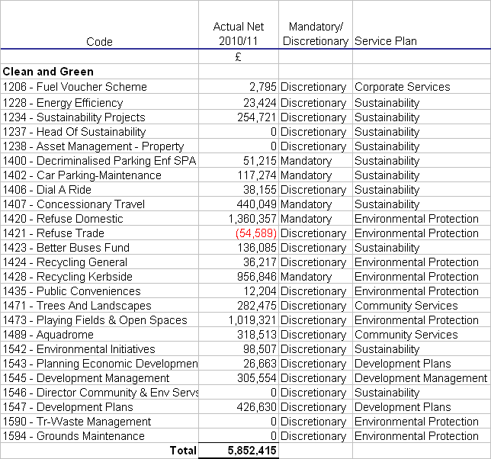
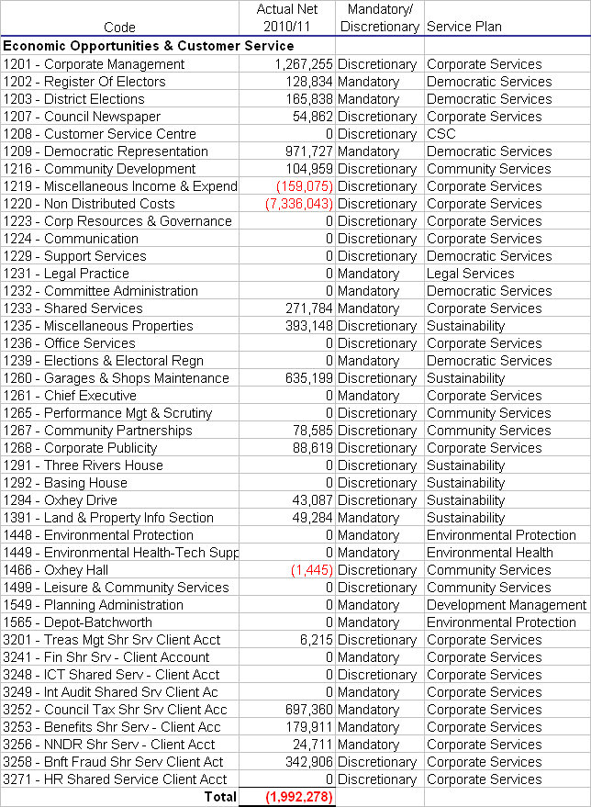
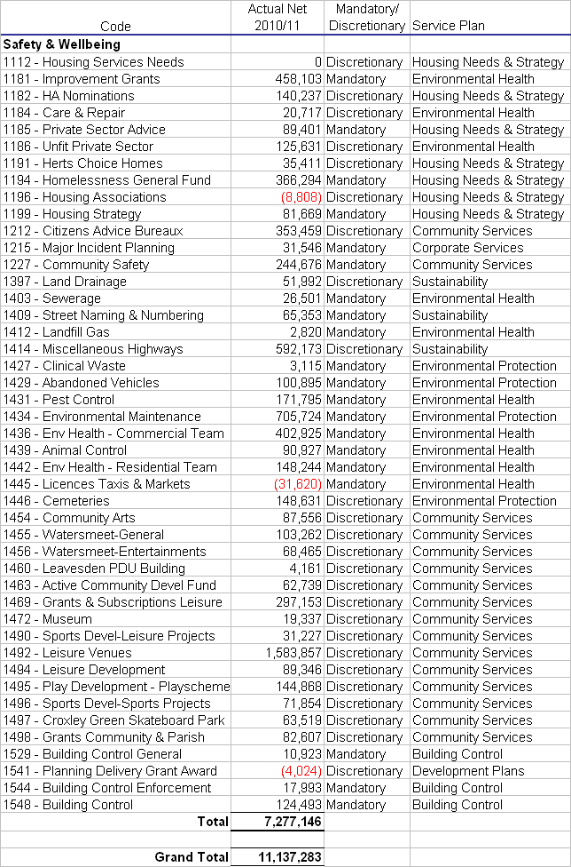
EXECUTIVE COMMITTEE – 30 JANUARY 2012

PART I - NOT DELEGATED

12. FINANCIAL PLANNING – REVENUE SERVICES
(DCRG)

1. Summary

1.1 The purpose of this report is to enable the Executive Committee to recommend to the Council the service levels and outputs it wishes to see in the medium to long-term and the associated revenue budget. This budget is a component part of the 2012/2013 Council Tax calculations.

2. Details

Base Budget

2.1 Officers have prepared a ‘base budget’. This is attached at Appendix 1 and includes a revised estimate for the current year, detailed figures for the three-year medium-term and high level forecasts for the period 2015-2022.

2.2 The revised estimate and figures for the three-year medium-term are also in the document entitled Summary Revenue Three-Year Medium-Term Financial Plan, posted on the ‘Budget Monitoring Reports’ page of the Council’s website at:-

http://www.threerivers.gov.uk/Default.aspx/Web/BudgetMonitoringReports

2.3 The three-year medium-term base budget includes:

    - Variances from the budgets agreed at this time last year. Month 9 variances are detailed on the website in the document entitled ‘Variances for the Current Period’. See also ‘Summary of Variances for the Year’ for the accumulative position.

    - Efficiency gains. The budget monitoring reports show that the efficiency gains identified this time last year are being achieved. The base budget also includes efficiency gains identified in the 2012-2015 service plans and considered by the policy and scrutiny committees in November. These are detailed at Appendix 2. No unidentified efficiency gains are included in the base budget.

    - Cost Reductions. The budget monitoring reports show those cost reductions identified this time last year that are, or are not, being achieved. Where savings are not being achieved, the expenditure has been put back into the base budget, with the exception of additional shared services (£200k in 2012/13 and £410k in 2013/14).

    - Estimates of fees and charges as attached at Appendix 3.

    - The Government Grant announced in the provisional Local Government Finance Settlement for 2012/13 (See Appendix 4) and an assumption that a further reduction in grant of -7.1% will occur in 2013/14 and 2014/15. This would reduce the Council’s grant to the level it would be should the ‘floor damping’ protection be totally removed. It should be noted, though, that the New Homes Bonus is to be ‘top sliced’ from the national control totals. The Council has included this in its capital funding statement. It cannot be guaranteed that the impact of top slicing will not further reduce the level of grant included in the revenue forecasts.

    - A forecast that predicts the Collection Fund to break even at 31 March 2012 (See Appendix 5).

    - A Council Tax Base of 38,883.03 for 2012/13 which was reported to the Council on 13 December 2011. This represents an increase of 0.89%. Subsequent year on year increases are assumed to be 0.5%.

    - A council tax increase of 1.98% in 2012/13 and subsequent years (the Committee will be asked to confirm or vary this figure at agenda item 15). The Secretary of State for Communities and Local Government has confirmed that district councils setting their basic amount of tax for 2012/13 at a level which is no more than its basic amount of council tax for 2011/12, will be eligible to receive a one-off specific grant equivalent to a 2.5% increase in its 2011/12 basic amount of council tax multiplied by the authority’s council tax base for 2012/13. Members will recall that similar arrangements applied last year, but that the Government provided supplementary funding in subsequent years of the spending review. £150,060 is included in the council’s budget for the financial years 2011/12 to 2014/15 but this year’s ‘offer’ has not been included in the base budget. It is estimated that if the council freezes the tax for 2012/13 it will benefit by £150,170. By taking the compounding effect of a council tax increase out of the base budget going forward, however, the Council would lose £1.4m by 2021/22.

2.4 The three-year medium-term financial plan has been extended to consider a longer ten-year planning horizon. Forecasts for the period from 2015/16 to 2021/22 have been calculated using the following assumptions:-

    - Annual increases in the council tax base of 0.5%

    - No increase in government grant for the period 2015/16 to 2017/18 and 2% per annum thereafter

    - Council tax increases of 1.98% per annum

    - Inflation currently set at 2.25% and included in accordance with the resolution of the Executive Committee on 5 September 2011 (Minute EX19/11 refers) as follows:

for the purpose of the 10 year plan, the Council set an assumed rate of inflation for the seven years following 2014/15; and that the other variables in the plan be set relative to this such that:

Employee cost: inflation +0.75%
Parish precepts: inflation +1%
Supplies and Services: Inflation -0.25%
Fees and charges: inflation +1% (being average inflationary increases in charges and 1% increase in average volumes)
Investment interest: inflation +2%
Efficiency savings: 1% of gross expenditure annually

    - Increasing revenue contributions to capital expenditure with effect from 2017/18.

Potential Growth

2.5 Using the scheme for prioritising revenue growth attached at Appendix 6, five proposals for growth are detailed at Appendix 7. These are not included in the base budget.

2.6 Members attention is also drawn to the fact that the base budget does not include the revenue implications of new capital expenditure. These are shown at Appendix 3 to Agenda Item 13.

Policy & Scrutiny Committees’ Advice

2.7 The policy and scrutiny committees’ advice on their priorities is detailed at Appendix 8.

Setting the Council Tax, Balances, Deficits and Surpluses

2.8 The Council needs to set a budget that gives an acceptable level of council tax, and breaks even in the medium to long term using the balances it has at its disposal.

2.9 The Council tax is calculated as follows:-

Council Tax Requirement | = | Band D Tax
Council Tax Base

The council tax requirement is the Council’s net revenue expenditure, after crediting government grants, less the use of any balances in the year (i.e. any deficit in the year). The table at Appendix 9 shows the Council Tax increase in 2012/13 for various levels of council tax requirement.

2.10 A Budget Setting Model is available from officers which includes the base budget as a starting point and which allows the various assumptions as to the levels of council tax base, government grant, council tax increase, inflation, interest rates, revenue contributions and growth to be altered so as to calculate whether there is a deficit or surplus for any year and the balances carried forward.

2.11 The Budget Setting Model integrates decisions on revenue and capital expenditure. For example, the revenue income from interest derives primarily from capital receipts used to fund capital expenditure. If the Council wishes to fund higher levels of capital expenditure then interest will fall in the revenue account.

2.12 Excess balances can be used to support revenue expenditure, applied to capital expenditure or a combination of these. The Council should agree to retain some of the balance as ‘working balances’. These should be retained at a prudent minimum to assist cash flow management, avoid the need to borrow in the short term, and cover unforeseen expenditure. The prudent minimum level of balances depends on the council’s view of its financial risks and is considered further under Risk Management below.

Capping

2.13 The Localism Act includes powers to abolish Whitehall capping and instead allow local residents to veto excessive council tax rises through a referendum. The Council will have to determine whether its council tax increase is excessive in relation to principles set out by the Secretary of State. The Government is ‘minded’ to propose that increases greater than 3.5% will be excessive for district councils.

3. Options/Reasons for Recommendation

3.1 The recommendation below enables the Committee to make recommendations to the Council on 21 February 2012 concerning the Council’s budget.

4. Policy/Budget Reference and Implications

4.1 The recommendations in this report contribute to the process whereby the Council will approve and adopt its budget under Article 4 of the Council’s Constitution.

5. Environmental, Community Safety, Customer Services Centre, Communications & Website Implications

5.1 Dependent on budget decisions.

6. Financial Implications

6.1 Included above.

7. Legal Implications

7.1 The Localism Act gives councils more freedom to offer business rate discounts. The Council has no plans to do so at present.

7.2 The Government has published a Local Government Finance Bill which, when enacted, will put into law its proposals for local retention of non-domestic rates and the localisation of support for council tax (council tax reduction schemes). The Council is yet to complete a full assessment of the impact but has allowed for some contingency in its financial and budgetary risk assessment (see below).

8. Equal Opportunities Implications

8.1 See Agenda Item 15 below.

9. Staffing Implications

9.1 These depend on the budget set. The Council has clear policies and procedures in circumstances where it needs to reduce staff levels, for example, redeployments are made wherever possible. Staff and their representatives have been kept informed of the strategic, service and financial planning process.

10. Risk Management and Health & Safety Implications

10.1 The Council has agreed its risk management strategy which can be found on the website at http://www.threerivers.gov.uk . Financial and budgetary risks are shown at Appendix 10.

10.2 The Council’s financial exposure over a three-year medium-term period has been calculated for each of its budgetary risks. It is acknowledged that were any of the risks to occur then the impact might last longer, on the other hand actions to mitigate the risk would be taken over the three year period. Using the risk management strategy, the percentage likelihood of the risk occurring has been applied to calculate a sum to be held as a contingency for that risk.

10.3 The following table gives the outcome of this exercise:-

 | Three Year Exposure | Financial  Loss |  |  | Contingency
 | £ | Impact | Likelihood | % | £
Pay Awards | 282,080 | IV | F | 2 | 5,640
Employers Pension Contributions | 33,850 | II | F | 2 | 680
Inflation | 80,960 | III | D | 35 | 28,340
Cash-flow & Adverse Interest Rate | 900,000 | IV | D | 35 | 315,000
Fees & Charges Income | 2,020,790 | V | D | 25 | 505,200
Loss of Partial Exemption on VAT | 300,000 | III | E | 15 | 45,000
Emergencies/ Bellwin Scheme | >1,000,000 | V | F | 2 | 20,000
Employment Tribunals | 60,000 | II | C | 60 | 36,000
Achieving Cost Reductions | 4,110,000 | V | E | 10 | 411,000
Potential Litigation etc | 200,000 | III | D | 35 | 70,000
Government Grant | 350,000 | III | C | 50 | 175,000
Localising Support for Council Tax | 225,000 | III | E | 10 | 22,500

10.4 It is recommended that £1,200,000 (approximately 10% of the net revenue expenditure) plus an amount for the contingencies be retained in the General Fund as a prudent minimum balance.

10.5 The total of contingencies listed above is £1,634,360. If the Committee agrees that, say, £1,600,000 is a reasonable sum, then the General Fund working balance should be set at £1,600,000 plus £1,200,000, i.e. £2,800,000. The Committee agreed to a figure of £2,500,000 last year.

10.6 In the officers’ opinion none of the risks above, in isolation, were they to come about, would seriously prejudice the achievement of the Strategic Plan and are therefore operational risks that will be included and managed via the Corporate Services Service Plan. The effectiveness of treatment plans are reviewed by the Audit Committee annually.

11. Recommendation

11.1 That this report be noted.

Report prepared by:
David Gardner – Director of Corporate Resources and Governance

Background Papers

Reports to, and Minutes of, Executive Committee and Policy and Scrutiny Committees – “Strategic, Service and Financial Planning 2012-2015”.

The recommendations contained in this report DO NOT constitute a KEY DECISION but contribute to the process whereby the Council will approve and adopt its Strategic, Service and Financial Plans under Article 4 of the Council’s Constitution

APPENDICES / ATTACHMENTS

1 | 10 Year Revenue Base Budget
2 | Efficiency Gains
3 | Fees and Charges
4 | Local Government Finance Settlement – Government Grant
5 | Collection Fund Adjustment
6 | Scheme for Prioritising Revenue Growth
7 | Proposals for Revenue Growth
8 | Policy & Scrutiny Committees’ Advice
9 | Council Tax Calculation
10 | Financial & Budgetary Risks – Risk Register

APPENDIX 1
TEN YEAR REVENUE BASE BUDGET
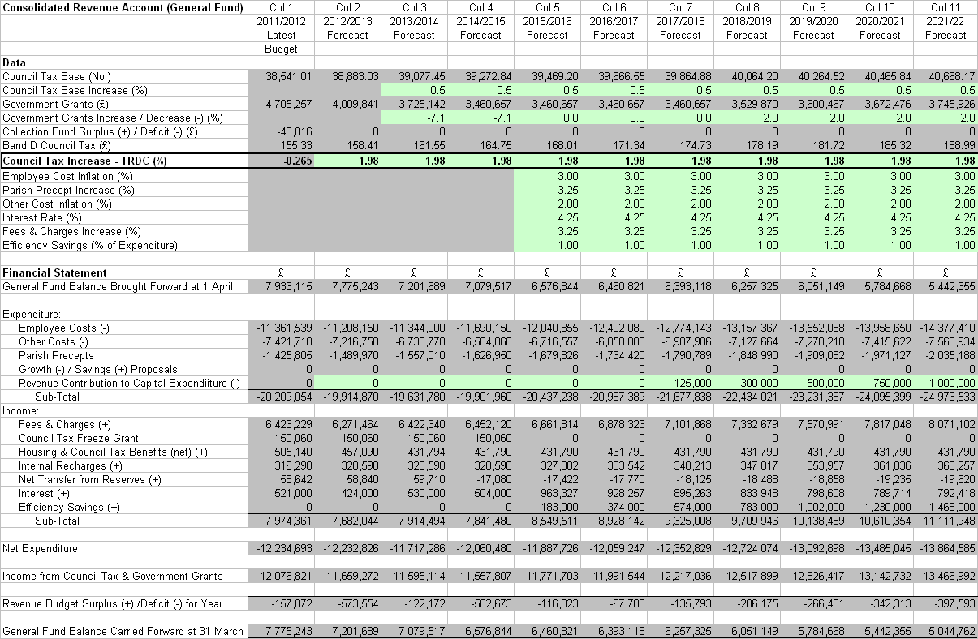

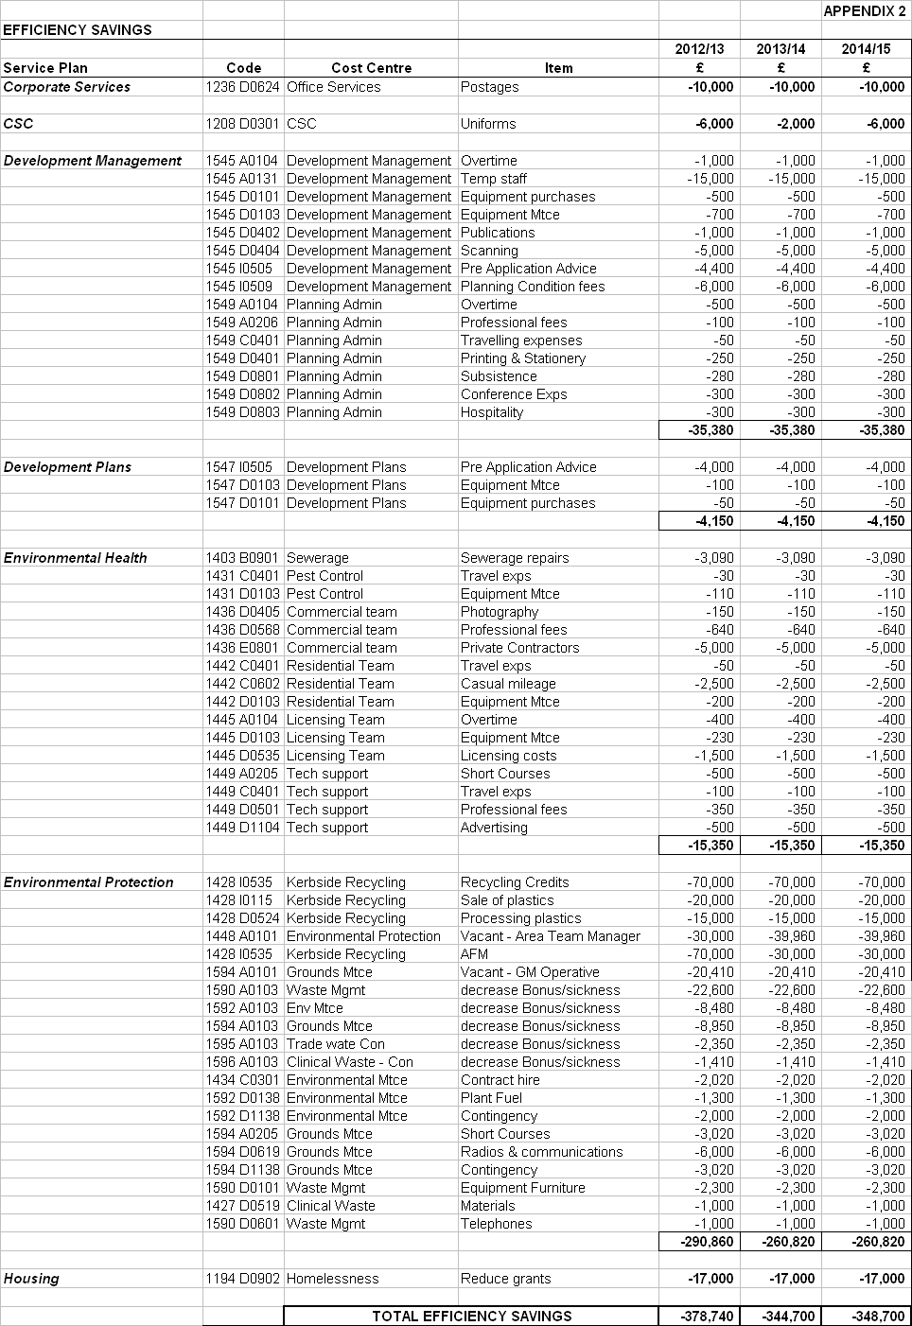

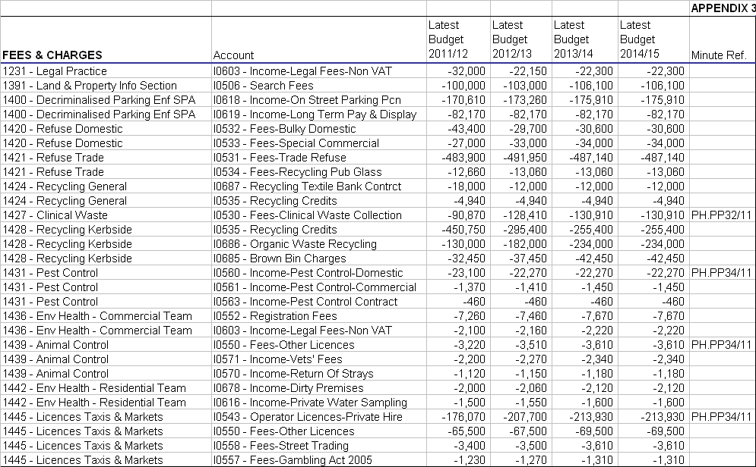
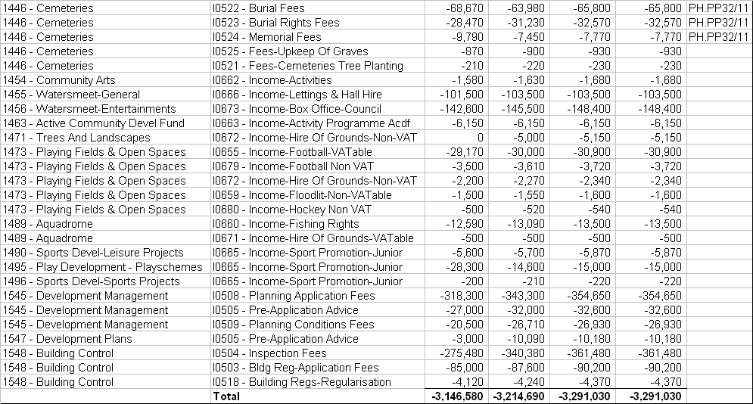

Notes:

1. Minute References

Public Services and Health Policy and Scrutiny Committee – 3 November 2011

Minute PH.PP32/11 Environmental Protection Fees And Charges

The Head of Environmental Protection reported that Officers were recommending a 60% increase in fees and charges for the collection of clinical waste to cover the cost of providing the service. In the last two years domestic clinical waste had trebled which had meant two vehicles were now required to deliver the service and hence the increase. Officers considered that the 60% increase would still be competitive but it was difficult to get price comparisons. The Committee requested that if officers encountered any problems these be referred back to the Portfolio Holder and the Chairman of the Committee.
Members agreed with the Officer recommendation that there should be no increases to Special Collections.

ACTION AGREED:-

That the Executive Committee be recommended:

(1) There is no increase to the fees for trade waste in 2012/13;

(2) The clinical waste fees and charges be increased by 60%;

(3) All cemetery fees and charges be increased by 5.2%;

(4) That anyone who has lived within Three Rivers District for more than 10 years, but moved out within the two years immediately prior to their death, pay the fees equivalent to residents status; and

(5) That the 250% increase in charge for the Deed of Right to Exclusive Burial be invoked when the person actually purchasing the Deed lives outside of the District and not be dependent upon where the deceased person lives.

(6) That there should be no increases to Special Collections.

Minute PH.PP34/11 Environmental Health – Review Of Fees And Charges 2012/13

To consider a review of Environmental Health fees and charges for 2012/13 which recommended that Environmental Health fees and charges for 2012/13 be increased by 5.2% on the current 2011/12 rates.

ACTION AGREED:-

(1) That this report be noted; and

To Executive Committee:

(2) That the proposed Environmental Health fees and charges for 2012/13 be approved and incorporated into the current budget setting process.

Leisure and Community Safety Policy and Scrutiny Committee - 10 January 2012

Minute L.PP61/11 Fees and Charges for Leisure and Community Activities 2012/13

Members asked why some charges were proposed to increase by more than the general increase of 5.2%.
The Head of Leisure and Community Services advised that these increases related to the actual equipment replacement costs and staffing costs. He advised that the delegated authority given to the Watersmeet Venue Manager to vary hire charges for commercial bookings was crucial in allowing him the necessary flexibility to achieve the financial targets set for Watersmeet.

ACTION AGREED:-

that the Committee recommends the following changes to fees and charges for 2012/2013 to the Executive Committee:

(a) Watersmeet room hire rates to increase by 5.2%. Watersmeet technical and other charges to increase by rounded amounts averaging at inflation, as shown in Appendix 1.

(b) Hire of parks and open spaces, and filming charges to increase by 5.2%, as shown in Appendix 2.

(c) Charges for the booking of sports pitches to increase by 5.2%, as shown in Appendix 2.

2 Penalty Charge – Single Persons Discount.

The Committee is asked to note that in approving the budget the Council is agreeing that it may, in appropriate circumstances, make a penalty charge to residents who improperly claim a single persons discount for council tax purposes.

3 Base Budget

The charges reported to the policy and scrutiny committees have been included in the base budget figures.

APPENDIX 4

LOCAL GOVERNMENT FINANCE SETTLEMENT – GOVERNMENT GRANT

The Chancellor of the Exchequer announced in the Comprehensive Spending Review (CSR) on 20 October 2010, reductions in government grants to local authorities of 28% in real terms over the next four years, averaging 7.1% per year.

The fact that the government indicated that it would protect funding for social care and education – services provided by the county council – implied that districts may be worse off than the average.

The formula grant distribution has four elements, the Relative Needs Formulae, The Relative Resource Amount, the Central Allocation (an amount per head) and the floor damping scheme.

The Relative Needs Formula calculates relative need rather than the actual amount needed to provide services. It comprises a number of ‘blocks’ with a separate formula for each. The blocks are:-

- Children’s Services | - Police | - Adults’ Personal Social Services
- Highway Maintenance | - Fire | - Environmental, Protective & Cultural Services
- Capital Financing

The Council’s needs relate only to Environmental, Protective & Cultural Services and Capital Financing.

The Relative Resource Amount is negative and takes into account the fact that areas that can raise income locally require less government support.

The Central Allocation is shared out on a per head basis.

In order that councils are protected from detrimental grant changes the government sets a guaranteed minimum increase/decrease in grant, called Floor Damping. The cost of achieving floor increases is met by scaling back increases above the floor.

The Government has confirmed the provisional grant for the second year of the CSR period (2012/13). The relevant components of the Council’s grant are as follows:

 | 2010/11 | 2011/12 |  | 2012/13
 | £ | £ | Change  % | £ | Change  %
Relative Needs Amount | 2,054,661 | 1,521,052 | -26.0 | 1,355,926 | -10.9
Relative Resource Amount | -3,311,242 | -1,963,652 | +40.7 | -1,908,107 | +2.8
Central Allocation | 6,357,166 | 4,417,583 | -30.5 | 4,019,439 | -9.0
Floor Damping | 597,871 | 696,585 | +16.5 | 542,583 | -21.1
Formula Grant | 5,698,457 | 4,671,568 | -18.0 | 4,009,841 | -14.2
Revenue Support Grant | 722,548 | 1,101,648 | +52.5
Redistributed Business Rates | 4,975,908 | 3,569,920 | -28.3
Formula Grant | 5,698,457 | 4,671,568 | -18.0 | 4,009,841 | -14.2

It can be seen from the table above that the Council is relying on the floor damping mechanism to retain its level of grant. Without floor damping the Council would receive £3.467m in 2012/13.

The floor damping calculation for 2012/13 is shown below:

2010/11 Budget Requirement | £11.653m
2010/11 Formula Grant | £5.698m
Formula Grant as percentage of Budget Requirement | 48.9%
Ranks 163 out of 201 districts and therefore falls into Floor Band 4 and means that
Grant cannot fall by more than 14.2%

2011/12 Adjusted Formula Grant | £4.673m
2012/13 ‘Raw’ Grant | £3.467m
Change | -£1.206m
Decrease before floor damping | -25.81%
Maximum fall in grant (£4.673m * 14.2%) | £0.664m
Total Grant (£4.673m - £0.664m) | £4.009m

The Parliamentary Under-Secretary of State for Communities and Local Government in a statement to the House of Commons on 8 December 2011 said that no authority would face more than a 8.8% reduction in spending power in 2012/13 and that the special transitional grant arrangements put in place for 2011/12 would continue to be made available where this would otherwise occur.

The table below demonstrates that the Council does not qualify for the Transitional Grant:-

2012/13 Transitional Grant | £m
2011/12 Spending Power | 10.877
2012/13 Spending Power | 10.213
Change -6.1% | -0.664

Longer term planning has been made difficult by the Government not announcing provisional grant figures for years three and four of the CSR period, i.e. 2013/14 and 2014/15. If grant were to fall to its ‘raw’ level by the end of the CSR period (i.e. floor damping would no longer apply), then the Council could expect to see a further decrease in grant of 14.9% over the two years 2013/14 and 2014/15. Officers have used reductions of 7.1% in each year in the budget model.

APPENDIX 5

COLLECTION FUND ADJUSTMENT

The estimated position on the Collection Fund at 31 March 2012 is shown below. Any surplus/ deficit at the end of the financial year would have been shared between Three Rivers, the County Council and the Police Authority.

 | 2011/2012
COLLECTION FUND | Estimated
 | Council
Income and Expenditure Account | Tax
 | £
Income
Council Tax | 51,194,697
Council Tax Benefit | 5,099,116
Contributions towards Previous Year Deficit
Hertfordshire County Council | 236,880
Hertfordshire Police Authority | 31,296
Three Rivers District Council | 40,816
Contribution from Provision for Doubtful Debts | 6,244
Total Income | 56,609,049
Expenditure
Precepts and Demands
Hertfordshire County Council | 43,120,838
Hertfordshire Police Authority | 5,697,132
Three Rivers District Council | 7,412,380
Total Expenditure | 56,230,350
Surplus/Deficit(-) for Year | 378,699
COLLECTION FUND | Estimated
Fund Balance | Council
and Appropriation Account | Tax
 | £
Balance Brought Forward 01.04.2011 | -378,699
Add:
Surplus/Deficit (-) for Year | 378,699
Balance Carried Forward 31.03.2012 | 0
Appropriations Reducing/Increasing(-)
2012/2013 Council Tax Charge:
Transfer to:
Three Rivers DC General Fund | 0
Hertfordshire County Council | 0
Hertfordshire Police Authority | 0
Total | 0

APPENDIX 6
SCHEME FOR PRIORITISING REVENUE GROWTH

Criteria |  | Revenue Growth
 |  | Score | Description
Measure of Quality of | a | 3 | Maintaining Current Service
Service |  | 6 | Improved Internal Service
 |  | 9 | Improved External Service
Customer Impact / Quantity | b | 3 | Affects < 10% of residents
of Service |  | 6 | Affects < 50% of residents
 |  | 9 | Affects all residents
Links to Strategic Plan | c | 2 | Contributes to General Theme
 |  | 4 | Contributes to General Aim
 |  | 6 | Contributes to Specific Objective
Impact on Partners | d | 1 | No impact on partner agencies or joint priorities
(as defined in the |  | 2 | Impacts on 1 partner agency / priority
Community Strategy) |  | 3 | Impacts several partners / priorities
Partnership Funding | e | 1 | No Partnership Funding
 |  | 2 | Partly Funded by Partners
 |  | 3 | Fully Funded by Partners
Equalities | f | 1 | No impact on vulnerable groups
 |  | 2 | Impacts on one vulnerable group
 |  | 3 | Impacts several vulnerable groups
Asset Management | g | 1 | Not related to asset maintenance
 |  | 2 | Allowing asset to continue in use
 |  | 3 | Expenditure required to bring asset up to standard enabling service to continue (i.e. an element of ‘backlog’ repair exists)
Statutory/Discretionary | h | 1 | Entirely Discretionary
Service |  | 2 | Partly Statutory
 |  | 3 | Entirely Statutory
Contractually Committed | i | 1 | No Commitment
 |  | 2 | Moral Obligation (e.g. SLA)
 |  | 3 | Contractually Committed

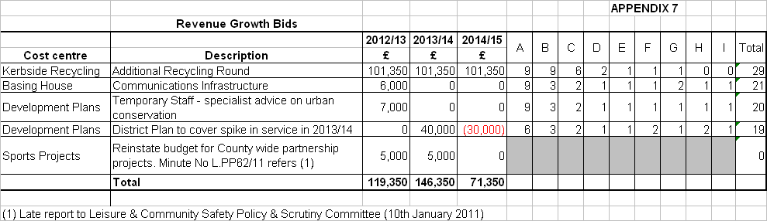
APPENDIX 8
PRIORITIES FOR REVENUE EXPENDITURE 2012-2015
ADVICE OF POLICY & SCRUTINY COMMITTEES

LEISURE AND COMMUNITY SAFETY POLICY AND SCRUTINY COMMITTEE
Strategic, Service and Financial Planning 2012-2015
1 November 2011 – Minute L.PP48/11

In response to questions the Head of Leisure and Community Services advised that the employee cost figures for the Aquadrome in cost centre 1489 showed a rise in the 2011/12 budget followed by falls in the expected outturn and subsequent years because the part- time post of a Park Ranger had originally been included in the Aquadrome budget (1489), but this cost had been transferred to cost centre 1471 – Trees and Landscapes during the year to keep the full Park Ranger costs within a single cost centre.

ACTIONS AGREED:-

that the budgets and efficiency savings contained in the Service Plan be noted.

Note: There were no proposals for revenue growth.

PUBLIC SERVICES AND HEALTH POLICY AND SCRUTINY COMMITTEE
Strategic, Service and Financial Planning 2012-2015
3 November 2011 – Minute PH.PP29/11

The Head of Development Management and Environmental Health advised the Committee on the efficiency gains included in the service plan which included the deletion of the CEHO post. There had been a one off saving of legal fees of £49k following the conclusion of a human rights legal case.

The Head of Environmental Protection reported:
The Area Team Manager position would not be reappointed after July 2012 and the team would reduce from 5 to 4 people.
The Council was anticipating receiving an increased AFM payment.
The Council would be losing the Grounds Maintenance Contract with Thrive Homes from 31 March 2012 so the vacant post would not filled.
There had been a decrease in waste management staff costs.
The requests to purchase a second brown bin had increased recently which would generate additional income.
In response to a question on fuel costs the Head of Environmental Protection advised that additional funding would be required and would be reported as part of the budget monitoring in Period 7. The total fuel budget was £400,000 a year an increase of £100K.

ACTION AGREED:-

that the budgets and efficiency savings contained in the service plans be noted, and

that the Committee recommends to the Executive Committee that the proposal for an additional recycling round and the proposals for additional income be agreed.

SUSTAINABLE ENVIRONMENT POLICY AND SCRUTINY COMMITTEE
Strategic, Service and Financial Planning 2012-2015
8 November 2011 – Minute SE35/11

The Head of Development Management and Environmental Health advised that the departure of a Principal Planner had provided scope for a staffing reorganisation which had improved the staff structure. Future legislation on charging for services would be based on recovery of costs, which would require rigorous work records.

He confirmed that the introduction of a chargeable pre-application advice service had been successful as it provided guidance to developers which reduced the incidence of rejected applications.

The Head of Development Plans reported good progress on the Local Development Framework. The Council was the first in Hertfordshire to have achieved the adoption of the Core Strategy and good progress was being made on the other elements. Future challenges included producing Development Plan Documents (DPDs) for site allocations, development management policies and gypsies and travellers, together with the introduction of the Community Infrastructure Levy (CIL) charging schedule, obtaining specialist advice on urban conservation and preparing an economic development strategy. The examinations associated with the Gypsy and Traveller DPD and CIL would require additional revenue resources in 2013/14 for which revenue growth items had been put forward.

ACTION AGREED:-

that the budgets and efficiency savings contained in the Service Plans be noted; and,

that the Sustainable Environment Policy and Scrutiny Committee recommends the Executive Committee to adopt …… the priorities for revenue growth set out in the report.

RESOURCES POLICY AND SCRUTINY COMMITTEE
Strategic, Service and Financial Planning 2012-2015
10 November 2011 – Minute R.PS24/11

ACTIONS AGREED :-

that the budgets and efficiency savings contained in the service plans be noted;

that the one proposal for growth be noted and the Executive Committee be recommended that it be included in the 2012/13 budget; and,

that the Committee notes that there are no proposals for service reductions or additional income.

APPENDIX 9
THE COUNCIL TAX CALCULATION

Council Tax Requirement | = | Band D Tax
Council Tax Base

The base budget figures for 2012/13 (excluding parish precepts) are:-

6,159,461 | = | 158.41
38,883.03

Examples of Three Rivers increases (excluding parish precepts):-

C/Tax Requirement |  |  | District Council Tax |  |  | Comment
£ | Increase/  Decrease (-)  %  % |  | Band D  £ | Increase/  Decrease (-)  % |  | Comment
5,986,575 | 0.00 |  | 153.96 | -0.89 |  | C/Tax Decrease at 2011/12 council tax requirement
6,039,701 | +0.89 |  | 155.33 | 0.00 |  | Council Tax Requirement giving standstill council tax
6,159,461 | +2.89 |  | 158.41 | +1.98 |  | Council Tax at level of Base Budget
6,251,225 | +4.42 |  | 160.77 | +3.50 |  | Council Tax Requirement giving excessive budget

Notes:
1. The Total Budget Requirement is the net expenditure after contributing to or using balances, i.e. the income the Council requires from council tax and government grant.
2. At this stage, the grant figures used for the calculations above are those contained in the Government’s consultation proposals.

The Committee will be aware that the parish precepts are included as part of the Council’s expenditure. The following parish precepts are included at this stage:

Parish | 2011/12  £ | 2012/13  £ | Change  % | Status
Abbots Langley | 558,955 | 564,000 | +0.9 | Agreed by Parish Council
Chorleywood | 338,500 | 341,850 | +1.0 | Draft Figure from Parish Council
Croxley Green | 245,200 | 258,242 | +5.3 | Draft Figure from Parish Council
Sarratt | 72,500 | 72,500 | 0.0 | Agreed by Parish Council
Watford Rural | 210,650 | 217,740 | +3.4 | Agreed by Parish Council
Total | 1,425,805 | 1,454,332 | +2.0

Until the parish precept figures are all confirmed, the base budget for 2012/13 includes £1,489,970 for parish precepts (an increase of 4.5%). Including the parish precepts at this level gives the following council tax requirement and the corresponding average council tax increases:-

C/Tax Requirement |  |  | Inclusive Council Tax |  |  | Comment
£ | Increase/  Decrease (-)  %  % |  | Band D  £ | Increase/  Decrease (-)  % |  | Comment
7,412,380 | 0.00 |  | 190.63 | -0.88 |  | C/Tax Decrease at 2011/12 council tax requirement
7,477,984 | +0.89 |  | 192.32 | 0.00 |  | Council Tax Requirement giving standstill council tax
7,649,431 | +3.20 |  | 196.73 | +2.29 |  | Council Tax at level of Base Budget

The calculation of special expenses, when setting the council tax on 21 February 2012, will mean that no one part of the area will be charged the average council tax.

APPENDIX 10

FINANCIAL AND BUDGETARY RISKS - RISK REGISTER
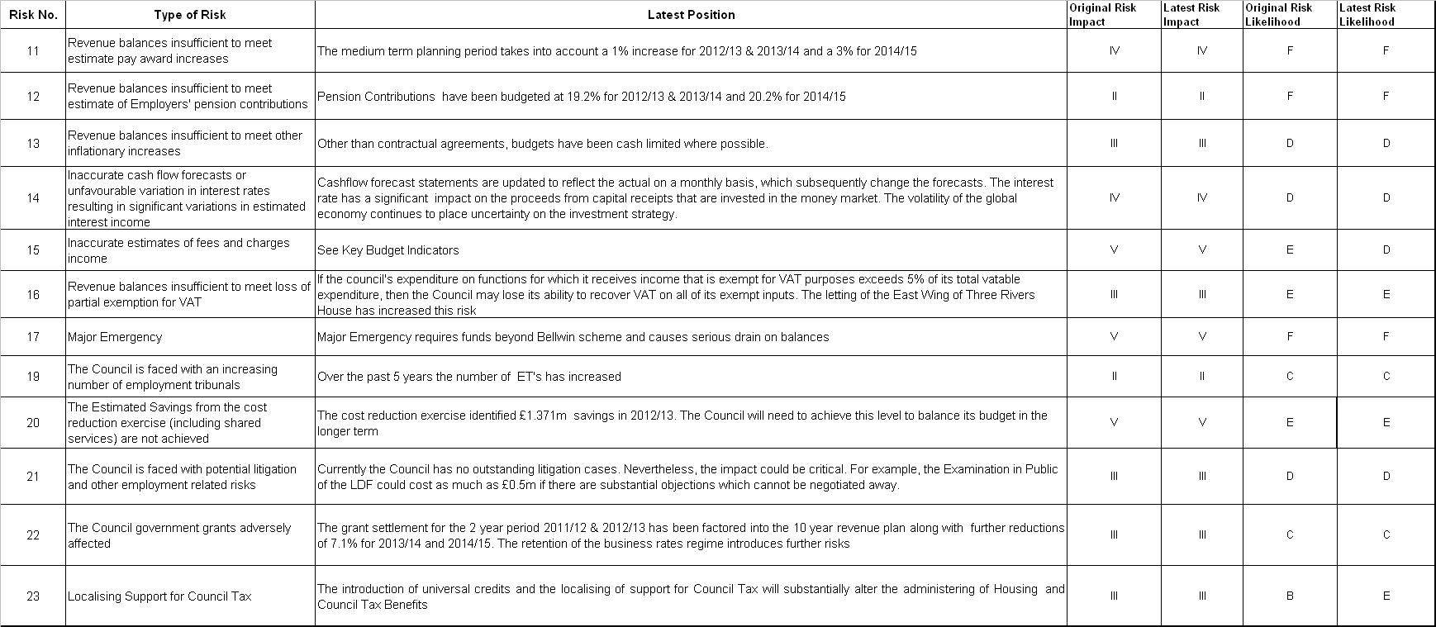

EXECUTIVE COMMITTEE – 30 JANUARY 2012

PART I - NOT DELEGATED

13. FINANCIAL PLANNING – CAPITAL INVESTMENT PROGRAMME
(DCRG)

1. Summary

1.1 The purpose of this report is to enable the Executive Committee to recommend to the Council its capital investment programme, in the light of the available funding.

2. Details

Capital Investment Programme

2.1 Officers have prepared a model, forecasting capital expenditure and its funding. This is attached at Appendix 1 and includes a revised estimate for the current year and detailed figures for the period up to and including 2021-2022. The figures currently assume that all potential schemes are approved. However, the budget model allows levels of expenditure to be altered to show how this affects the capital balances carried forward. It is also integrated with the revenue model, where revenue contributions can be entered and the interest earned on capital balances is shown. Further explanation is available from officers.

Capital Funding

2.2 The first section of the capital budget model shows the balances of capital funding brought forward into each financial year and the funding generated in each year. The Capital Investment Programme is funded from a number of sources which can be categorised as either ‘earmarked’ funding (targeted at specific schemes) or ‘unrestricted’ funding (available to fund any scheme).

Earmarked Funding

Government Grants

2.3 Grants for specific purposes may be available from the Government, e.g. Disabled Facility Grants.

2.4 The New Homes Bonus commenced in April 2011, and ‘match funds’ the additional council tax raised for new homes and empty properties brought back into use, with an additional amount for affordable homes, for six years. For the purposes of forward planning officers have included an estimate of the new homes bonus as earmarked funding. This is on the basis that it would not be prudent to support revenue expenditure from this source and that new homes increase the need for capital expenditure on infrastructure / leisure facilities etc. For accounting purposes the grant is treated as a revenue grant and the accounts will therefore show a revenue contribution to capital expenditure.

Partnership Funding

2.5 The Council attracts partnership funding from local authorities, e.g. the County Council, and other agencies, e.g. the Community Safety Partnership and the Waste Partnership.

Third Party Contributions

2.6 These include contributions from private developers where the Council has been able to negotiate benefits when planning permission is sought (known as Section 106 agreements or planning gain). These are to be replaced, in part, by the Community Infrastructure Levy, to be determined by members through a future report to this Committee. Current Section 106 monies are guaranteed.

2.7 Other Funding

The Council has benefited in the past from other funding such as lottery grants. Whilst funding from public private partnerships (PPP) and private finance initiatives (PFI) is still available the opportunities for a Council of Three Rivers’ size appear extremely limited.

Unrestricted Funding

The Use of Capital Receipts

2.8 When the Council sold its housing stock to Thrive Homes Ltd, the Transfer Agreement included a Right to Buy Sharing Agreement whereby the Council is entitled to a share of the post-transfer receipts from Right to Buy sales and a ‘VAT Shelter Agreement’ whereby the Council benefits from the recovery of VAT on continuing works carried out by Thrive. It should be noted that the estimate of funding available from the Right to Buy Sharing Agreement has been considerably reduced in the light of the number of houses being sold. Other capital receipts derive from the selling of assets, e.g. land.

Reserve for Capital Expenditure

2.9 The Council has a general reserve which it has put aside for future capital expenditure. It has the ability, should it wish, to re-designate this reserve for revenue use.

Revenue Contributions

2.10 Capital Expenditure may be met directly from Council Tax.

Borrowing

2.11 It is not proposed to borrow to fund capital expenditure in the medium or long-term.

Capital Expenditure

2.12 The second section of the capital budget model shows capital expenditure. This can be defined as expenditure which benefits the community over a number of years. Regulations prevent the Council charging day to day expenditure to capital since it is imprudent to fund regular on-going costs from finite capital resources.

2.13 The first schemes to be listed are those that were expected to be completed in the current year. The position on the current year’s capital programme is summarised on the Current Year Scheme by Scheme Detail page of the budget monitoring reports on the Council’s website at:-

http://www.threerivers.gov.uk/Default.aspx/Web/BudgetMonitoringReports

This section also identifies where an element of re-phasing is now expected. Expenditure in 2012/13 on these schemes is committed.

2.14 The proposed expenditure on the remaining schemes is not committed.

2.15 The schemes shown in the capital budget model are described in more detail at Appendix 2.

2.16 Proposals for uncommitted capital investment over the next three years have been considered by the policy and scrutiny committees. Appendix 3 shows the scheme costs, the revenue implications, links to the Strategic Plan, and the priorities given to each scheme by officers using the scheme detailed at Appendix 4.

2.17 The advice of the policy and scrutiny committees is contained in Appendix 5. The committees confirmed the priorities they set this time last year and slotted in three new schemes which are hatched in grey at Appendix 3. Where these priorities differ from those determined by the officers, a note to that effect is attached to Appendix 3.

Balances

2.18 The final section of the capital budget model shows from which sources it is proposed to fund the expenditure and the balances carried forward at the end of each year.

3. Options/Reasons for Recommendation

3.1 The recommendations at agenda item 15 below enable the Committee to make recommendations to the Council on 21 February 2012 concerning the Council’s budget.

4. Policy/Budget Reference and Implications

4.1 The recommendations in this report contribute to the process whereby the Council will approve and adopt its strategic, service and financial plans under Article 4 of the Council’s Constitution.

5. Equal Opportunities, Legal, Environmental, Community Safety, Customer Services Centre, Communications & Website, Risk Management and Health & Safety Implications

5.1 None specific.

6. Financial Implications

6.1 In determining which schemes should be included in the programme it is recommended that members take the following steps:

a) determine the value of those uncommitted schemes with earmarked funding that should proceed;

b) then choose further uncommitted schemes that use unrestricted funding taking into account the sustainability of incurring capital expenditure at a rate exceeding receipts and any revenue implications.

7. Equal Opportunities Implications

7.1 See Agenda Item 15 below.

8. Staffing Implications

8.1 The requirements for surveying expertise will be closely monitored to ensure that the capital investment programme can be delivered. For committed schemes, internal professional fees are separately identified. For uncommitted schemes, fees are included within the scheme total, and will be separately identified when members have determined which schemes should proceed. The one exception is an amount of £30k which has been included under Regeneration Schemes for the South Oxhey Project.

9. Risk Management and Health & Safety Implications

9.1 There are no risks to the Council in agreeing the recommendation below.

10. Recommendation

10.1 That the report is noted.

Report prepared by: David Gardner – Director of Corporate Resources
Dot Reynolds – Finance Manager (Shared Services)
Alan Power – Head of Finance (Shared Services)

Background Papers
Part I Local Government Act 2003 and regulations thereunder.
Treasury Management in the Public Services, Code of Practice and Cross-Sectoral Guidance Notes, published by CIPFA.
The Prudential Code for Capital Finance in Local Authorities - CIPFA.

APPENDICES / ATTACHMENTS

1 | Ten Year Financial Plan – Capital Investment Programme
2 | Description of Schemes 2011-2022
3 | Capital Investment Programme 2012-2015 - Priorities
4 | Scheme for Prioritising Capital Bids
5 | Advice of Policy & Scrutiny Committees

The recommendations contained in this report DO NOT constitute a KEY DECISION but contribute to the process whereby the Council will approve and adopt its Strategic, Service and Financial Plans under Article 4 of the Council’s Constitution
APPENDIX 1
TEN YEAR FINANCIAL PLAN – CAPITAL INVESTMENT PROGRAMME
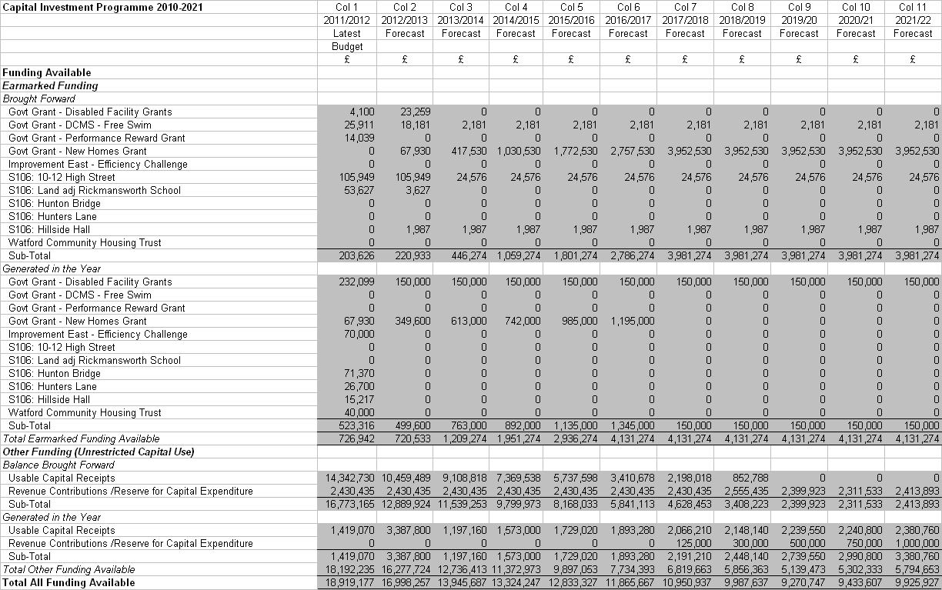
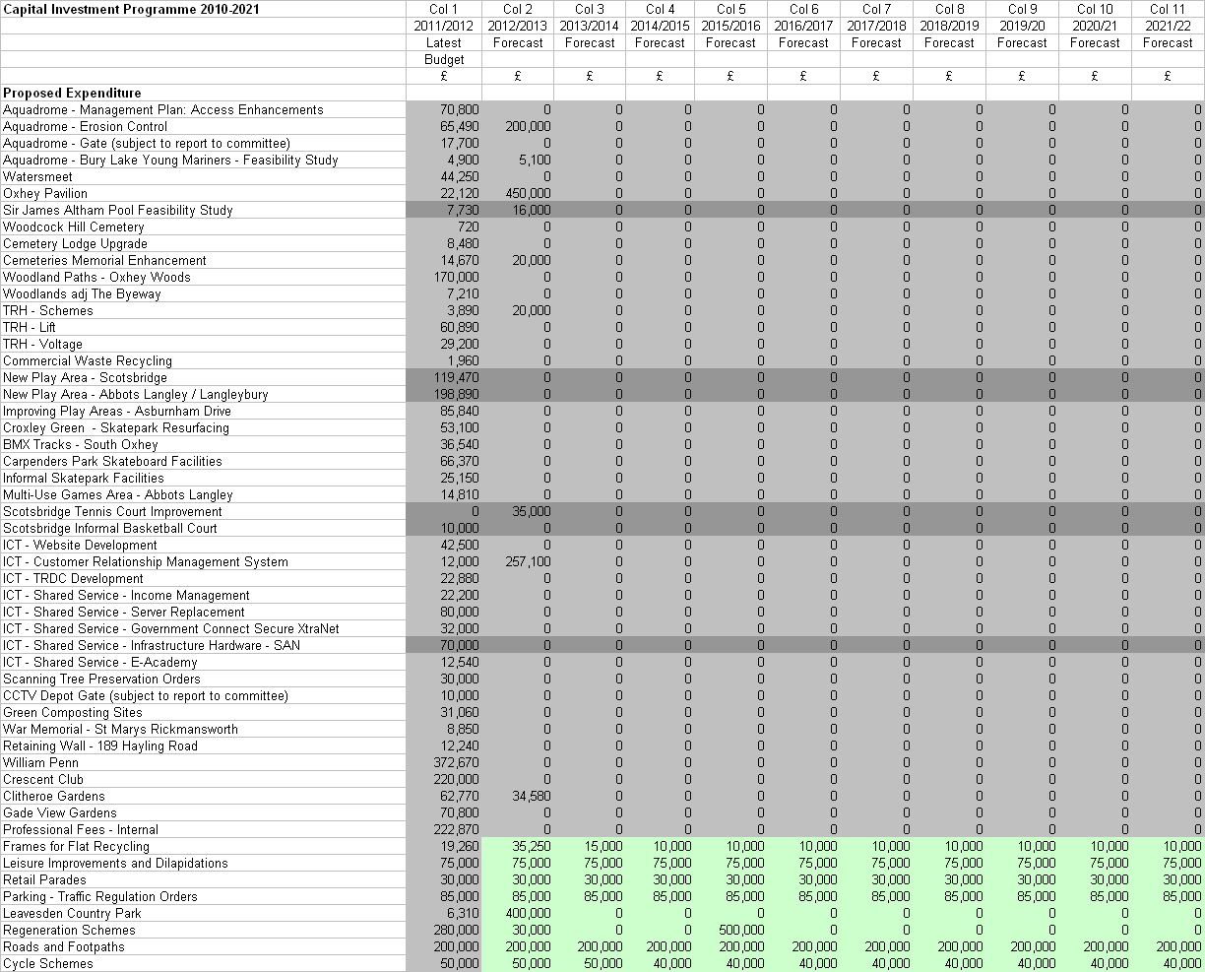
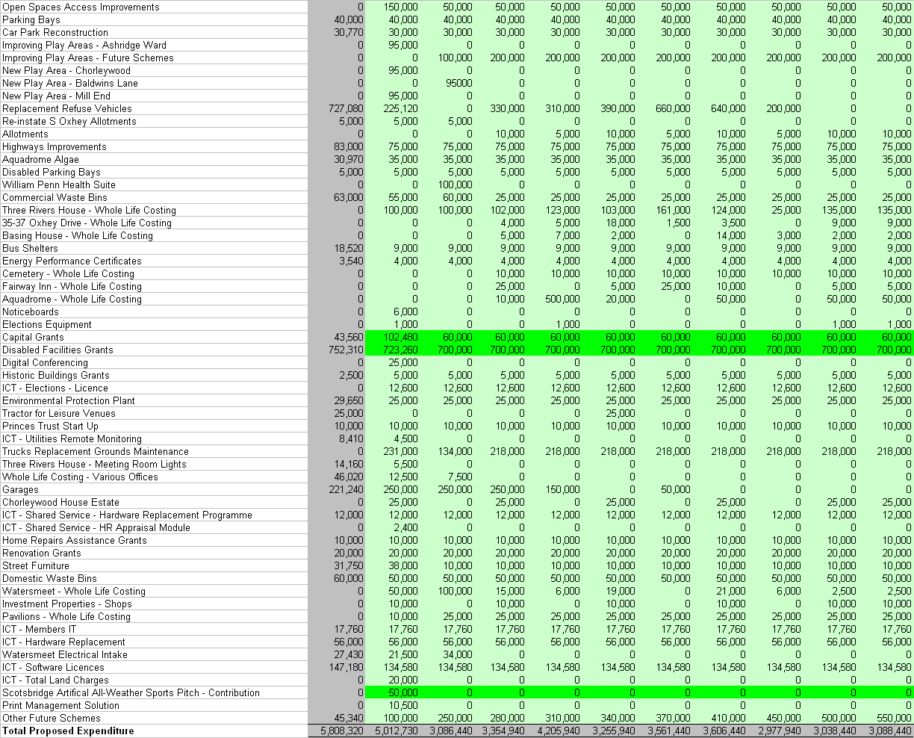
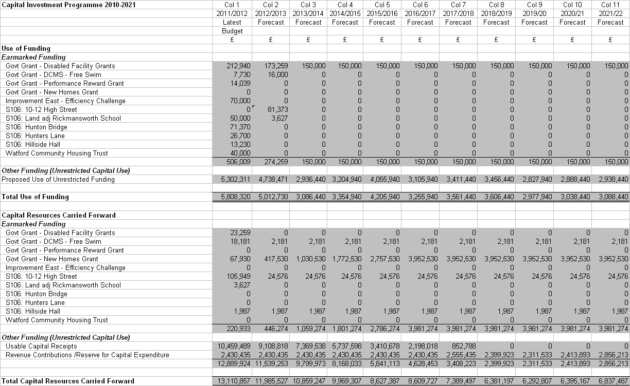
APPENDIX 2
TEN YEAR CAPITAL INVESTMENT PROGRAMME – DESCRIPTION OF SCHEMES

Short Title | Description
Aquadrome Access Enhancements | This project implements the Aquadrome Management Plan. Upgrading of the main access road and provision of additional footpath links. This will enable the Council to manage the current conflict between pedestrians and vehicular movements in and around the main entrance, thus providing a more welcoming experience for those visitors entering the site on foot.
Aquadrome Erosion Control | Installation of a weir/sluice to maintain water levels to minimise erosion of Batchworth Lake. Review of design of fishing platforms to prevent unauthorised access to the lake by anglers. Implement erosion control measures to ‘at risk’ areas, e.g. those where water-skiing causes damage. Implement Asbestos Management Plan.
Aquadrome Gate | Provision of an electronic gate to increase security and safety.
Aquadrome – Bury Lake Young Mariners Feasibility Study | The clubhouse is owned by TRDC and leased to the BLYM. It is now 80 years old and no longer fit for purpose. In particular the building is inadequate for people with disabilities, too small for the usage it attracts and is thermally inefficient. The Club are expecting over 500 members and has a nationally accredited disability section, and a thriving youth section many of whom teach sailing to their peers including 25 schools. The Club wish to replace the existing facility with a new clubhouse, workshop, storage, changing, training and toilet facilities.
Watersmeet | Domestic hot water system being replaced.  New fire alarm system.  Update floor tilt system.
Oxhey Pavilion | Pavilion to service 6 fullsize football pitches, 2 mini-football pitches, 1 rugby pitch and cricket table. See report to Leisure and Community Safety Policy & Scrutiny Committee on 14 September 2010.
Sir James Altham Feasibility Study | Investigating future options for provision of a swimming pool in South Oxhey
Woodcock Hill Cemetary | Parking bay at top of hill leading to the woodland section of the cemetery.
Cemetery Lodge Upgrade | Completion of backlog repairs to the Woodcock Hill and Chorleywood Road Cemetery Lodges
Cemeteries Memorial Enhancement | Repairs to dangerous memorials
Woodland Paths – Oxhey Woods | Key aim is to make the woods more accessible to all, including those with limited mobility. Scheme will build on the works already done to achieve and maintain UKWAS
Woodlands adjacent The Byeway | Purchase of additional woodland adjacent to Grove Wood
Three Rivers House – Schemes | Provision of stair lift in East wing
Three Rivers House – Lift | Renew existing controls including landing door operating system, hydraulic power unit and control valve and car buffer systems to enable staff and public safe access between floors and assist with DDA requirement.
Three Rivers House – Voltage | Provide voltage power optimisation to the electrical distribution system in Three Rivers House to improve power quality by providing voltage at an optimum supply. Will assist in complying with the Carbon Reduction Commitment Efficiency Scheme regulations.
Commercial Waste Recycling | This will result in a reduction in the amount of municipal waste being sent to landfill. Previous recycling targets related to domestic waste only, however the Landfill Allowance trading Scheme relates to municipal waste which includes commercial. It will reduce the risk of the Council having to meet the costs of rising landfill charges and LATS penalties.

Short Title | Description
New Play Area –Scotsbridge | See Item 7 of agenda for Leisure & Community Safety Policy & Scrutiny Committee – 4 January 2011.
New Play Area – A/L Langleybury | See Item 7 of agenda for Leisure & Community Safety Policy & Scrutiny Committee – 4 January 2011.
Improving Play Areas – Ashburnham Drive | New play area.
Croxley Green Skatepark Resurfacing | Re-surfacing Croxley Green Skate Park Base. Visual inspection has revealed an unevenness in the transition from concrete ramp to tarmac base. Visiting coaches have identified the wearing of the base within activity risk assessments.
BMX Track – South Oxhey | The provision of an open access BMX track, alongside the informal skateboarding area, to establish an area for young people to congregate, socialise and take part in what is now a new Olympic sport.
Carpenders Park Skateboard Facilities | Installation of new facility to provide young people within the Carpenders Park area the opportunity to take part in positive leisure activities.
Informal Skatepark Facilities | Informal recreational facilities for young people in West Hyde
Multi Use Games Area – Abbots Langley | Assisting Abbots Langley Parish Council with improvements to the MUGA
Scotsbridge Tennis Courts Improvement | Scheme using S106 monies
Scotsbridge Informal Basketball Court | Scheme using S106 monies
ICT – Website Development | Redesigned website with improved navigation, accessibility, social media and transactional services
ICT – Customer Relationship Management System | New CRM system to replace ageing Northgate system which is no longer being developed. Project to consider harmonisation possibilities with Watford B.C.
ICT – TRDC Development | Expenditure on non-shared services systems, i.e. unique to TRDC
ICT – Shared Services – Income Management | Request from Shared Services Joint Committee for 40% of funding for Implementation of income management system, now successfully completed but funding re-phased from 2010/11.
ICT – Shared Services – Server Replacement | Request from Shared Services Joint Committee for 40% of funding for replacing servers as recommended by consultant’s Infrastructure Review.
ICT – Shared Services – Government Connect Secure Xtranet | Request from Shared Services Joint Committee for 40% of funding to comply with Government security protocols.
ICT – Shared Services – Infrastructure Hardware – SAN | Request from Shared Services Joint Committee for 40% of funding for Storage Area Network.
ICT – Shared Services – E-Academy | Request from Shared Services Joint Committee for 40% of funding for self-service modules of Revenues and Benefits system.
Scanning Tree Preservation Orders | Enables more efficient use of resources. 751 paper files going back over 30 years will be put in an electronic format which can be easily accessed.
CCTV Depot Gate | Provision of CCTV to second gate at Batchworth Depot allowing introduction of one-way system and improving safety and security
Green Composting Sites | Sites to be established at the Aquadrome, Chorleywood House Estate, Leavesden Country Park and South Oxhey Playing Fields in order that Grounds Maintenance and the Arborist team recycle green waste arising from the sites for re-use at the site.
War Memorial – St Marys Rickmansworth | Restoration of Rickmansworth War Memorial located in the ‘closed’ churchyard of St Marys and consequently the responsibility of the Council. Safety works will stop the gradual deterioration of the concealed pins within the structure with which the facing Portland stone panels are secured to the core of the memorial.
Retaining Wall – 189 Hayling Road | Safety works to dangerous wall

Short Title | Description
William Penn | Finalising scheme costs of William Pen Leisure Centre
Crescent Club | To purchase the leasehold of the Crescent Club and ready the site for development
Clitheroe Gardens | To prepare the site for development as affordable housing
Gade View Gardens | To provide parking bays for 1-4 Gade View Gardens
Professional Fees – Internal | In-house Professional Fees associated with capital schemes managed by Asset Management
Frames for Flats Recycling | Install frames for recycling bins in blocks of flats – both the small number of flats not yet equipped with frames and also for new blocks – to enable residents to recycle their waste easily
Leisure Improvements and Dilapidations | This expenditure enhances the assets used to provide leisure and community facilities. Principally facilities operated by Hertsmere Leisure where the Council retains responsibility for major improvements.
Retail Parades | Enhancement of retail parades throughout the district. Enhancements required following safety audits
Parking – Traffic Regulation Orders | New parking controls throughout District. Safer environment with more effective use of available parking space.
Leavesden Country Park | Improved access to existing building managed by the Watford YMCA for park users, i.e. public toilets and small café. Increase the footprint of the gym area to improve throughput to make the facility financially viable, thus protecting the asset and rent received from the YMCA. Will also enable an increase of young people and those with a disability to use the premises.
Regeneration Schemes | Future years’ costs related specifically to the regeneration of South Oxhey.
Roads and Footpaths | When the housing stock was sold to Thrive Homes the Council retained the estate roads and paths which require a phased programme of works.
Cycle Schemes | Involves provision of new on road or new signed advisory routes. The aim is to have a co-ordinated network of cycle tracks linking all settlements throughout the District.
Open Spaces Access Improvements | Improve footpath networks on key open space sites to ensure continued public use and provide improved access in line with management plans and Green Flag objectives.
Parking Bays | The aim is to provide better parking facilities in residential areas experiencing pressure. The programme is to be determined by the Executive Committee following discussion at the Sustainable Environment Policy & Scrutiny Committee.
Car Par Reconstruction | Provision of reconstructed facilities. A programme for the reconstruction of the Council’s public short and long stay car parks commenced in 2007/08 with High Street West, Rickmansworth and following with Barton Way in Croxley Green in 2008. The on-going programme is to be determined by the Executive Committee following consideration by the Sustainable Environment Policy & Scrutiny Committee.
Improving Pay Areas – Ashridge | See Item 7 of agenda for Leisure & Community Safety Policy & Scrutiny Committee – 4 January 2011.
Improving Play Areas – Future Schemes | Amount included in programme for play areas yet to be identified.
New Play Area – Chorleywood | See Item 7 of agenda for Leisure & Community Safety Policy & Scrutiny Committee – 4 January 2011.
New Play Area – Baldwins Lane | See Item 7 of agenda for Leisure & Community Safety Policy & Scrutiny Committee – 4 January 2011.
New Play Area – Mill End | See Item 7 of agenda for Leisure & Community Safety Policy & Scrutiny Committee – 4 January 2011.
Replacement Refuse Vehicles | Planned replacement programme for waste and recycling vehicles over a seven year period.
Reinstate South Oxhey Allotments | Reinstatement of Allotment Land recommended by the Resources Committee on 13 November 2008. See Minute R.PS28/08.

Short Title | Description
Highways Improvements | District priority highway improvements. The aim is to improve highway safety in residential areas. A programme of new schemes is to be determined by the Executive Committee following discussion at the Sustainable Environment Policy & Scrutiny Committee.
Aquadrome Blue Green Algae | The project will treat the blue-green algae in both Batchworth and Bury Lake at the Aquadrome. In previous years, when the algae has not been treated, the Aquadrome has been closed due to algal blooms. Treatment will ensure that the varied licensees will be able to continue to use the Aquadrome, as will the general public. The water will be tested during the summer to measure the levels of algae.
Disabled Parking Bays | New Disabled Parking Bays around the District. The provision of “advisory” parking bays for residents with disabilities who require a car and have a Blue Badge.
William Penn Health Suite | Installation of sauna and steam room facilities into the refurbished wet side of the Leisure Centre
Commercial Waste Bins | It is intended that the funding be used to purchase both bins for trade and the replacement of existing paladin bins.
Three Rivers House – Whole Life Costing | Estimate included in programme to reflect on-going requirement for capital expenditure on the council’s assets and enable 10 year capital programme to be updated.
35-37 Oxhey Drive – Whole Life Costing | Estimate included in programme to reflect on-going requirement for capital expenditure on the council’s assets and enable 10 year capital programme to be updated.
Basing House – Whole Life Costing | Estimate included in programme to reflect on-going requirement for capital expenditure on the council’s assets and enable 10 year capital programme to be updated.
Bus Shelters | New facilities rather than maintenance of existing shelters
Energy Performance Certificates | On-going statutory requirement for the provision of Energy Performance Certificates and Display Energy Certificates to Council owned shops and premises over 1000 sq mtrs.
Aquadrome – Whole Life Costing | Estimate included in programme to reflect on-going requirement for capital expenditure on the council’s assets and enable 10 year capital programme to be updated.
Noticeboards | Additional noticeboards in South Oxhey
Election Equipment | Purchase of polling booths, portable ramps and ballot boxes
Capital Grants | These grants contribute to safer communities through increasing the number of leisure and community facilities available to targeted groups, and to sustainable communities through supporting and enabling the voluntary sector.
Disabled Facility Grants | The provision of mandatory grants to disabled people to facilitate access to, from and around their property.
Digital Conferencing | System to enable digital conferencing to reduce travel between venues for meetings
Historic Building Grants | Grants for Listed Buildings. New works to properties. Long term preservation and enhancement of the district’s built heritage.
ICT Elections Licence | Election IT software
Environmental Protection Plant | Funding for Environmental Protection plant, equipment and machinery
Tractor for Leisure Venues | Second hand tractor to replace 9 year old tractor which is irreparable. Used for moving fallen trees, clearing ditches, moving wood chippings and logs and to turn the compost for the green waste composting site. Will be road taxed and available for all leisure sites.

Short Title | Description
Princes Trust | Grant paid to Prince’s Trust which offers grants, loans and a range of advice to Three Rivers residents starting their own businesses. Prince’s Trust – grants (18-30 age group)
ICT – Utilities Remote Monitoring | Enables monitoring of energy and water use.
Trucks Replacement – Grounds Maintenance | A rolling programme of purchases as existing vehicles come to the end of their lives.
Three Rivers House - Meeting Room Lights | Renewal of lighting to Penn Chamber, Dickinson and O’Connor Rooms, improving energy efficiency and reduction of CO₂ emissions.
Whole Life Costing – Various Offices | Works identified through asset management plan.  Three Rivers House – Hot and cold water distribution systems, rationalisation of distribution pipework.  Basing House – heating boiler and pipework, lighting, toilet refurbishment.  South Oxhey Office – heating boiler, lighting, fire alarm, portable fire fighting equipment.
Garages | Garages retained after stock transfer. Capital works to enable letting.
Chorleywood House Estate – Whole Life Costing | Estimate included in programme to reflect on-going requirement for capital expenditure on the council’s assets and enable 10 year capital programme to be updated.
ICT - Shared Services – Hardware Replacement Programme | Request from Shared Services Joint Committee for 40% of funding for replacing harware in respect of shared services.
ICT – Shared Services – HR Appraisal Module | Request from Shared Services Joint Committee for 40% of funding to implement appraisal module.
Home Repairs Assistance Grants | The provision of grants to vulnerable people who cannot obtain commercial funding (including equity release). To carry out essential improvements where there is a severe hazard to health, safety and welfare of the resident.
Renovation Grants | The provision of discretionary grants to vulnerable people who cannot obtain commercial funding (including equity release). Designed to provide assistance with small scale works of repair, improvement and adaptations to a dwelling.
Street Furniture | Replacement of litter bins / Litter Bin Replacement Programme
Domestic Waste Bins | The funding is for the provision of new residual waste and organic waste bins and recycling boxes or bins to new housing developments and also to properties where the existing bin / box may be damaged, as well as satisfying demand for additional recycling boxes. This will enable all new properties to recycle and dispose their household waste, thereby reducing the amount of municipal waste being sent to landfill, and ensuring the council carries out its statutory duty under s45 of the Environmental Protection Act 1990.
Watersmeet – Whole Life Costing | Estimate included in programme to reflect on-going requirement for capital expenditure on the council’s assets and enable 10 year capital programme to be updated.
Investment Properties – Shops | Estimate included in programme to reflect on-going requirement for capital expenditure on the council’s assets and enable 10 year capital programme to be updated.
Pavilions – Whole Life Costing | Estimate included in programme to reflect on-going requirement for capital expenditure on the council’s assets and enable 10 year capital programme to be updated.
ICT – Members IT | Grants to members to allow them to undertake their duties

Short Title | Description
ICT – Hardware Replacement | PC and server replacement programme for services outside the scope of existing shared services
Watersmeet Electrical Intake | Renewal and upgrade of the main intake room and distribution system, obsolete control gear and ineffective aluminium distribution cabling. Replacement of sub main distribution boards, lighting uplift, movement detectors and separation of Daybreak Nursery services to comply with current requirements.
ICT - Software Licences | Permitted capitalisation of software licences
ICT – Total Land Charges | Electronic Land Charges module
Allotments – Whole Life Costing | Estimate included in programme to reflect on-going requirement for capital expenditure on the council’s assets and enable 10 year capital programme to be updated.
Fairway Inn – Whole Life Costing | Estimate included in programme to reflect on-going requirement for capital expenditure on the council’s assets and enable 10 year capital programme to be updated.
Cemeteries – Whole Life Costing | Estimate included in programme to reflect on-going requirement for capital expenditure on the council’s assets and enable 10 year capital programme to be updated.
Other Future Schemes | Amount put into the programme as an estimate of future schemes yet to be identified.
Scotsbridge Artifical All-weather Sports Pitch - Contribution | Contribution to proposal by Rickmansworth Hockey Club in partnership with Rickmansworth School as reported to Leisure and Community Safety Policy and Scrutiny Committee on 10 January 2012.
Other Future Schemes | Allowance made in programme for schemes yet to be identified.

APPENDIX 3
CAPITAL INVESTMENT PROGRAMME 2012-2015

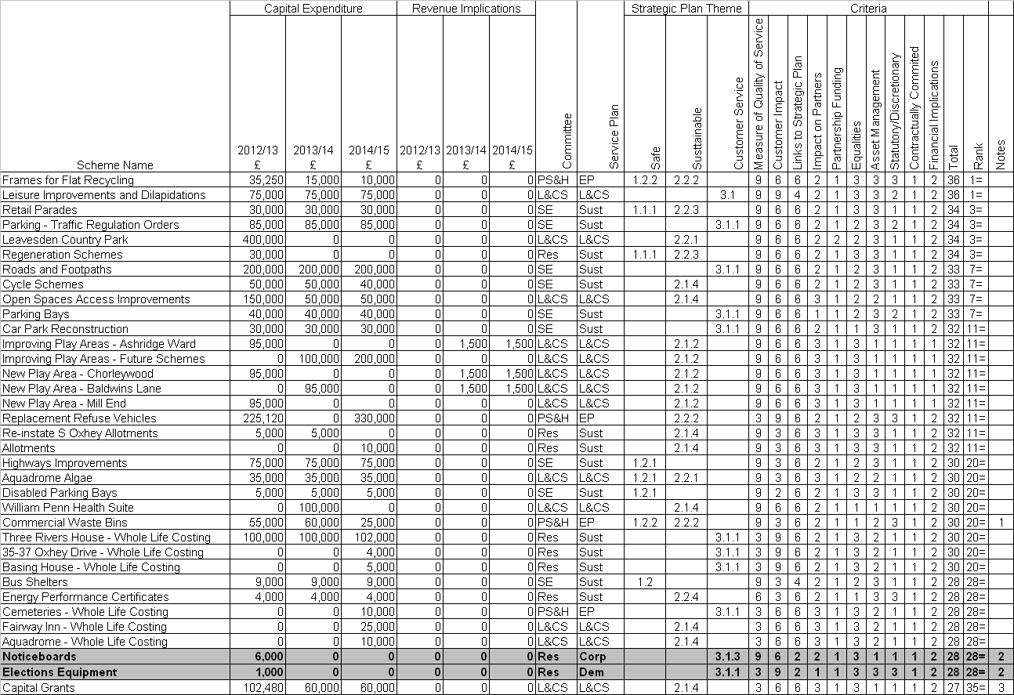
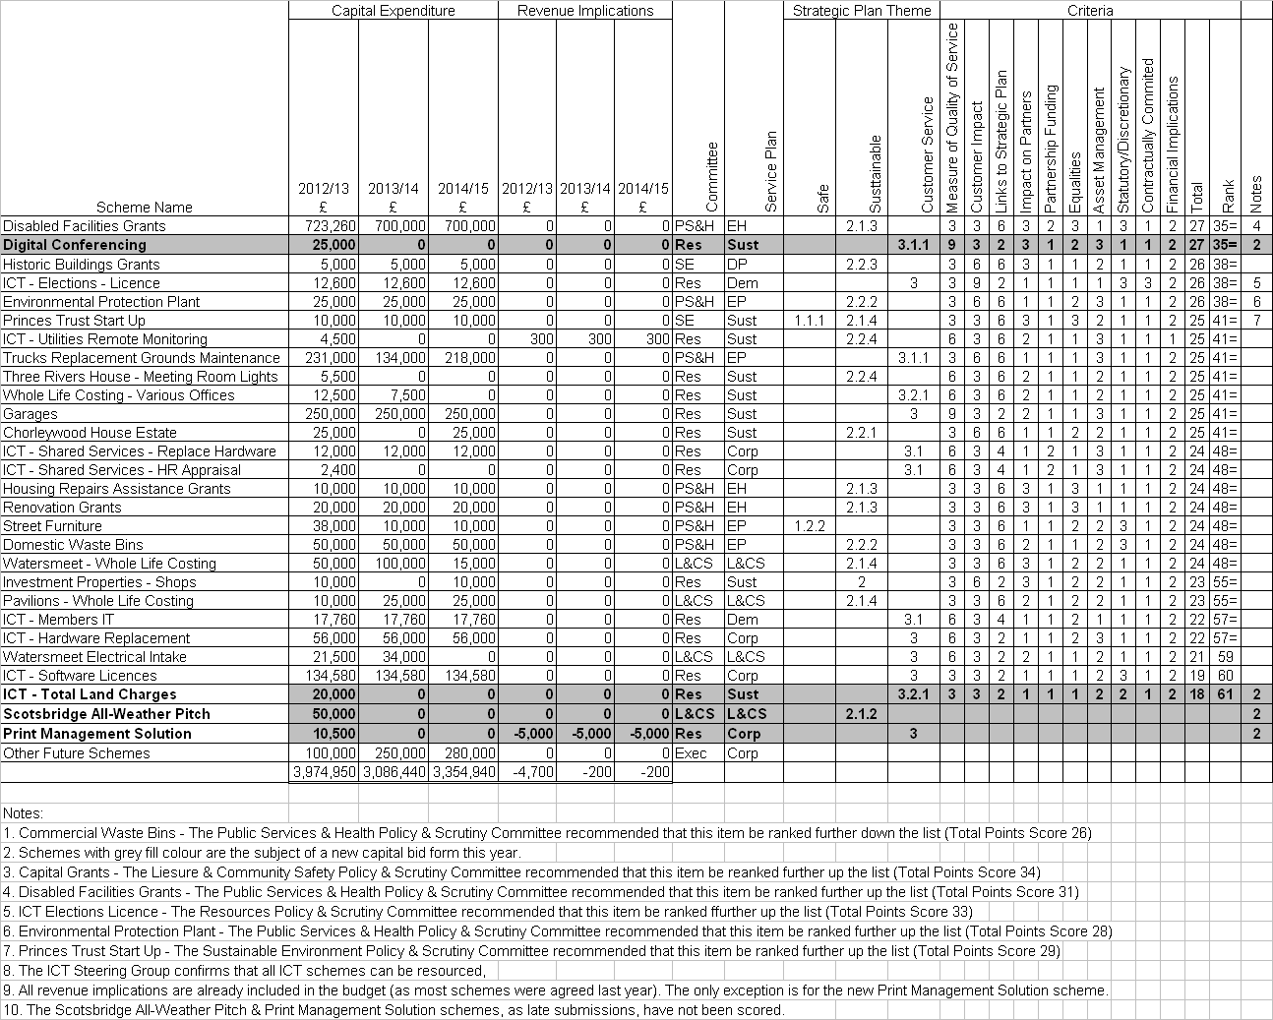

APPENDIX 4

SCHEME FOR PRIORITISING CAPITAL BIDS

Criteria |  | Capital Bids
 |  | Score
Measure of Quality of Service | a | 3 | Maintaining Current Service
 |  | 6 | Improved Internal Service
 |  | 9 | Improved External Service
Customer Impact / Quantity of | b | 3 | Affects < 10% of residents
Service |  | 6 | Affects < 50% of residents
 |  | 9 | Affects all residents
Links to Strategic Plan | c | 2 | Contributes to General Theme
 |  | 4 | Contributes to General Aim
 |  | 6 | Contributes to Specific Objective
Impact on Partners | d | 1 | No impact on partner agencies or joint priorities
(as defined in the Community |  | 2 | Impacts on 1 partner agency / priority
Strategy) |  | 3 | Impacts several partners / priorities
Partnership Funding | e | 1 | No Partnership Funding
 |  | 2 | Partly Funded by Partners
 |  | 3 | Fully Funded by Partners
Equalities | f | 1 | No impact on vulnerable groups
 |  | 2 | Impacts on one vulnerable group
 |  | 3 | Impacts on several vulnerable groups
Asset Management | g | 1 | Not related to asset maintenance
 |  | 2 | Allowing asset to continue in use
 |  | 3 | Expenditure required to bring asset up to standard enabling service to continue (i.e. an element of ‘backlog’ repair exists)
Statutory/Discretionary Service | h | 1 | Entirely Discretionary
 |  | 2 | Partly Statutory
 |  | 3 | Entirely Statutory
Contractually Committed | i | 1 | No Commitment
 |  | 2 | Moral Obligation (e.g. SLA)
 |  | 3 | Contractually Committed
Financial Implications | j | 1 | Revenue Cost
 |  | 2 | Revenue Neutral
 |  | 3 | Revenue Saving

APPENDIX 5
PRIORITIES FOR CAPITAL EXPENDITURE 2012-2015
ADVICE OF POLICY & SCRUTINY COMMITTEES

LEISURE AND COMMUNITY SAFETY POLICY AND SCRUTINY COMMITTEE
Strategic, Service and Financial Planning 2012-2015
1 November 2011 – Minute L.PP48/11

The Head of Leisure and Community Services confirmed that the Executive Committee had approved the Committee’s recommendation to commence the Mill End Play Area refurbishment in 2012/13 and defer the Baldwins Lane Play Area refurbishment until 2013/14.

The William Penn Health Suite had been included in the Capital Programme at Members’ request.

ACTIONS AGREED:-

that the Leisure and Community Safety Committee recommends the Executive Committee to adopt the priorities for capital investment set out in the report.

PUBLIC SERVICES AND HEALTH POLICY AND SCRUTINY COMMITTEE
Strategic, Service and Financial Planning 2012-2015
3 November 2011 – Minute PH.PP29/11

In response to a question on why there were two spare vehicles at the depot, the Head of Environmental Protection advised that these vehicles were rarely used but were available if another vehicle broke down and during the Christmas period. The vehicles could be sold for scrap but would not raise a great deal of money. If the Council were to hire a vehicle it would cost around £6,000 therefore the cost to the Council of keeping the vehicles was less than to hire from outside. There was a rolling programme to purchase new vehicles. The spare vehicles would be available for a further two years.

The Head of Environmental Protection agreed to provide a written response to the Committee on why there was no capital expenditure in year 2013/14 for replacement refuse vehicles, the need for £50k for domestic waste bins and whether the Litter bins/dog bins could be included in this budget.

ACTION AGREED:-

that the Committee confirms to the Executive Committee its priorities for capital investment as set out in each service plan.

SUSTAINABLE ENVIRONMENT POLICY AND SCRUTINY COMMITTEE
Strategic, Service and Financial Planning 2012-2015
8 November 2011 – Minute SE35/11

In response to a Member’s question the Head of Development Management and Environmental Health confirmed that the introduction of the Community Infrastructure Levy would not require the Council to spend all Section 106 monies received before 2014. Most unspent Section 106 contributions were subject to a 10-year clawback period.

The Asset Manager reported that the major initiative was the South Oxhey Regeneration, which was the subject of extensive and ongoing public consultation. A total of 5 staff would be needed to progress the project. He confirmed that the additional staffing costs for the South Oxhey Regeneration were expected to be financed via a joint venture development agreement with a commercial partner as set out in the business case for the project, which had still to be approved.

Solar water heating panels had already been installed at William Penn Leisure Centre to heat the water in the Main Pool.

In the capital schemes table a new item had been created by including all internal professional fees under a single heading for budgetary control purposes. These fees had previously been budgeted and were essential to progress the existing schemes which had been included in the previous year’s capital schemes.

ACTION AGREED:-

that the Sustainable Environment Policy and Scrutiny Committee recommends the Executive Committee to adopt the priorities for capital investment set out in the report.

RESOURCES POLICY AND SCRUTINY COMMITTEE
Strategic, Service and Financial Planning 2012-2015
10 November 2011 – Minute R.PS24/11

Members required further information on the capital bid concerning Digital Conferencing and until that information was forthcoming the project be relegated to last of those put forward to the Executive Committee by this Committee.

ACTIONS AGREED :-

that the Committee’s priorities for capital investment as set out in Appendix 4 to the report be agreed subject to Digital Conferencing being last on the list pending further information on what was proposed by the Scheme.

LEISURE AND COMMUNITY SAFETY POLICY AND SCRUTINY COMMITTEE
Scotsbridge Artificial All-Weather Sports Pitch
10 January 2012 – Minute L.PP60/11

This report provided an update on the Rickmansworth Hockey Club project to build an all-weather sports pitch at Scotsbridge Playing Fields, in partnership with Rickmansworth School.

ACTION AGREED:-

That the Committee recommends to the Executive Committee the following:

(1) that a planning application is prepared and submitted to the Council for full consideration;

(2) that the Hockey Club submit a community development plan for the proposed new facility detailing the usage and management of the facility for full consideration;

(3) that, subject to approval of the community development plan by the Executive Committee upon the recommendation of the Leisure and Community Safety Policy and Scrutiny Committee, delegated authority is given to the Director of Community and Environmental Services, in consultation with the Portfolio Holder for Leisure and Community, to agree terms for the grant of a lease for the area of Scotsbridge playing fields detailed in the report, for an artificial all-weather sports pitch;

(4) that consideration be given to a financial contribution of £50,000 to the project, which could be allocated from available S106 funding, from the housing developments on land adjacent to Rickmansworth School and the High Street, Rickmansworth; and

(5) that further reports will be presented to Members as the project progresses, in particular on details of the community development plan, proposed lease and funding agreements for the requisite approvals.

EXECUTIVE COMMITTEE – 30 JANUARY 2012

PART I – NOT DELEGATED

14. TREASURY MANAGEMENT
(DCRG)

1. Summary

1.1 This report presents to members:-

a) the Annual Treasury Management Report and Prudential Indicators for 2010/11;
b) a mid year review of the Treasury Management function 2011/12; and,
c) the Treasury Management Strategy for 2012/13 – 2014/15.

2. Details

2.1 The Chartered Institute of Public Finance and Accountancy (CIPFA) defines treasury management as: “The management of the local authority’s investments and cash flows, its banking, money market and capital market transactions; the effective control of the risks associated with those activities; and the pursuit of optimum performance consistent with those risks”.

2.2 This report meets the requirements of both the CIPFA Code of Practice on Treasury Management and the CIPFA Prudential Code for Capital Finance in Local Authorities and complies with the Local Government Act 2003.

3. Annual Treasury Management Report and Actual Prudential Indicators 2010/11

3.1 Attached at Appendix 1 is the Annual Treasury Management Report and Prudential Indicators for 2010/11. The report provides details of actual prudential and treasury indicators and actual treasury operations during 2010/11 compared to the estimates within the strategy. The report is made in line with the Council’s approved policy on Treasury Management.

3.2 During 2010/11, the Council complied with its legislative and regulatory requirements. The Director of Corporate Resources & Governance confirms that the statutory borrowing limit (the authorised limit) was not breached.

3.3 The financial year 2010/11 continued the challenge of low investment returns and continuing risk.

3.4 The Director of Corporate Resources and Governance also confirms that no borrowing was undertaken. At 31 March 2011, the Council had no external debt and its investments totalled £26,067m (£28,680m at 31 March 2010).

3.5 The report contains:
- Capital activity during the year;
- Reporting of the required prudential and treasury indicators;
- Impact of this activity on the Council’s underlying indebtedness (the Capital Financing Requirement);
- Overall treasury position and the impact on investment balances;
- Summary of the economy and interest rates;
- Investment Rates in 2010/11
- Investment Outturn for 2010/11

4. Mid Year Review of the Treasury Management Function

4.1 Attached at Appendix 2 is a mid year review of the Treasury Management function for 2011/12. The review updates members with the progress on the capital position, amends prudential indicators as necessary, considers whether the Council is meeting the strategy and whether any policies require revision.

4.2 The underlying economic environment remains difficult for the Council, foremost being the concerns over investment counterparty risk. This background encourages the Council to continue maintaining investments short term and with high quality counterparties. The downside of such a policy is that investment returns remain low.

4.3 The basis of the treasury management strategy, the investment strategy and the performance indicators are not changed.

4.4 The prudential code requires the Council to update:

- The Council’s capital expenditure plans;
- How these plans are being financed;

These requirements are met by the Council’s Budget Monitoring reports, which include revised capital expenditure and funding statements.

5. Treasury Management Strategy Statement 2012/13 – 2014/15

5.1 The Council is required to operate a balanced budget, which, after allowing for contributions to and from reserves, broadly means that cash raised during the year will meet cash expenditure. Part of the treasury management operation is to ensure that this cash flow is adequately planned, with cash being available when it is needed. Surplus monies are invested in low risk counterparties or instruments commensurate with the Council’s low risk appetite, providing adequate liquidity initially before considering investment return.

5.2 The Treasury Management Strategy Statement for 2012/13 to 2014/15 is attached at Appendix 3. It covers two main areas:

Capital Issues
- the capital plans and the prudential indicators 2012/13 – 2014/15;
- the Minimum Revenue Provision strategy and policy statement

Treasury management Issues
- the current portfolio position;
- treasury indicators: limits to borrowing activity;
- prospects for interest rates;
- the borrowing strategy;
- annual investment strategy;
- reporting requirments;
- policy on use of external service providers; and
- member and officer training

5.3 The Treasury Management Policy Statement, stating the policies, practices, objectives and approaches to risk management of its treasury management activities, has previously been adopted by the Executive Committee. There are no changes to the Treasury Management Policy Statement to report and the treasury service confirm that they are complying with all aspects of the the Treasury Policy Statement and will continue to comply in future years.

6. Policy/Budget Implications

6.1 None.

7. Legal, Staffing, Environmental, Community Safety, Customer Services Centre, and Website Implications

7.1 None specific.

8. Financial Implications

8.1 None specific.

9. Risk Management Implications

9.1 The Council has agreed its risk management strategy which can be found on the Website at http//www.threerivers.gov.uk.

9.2 The subject of this report is covered by the Finance (Shared Services) Service Plan. Any risks resulting from this report will be included in the risk register and, if necessary, managed within this plan.

10. Recommendation

10.1 That this report be noted.

Background Papers
UK Economic Forecasts provided by Sector.
CIPFA Prudential Code for Capital Finance in Local Authorities, 2011 Edition
CIPFA Treasury Management in the Public Services – Code of Practice and Cross-Sectoral Guidance Notes, 2011 Edition
CIPFA Treasury Management in the Public Services, Guidance Notes for Local Authorities, 2011 Edition
Report prepared by:
Dot Reynolds (Finance Manager) & Richard Hammerman (Senior Accountant)

Data sources:
- Outturn figures from E Financials, Logotech Treasury Management and Statement of Accounts.
- UK Economic Forecasts provided by Sector, the Council's treasury advisors.
Data checked by: Dot Reynolds (Finance Manager) & Richard Hammerman (Senior Accountant)
Data rating:
1 | Poor
2 | Sufficient
3 | High | ✓

APPENDICES / ATTACHMENTS
Appendix 1 Annual Report On The Treasury Management Service 2010/11
(Incorporating Outturn Prudential Indicators)
Appendix 2 Mid Year Treasury Management Monitoring Report
Appendix 3 Treasury Management Strategy Statement 2012/13 – 2014/15
APPENDIX 1
ANNUAL REPORT ON THE TREASURY MANAGEMENT SERVICE 2010/11
(INCORPORATING OUTTURN PRUDENTIAL INDICATORS)

- The Council’s Capital Activity during 2010/11
The Council undertakes capital expenditure on long-term assets. These activities may either be:
- Financed immediately through the application of capital or revenue resources (capital receipts, capital grants, revenue contributions etc.), which has no resultant impact on the Council’s borrowing need; or
- If insufficient financing is available, or a decision is taken not to apply resources, the capital expenditure will give rise to a borrowing need.
- The Council did not borrow during 2010/11.

2. Reporting of the Required Prudential and Treasury Indicators
- During 2010/11, the Council complied with its legislative and regulatory requirements. The key actual prudential and treasury indicators detailing the impact of capital expenditure activities during the year, with comparators, are as follows:

Actual prudential and treasury indicators | 2009/10  Actual | 2010/11  Actual
Actual capital expenditure | £7.027m | £5,773m
Total Capital Financing Requirement: | Nil | Nil
Net borrowing | -£28.680m | -£26.067m
External debt | Nil | Nil
Investments - under 1 year | £28.680m | £26.067m
The actual capital expenditure forms one of the required prudential indicators. The table below shows the actual capital expenditure and how this was financed.
£000 | 2009/10  Actual | 2010/11  Estimate | 2010/11  Actual
Capital expenditure | 7,027 | 5,779 | 5,773
Total capital expenditure
Resourced by:
- Capital receipts | 5,746 | 4,551 | 4,545
- Capital grants | 1,281 | 1,228 | 1,228
Unfinanced capital expenditure | 0 | 0 | 0

3. Impact of this activity on the Council’s underlying indebtedness (the Capital Financing Requirement);
The Council’s underlying need to borrow for capital expenditure is termed the Capital Financing Requirement (CFR). This figure is a gauge of the Council’s debt position. The CFR results from the capital activity of the Council and what resources have been used to pay for the capital spend. It represents the 2010/11 unfinanced capital expenditure (see above table), and prior years’ net or unfinanced capital expenditure which has not yet been paid for by revenue or other resources.

The Council’s CFR for the year was zero. This includes leasing schemes on the balance sheet, which increase the Council’s borrowing need, the CFR. No borrowing is actually required against these schemes as a borrowing facility is included in the contract (if applicable).

The borrowing activity is constrained by prudential indicators for net borrowing and the CFR, and by the authorised limit.

The authorised limit - the authorised limit is the “affordable borrowing limit” required by section 3 of the Local Government Act 2003. The Council does not have the power to borrow above this level. The table below demonstrates that during 2010/11 the Council has maintained gross borrowing within its authorised limit.

The operational boundary – the operational boundary is the expected borrowing position of the Council during the year. Periods where the actual position is either below or over the boundary is acceptable subject to the authorised limit not being breached.

Actual financing costs as a proportion of net revenue stream - this indicator identifies the trend in the cost of capital (borrowing and other long term obligation costs net of investment income) against the net revenue stream.

 | 2009/10  Actual | 2010/11  Actual
Authorised limit | £7m | £7m
Maximum gross borrowing position | £5m | £5m
Operational boundary | £5m | £5m
Average gross borrowing position | Nil | Nil
Financing costs as a proportion of net revenue stream | -2.62% | -2.87%

4. Overall treasury position and the impact on investment balances

The Council’s debt and investment position is organised by the treasury management service in order to ensure adequate liquidity for revenue and capital activities, security for investments and to manage risks within all treasury management activities. Procedures and controls to achieve these objectives are well established both through Member reporting detailed in the summary, and through officer activity detailed in the Council’s Treasury Management Practices. At the beginning and the end of 2010/11 the Council‘s treasury position was as follows:

 | 31 March 2010 Principal | Rate/ Return | 31 March 2011 Principal | Rate/ Return
Total debt | Nil |  | Nil
CFR | Nil |  | Nil
Investments - in house | £28.680m | 1.45% | £26.067m | 1.01%
Total investments | £28.680m | 1.45% | £26.067m | 1.01%

The maturity structure of the investment portfolio was all under one year.

The exposure to fixed and variable rates was as follows:
 | 31 March 2010  Actual | 31 March 2011  Actual
Fixed rate (principal or interest) | £24.500m | £20.057m
Variable rate (principal or interest) | £4.180m | £6.010m

5. Summary of the Economy and Interest Rates
The expectation for interest rates within the strategy for 2010/11 anticipated low but rising Bank Rate (starting in quarter 4 of 2011) with similar gradual rises in medium and longer term fixed interest rates over 2010/11. Variable or short-term rates were expected to be the cheaper form of borrowing over the period. Continued uncertainty in the aftermath of the 2008 financial crisis promoted a cautious approach, whereby investments would continue to be dominated by low counterparty risk considerations, resulting in relatively low returns compared to borrowing rates.

In this scenario, the treasury strategy was to postpone borrowing to avoid the cost of holding higher levels of investments and reduce counterparty risk.

The actual movement in interest rates broadly followed the expectations in the strategy, as detailed in the following section.

2010/11 proved to be another watershed year for financial markets. Rather than a focus on individual institutions, market fears moved to sovereign debt issues, particularly in the peripheral Euro zone countries. Local authorities were also presented with changed circumstances following the unexpected change of policy on Public Works Loan Board (PWLB) lending arrangements in October 2010. This resulted in an increase in new borrowing rates of 0.75 – 0.85%, without an associated increase in early redemption rates. This made new borrowing more expensive and repayment relatively less attractive.

UK growth proved mixed over the year. The first half of the year saw the economy outperform expectations, although the economy slipped into negative territory in the final quarter of 2010 due to inclement weather conditions. The year finished with prospects for the UK economy being decidedly downbeat over the short to medium term while the Japanese disasters in March, and the Arab Spring, especially the crisis in Libya, caused an increase in world oil prices, which all combined to dampen international economic growth prospects.

The change in the UK political background was a major factor behind weaker domestic growth expectations. The new coalition Government struck an aggressive fiscal policy stance, evidenced through heavy spending cuts announced in the October Comprehensive Spending Review, and the lack of any “giveaway” in the March 2011 Budget. Although the main aim was to reduce the national debt burden to a sustainable level, the measures are also expected to act as a significant drag on growth.

Gilt yields fell for much of the first half of the year as financial markets drew considerable reassurance from the Government’s debt reduction plans, especially in the light of Euro zone sovereign debt concerns. Expectations of further quantitative easing also helped to push yields to historic lows. However, this positive performance was mostly reversed in the closing months of 2010 as sentiment changed due to sharply rising inflation pressures. These were also expected (during February / March 2011) to cause the Monetary Policy Committee to start raising Bank Rate earlier than previously expected.

The developing Euro zone peripheral sovereign debt crisis caused considerable concerns in financial markets. First Greece (May), then Ireland (December), were forced to accept assistance from a combined EU / IMF rescue package. Subsequently, fears steadily grew about Portugal, although it managed to put off accepting assistance till after the year end. These worries caused international investors to seek safe havens in investing in non-Euro zone government bonds.

Deposit rates picked up modestly in the second half of the year as rising inflationary concerns, and strong first half growth, fed through to prospects of an earlier start to increases in Bank Rate. However, in March 2011, slowing actual growth, together with weak growth prospects, saw consensus expectations of the first UK rate rise move back from May to August 2011 despite high inflation. However, the disparity of expectations on domestic economic growth and inflation encouraged a wide range of views on the timing of the start of increases in Bank Rate in a band from May 2011 through to early 2013. This sharp disparity was also seen in MPC voting which, by year-end, had three members voting for a rise while others preferred to continue maintaining rates at ultra low levels.

Risk premiums were also a constant factor in raising money market deposit rates beyond 3 months. Although market sentiment has improved, continued Euro zone concerns, and the significant funding issues still faced by many financial institutions, mean that investors remain cautious of longer-term commitment. The European Commission did try to address market concerns through a stress test of major financial institutions in July 2010. Although only a small minority of banks “failed” the test, investors were highly sceptical as to the robustness of the tests, as they also are over further tests now taking place with results due in mid-2011.

Chart 1: Bank Rate v LIBID investment rates
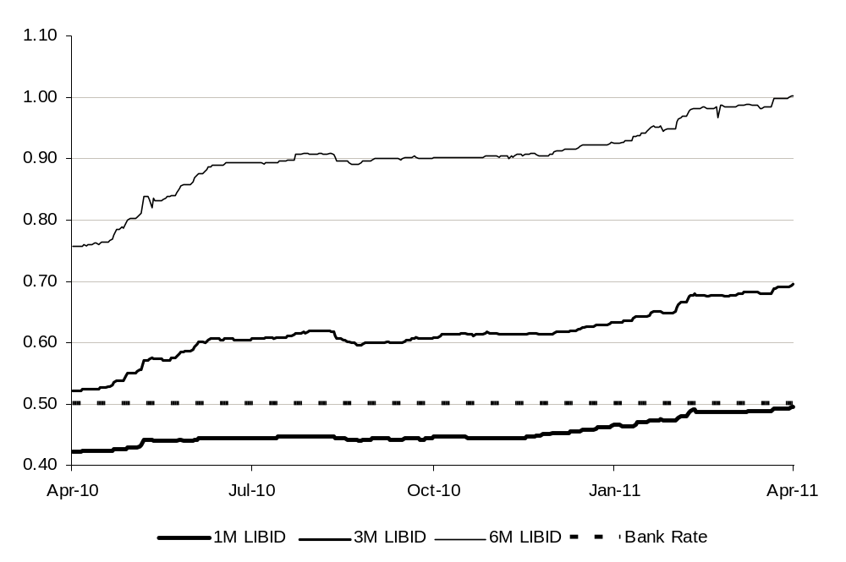

Chart 2: Average v new borrowing rates
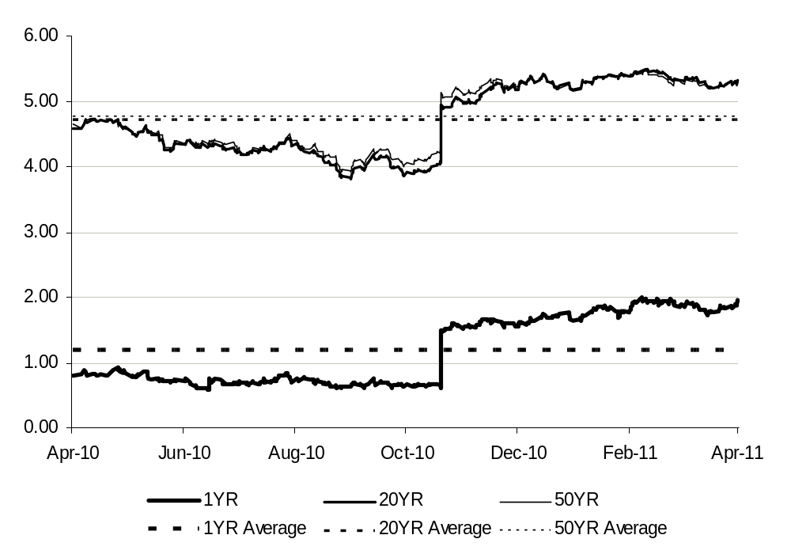

6. Investment Rates in 2010/11
The tight monetary conditions following the 2008 financial crisis continued through 2010/11 with little material movement in the shorter term deposit rates. Bank Rate remained at its historical low of 0.5% throughout the year, although growing market expectations of the imminence of the start of monetary tightening saw 6 and 12 month rates picking up.

Overlaying the relatively poor investment returns was the continued counterparty concerns, most evident in the Euro zone sovereign debt crisis which resulted in rescue packages for Greece, Ireland and latterly Portugal. Concerns extended to the European banking industry with an initial stress testing of banks failing to calm counterparty fears, resulting in a second round of testing currently in train. This highlighted the ongoing need for caution in treasury investment activity.
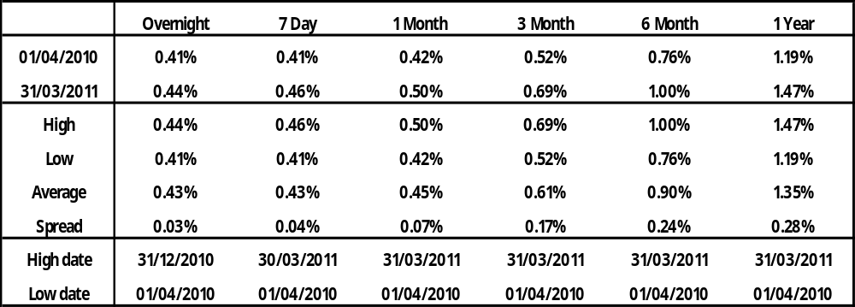

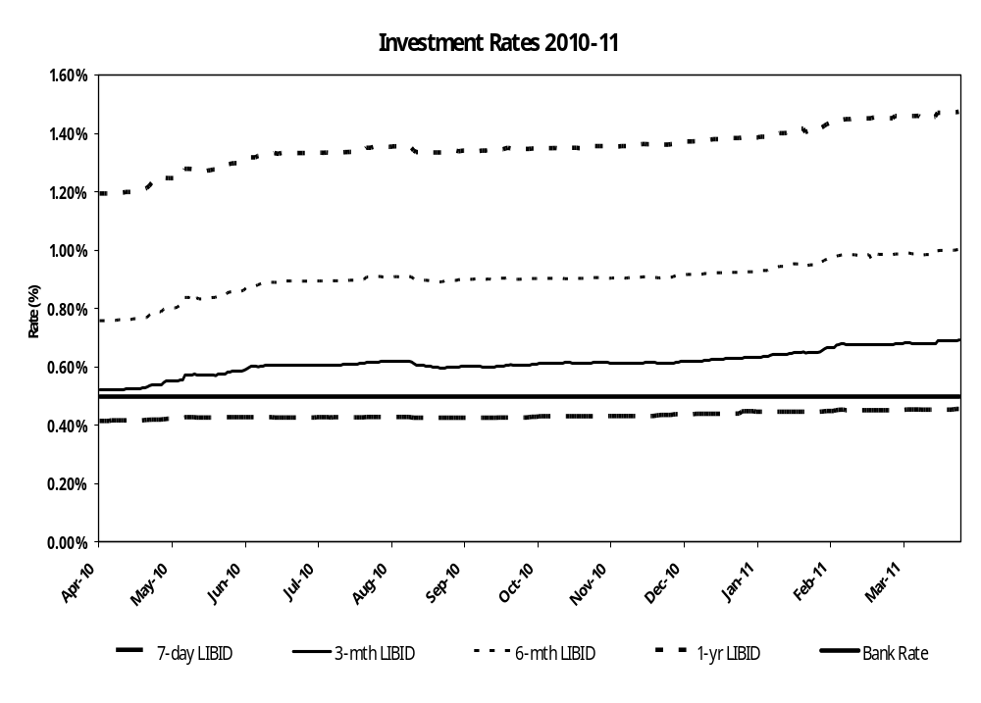

7. Investment Outturn for 2010/11

Investment Policy – the Council’s investment policy is governed by CLG guidance, which was been implemented in the annual investment strategy approved by the Council on 22 February 2011. This policy sets out the approach for choosing investment counterparties, and is based on credit ratings provided by the three main credit rating agencies supplemented by additional market data (such as rating outlooks, credit default swaps, bank share prices etc.).

The investment activity during the year conformed to the approved strategy, and the Council had no liquidity difficulties.

Resources – the Council’s longer term cash balances comprise, primarily, revenue and capital resources, although these will be influenced by cash flow considerations. The Council’s core cash resources comprised as follows, and met the expectations of the budget:
Balance Sheet Resources | 31 March 2010  £m | 31 March 2011  £m
General Fund | 8.232 | 7.933
Earmarked reserves | 4.324 | 4.074
Grants Unapplied | 15.000 | 15.000
Usable capital receipts | 17.486 | 14.357
Total | 30.057 | 26.379

Investments held by the Council - the Council maintained an average balance of £32.3m of internally managed funds. The internally managed funds earned an average rate of return of 1.01%. The comparable performance indicator is the average 3 month LIBID rate, which was 0.61%.

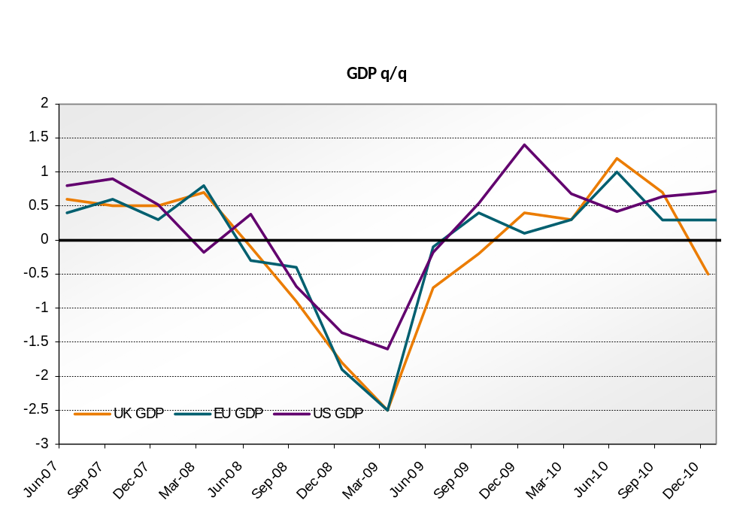

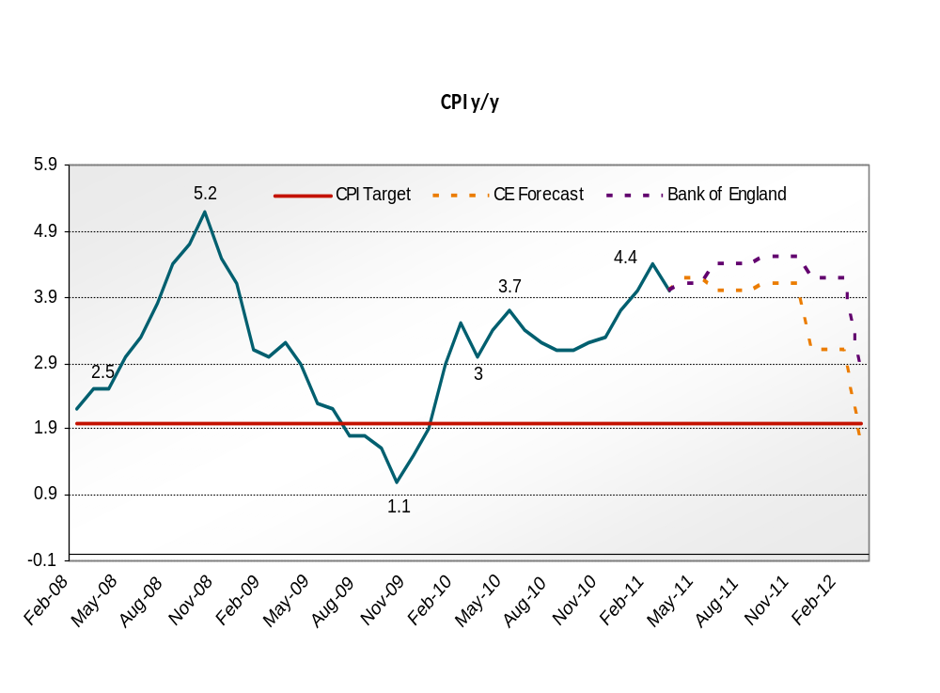

APPENDIX 2
MID YEAR TREASURY MANAGEMENT MONITORING REPORT

    - Capital Financing Requirement (CFR), External Debt and Operational Boundary

The CFR and Operational Boundary estimates are shown below:

Limits to Borrowing Activity
Prudential Indicator  £m | 2011/12  Original  Estimate | Current Borrowing Position | 2011/12  Revised  Estimate
Capital Financing Requirement | 0 | 0 | 0
External Debt / the Operational Boundary
Long Term Borrowing | 0 | 0 | 0
Short Term Borrowing* | 5 | 0 | 5
The first key control over the treasury activity is a PI to ensure that over the medium term, net borrowing (borrowings less investments) will only be for a capital purpose. As the Council is debt free, this control will always be met.

    - The Authorised Limit

This PI, which is required to be set and revised by Members, controls the overall level of borrowing and represents the limit beyond which borrowing is prohibited. It reflects the level of borrowing which, while not desired, could be afforded in the short term, but is not sustainable in the longer term. It is the expected maximum borrowing need with some headroom for unexpected movements. This is the statutory limit determined under section 3 (1) of the Local Government Act 2003.
Authorised limit for external debt  £m | 2011/12  Original  Indicator | Current  Borrowing Position | 2011/12  Revised  Indicator
Short Term Borrowing | 7 | 0 | 7

    - Interest Rate Movements and Expectations

The information relating to the interest rate movements and future expectations is shown within the Treasury Management Strategy Statement 2012/13 – 2014/15.

    - Current Investment Position

This information is reported in the Members Information Bulletins.

The Council’s held £31.760m of investments at 30 September 2011 and the list of investments and counterparties is shown below:

Sector | Country | Up to One Year
Banks | UK | £8.960m
Building Societies | UK | £22.500m
Local Authority | UK | £0.300m

List of Investments as at 30 September 2011:

 | Principal
NATWEST BANK | (8,960,000)
WEST HERTS CREMATORIUM | (300,000)
SKIPTON BS | (2,500,000)
PRINCIPALITY BS | (1,500,000)
LEED & HOLBECK BS | (2,000,000)
COVENTRY BS | (2,000,000)
LEEDS & HOLBECK BS | (2,000,000)
COVENTRY BS | (1,500,000)
SKIPTON BS | (1,500,000)
NEWCASTLE BS | (1,000,000)
PRINCIPALITY BS | (1,500,000)
NORWICH & PETERBOROUGH BS | (2,000,000)
SKIPTON BS | (2,000,000)
NEWCASTLE BS | (1,000,000)
PRINCIPALITY BS | (2,000,000)
 | (31,760,000)

The Council has no sums invested for greater than 364 days.

The Revised cash flow model for the current financial year (giving interest earned, on a cash basis) is shown within the Treasury Management Strategy Statement 2012/13 – 2014/15. Using this model, the revised budget position for investment income, on an accruals basis, is:
 | 2011/12  Original  Estimate | 2011/12  Latest  Estimate | 2011/12  Revised  Estimate
Interest Receivable | £607,130 | £370,130 | £332,000

The following reports the current position against the benchmarks originally approved.

    - Security

The Council’s maximum security risk benchmark for the current portfolio, when compared to these historic default tables, was set as follows:
0.01% historic risk of default when compared to the whole portfolio.

Note: The benchmarks are an average risk of default measure, and would not constitute an expectation of loss against a particular investment. They benchmarks are embodied in the criteria for selecting cash investment counterparties and these will be monitored and reported to Members. As this data is collated, trends and analysis will be collected and reported. Where counterparty is not credit rated a proxy rating will be applied.

The Director of Corporate Resources & Governance can report that the investment portfolio was maintained within this overall benchmark during this year to date.

    - Liquidity

The Council set liquidity facilities/benchmarks to maintain:
- Bank overdraft - £0.5m
- Liquid short term deposits of at least £2m available with a week’s notice.
- Weighted Average Life benchmark is expected to be 0.5years, with a maximum of 10 years.

The Director of Corporate Resources & Governance can report that liquidity arrangements were adequate during the year to date.

    - Yield

Local measures of yield benchmarks are:
- Investments – returns 0.12% above average bank rate

The Director of Corporate Resources & Governance can report that return up to 30 September 2011 averaged 1.12%, against a benchmark rate of 0.62%. The actual investment interest rate is therefore 0.5% (81%) above the benchmark rate.

APPENDIX 3

TREASURY MANAGEMENT STRATEGY STATEMENT 2012/13 – 2014/15

The Capital Plans and the Prudential Indicators 2012/13 – 2014/15

The Council’s capital expenditure plans are the key driver of treasury management activity. The output of the capital expenditure plans are reflected in prudential indicators, which are designed to assist members’ overview and confirm capital expenditure plans.

Capital Expenditure

This prudential Indicator is a summary of the Council’s capital expenditure plans, both those agreed previously, and those forming part of this budget cycle. Members are asked to approve the capital expenditure forecasts within the proposed capital expenditure programme.

The capital expenditure plans are financed in full by capital receipts, capital grants or capital reserves. Over the next three years there are no planned shortfalls of resources which would result in a funding need (borrowing).

The Council’s Borrowing Need (the Capital Financing Requirement)

The second prudential indicator is the Council’s Capital Financing Requirement (CFR). The CFR is simply the total historic outstanding capital expenditure which has not yet been paid for from either revenue or capital resources. It is essentially a measure of the Council’s underlying borrowing need. Any capital expenditure above, which has not immediately been paid for, will increase the CFR.

Following accounting changes the CFR includes any other long term liabilities (e.g. finance leases) brought onto the balance sheet. Whilst this increases the CFR, and therefore the Council’s borrowing requirement, these types of scheme include a borrowing facility and so the Council is not required to separately borrow for these schemes. The Council is asked to approve the CFR projections below:

£m | 2010/11  Actual | 2011/12  Estimate | 2012/13  Estimate | 2013/14  Estimate | 2014/15  Estimate
Capital Financing Requirement | 0 | 0 | 0 | 0 | 0

The Use of the Council’s Resources and the Investment Position

The application of resources (capital receipts, reserves etc.) to either finance capital expenditure or other budget decisions to support the revenue budget will have an ongoing impact on investments unless resources are supplemented each year from new sources (asset sales etc). More details can be found in the medium term financial plan.

Affordability Prudential Indicators

The previous sections cover the overall capital and control of borrowing prudential indicators, but within this framework prudential indicators are required to assess the affordability of the capital investment plans. These provide an indication of the impact of the capital investment plans on the Council’s overall finances. The Council is asked to approve the following indicators:

Actual and estimates of the ratio of financing costs to net revenue stream

This indicator identifies the trend in the cost of capital (borrowing and other long term obligation costs net of investment income) against the net revenue stream. The Council is debt-free and has a zero CFR, this indicator is not applicable.

Estimates of the incremental impact of capital investment decisions on council tax

This indicator identifies the revenue costs associated with proposed changes to the three year capital programme recommended in this budget report compared to the Council’s existing approved commitments and current plans. The assumptions are based on the budget, but will invariably include some estimates, such as the level of Government support, which are not published over a three year period.

The changes are given in detail in the proposed Capital Investment Programme.

Minimum Revenue Provision (MRP) Strategy and Policy Statement

The Council is required to pay off an element of the accumulated General Fund capital spend each year (the CFR) through a revenue charge (the minimum revenue provision - MRP), although it is also allowed to undertake additional voluntary payments if required (voluntary revenue provision - VRP).

CLG Regulations have been issued which require the full Council to approve an MRP Statement in advance of each year. A variety of options are provided to councils, so long as there is a prudent provision. The Council is recommended to approve the following MRP Statement:

The Council has no debt and a zero Capital Financing Requirement, so will not be making a Minimum Revenue Provision.
For any unsupported borrowing as a result of Finance Leases, the MRP policy will be either:
- Asset Life Method – MRP will be based on the estimated life of the assets, in accordance with the proposed regulations (this option must be applied for any expenditure capitalised under a Capitalisation Direction) (Option 3); or
- Depreciation method – MRP will follow standard depreciation accounting procedures (Option 4);
These options provide for a reduction in the borrowing need over approximately the asset’s life.

Repayments included in annual finance leases are applied as MRP.

Treasury Management Issues

1 Treasury Management Strategy

The treasury management strategy is an important part of the overall financial management of the Council’s affairs. The prudential indicators consider the affordability and impact of capital expenditure decisions, and set out the Council’s overall capital framework. The treasury service considers the effective funding of these decisions. Together they form part of the process which ensures the Council meets its balanced budget requirement under the Local Government Finance Act 1992.

The Council’s treasury activities are strictly regulated by statutory requirements and a professional code of practice (the CIPFA Code of Practice on Treasury Management). This Council has adopted the Code of Practice on Treasury Management.

As a result of adopting the Code the Council also adopted a Treasury Management Policy Statement. This adoption is the requirements of one of the prudential indicators.

The Constitution requires a strategy to be reported to Council outlining the expected treasury activity for the forthcoming 3 years. A key requirement of this report is to explain both the risks, and the management of the risks, associated with the treasury service. A further treasury report is produced after the year-end to report on actual activity for the year. A new requirement of the revision to the Code of Practice requires a mid-year monitoring report.

This strategy covers:
- The Council’s debt and investment projections;
- The Council’s estimates and limits on future debt levels(borrowing activity);
- The expected movement in interest rates;
- The Council’s borrowing and investment strategies;
- Specific limits on treasury activities;
- Treasury performance indicators;
- Treasury Advice
- Training of Officers and Members

The capital expenditure plans set out in provide details of the service activity of the Council. The treasury management function ensures that the Council’s cash is organised in accordance with the the relevant professional codes, so that sufficient cash is available to meet this service activity. This will involve both the organisation of the cash flow and, where capital plans require, the organisation of approporiate borrowing facilities. The strategy covers the relevant treasury / prudential indicators, the current and projected debt positions and the annual investment strategy.

1.1 Current Portfolio Position

The Council’s treasury portfolio position at 31 March 2011, with forward projections are summarised below.

£m | 2010/11  Actual | 2011/12  Estimate | 2012/13  Estimate | 2013/14  Estimate | 2014/15  Estimate
External borrowing N/A N/A N/A N/A N/A
Investments
Total investments 31st March | 26.1 | 21.8 | 21.0 | 20.1 | 19.3
Investment change | -2.5 | -4.3 | -8.8 | -0.9 | -0.8

Another key prudential indicators is that the Council needs to ensure that its total borrowing, net of any investments, does not, except in the short term, exceed the total of the CFR in the preceding year plus the estimates of any additional CFR for 2012/13 and the following two financial years (shown as net borrowing above). This allows some flexibility for limited early borrowing for future years, but ensures that borrowing is not undertaken for revenue purposes. As the Council is debt free, this performance indicator will always be met.

The Director of Corporate Resources & Governance reports that the Council complied with this prudential indicator in the current year and does not envisage difficulties for the future. This view takes into account current commitments, existing plans, and the proposals in this budget report.

  - Treasury Indicators: Limits to Borrowing Activity

The Operational Boundary. This is the limit beyond which external borrowing is not normally expected to exceed. In most cases, this would be a similar figure to the CFR, but may be lower or higher depending on the levels of actual borrowing.

Operational boundary £m | 2011/12  Estimate | 2012/13  Estimate | 2013/14  Estimate | 2014/15  Estimate
Borrowing | 5 | 5 | 5 | 5
Other long term liabilities | 0 | 0 | 0 | 0
Total | 5 | 5 | 5 | 5

The Authorised Limit for external borrowing. A further key prudential indicator represents a control on the maximum level of borrowing. This represents a limit beyond which external borrowing is prohibited, and this limit needs to be set or revised by the full Council. It reflects the level of external borrowing which, while not desired, could be afforded in the short term, but is not sustainable in the longer term.

This is the statutory limit determined under section 3 (1) of the Local Government Act 2003. The Government retains an option to control either the total of all councils’ plans, or those of a specific council, although this power has not yet been exercised.

The Council is asked to approve the following Authorised Limit:

Authorised limit £m | 2011/12  Estimate | 2012/13  Estimate | 2013/14  Estimate | 2014/15  Estimate
Borrowing | 7 | 7 | 7 | 7
Other long term liabilities | 0 | 0 | 0 | 0
Total | 7 | 7 | 7 | 7

1.3 Prospects for Interest Rates

The Council has appointed Sector as its treasury advisor and part of their service is to assist the Council to formulate a view on interest rates. The following table gives the Sector central view.

Annual Average % | Bank Rate | Money Rates |  | PWLB Borrowing Rates
 |  | 3 month | 1 year | 5 year | 25 year | 50 year
March 2012 | 0.50 | 0.70 | 1.50 | 2.30 | 4.20 | 4.30
June 2012 | 0.50 | 0.70 | 1.50 | 2.30 | 4.20 | 4.30
Sept 2012 | 0.50 | 0.70 | 1.50 | 2.30 | 4.30 | 4.40
Dec2012 | 0.50 | 0.70 | 1.60 | 2.40 | 4.30 | 4.40
March 2013 | 0.50 | 0.75 | 1.70 | 2.50 | 4.40 | 4.50
June 2013 | 0.50 | 0.80 | 1.80 | 2.60 | 4.50 | 4.60
Sept 2013 | 0.75 | 0.90 | 1.90 | 2.70 | 4.60 | 4.70
Dec 2013 | 1.00 | 1.20 | 2.20 | 2.80 | 4.70 | 4.80
March 2014 | 1.25 | 1.40 | 2.40 | 2.90 | 4.80 | 4.90
June 2014 | 1.50 | 1.60 | 2.60 | 3.10 | 4.90 | 5.00

Growth in the UK economy is expected to be weak in the next two years and there is a risk of a technical recession (i.e. two quarters of negative growth). Bank Rate, currently 0.5%, underpins investment returns and is not expected to start increasing until quarter 3 of 2013 despite inflation currently being well above the Monetary Policy Committee inflation target. Hopes for an export led recovery appear likely to be disappointed due to the Eurozone sovereign debt crisis depressing growth in the UK’s biggest export market. The Comprehensive Spending Review, which seeks to reduce the UK’s annual fiscal deficit, will also depress growth during the next few years.

Fixed interest borrowing rates are based on UK gilt yields. The outlook for borrowing rates is currently much more difficult to predict. The UK total national debt is forecast to continue rising until 2015/16; the consequent increase in gilt issuance is therefore expected to be reflected in an increase in gilt yields over this period. However, gilt yields are currently at historically low levels due to investor concerns over Eurozone sovereign debt and have been subject to exceptionally high levels of volatility as events in the Eurozone debt crisis have evolved.

This challenging and uncertain economic outlook has a several key treasury mangement implications:
- The Eurozone sovereign debt difficulties, most evident in Greece, provide a clear indication of much higher counterparty risk. This continues to suggest the use of higher quality counterparties for shorter time periods;
- Investment returns are likely to remain relatively low during 2012/13;
- Borrowing interest rates are currently attractive, but may remain low for some time. The timing of any borrowing will need to be monitored carefully;
- There will remain a cost of capital – any borrowing undertaken that results in an increase in investments will incur a revenue loss between borrowing costs and investment returns.

  - Borrowing Strategy

The Council became debt-free during the financial year 2000/01 and it is anticipated that there will be no capital borrowing during the next three years.

1.5 Annual Investment Strategy

    - Key Objectives

The Council’s investment strategy primary objectives are safeguarding the re-payment of the principal and interest of its investments on time, then ensuring adequate liquidity, with the investment return being the final objective. Following the economic background above, the current investment climate has one over-riding risk, counterparty security risk. As a result of these underlying concerns officers are implementing an operational investment strategy which tightens the controls already in place in the approved investment strategy.

1.5.2 Investment Policy

The Council’s investment policy has regard to the CLG’s Guidance on Local Government Investments (“the Guidance”) and the 2011 revised CIPFA Treasury Management in Public Services Code of Practice and Cross Sectoral Guidance Notes (“the CIPFA TM Code”). The Council’s investment priorities will be security first, liquidity second, then return.

Investment instruments identified for use in the financial year are listed below under the ‘Specified’ and ‘Non-Specified’ Investments categories. Counterparty limits will be as set through the Council’s Treasury Management Practices – Schedules.

1.5.3 Creditworthiness policy

The Council will ensure:
- It maintains a policy covering both the categories of investment types it will invest in and the criteria for choosing investment counterparties with adequate security, and monitoring their security. This is set out in the Specified and Non-Specified investment sections below.
- It has sufficient liquidity in its investments. For this purpose it will set out procedures for determining the maximum periods for which funds may prudently be committed. These procedures also apply to the Council’s prudential indicators covering the maximum principal sums invested.

The Director of Corporate Resources and Governance will maintain a counterparty list in compliance with the following criteria and will revise the criteria and submit them to Council for approval as necessary. This criterion is separate to that which chooses Specified and Non-Specified investments as it provides an overall pool of counterparties considered high quality the Council may use rather than defining what its investments are.

The rating criteria use the lowest common denominator method of selecting counterparties and applying limits. This means that the application of the Council’s minimum criteria will apply to the lowest available rating for any institution. For instance if an institution is rated by two agencies, one meets the Council’s criteria, the other does not, the institution will fall outside the lending criteria. This is in compliance with a CIPFA Treasury Management Panel recommendation in March 2009 and the CIPFA Treasury Management Code of Practice.

Credit rating information is supplied by our treasury consultants on all active counterparties that comply with the Council’s criteria. Any counterparty failing to meet the criteria would be omitted from the counterparty (dealing) list. Any rating changes, rating watches (notification of a likely change), rating outlooks (notification of a possible longer term change) are provided to officers almost immediately after they occur and this information is considered before dealing. For instance a negative rating watch applying to a counterparty at the minimum Council criterion will be suspended from use, with all others being reviewed in light of market conditions.

Counterparty Categories

The Council uses the following criteria in choosing the categories of institutions in which to invest:
- Banks 1 - Good Credit Quality
The Council will only use UK banks which meet the Rating criteria given in the table below
- Banks 2 – Eligible Institutions
The Council will use organisations considered an Eligible Institution for the HM Treasury Credit Guarantee Scheme initially announced on 13 October 2008, with the necessary short and long term ratings required in Banks 1 above.
- Banks 3 – The Council’s own banker
For transactional purposes, if the bank falls below the above criteria, it will be included, although in this case balances will be minimised in both monetary size and time within operational constraints.
- Bank Subsidiary and Treasury Operations – the Council will use these where the parent bank has the necessary ratings outlined above.
- Building Societies
the Council will use all Societies which:
either
    - meet the ratings for banks outlined above
or
    - are eligible Institutions; and have assets in excess of limits for each category
- Specific Public Bodies
The Council may lend to Public Bodies other than Local Authorities. The criterion for lending to these bodies is that the loan has been approved by Full Council.
- Local Authorities
A limit of 10% will be applied to the use of Non-Specified investments.

For details of Specified and Non-Specified Investments see below.

Country and sector considerations

Due care will be taken to consider the country, group and sector exposure of the Council’s investments. In part, the country selection will be chosen by the credit rating of the Sovereign state in Banks 1 above. In addition:
- Currently, the Council only invests in UK institutions;
- Limits in place above will apply to Group companies;
- Sector limits will be monitored regularly for appropriateness.

Use of additional information other than credit ratings
Additional requirements under the Code of Practice require the Council to supplement credit rating information. Whilst the above criteria rely primarily on the application of credit ratings to provide a pool of appropriate counterparties for officers to use, additional operational market information will be applied before making any specific investment decision from the agreed pool of counterparties. This additional market information (for example Credit Default Swaps, negative rating watches/outlooks) will be applied to compare the relative security of differing investment counterparties.

Time and Monetary Limits applying to Investments
The time and monetary limits for institutions on the Council’s Counterparty List summarised in the table below, are driven by the above criteria. These limits will cover both Specified and Non-Specified Investments.

The Council’s investment policy has regard to the CLG’s Guidance on Local Government Investments (“the Guidance”) and the 2011 revised CIPFA Treasury Management in Public Services Code of Practice and Cross Sectoral Guidance Notes (“the CIPFA TM Code”). The Council’s investment priorities will be security first, liquidity second, then return.

Exceptional Circumstances
The criteria for choosing counterparties set out above provide a sound approach to investment in “normal” market circumstances. Whilst Members are asked to approve this base criteria above, under the exceptional current market conditions the Director of Corporate Resources and Governance may temporarily restrict further investment activity to those counterparties considered of higher credit quality than the minimum criteria set out for approval. These restrictions will remain in place until the banking system returns to “normal” conditions. Similarly, the time periods for investments will be restricted.
Examples of these restrictions would be the greater use of the Debt Management Deposit Account Facility (DMADF – a Government body which accepts local authority deposits), Money Market Funds, and strongly rated institutions. The credit criteria have been amended to reflect these facilities.

Sensitivity to Interest Rate Movements

Future Council accounts will be required to disclose the impact of risks on the Council’s treasury management activity. Whilst most of the risks facing the treasury management service are addressed elsewhere in this report (credit risk, liquidity risk, market risk, maturity profile risk), the impact of interest rate risk is discussed but not quantified. The table below highlights the estimated impact of a 1% increase/decrease in all interest rates to the estimated treasury management costs/income for next year. That element of the debt and investment portfolios which are of a longer term, fixed interest rate nature will not be affected by interest rate changes.
 | 2012/13  Estimated  + 1%  £m | 2012/13  Estimated  - 1%  £m
Revenue Budgets
Interest on Borrowing | N/A | N/A
Net General Fund Borrowing Cost | N/A | N/A
Investment income | 0.265 | -0.264

    - Investment Strategy

In-house funds. Investments will be made with reference to the core balance and cash flow requirements and the outlook for short-term interest rates (i.e. rates for investments up to 12 months).

Investment returns expectations. Bank Rate is forecast to remain unchanged at 0.5% before starting to rise from quarter 3 of 2013. Bank Rate forecasts for financial year ends (March) are:
- 2011/ 2012 0.50%
- 2012/ 2013 0.50%
- 2013/ 2014 1.25%
- 2014/ 2015 2.50%

There are downside risks to these forecasts (i.e. start of increases in Bank Rate is delayed even further) if economic growth remains weaker for longer than expected. However, should the pace of growth pick up more sharply than expected there could be upside risk, particularly if Bank of England inflation forecasts for two years ahead exceed the Bank of England’s 2% target rate.

The suggested budgeted investment earnings rates for returns on investments placed for periods up to three months during each financial year for the next five years are as follows:
2012/13 1.50%
2013/14 2.00%
2014/15 2.00%
2015/16 4.25%
2016/17 4.25%

Invesment treasury indicator and limit - total principal funds invested for greater than 364 days. These limits are set with regard to the Council’s liquidity requirements and to reduce the need for early sale of an investment, and are based on the availability of funds after each year-end.

The Council is asked to approve the treasury indicator and limit: -

Maximum principal sums invested > 364 days
£m | 2012/13 | 2013/14 | 2014/15
Principal sums invested > 364 days | £2m | £2m | £2m

Treasury Management Limits on Activity
- There are three debt related treasury activity limits but as the Council is debt free these do not apply.

    - Investment Risk & Security Benchmarking

These benchmarks are simple guides to maximum risk and so may be breached from time to time, depending on movements in interest rates and counterparty criteria. The purpose of the benchmark is that officers will monitor the current and trend position and amend the operational strategy to manage risk as conditions change. Any breach of the benchmarks will be reported, with supporting reasons in the Mid-Year or Annual Report.

Security - The Council’s maximum security risk benchmark for the current portfolio, when compared to these historic default tables, is:
- 0.01% historic risk of default when compared to the whole portfolio.
Liquidity – In respect of this area the Council seeks to maintain:
- Bank overdraft - £0.5m
- Liquid short term deposits of at least £2m available with a week’s notice.
- Weighted Average Life benchmark is expected to be 0.5years, with a maximum of 10 years for an individual loan with a public body.
Yield - Local measures of yield benchmark is (Performance Indicator):
- Investments – returns 0.12% above average bank rate

Security of the investments – In context of benchmarking, assessing security is a much more subjective area to assess. Security is currently evidenced by the application of minimum credit quality criteria to investment counterparties, primarily through the use of credit ratings supplied by the three main credit rating agencies (Fitch, Moody’s and Standard and Poors). Whilst this approach embodies security considerations, benchmarking levels of risk is more problematic. One method to benchmark security risk is to assess the historic level of default against the minimum criteria used in the Council’s investment strategy. The table beneath shows average defaults for differing periods of investment grade products for each Fitch/Moody’s Standard and Poors long term rating category over the period 1990 to 2009.

Years | 1 | 2 | 3 | 4 | 5
AAA | 0.00% | 0.01% | 0.05% | 0.10% | 0.17%
AA | 0.03% | 0.06% | 0.08% | 0.14% | 0.20%
A | 0.08% | 0.22% | 0.37% | 0.52% | 0.70%
BBB | 0.24% | 0.68% | 1.19% | 1.79% | 2.42%
BB | 1.22% | 3.24% | 5.34% | 7.31% | 9.14%
B | 4.06% | 8.82% | 12.72% | 16.25% | 19.16%
CCC | 24.03% | 31.91% | 37.73% | 41.54% | 45.22%

The Council’s minimum long term rating criteria is currently “AA”, meaning the average expectation of default for a one year investment in a counterparty with an “AA” long term rating would be 0.03% of the total investment (e.g. for a £1m investment the average loss would be £300). This is only an average - any specific counterparty loss is likely to be higher - but these figures do act as a proxy benchmark for risk across the portfolio.

The Council’s investments in rated institutions are all for periods of less than one year, so the average loss will be scaled down by the length of investment.

The Council’s maximum security risk benchmark for the whole portfolio, when compared to these historic default tables, is:
- 0.01% historic risk of default when compared to the whole portfolio.

As the Council has no investment in rated institutions for more than 364 days, the security benchmark for more than one year is not applicable:

 | 1 year | 2 years | 3 years | 4 years | 5 years
Maximum | 0.01% | N/A | N/A | N/A | N/A

Note: This benchmark is an average risk of default measure, and would not constitute an expectation of loss against a particular investment.

    - Performance Indicators

The Code of Practice on Treasury Management requires the Council to set performance indicators to assess the adequacy of the treasury function over the year. These are distinct historic indicators, as opposed to the prudential indicators, which are predominantly forward looking. The performance indicators used by this Council for the treasury function is:
- Investments – returns 0.12% above average bank rate

The results of this indicator will be reported in the Treasury Annual Report.

1.5.7 Liquidity and Yield Benchmarking
A proposed development for Member reporting is the consideration and approval of liquidity benchmarks. These benchmarks are targets and so may be breached from time to time. Any breach will be reported, with supporting reasons, in the Annual Treasury Report.

Yield – These benchmarks are currently widely used to assess investment performance. The Local measure of yield benchmark is:
- Investments – returns 0.12% above average bank rate

Liquidity – This is defined as “having adequate, though not excessive cash resources, borrowing arrangements, overdrafts or standby facilities to enable it at all times to have the level of funds available to it which are necessary for the achievement of its business/service objectives” (CIPFA Treasury Management Code of Practice). In respect of this area, the Council seeks to maintain:
- Bank overdraft - £0.5m
- Liquid short term deposits of at least £2m available with a week’s notice.

The availability of liquidity and the term risk in the portfolio can be benchmarked by the monitoring of the Weighted Average Life (WAL) of the portfolio – shorter WAL would generally embody less risk. In this respect, the proposed benchmark is to be used:
- WAL benchmark is expected to be 0.5 years, with a maximum of 10 years.

  - Reporting Requirments

End of year investment report - At the end of the financial year, the Council will report on its investment activity as part of its Annual Treasury Management Report.

Mid-year investment report - In the middle of the financial year, the Council will report on its investment activity as part of its Mid Year Treasury Management Report.

1.7 Policy on the use of external service providers

The Council uses Sector as its external treasury management advisors.

The Council recognises that responsibility for treasury management decisions remains with the organisation at all times and will ensure that undue reliance is not placed upon our external service providers.

It also recognises that there is value in employing external providers of treasury management services in order to acquire access to specialist skills and resources. The Council will ensure that the terms of their appointment and the methods by which their value will be assessed are properly agreed and documented, and subjected to regular review.

1.8 Member and Officer Training

The increased Member consideration of treasury management matters and the need to ensure officers dealing with treasury management are trained and kept up to date requires a suitable training process for Members and officers. This Council has addressed this important issue by:
- Ensuring that officers attend suitable courses and seminars to keep their technical knowledge up to date
- Keeping up to date with CIPFA publications on Treasury Management
- Regular briefings both by e mail and face to face with the Council’s consultants
- Membership of the CIPFA Corporate Services Benchmarking Club for Treasury Management
- Reports and briefing sessions to Members on major changes to Treasury policies and strategies

CASH FLOW BY PERIOD FOR YEAR 2010/11

 | Month | April 10 | May 10 | June 10 | July 10 | Aug 10 | Sept 10 | Oct 10 | Nov 10 | Dec 10 | Jan 11 | Feb 11 | Mar 11
 | Period: | 1 | 2 | 3 | 4 | 5 | 6 | 7 | 8 | 9 | 10 | 11 | 12 | TOTAL
 |  | Actual | Actual | Actual | Actual | Actual | Actual | Actual | Actual | Actual | Actual | Actual | Actual
 |  | £000 | £000 | £000 | £000 | £000 | £000 | £000 | £000 | £000 | £000 | £000 | £000 | £000
Cash Balance Brought Forward |  | 68 | 105 | 102 | 94 | 94 | 117 | 99 | 111 | 115 | 34 | 50 | 49 | 68
RECEIPTS
Misc Inc | -Hsg Ben Subsidy | 2,225 | 2,225 | 2,116 | 1,416 | 2,225 | 2,225 | 3,702 | 2,322 | 2,305 | 2,305 | 2,305 | 2,326 | 27,697
 | -Grant |  | 198 | 0 | 0 | 0 | 0 | 0 | 0 | 0 | 0 | 0 | 0 | 198
 | -VAT |  | 213 | 61 | 378 |  | 171 | 139 | 107 | 84 | 0 | 57 | 69 | 1,279
Capital Receipts & Earmarked Fuding |  | 225 | 1,011 | 408 | 2 | 271 | 4 | 5 | 146 | 0 | 0 | 165 | 327 | 2,564
Other revenue income/expenditure |  | 1,040 | 1,700 | (2,700) | 830 | 190 | 870 | (610) | 410 | 1,780 | (1,140) | 690 | 710 | 3,770
Rent Income | -Shops, Garages &Thrive | 305 | 226 | 448 | 257 | 348 | 304 | 370 | 331 | 232 | 317 | 281 | 330 | 3,749
Mortgages |  | 2 | 1 | 2 | 1 | 2 | 1 | 1 | 1 | 1 | 2 | 2 | 1 | 17
Council Tax |  | 5,402 | 3,476 | 6,199 | 4,779 | 4,882 | 4,963 | 5,135 | 4,968 | 3,733 | 5,925 | 956 | 625 | 51,043
NNDR |  | 4,436 | 2,215 | 3,260 | 1,971 | 2,455 | 1,856 | 2,517 | 2,671 | 1,724 | 2,352 | 321 | 297 | 26,075
Thrive | -SLAs | 17 | 9 | 18 | 10 | 18 | 24 | 20 | 9 | 15 | 8 | 9 | 23 | 180
TOTAL RECEIPTS |  | 13,652 | 11,274 | 9,812 | 9,644 | 10,391 | 10,418 | 11,279 | 10,965 | 9,874 | 9,769 | 4,786 | 4,708 | 116,572
PAYMENTS
Precepts | -County | 4,849 | 4,849 | 4,849 |  | 4,849 | 4,849 | 4,849 | 4,849 |  | 4,849 | 4,849 | 4,849 | 48,490
 | -Parish | 713 |  | 0 | 0 | 0 | 713 |  | 0 | 0 | 0 | 0 | 0 | 1,426
Net Payment of NNDR/RSG |  | 928 | 1,871 | 1,871 | 1,871 | 1,871 | 1,871 | 350 | 1,871 | 1,871 | 1,871 | 174 | 1,032 | 17,452
Salaries |  | 549 | 623 | 593 | 562 | 562 | 574 | 547 | 539 | 563 | 540 | 547 | 548 | 6,747
Creditors | - Cheques | 472 | 288 | 643 | 231 | 487 | 565 | 236 | 165 | 143 | 196 | 340 | 276 | 4,042
 | - Chaps | 38 | 361 |  | 8 |  |  |  |  |  |  | 47 | 68 | 522
 | - BACS (Incl HBen) | 2,881 | 3,774 | 3,711 | 3,104 | 3,162 | 3,064 | 3,487 | 5,259 | 2,917 | 2,829 | 2,829 | 3,805 | 40,822
TOTAL PAYMENTS |  | 10,430 | 11,766 | 11,667 | 5,776 | 10,931 | 11,636 | 9,469 | 12,683 | 5,494 | 10,285 | 8,786 | 10,578 | 119,501
Net Bal: receipts/(payments) |  | 3,290 | (387) | (1,753) | 3,962 | (446) | (1,101) | 1,909 | (1,607) | 4,495 | (482) | (3,950) | (5,821) | (2,861)
Inv repaid | - Principal | 11,045 | 15,725 | 11,440 | 6,370 | 9,635 | 18,795 | 11,520 | 20,105 | 2,680 | 9,905 | 12,010 | 11,575 | 140,805
 | - Interest (cash basis) | 15 | 29 | 17 | 2 | 28 | 35 | 32 | 42 | 4 | 27 | 29 | 44 | 304
 |  | 14,350 | 15,367 | 9,704 | 10,334 | 9,217 | 17,729 | 13,461 | 18,540 | 7,179 | 9,450 | 8,089 | 5,798 | 138,248
Temp(Invest)/Borrow |  | (14,245) | (15,265) | (9,610) | (10,240) | (9,100) | (17,630) | (13,350) | (18,425) | (7,145) | (9,400) | (8,040) | (5,685) | (138,135)
Balance Carried Forward |  | 105 | 102 | 94 | 94 | 117 | 99 | 111 | 115 | 34 | 50 | 49 | 113 | 113

CASH FLOW FORECAST BY PERIOD FOR YEAR 2011/12

 | Month | April 11 | May 11 | June 11 | July 11 | Aug 11 | Sept 11 | Oct 11 | Nov 11 | Dec 11 | Jan 12 | Feb 12 | Mar 12
 | Period: | 1 | 2 | 3 | 4 | 5 | 6 | 7 | 8 | 9 | 10 | 11 | 12 | TOTAL
 |  | Actual | Actual | Actual | Actual | Actual | Actual | Actual | Actual | Est | Est | Est | Est
 |  | £000 | £000 | £000 | £000 | £000 | £000 | £000 | £000 | £000 | £000 | £000 | £000 | £000
Cash Balance Brought Forward |  | 113 | 226 | 324 | 45 | 83 | 97 | 64 | 94 | 169 | 116 | 4 | 4 | 113
RECEIPTS
Misc Inc | -Hsg Ben Subsidy | 2,298 | 2,298 | 2,185 | 2,411 | 2,086 | 2,298 | 2,046 | 2,279 | 2,279 | 2,279 | 2,279 | 2,279 | 27,017
 | -Grant | 202 | 20 | 20 | 20 | 20 | 20 | 20 | 20 | 20 | 20 | 20 | 20 | 422
 | -VAT | 85 | 186 | 67 | 121 | 0 | 327 | 126 | 109 | 114 | 126 | 126 | 126 | 1,513
Capital Receipts & Earmarked Fuding |  | 207 | 196 | 93 | 6 | 12 | 0 | 29 |  | 87 |  |  | 570 | 1,200
Other revenue income/(expenditure) |  | 1,170 | (60) | 210 | 1,250 | 1,170 | (500) | 400 | (170) | 200 | 410 | 410 | 410 | 4,900
Rent Income | -Shops Garages & Thrive | 257 | 327 | 322 | 331 | 314 | 325 | 330 | 315 | 320 | 320 | 320 | 320 | 3,801
Council Tax |  | 5,229 | 5,098 | 4,987 | 4,945 | 3,880 | 5,884 | 5,174 | 5,070 | 5,030 | 5,030 | 960 | 630 | 51,917
NNDR |  | 3,722 | 3,215 | 2,303 | 2,245 | 2,597 | 2,054 | 2,332 | 2,633 | 2,640 | 2,640 | 320 | 300 | 27,001
Thrive | -SLAs | 19 | 9 | 13 | 9 | 44 | 14 | 20 | 8 | 14 | 8 | 9 | 23 | 190
TOTAL RECEIPTS |  | 13,189 | 11,289 | 10,200 | 11,338 | 10,123 | 10,422 | 10,477 | 10,264 | 10,704 | 10,833 | 4,444 | 4,678 | 117,961
PAYMENTS
Precepts | -County | 4,855 | 0 | 4,855 | 4,855 | 4,855 | 4,855 | 4,855 | 4,855 |  | 4,855 | 4,855 | 4,855 | 48,550
 | -Parish | 713 |  |  |  |  | 713 |  |  |  |  |  |  | 1,426
Net Payment of NNDR/RSG |  | 784 | 2,006 | 2,006 | 2,006 | 2,006 | 2,006 | 2,006 | 779 | 2,006 | 2,006 | 83 | 1,083 | 18,777
Salaries |  | 541 | 566 | 547 | 544 | 539 | 569 | 544 | 532 | 556 | 556 | 556 | 556 | 6,606
Creditors | - Presented Cheques | 117 | 292 | 168 | 98 | 95 | 118 | 203 | 67 | 140 | 263 | 263 | 263 | 2,087
 | - Chaps | 3 | 206 |  |  |  |  |  |  |  |  |  |  | 209
 | - BACS | 2,790 | 4,139 | 3,177 | 4,475 | 3,091 | 2,384 | 5,143 | 3,022 | 2,948 | 4,608 | 4,608 | 4,608 | 44,992
TOTAL PAYMENTS |  | 9,803 | 7,209 | 10,753 | 11,978 | 10,586 | 10,645 | 12,751 | 9,255 | 5,650 | 12,288 | 10,365 | 11,365 | 122,647
Net Bal: receipts/(payments) |  | 3,499 | 4,306 | (229) | (595) | (380) | (126) | (2,210) | 1,103 | 5,223 | (1,339) | (5,916) | (6,683) | (4,573)
Inv repaid | - Principal | 6,790 | 14,215 | 8,230 | 10,005 | 15,675 | 7,540 | 13,910 | 28,900 | 5,925 | 8,000 | 20,000 | 8,160 | 147,350
 | - Interest | 2 | 43 | 4 | 28 | 27 | 10 | 19 | 111 | 8 | 3 | 50 | 15 | 320
 |  | 10,291 | 18,564 | 8,005 | 9,438 | 15,322 | 7,424 | 11,719 | 30,114 | 11,156 | 6,664 | 14,134 | 1,492 | 143,097
Temp(Invest)/Borrow |  | (10,065) | (18,240) | (7,960) | (9,355) | (15,225) | (7,360) | (11,625) | (29,945) | (11,040) | (6,660) | (14,130) | (1,490) | (143,095)
Balance Carried Forward |  | 226 | 324 | 45 | 83 | 97 | 64 | 94 | 169 | 116 | 4 | 4 | 2 | 2
CASH FLOW FORECAST BY PERIOD FOR YEAR 2012/13

 | Month | April 12 | May 12 | June 12 | July 12 | Aug 12 | Sept 12 | Oct 12 | Nov 12 | Dec 12 | Jan 13 | Feb 13 | Mar 13
 | Period: | 1 | 2 | 3 | 4 | 5 | 6 | 7 | 8 | 9 | 10 | 11 | 12 | TOTAL
 |  | Est | Est | Est | Est | Est | Est | Est | Est | Est | Est | Est | Est
 |  | £000 | £000 | £000 | £000 | £000 | £000 | £000 | £000 | £000 | £000 | £000 | £000 | £000
Cash Balance Brought Forward |  | 2 | (5) | (2) | (2) | (2) | (4) | (2) | 4 | 2 | (2) | 1 | (2) | 2
RECEIPTS
Misc Inc | -Hsg Ben Subsidy | 2,360 | 2,360 | 2,240 | 2,470 | 2,140 | 2,360 | 2,100 | 2,340 | 2,340 | 2,340 | 2,340 | 2,340 | 27,730
 | -Grant | 200 | 20 | 20 | 20 | 20 | 20 | 20 | 20 | 20 | 20 | 20 | 20 | 420
 | -VAT | 70 | 160 | 60 | 100 |  | 280 | 110 | 90 | 100 | 110 | 110 | 110 | 1,300
Capital Receipts & Earmarked Fuding |  | 900 | 25 | 350 |  | 300 | 140 | 350 |  | 140 | 400 | 400 | 140 | 3,145
Other revenue income/expenditure |  | 1,170 | (60) | 210 | 1,250 | 1,170 | (500) | 400 | (170) | 200 | 410 | 410 | 410 | 4,900
Rent Income | -Shops Garages & Thrive | 270 | 350 | 340 | 350 | 330 | 350 | 350 | 330 | 340 | 340 | 340 | 340 | 4,030
Council Tax |  | 5,330 | 5,200 | 5,090 | 5,040 | 3,960 | 6,000 | 5,280 | 5,170 | 5,130 | 5,130 | 980 | 640 | 52,950
NNDR |  | 3,940 | 3,400 | 2,440 | 2,370 | 2,750 | 2,170 | 2,470 | 2,790 | 2,790 | 2,790 | 340 | 320 | 28,570
Thrive | -SLAs | 20 | 10 | 10 | 10 | 40 | 10 | 20 | 10 | 10 | 10 | 10 | 20 | 180
TOTAL RECEIPTS |  | 14,260 | 11,465 | 10,760 | 11,610 | 10,710 | 10,830 | 11,100 | 10,580 | 11,070 | 11,550 | 4,950 | 4,340 | 123,225
PAYMENTS
Precepts | -County | 4,950 |  | 4,950 | 4,950 | 4,950 | 4,950 | 4,950 | 4,950 |  | 4,950 | 4,950 | 4,950 | 49,500
 | -Parish | 750 |  |  |  |  | 750 |  |  |  |  |  |  | 1,500
Net Payment of NNDR/RSG |  | 1,023 | 2,192 | 2,192 | 2,192 | 2,192 | 2,192 | 2,192 | 2,192 | 2,192 | 2,192 | 173 | 1,203 | 22,127
Salaries |  | 560 | 560 | 560 | 560 | 560 | 560 | 560 | 560 | 560 | 560 | 560 | 560 | 6,720
Creditors | - Cheques | 70 | 90 | 70 | 80 | 240 | 410 | 190 | 140 | 130 | 140 | 200 | 250 | 2,010
 | - BACS | 3,310 | 3,220 | 3,710 | 3,420 | 3,600 | 3,400 | 3,460 | 4,590 | 3,260 | 3,410 | 3,460 | 3,700 | 42,540
TOTAL PAYMENTS |  | 10,663 | 6,062 | 11,482 | 11,202 | 11,542 | 12,262 | 11,352 | 12,432 | 6,142 | 11,252 | 9,343 | 10,663 | 124,397
Net Bal: receipts/(payments) |  | 3,599 | 5,398 | (724) | 406 | (834) | (1,436) | (254) | (1,848) | 4,930 | 296 | (4,392) | (6,325) | (1,170)
Inv repaid | - Principal | 17,130 | 3,490 | 20,790 | 8,910 | 20,120 | 9,340 | 19,340 | 7,930 | 19,130 | 6,100 | 24,110 | 6,410 | 162,800
 | - Interest | 56 | 20 | 52 | 22 | 50 | 23 | 48 | 20 | 48 | 15 | 60 | 16 | 432
 |  | 20,785 | 8,908 | 20,118 | 9,338 | 19,336 | 7,928 | 19,134 | 6,102 | 24,108 | 6,411 | 19,778 | 101 | 162,061
Temp(Invest)/Borrow |  | (20,790) | (8,910) | (20,120) | (9,340) | (19,340) | (7,930) | (19,130) | (6,100) | (24,110) | (6,410) | (19,780) | (100) | (162,060)
Balance Carried Forward |  | (5) | (2) | (2) | (2) | (4) | (2) | 4 | 2 | (2) | 1 | (2) | 1 | 1
CASH FLOW FORECAST BY PERIOD FOR YEAR 2013/14

 | Month | April 13 | May 13 | June 13 | July 13 | Aug 13 | Sept 13 | Oct 13 | Nov 13 | Dec 13 | Jan 14 | Feb 14 | Mar 14
 | Period: | 1 | 2 | 3 | 4 | 5 | 6 | 7 | 8 | 9 | 10 | 11 | 12 | TOTAL
 |  | Est | Est | Est | Est | Est | Est | Est | Est | Est | Est | Est | Est
 |  | £000 | £000 | £000 | £000 | £000 | £000 | £000 | £000 | £000 | £000 | £000 | £000 | £000
Cash Balance Brought Forward |  | 1 | (3) | (2) | (4) | (5) | 1 | 2 | 4 | 2 | 3 | 4 | 2 | 1
RECEIPTS
Misc Inc | -Hsg Ben Subsidy | 2,410 | 2,410 | 2,280 | 2,520 | 2,180 | 2,410 | 2,140 | 2,390 | 2,390 | 2,390 | 2,390 | 2,390 | 28,300
 | -Grant | 200 | 20 | 20 | 20 | 20 | 20 | 20 | 20 | 20 | 20 | 20 | 20 | 420
 | -VAT | 70 | 150 | 60 | 90 |  | 260 | 100 | 80 | 90 | 100 | 100 | 100 | 1,200
Capital Receipts & Earmarked Fuding |  |  |  | 662 |  |  | 100 |  |  | 100 |  |  | 100 | 962
Other revenue income/expenditure |  | 1,190 | (60) | 210 | 1,280 | 1,190 | (510) | 410 | (170) | 200 | 420 | 420 | 420 | 5,000
Rent Income | -Shops Garages & Thrive | 280 | 370 | 360 | 370 | 350 | 370 | 370 | 350 | 360 | 360 | 360 | 360 | 4,260
Council Tax |  | 5,440 | 5,300 | 5,190 | 5,140 | 4,040 | 6,120 | 5,380 | 5,270 | 5,230 | 5,230 | 1,000 | 650 | 53,990
NNDR |  | 4,170 | 3,600 | 2,580 | 2,510 | 2,910 | 2,300 | 2,610 | 2,950 | 2,950 | 2,950 | 360 | 340 | 30,230
Thrive | -SLAs | 20 | 10 | 10 | 10 | 40 | 10 | 20 | 10 | 10 | 10 | 10 | 20 | 180
TOTAL RECEIPTS |  | 13,780 | 11,800 | 11,372 | 11,940 | 10,730 | 11,080 | 11,050 | 10,900 | 11,350 | 11,480 | 4,660 | 4,400 | 124,542
PAYMENTS
Precepts | -County | 5,050 |  | 5,050 | 5,050 | 5,050 | 5,050 | 5,050 | 5,050 |  | 5,050 | 5,050 | 5,050 | 50,500
 | -Parish | 780 |  |  |  |  | 780 |  |  |  |  |  |  | 1,560
Net Payment of NNDR/RSG |  | 1,130 | 2,410 | 2,410 | 2,410 | 2,410 | 2,410 | 2,410 | 2,410 | 2,410 | 2,410 | 190 | 1,320 | 24,330
Salaries |  | 570 | 570 | 570 | 570 | 570 | 570 | 570 | 570 | 570 | 570 | 570 | 570 | 6,840
Creditors | - Cheques | 60 | 80 | 70 | 70 | 230 | 420 | 190 | 140 | 120 | 140 | 200 | 250 | 1,970
 | - BACS | 3,160 | 3,070 | 3,570 | 3,270 | 3,460 | 3,250 | 3,310 | 4,480 | 3,110 | 3,260 | 3,320 | 3,560 | 40,820
TOTAL PAYMENTS |  | 10,750 | 6,130 | 11,670 | 11,370 | 11,720 | 12,480 | 11,530 | 12,650 | 6,210 | 11,430 | 9,330 | 10,750 | 126,020
Net Bal: receipts/(payments) |  | 3,031 | 5,667 | (300) | 566 | (995) | (1,399) | (478) | (1,746) | 5,142 | 53 | (4,666) | (6,348) | (1,477)
Inv repaid | - Principal | 19,780 | 100 | 22,880 | 5,770 | 22,660 | 6,360 | 21,740 | 4,980 | 21,330 | 3,250 | 26,540 | 8,310 | 163,700
 | - Interest | 66 |  | 76 | 19 | 76 | 21 | 72 | 18 | 71 | 11 | 88 | 14 | 533
 |  | 22,877 | 5,768 | 22,656 | 6,355 | 21,741 | 4,982 | 21,334 | 3,252 | 26,543 | 3,314 | 21,962 | 1,976 | 162,756
Temp(Invest)/Borrow |  | (22,880) | (5,770) | (22,660) | (6,360) | (21,740) | (4,980) | (21,330) | (3,250) | (26,540) | (3,310) | (21,960) | (1,980) | (162,760)
Balance Carried Forward |  | (3) | (2) | (4) | (5) | 1 | 2 | 4 | 2 | 3 | 4 | 2 | (4) | (4)
CASH FLOW FORECAST BY PERIOD FOR YEAR 2014/15

 | Month | April 14 | May 14 | June 14 | July 14 | Aug 14 | Sept 14 | Oct 14 | Nov 14 | Dec 14 | Jan 15 | Feb 15 | Mar 15
 | Period: | 1 | 2 | 3 | 4 | 5 | 6 | 7 | 8 | 9 | 10 | 11 | 12 | TOTAL
 |  | Est | Est | Est | Est | Est | Est | Est | Est | Est | Est | Est | Est
 |  | £000 | £000 | £000 | £000 | £000 | £000 | £000 | £000 | £000 | £000 | £000 | £000 | £000
Cash Balance Brought Forward |  | (4) | 3 | (1) | (3) | 2 | (0) | (3) | 1 | (5) | (2) | (5) | (5) | (4)
RECEIPTS
Misc Inc | -Hsg Ben Subsidy | 2,410 | 2,410 | 2,280 | 2,520 | 2,180 | 2,410 | 2,140 | 2,390 | 2,390 | 2,390 | 2,390 | 2,390 | 28,300
 | -Grant | 200 | 20 | 20 | 20 | 20 | 20 | 20 | 20 | 20 | 20 | 20 | 20 | 420
 | -VAT | 70 | 150 | 60 | 90 | 0 | 260 | 100 | 80 | 90 | 100 | 100 | 100 | 1,200
Capital Receipts & Earmarked Fuding |  |  |  | 900 |  |  | 100 |  |  | 100 |  |  | 100 | 1,200
Other revenue income/expenditure |  | 1,210 | (60) | 210 | 1,310 | 1,210 | (520) | 420 | (170) | 200 | 430 | 430 | 430 | 5,100
Rent Income | -Shops Garages & Thrive | 280 | 370 | 360 | 370 | 350 | 370 | 370 | 350 | 360 | 360 | 360 | 360 | 4,260
Council Tax |  | 5,550 | 5,400 | 5,290 | 5,240 | 4,120 | 6,240 | 5,490 | 5,370 | 5,330 | 5,330 | 1,020 | 660 | 55,040
NNDR |  | 4,410 | 3,810 | 2,730 | 2,650 | 3,080 | 2,430 | 2,760 | 3,120 | 3,120 | 3,120 | 380 | 360 | 31,970
Thrive | -SLAs | 20 | 10 | 10 | 10 | 40 | 10 | 20 | 10 | 10 | 10 | 10 | 20 | 180
TOTAL RECEIPTS |  | 14,150 | 12,110 | 11,860 | 12,210 | 11,000 | 11,320 | 11,320 | 11,170 | 11,620 | 11,760 | 4,710 | 4,440 | 127,670
PAYMENTS
Precepts | -County | 5,150 | 0 | 5,150 | 5,150 | 5,150 | 5,150 | 5,150 | 5,150 | 0 | 5,150 | 5,150 | 5,150 | 51,500
 | -Parish | 820 | 0 | 0 | 0 | 0 | 820 | 0 | 0 | 0 | 0 | 0 | 0 | 1,640
Net Payment of NNDR/RSG |  | 1,240 | 2,650 | 2,650 | 2,650 | 2,650 | 2,650 | 2,650 | 2,650 | 2,650 | 2,650 | 210 | 1,450 | 26,750
Salaries |  | 590 | 590 | 590 | 590 | 590 | 590 | 590 | 590 | 590 | 590 | 590 | 590 | 7,080
Creditors | - Cheques | 60 | 80 | 60 | 70 | 230 | 410 | 180 | 130 | 120 | 130 | 190 | 250 | 1,910
 | - BACS | 3,100 | 3,010 | 3,510 | 3,210 | 3,400 | 3,190 | 3,250 | 4,420 | 3,050 | 3,200 | 3,260 | 3,500 | 40,100
TOTAL PAYMENTS |  | 10,960 | 6,330 | 11,960 | 11,670 | 12,020 | 12,810 | 11,820 | 12,940 | 6,410 | 11,720 | 9,400 | 10,940 | 128,980
Net Bal: receipts/(payments) |  | 3,186 | 5,783 | (101) | 537 | (1,018) | (1,490) | (503) | (1,769) | 5,205 | 38 | (4,695) | (6,505) | (1,314)
Inv repaid | - Principal | 16,960 | 1,980 | 20,200 | 7,770 | 20,170 | 8,330 | 19,220 | 6,870 | 18,780 | 5,130 | 24,050 | 10,190 | 159,650
 | - Interest | 57 | 7 | 67 | 26 | 67 | 28 | 64 | 24 | 63 | 17 | 80 | 17 | 516
 |  | 20,203 | 7,769 | 20,167 | 8,332 | 19,220 | 6,867 | 18,781 | 5,125 | 24,048 | 5,185 | 19,435 | 3,702 | 158,852
Temp(Invest)/Borrow |  | (20,200) | (7,770) | (20,170) | (8,330) | (19,220) | (6,870) | (18,780) | (5,130) | (24,050) | (5,190) | (19,440) | (3,700) | (158,850)
Balance Carried Forward |  | 3 | (1) | (3) | 2 | (0) | (3) | 1 | (5) | (2) | (5) | (5) | 2 | 2

Interest Rate Forecast 2011/2015 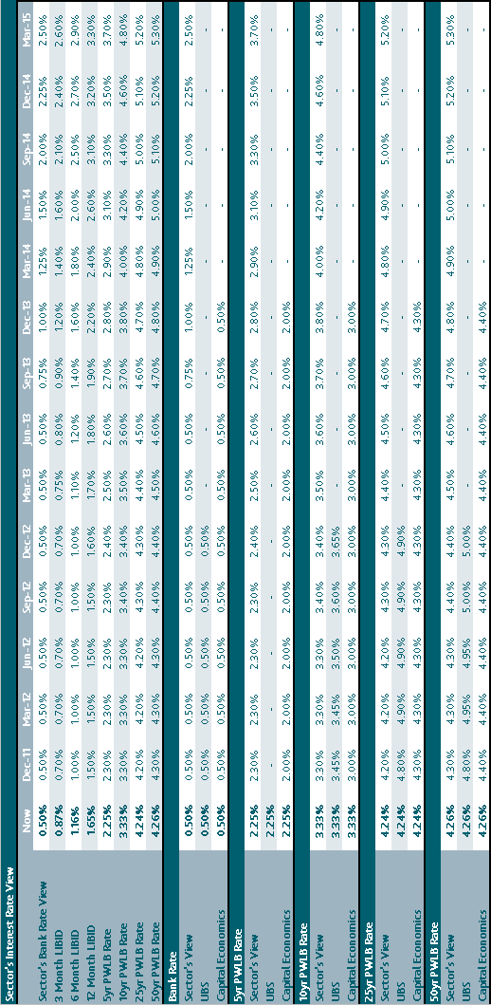
Economic Background

Global economy

The outlook for the global economy remains clouded with uncertainty with the UK economy struggling to generate sustained recovery that offers any optimistim for the outlooks for 2011 and 2012, or possibly even into 2013. Consumer and business confidence levels are low and with little to boost sentiment, it is not easy to see potential for a significant increase in the growth rate in the short term.

At the centre of much of the uncertainty is the ongoing Eurozone sovereign debt crisis which has intensified, rather than dissipated throughout 2011. The main problem has been Greece, where, even with an Eurozone/IMF/ECB bailout package and the imposition of austerity measures aimed at deficit reduction, the lack of progress and the ongoing deficiency in addressing the underlying lack of competitiveness of the Greek economy, has seen an escalation of their problems. These look certain to result in a default of some kind but it currently remains unresolved if this will be either “orderly” or “disorderly”, and/or also include exit from the €uro bloc.

As if that were not enough there is growing concern about the situation in Italy and the risk that contagion has not been contained. Italy is the third biggest debtor country in the world but its prospects are limited given the poor rate of economic growth over the last decade and the lack of political will to address the need for fundamental reforms in the economy. The Eurozone now has a well established track record of always doing too little too late to deal with this crisis; this augurs poorly for future prospects, especially given the rising level of electoral opposition in northern EU countries to bailing out profligate southern countries.

The US economy offers little to lift spirits. With the next Presidential elections due in November 2012, the current administration has been hamstrung by political gridlock with the two houses split between the main parties. In quarter 3 the Federal Reserve started “Operation Twist” in an effort to re-ignite the economy in which growth is stalling. High levels of consumer indebtedness, unemployment and a moribund housing market are weighing heavily on consumer confidence and so on the abiltity to generate sustained economic growth.

Hopes for broad based recovery have, therefore, focussed on the emerging markets but these areas have been struggling with inflationary pressures in their previously fast growth economies. China, though, has maintained its growth pattern, despite tightening monetary policy to suppress inflationary pressures, but some forward looking indicators are causing concern that there may not be a soft landing ahead, which would then be a further dampener on world economic growth.

Economy

The Government’s austerity measures, aimed at getting the public sector deficit into order over the next four years, have yet to fully impact on the economy. However, coming at a time when economic growth has virtually flatlined and concerns at the risk of a technical recession (two quarters of negative growth) in 2012, it looks likely that the private sector will not make up for the negative impact of these austerity measures given the lack of an export led recovery due to the downturn in our major trading partner – the EU. The housing market, a gauge of consumer confidence, remains weak and the outlook is for house prices to be little changed for a prolonged period.

Economic Growth - GDP growth has, basically, flatlined since the election of 2010 and, worryingly, the economic forcecasts for 2011 and 2012 have been revised lower on a near quarterly basis as the UK recovery has, effectively, stalled. With fears of a potential return to recession the Bank of England embarked on a second round of Quantitive Easing to stimulate economic activity.

Unemployment - With the impact of the Government’s austerity strategy impacting the trend for 2011 of steadily increasing unemployment, there are limited prospects for any improvement in 2012 given the deterioration of growth prospects.

Inflation and Bank Rate - For the last two years, the MPC’s contention has been that high inflation was the outcome of temporary external factors and other one offs (e.g. changes in VAT); that view remains in place with CPI inflation standing at 5.2% at the start of quarter 4 2011. They remain of the view that the rate will fall back to, or below, the 2% target level within the two year horizon.

AAA rating - The ratings agencies have recently reaffirmed the UK’s AAA sovereign rating and have expressed satisfaction with Government policy at deficit reduction. They have, though, warned that this could be reviewed if the policy were to change, or was seen to be failing to achieve its desired outcome. This credit position has ensured that the UK government is able to fund itself at historically low levels and with the safe haven status from Eurozone debt also drawing in external investment the pressure on rates has been down, and looks set to remain so for some time.

Sector’s forward view

Economic forecasting remains troublesome with so many external influences weighing on the UK. There does, however, appear to be consensus among analysts that the economy remains weak and whilst there is still a broad range of views as to potential performance, they have all been downgraded throughout 2011. Key areas of uncertainty include:
- a worsening of the Eurozone debt crisis and heightened risk of the breakdown of the bloc or even of the currency itself;
- the impact of the Eurozone crisis on financial markets and the banking sector;
- the impact of the Government’s austerity plan on confidence and growth and the need to rebalance the economy from services to exporting manufactured goods;
- the under-performance of the UK economy which could undermine the Government’s policies that have been based upon levels of growth that increasingly seem likely to be undershot;
- a continuation of high levels of inflation ;
- the economic performance of the UK’s trading partners, in particular the EU and US, with some analysts suggesting that recession could return to both;
- stimulus packages failing to stimulate growth;
- elections due in the US, Germany and France in 2012 or 2013;
- potential for protectionism i.e. an escalation of the currency war / trade dispute between the US and China.

The overall balance of risks remains weighted to the downside. Lack of economic growth, both domestically and overseas, will impact on confidence putting upward pressure on unemployment. It will also further knock levels of demand which will bring the threat of recession back into focus.

Sector believes that the longer run trend is for gilt yields and PWLB rates to rise due to the high volume of gilt issuance in the UK, and the high volume of debt issuance in other major western countries.

Given the weak outlook for economic growth, Sector sees the prospects for any interest rate changes before mid-2013 as very limited. There is potential for the start of Bank Rate increases to be even further delayed if growth disappoints.

Treasury Management Practice (TMP1)
Credit and Counterparty Risk Management

The CLG issued Investment Guidance in 2010, and this forms the structure of the Council’s policy below. These guidelines do not apply to either trust funds or pension funds, which operate under a different regulatory regime.

The key intention of the Guidance is to maintain the current requirement for councils to invest prudently, and that priority is given to security and liquidity before yield. In order to facilitate this objective the guidance requires this Council to have regard to the CIPFA publication Treasury Management in the Public Services: Code of Practice and Cross-Sectoral Guidance Notes. This Council has adopted the Code and will apply its principles to all investment activity. In accordance with the Code, the Director of Corporate Resources & Governance has produced its Treasury Management Practices (TMPs). This part, TMP 1(5), covering investment counterparty policy requires approval each year.

Annual Investment Strategy - The key requirements of both the Code and the investment guidance are to set an annual investment strategy, as part of its annual treasury strategy for the following year, covering the identification and approval of following:

- The strategy guidelines for choosing and placing investments, particularly non-specified investments.
- The principles to be used to determine the maximum periods for which funds can be committed.
- Specified investments that the Council will use. These are high security (i.e. high credit rating, although this is defined by the Council, and no guidelines are given), and high liquidity investments in sterling and with a maturity of no more than a year.
- Non-specified investments, clarifying the greater risk implications, identifying the general types of investment that may be used and a limit to the overall amount of various categories that can be held at any time.

The investment policy proposed for the Council is:

Strategy Guidelines – The main strategy guidelines are contained in the body of the treasury strategy statement.

Specified Investments – These investments are sterling investments of not more than one-year maturity, or those which could be for a longer period but where the Council has the right to be repaid within 12 months if it wishes. These are considered low risk assets where the possibility of loss of principal or investment income is small. These would include sterling investments which would not be defined as capital expenditure with:
- The UK Government (such as the Debt Management Account deposit facility, UK Treasury Bills or a Gilt with less than one year to maturity).
- A local authority, parish council or community council.
- A body that is considered of a high credit quality (such as a bank or building society) with a minimum short term rating of F-1 (or the equivalent) as rated by Standard and Poor’s, Moody’s or Fitch rating agencies or a Building Society with assets over £1,000m. Non rated Building Societies will need to be non-specified investments.

Within these bodies, and in accordance with the Code, the Council has set additional criteria to set the time and amount of monies which will be invested in these bodies. These criteria are defined in the Treasury Management Strategy.

Non-Specified Investments – Non-specified investments are any other type of investment (i.e. not defined as Specified above). The identification and rationale supporting the selection of these other investments and the maximum limits to be applied are set out below. Non specified investments would include any sterling investments with:

 | Non Specified Investment Category | Limit (£ or %)
 | Any bank or building society that has a minimum long term credit rating of A (or equivalent), for deposits with a maturity of greater than one year (including forward deals in excess of one year from inception to repayment). | £2m or 10%
 | The Council’s own banker if it fails to meet the basic credit criteria. In this instance balances will be minimised as far as is possible. | In this instance balances will be minimised as far as possible
 | Building societies not meeting the basic security requirements under the specified investments.  The operation of some building societies does not require a credit rating, although in every other respect the security of the society would match similarly sized societies with ratings. The Council may use such building societies which were originally considered Eligible Institutions and have a minimum asset size of £1,500m, but will restrict these type of investments to £2m for one month | £2m
 | Specific Public Bodies  The Council can seek Member approval to make loans to other public bodies for periods of more than one year. | £2m
 | Other Local Authorities | £2m

In accordance with the Code, the Council has developed additional criteria to set the overall amount of monies which will be invested in these bodies. These criteria are defined in the Treasury Management Strategy.
In respect of categories d and e, these will only be considered after obtaining external advice and subsequent Member approval.

The Monitoring of Investment Counterparties - The credit rating of counterparties will be monitored regularly. The Council receives credit rating information (changes, rating watches and rating outlooks) from Sector as and when ratings change, and counterparties are checked promptly. On occasion ratings may be downgraded when an investment has already been made. The criteria used are such that a minor downgrading should not affect the full receipt of the principal and interest. Any counterparty failing to meet the criteria will be removed from the list immediately by the Director of Corporate Resources & Governance, and if required new counterparties which meet the criteria will be added to the list.
Institution Type | Max Amount: |  |  | £2m | £10m | £10m | £4m | £2m
 | Max Length: |  |  | 10 Years | 364 Days | 6 Months | 3 Months | 1 Month
 | Minimum Short Term Ratings
 | Fitch | Moody's | S&P
UK Banks
Banks with Clearing Status in the United Kingdom | F1 | P-1 | A-1 |  | Backed up by AA(F), Aa2(M) and AA(S&P) long term credit rating | Backed up by single A long term ratings by all agencies | Backed up by lower than A long term rating
The Council's own Bankers | F1 | P-1 | A-1 | If Council's own bankers fall below the minimum long term criteria for UK banks, cash balances will be managed within operational liquidity constraints
Wholly Owned Subsidiaries of UK Clearing Banks - Parent Ratings | F1 | P-1 | A-1 |  | Backed up by AA(F), Aa2(M) and AA(S&P) long term credit rating | Backed up by single A long term ratings by all agencies | Backed up by lower than A long term rating
UK Building Societies
Either | F1 | P-1 | A-1 |  | Backed up by AA(F), Aa2(M) and AA(S&P) long term credit rating | Backed up by single A long term ratings by all agencies | Backed up by lower than A long term rating
Or |  |  |  |  | Assets over £15,000m | Assets over £5,000m | Assets of £2,500m | Assets over £1,000m
Specific Public Bodies |  |  |  | As approved by Members
UK Local Authorities |  |  |  | The Council can invest in all UK Local Authorities whether rated or not
Notes
1 F1+, P-1 and A-1+ are the highest short term credit ratings of Fitch, Moody's and Standard and Poor's respectively
2 Minimum Short Term Ratings - Where given, these must be met, for all categories
3 Building Societies - A Building Society has to meet either the ratings criteria or the assets criterion to be included in the category, not both
4 Maximum amount is the maximum, in total, over all investments, with any one institution
5 As of the end of 2011, due to adverse market conditions and increased counter party risk, the maximum length of investment was reduced to 3 months, unless the counterparty was partially government owned when the maximum investment length increased to 6 months. This policy will continue until the market conditions improve and counter party risk decreases and allows the Council to revert to the policy above.
EXECUTIVE COMMITTEE – 30 JANUARY 2012

PART I - NOT DELEGATED

15. STRATEGIC, SERVICE AND FINANCIAL PLANNING - RECOMMENDATIONS
(DCRG)

1. Summary

1.1 This report enables the Committee to make its recommendations on the strategic, service and financial plans to the Council on 21 February 2012.

2. Details

Context

2.1 The Committee is reminded that each report on this agenda cannot be considered in isolation. It is suggested that decisions are left until this report is considered.

2.2 A Budget Setting Model is available from officers.

Strategic and Service Plans

2.3 The Committee should consider the strategic and service plans and approve their contents subject to the financial resources allocated to them below.

Revenue Budget

2.4 The Committee should agree the revenue budget. Specifically, the Committee should amend the base budget for:-

a) the revenue implications of any capital expenditure on schemes that it proposes, and

- any growth it proposes to add to the base budget.

The Committee should determine whether there is the scope in the medium or long-term to make a revenue contribution to capital expenditure and, in the light of the annual deficits/surpluses resulting, determine the balances it wishes to see carried forward.

Capital Investment Programme

2.5 The Committee should note the amounts available to invest in capital expenditure and the assumptions made in determining that funding. The Committee should allocate those funds to capital schemes taking into account:-

a) committed schemes, particularly those re-phased from 2011/12,

b) specific capital schemes for which there is earmarked funding, and,

c) other schemes.

2.6 The Committee should agree the level of capital investment for 2012/13 to 2014/15 and over the longer-term, having regard to any balances it wishes to see carried forward.

Strategic and Service Plans

2.7 Having recommended appropriate budgets the Committee should review the outputs in the strategic and service plans in the light of the resources allocated to them, in order to ensure that the plans can be achieved.

3. Options/Reasons for Recommendation

3.1 The recommendation below enables the Committee to make recommendations to the Council on 21 February 2012 concerning the Council’s strategic, service and financial plans.

4. Policy/Budget Reference and Implications

4.1 The recommendations in this report contribute to the process whereby the Council will approve and adopt its strategic, service and financial plans under Article 4 of the Council’s Constitution.

5. Financial, Staffing, Environmental, Community Safety, Customer Services Centre, Communications & Website Implications

5.1 Dependant on budget decisions. Specific comments are contained within earlier reports.

6. Financial Implications

6.1 The key financial implications for the Council are:-

- Balances are healthy in the medium-term, although officers are recommending an increase from £2.5m to £2.8m in the minimum prudent revenue balance in the light of the financial and budgetary risks.
- Significant revenue savings have been achieved and are included in the base budget The Council should continue to monitor closely the achievement of savings anticipated, particularly those from shared services.
- The Council will have to weigh the benefits of accepting the Government’s offer of a one-off grant if it freezes the council tax charge for 2012/13 against the longer term financial implications.
- Future levels of government grant are still uncertain.
- The Council is still relying on interest income to support the revenue account. The future assumptions on interest rates and inflation should be closely monitored.
- The capital programme relies on shared right to buy receipts and the VAT shelter receipts, the levels of which will need to be continuously monitored.
- The impact of universal credits, the localisation of support to council tax and the retention of national non-domestic rates is still largely unknown and will need to be closely monitored

7. Legal Implications

7.1 Section 25 of the Local Government Act 2003 places a duty on the Chief Finance Officer to report on the robustness of the estimates and the adequacy of the financial reserves. The Director of Corporate Resources and Governance will provide advice at the meeting.

8. Equal Opportunities Implications

8.1 Relevance Test

Has a relevance test been completed for Equality Impact? | No
Did the relevance test conclude a full impact assessment was required? | No  (not applicable)

8.2 Impact Assessment

A relevance test has not been carried out on the recommendations for their equality impact, however, each service plan includes an equality action plan. There is a programme of equality impact assessments for individual service areas and any new proposals for individual services will require an impact assessment. Data has been gathered on the equality impact of changes in council tax. No significant differences of opinion were found on the grounds of race, disability or gender.

9. Risk Management and Health & Safety Implications

9.1 The Committee should recommend that the strategic, financial and budgetary risks identified be incorporated into service plans as appropriate.

10. Recommendations

Either

10.1 To Council:-

(a) That the Strategic Plan 2012-2015 be approved. (Agenda Item 10 refers).

(b) That the strategic risks associated with the Strategic Plan be agreed and their management be monitored in accordance with the risk management strategy. (Agenda Item 10 refers).

(c) That the Service Plans 2012-2015 be approved. (Agenda Item 11 refers).

(d) That the 2011/2012 revised estimates for the revenue account be agreed giving a balance at 31 March 2012 of £7,775,243. (Agenda Item 12, Appendix 1 refers).

(e) That the draft revenue estimates in respect of the revenue account for the period 1 April 2012 to 31 March 2022, subject to the changes agreed, be approved (Agenda Item 12 refers).

(f) That the financial and budgetary risks be agreed and their management monitored by the Audit Committee. (Agenda Item 12 refers).

(g) That the Council’s total capital investment programme for 2011/2012 be agreed at £5,808,320. (Agenda Item 13 refers).

(h) That the arrangements for funding the 2011/2012 capital investment programme resulting in an estimated balance of capital resources at 31 March 2012 of £13,110,857 be agreed. (Agenda Item 13 refers).

(i) That the Council notes the capital funding available and approves the Executive Committee’s allocation of funds for the period from 1 April 2012 to 31 March 2022 between:

1) Specific capital schemes for which there is earmarked funding, and,

2) other schemes.

(Agenda Item 13 refers).

(j) That the Council notes the Annual Treasury Management Report and Actual Prudential Indicators for 2010/11, the Mid Year Treasury Management Monitoring Report for 2011/12 and the Treasury Management Strategy Statement 2012/13 – 2014/15.

(Agenda Item 14 refers).

(k) That the Council approves the key elements of the Treasury Management Strategy Statement as follows:-
- The Prudential Indicators and Limits for 2012/13 to 2014/15, including the Authorised Limit Prudential Indicator.
- The Minimum Revenue Provision (MRP) Statement which sets out the Council’s policy on MRP.
- The Treasury Management Strategy 2012/13 to 2014/15 and the Treasury Prudential Indicators.
- The Investment Strategy 2012/13 and the detailed criteria contained in the treasury management strategy.

(Agenda Item 14 refers).

(l) That the Council notes the Director of Corporate Resources and Governance’s advice on the robustness of the estimates and the adequacy of the financial reserves.

(m) That it be noted that £2.8m be considered as a prudent minimum balance for the general fund.

Or

10.2 That the Executive Committee notes that the Administration will present its recommendations on strategic, service and financial planning to the Council meeting on 21 February 2012.

Report prepared by:
David Gardner – Director of Corporate Resources and Governance

Background Papers: None.

The recommendations contained in this report DO NOT constitute a KEY DECISION but contribute to the process whereby the Council will approve and adopt its Strategic, Service and Financial Plans under Article 4 of the Council’s Constitution

