Three Rivers District Council

HR POLICY: CHIEF OFFICER/ senior STAFF Reward POLICY

DATE FIRST ISSUED: January 2012

DATES REVIEWED:

1. INTRODUCTION

1.1 The council’s success relies on the talent and contribution of its workforce enabling and ensuring it meets its objectives. Our Reward strategy seeks to ensure the council is able to attract, recruit, retain and engage the right people in order to achieve this.

1.2 The Reward Policy pulls together all the elements that make up the council’s extrinsic reward practices. Thus it provides assurances of our consistency, fairness and transparency and gives clarity to all our stakeholders about how and what our people are rewarded for. It defines the level and elements of remuneration, for Chief Officers, and all Senior staff in accordance with the requirements of section 38(1) of the Localism Act 2011.

1.3 Remuneration levels, all other payments, incremental progression, performance related pay, bonus payments, redundancy, severance/ compensation, and retirement payments, and the council’s policy on re-engagement of officers is confirmed.

1.4 The council employs 306 officers, that represents a full time equivalent based on a 37 hour week of 287.08.

1.5 The total gross expenditure for the council for the financial year 2010 2011 was £52,526,000.

1.6 Best practice recommends the council develops a remuneration committee. The remuneration committee would be consulted on all council decisions relating to pay and reward for Senior Officers thus ensuring openness and accountability.

1.7 This policy is reviewed and approved annually by Full Council, and may be accessed via the council’s external web site.

2. SCOPE OF THE POLICY

2.1 The policy applies to all Chief Officers and Deputy Chief Officers/ Senior Managers. That is the Head of Paid Service (CEO), Directors, Heads of Service; Statutory Officers (Section 151 and Monitoring Officer), and Section Heads/ Managers.

2.2 Organisation structure charts and a list of the services provided by the council are located in appendix 1.

3.0 TERMS AND CONDITIONS OF SERVICE

3.1 The council’s Chief Officers; i.e. the CEO and Directors are engaged on JNC national terms and conditions of service.

3.2 The council’s Deputy Chief Officers; i.e. statutory and non statutory officers, Heads of Service, and Section Heads/ managers are engaged on NJC national terms and conditions of service.

3.3 It should be noted that different national negotiating machinery applies across the Senior Management Team

3.4 Job Descriptions and person specifications for the Chief Executive and first tier officers (Directors) are not currently available and need to be appended to this policy.

4. PRINCIPLES

4.1 The Reward policy reflects the aspirations of the council’s strategic objectives and defines the council’s approach to managing reward that is guided by the following principles

4.2 All council officer jobs are job evaluated using an analytical job evaluation scheme to allocate points to posts and establish relativity between all posts in the organisation.

4.3 The council reviews appropriate external pay market information to ensure remuneration levels are consistent with Local Government, provide value for money for the tax payer, and support the council to remain competitive as an employer in areas of skills shortage.

4.4 If appropriate, market factors are applied to hard to fill posts. Where applied, these supplements are reviewed annually in accordance with the market factor policy.

4.5 Chief Officers - the Head of Paid Service and Directors - are remunerated within a graded pay model with incremental spinal column points. Progression within the grade is time based and where appropriate awarded annually up to the top of the grade, effective from 1 April, (see appendix 2).

4.6 Deputy Chief Officers; i.e. Heads of service, (Shared Services or non shared services), statutory officers and Section Heads/ Managers are remunerated by one of the following pay models :-

Senior Managers’ salary scheme – appendix 3
Within the top two grades of the council’s Salary Scales - appendix 4
Shared Services Head of Service salary scheme – appendix 5
Shared Services Officers salary scheme – appendix 5

Salary progression for Deputy Chief Officers may be either time based or performance based depending upon which salary scheme applies to their post.

Senior Managers’ Salary Scheme – appendix 3 - Posts that are graded above PO1 - 4 and/ or who report directly to a Chief Officer are graded within the Senior Managers’ scheme. This scheme is performance related and the incremental spinal points allow the council to reward performance in addition to knowledge, skills experience and commitment. The salary scheme has 4 grades, each consisting of 4 spinal column points. An annual assessment of performance determines the appropriate point within the grade that will be awarded to the post holder for the following year. The spinal point may increase, remain the same, or decrease. The Senior Managers’ Salary policy should be accessed for full information.

Shared Services Heads of Service – appendix 5 – Progression within this pay model is service/ time based and if appropriate is awarded from 1 April each year up to the top of the grade.

All other Senior Managers (not Shared Services) - appendix 4 – Progression within this pay model is service/ time based and if appropriate is awarded from 1 April each year up to the top of the grade.

Shared Services Senior Managers/ Section Heads -appendix 5 – Progression is service/ time based and if appropriate is awarded from 1 April each year up to the top of the grade.

4.5 The council is committed to the principle of fairness; is clear about what people are being paid for, and is consistent, systematic and transparent when applying reward practices. Pay models have been developed based upon appropriate pay market information and ensure that the ratio of pay levels between the highest paid officer and the median/ mean average/ low paid earnings in the council remains consistent and is not distorted as a result of pay awards.

5. EQUALITIES

5.1 The council is committed to equality of opportunity. All members of staff will be treated fairly based on ability, performance and contribution irrespective of their employment or contractual status and personal circumstances, i.e. part time, fixed term. The council monitors equalities data and this policy shall be applied fairly, consistently and equitably for all employees irrespective of race, gender, disability, age, offending past, caring or dependency status, religion or belief, sexual orientation, or gender identity and it is incumbent on those managing this policy to ensure that this is the case.

6. GRADING

6.1 Chief Officers - CEO, Directors, and the Shared Services Head of Service posts –

Job evaluation – posts are job evaluated by the LGE/ HAY Senior manager job evaluation scheme. The LGE Salaries and numbers survey provides the source of comparative pay information, and posts are remunerated in accordance with the JNC guidance for equivalent local authorities. Levels of remuneration for the Shared Services Heads of Service reflect the complexity for a Head of Service having to provide a shared service across multiple councils. Salaries reflect the full range of duties within the role including any requirement for out of hours working or unsocial hours.

6.2 Pay model - The pay model applicable is the Chief Officers’ pay model in appendix 2, or the Shared Services’ Heads of Service pay model in appendix 5.

6.4 Labour market information - The remuneration levels within the above pay models are based upon those defined in the LGE Salaries and Numbers survey for equivalent roles in similar local authorities. There are no market supplements awarded to Chief Officer or Shared Services Head of Service posts.

6.5 Deputy Chief Officers/ Heads of Service/ Managers/ Section Heads

6.6 Job evaluation – non Shared Services - All deputy Chief Officer posts are job evaluated using the GLEA manual scheme (Greater London equalities model). The GLEA scheme is used to evaluate all non Shared Services officer posts in the council, ensuring relativity between posts is established and there is consistency of grading. The Job Evaluation policy should be consulted for further information.

6.7 Pay model - The pay model applicable is the Senior Manager salary scheme model in appendix 4.

6.8 Job evaluation – Shared Services - Shared Services posts are job evaluated using the Local Government Job Evaluation Scheme (LGJES) to ensure consistency with all other Shared Services officer roles in both councils, irrespective of which council is the employer.

6.9 Labour market information - The Croner Reward Job Evaluation system and the Croner Market Pay analysis for Public Services provides the source of comparative pay information for all deputy chief officer posts that are hard to fill or are in areas of skills shortages within the council. Market supplements apply to the following Deputy Chief Officer roles –

Finance Manager - see 5.10 below.

6.8 All other posts in the council

6.9 All other officer posts are job evaluated using the GLEA Job Evaluation Scheme, (with the exception of Environmental Maintenance staff whose terms and conditions are protected under TUPE). Posts are graded within the pay structure detailed in appendix 6, and where appropriate a market factor supplement will apply. The Market forces payments policy should be consulted for further information.

6.10 Market Factor supplements apply to the following posts in the council

Principal Planner
Environmental health practitioner
Senior Building Control Surveyor
Building Surveyor
Senior Auditor
Finance Manager

7 INCREMENTS

7.1 Posts remunerated in the Senior Manager Salary Scheme do not attract an automatic annual increment. Pay awards (with the exception of cost of living awards) are based upon the outcome of a structured performance assessment.

7.3 Posts which are not remunerated on the Senior Managers Salary scheme receive annual, time based increments effective on 1 April, until remuneration reaches the top of the grade.

7.2 On appointment, all posts will normally be remunerated at the lowest incremental spinal column point within the grade.

7.4 The council will apply the annual cost of living percentage increment as negotiated by the NJC national agreement to the values of incremental spinal column points as appropriate. However, there has been no nationally or locally negotiated incremental cost of living rise since 2009.

8 ADDITIONAL PAYMENTS

8.1 London Weighting (LW) – is the inner fringe London Weighting Allowance and is negotiated as part of the national framework. LW is an additional payment that is made to all officers in the council with the exception of Chief Officers, and Officers on the Senior Manager Salary Scheme. The rate is negotiated nationally by the NJC.

8.2 The Head of Paid Service receives additional payment as fees for Returning Officer duties during elections as and when appropriate.

9 PERFORMANCE RELATED PAYMENTS AND BONUSES

9.1 The Senior Manager Salary Scheme provides the opportunity to reward performance, however most officers have already achieved the top of the grade.

9.2 Posts that are not remunerated in the Senior Manager Salary scheme have no facility for reward for performance. Most officers have achieved the top of their grade due to longevity in post.

10. LOCAL GOVERNMENT PENSION SCHEME

10.1 All officers are eligible to join and contribute to the Local Government Pension Scheme. Officer contribution rates are a percentage of their earnings. Levels of contribution are stated by the scheme, and are based on the whole time equivalent value of all contractual pay excluding any travel allowance payments. The employer’s contribution to the scheme is 19%.

Band | Range (whole time equivalent) | Employee Contribution Rate
1 | £0 - £12,900 | 5.5%
2 | More than £12,900 up to £15,001 | 5.8%
3 | More than £15,001 up to £19,400 | 5.9%
4 | More than £19,400 up to £32,400 | 6.5%
5 | More than £32,400 up to £43,300 | 6.8%
6 | More than £43,300 up to £81,100 | 7.2%
7 | More than £81,100 | 7.5%

10.2 The normal retirement Local Government Pension scheme retirement age is 65.

10.3 With the exception of early retirement for the reason of permanent ill health (to which no age restrictions apply), the earliest age an officer can retire and receive pension benefits is 55.

10.4 Early retirement will only ever be granted in certain special circumstances and these are as follows:

Early termination of employment in the interests of efficiency to the service
Early termination of employment for the reason of redundancy
On ill health grounds
On compassionate grounds
By taking flexible retirement (part pension/ part employment)

10.5 The Council’s early retirement and early termination compensation policy applies and should be consulted for further information.

11 SEVERANCE PAYMENTS – EARLY TERMINATION OF EMPLOYMENT IN THE INTEREST OF EFFICIENCY TO THE SERVICE.

11.1 There may be situations that are initiated by management to facilitate organisational change where a post to be vacated would be replaced. The Early Retirement and Early Termination Compensation policy applies and should be consulted.

11.2 Where appropriate, the council will make a discretionary severance/ compensation payment by applying a 1.5 multiplier to each week’s redundancy pay, thus providing up to a maximum of 45 weeks’ pay based on contractual pay.

11.3 Officers aged 55 and above will be eligible to retire in this circumstance and will have access to their accrued pension benefit.

11.4 The council does not augment additional pension membership.

12 REDUNDANCY PAYMENTS – EARLY TERMINATION OF EMPLOYMENT FOR THE REASON OF REDUNDANCY

12.1 In the event of redundancy, i.e. where a post to be vacated would not be replaced, the council pays a discretionary redundancy payment by applying a 2.2 multiplier to each week’s redundancy pay, thus providing up to a maximum of 60 weeks’ pay based on contractual pay.

12.2 Officers aged 55 and above will be eligible to retire in this circumstance and will have access to their accrued pension benefit.

12.3 The council does not augment additional pension membership.

12.4 The council’s Redundancy policy applies and should be consulted.

13 EARLY RETIREMENT FOR THE REASON OF ILL HEALTH

13.1 To qualify an officer must be confirmed by the Council’s Medical adviser as being permanently unable of discharging the duties of their employment because of ill health or infirmity and have a reduced likelihood of obtaining gainful employment before age 65.

14. EARLY RETIREMENT ON COMPASSIONATE GROUNDS

14.1 To qualify an officer must a have compelling hardship or difficulty that would most usually be due to caring responsibilities.

15. FLEXIBLE RETIREMENT

15.1 This is subject to agreement by the council, providing an option for an officer to continue in employment post state retirement age and to take some or all their Local Government pension that is due to them whilst continuing to work on reduced hours or reduced pay. The benefit for the council is the ability to retain skills, knowledge and experience. The flexible retirement policy should be consulted for full information.

16 RE-EMPLOYMENT POST SEVERANCE OR REDUNDANCY

16.1 The re-employment of officers who have been granted early retirement, are receiving their Local Government pension, or have received a severance/ compensation payment, or a redundancy payment is discouraged. The following criteria should be considered. Refer to the council’s policy for early retirement/ early termination compensation for further information.

    - What is the nature of the work to be undertaken?
    - How similar is the work to that formerly undertaken by the individual?
    - Is it work that the individual could have been redeployed to?
    - The work should be a specific project or task where the skills/ knowledge set required is unique to that individual
    - The work should be such that it could not be undertaken by anyone else currently employed in the council

17 OFFICERS WHO HAVE RETIRED AND ARE IN RECEIPT OF PENSION

17.1 If an officer is in receipt of their Local Government Pension and returns to work for the council an abatement of their pension will apply if the pay for the new post plus the LGPS pension they receive exceeds the value of the salary for the post from which they retired. LPFA should be consulted for advice.

18 PAY RELATIVITY AND LOWER PAID STAFF

18.1 The council is committed to the principle of fairness when setting pay levels for all officers. All jobs are job evaluated meaning each has an analytical score providing its relative value in the organisation. Each job is graded and linked to a defined pay model.

18.2 The council defines its lowest paid staff as those whose posts are graded on the lowest grade in the pay model. Pay rates are based on whole time equivalent salaries.

18.2 The mean average earnings in the council are £25,472, giving a ratio with the highest paid officer of 1:4.5. The median earnings in the council are £32,277, giving a ratio with the highest paid officer of 1:3.6. The lowest earnings in the council are £13,589 giving a ratio with the highest paid officer of 1:8.5.

18.3 The lowest pay band on the pay model is not in use. The lowest scale point within this band is remunerated above national minimum wage level, see appendix 7. The lowest remunerated spinal column point gives a ratio with NMW of 1:1.36.

18.4 Cost of living pay increases in the council are awarded in conjunction with those negotiated nationally by JNC/ NJC. An analysis of pay awards for the previous 5 years is provided at appendix 7.

Appendix 1
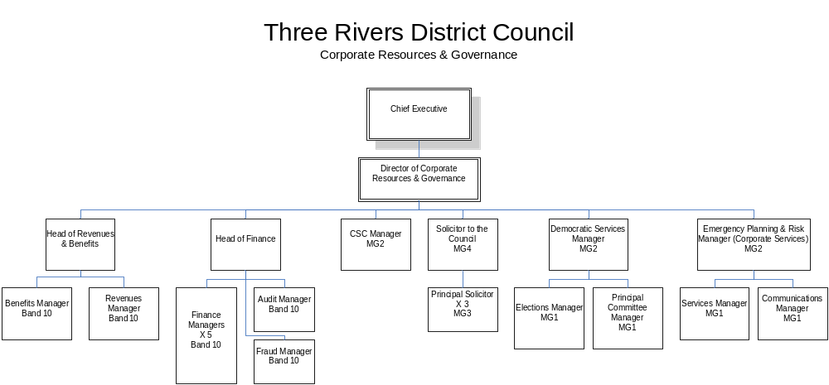

List of Services – 2 Shared Services, Democratic Services, Legal Services, Emergency planning and risk management, Office Services

Notes – Head of Revenues and Benefits, Head of Finance and their reporting line officers are Shared Services posts

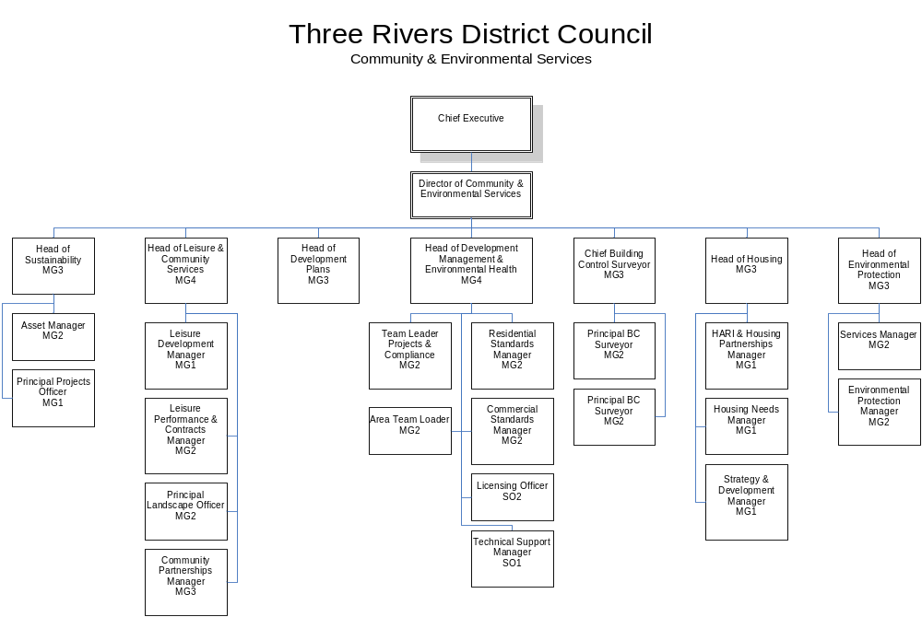
List of services – Planning including development and Building Control, Environmental Health, Refuse and Recycling, Grounds maintenance, Street Cleansing, Leisure services, Tree Unit, Sustainability, Community Partnerships and Safety

Appendix 2

Chief Officer Pay

Position Held | Salary Range  Wef 1.4.08  (£) |  | scp  wef 1.4.08  (£) | Maximum scp  (£)
Chief Executive | 104,811 – 116,181 |  | 116,181 | 116,181
 | Increments | 104,811  108,623  112,402  116,181
Directors | 73,871 – 87,136 |  | 87,136 | 87,136
 | Increments | 73,871  76,418  78,966  81,514  84,301  87,136

Notes - the decision was made not to award the 1% increment for April 2009, there has therefore
been no pay award for CO/ CEO grades since April 2008.

Rates are inclusive of local weighting allowance (LW)

An essential car user allowance applies in accordance with the rates negotiated nationally by NJC/
JNC
Appendix 3

Senior Managers’ Salary Scheme

Evaluated Grade | Assessed Performance Level | Pay as at 1/4/09 (inclusive of 1.0% pay award)
 | 1 | 32,151
Mgmt Grade 1 | 2 | 34,629
 | 3 | 37,110
 | 4 | 39,601
 | 1 | 39,601
Mgmt Grade 2 | 2 | 42,080
 | 3 | 44,564
 | 4 | 47,046
 | 1 | 47,046
Mgmt Grade 3 | 2 | 49,530
 | 3 | 52,018
 | 4 | 54,500
 | 1 | 54,500
Mgmt Grade 4 | 2 | 56,981
 | 3 | 59,466
 | 4 | 61,950

The scheme applies to posts graded PO1-4 and above, and/ or who are in the top 2 tiers of the
organisation structure reporting to Directors

Pay is inclusive of Local weighting allowance (LW), overtime payments and premium rates for
unsocial hours working.

Appendix 4

Salary scales as at 1 April 2009 for posts graded at PO1 and above

 | Spinal Column point | per hour exclusive of LW | per week exclusive of LW | per month exclusive of LW | per annum inclusive of LW | Basic
PO 1 | 33 | 14.43 | 534.09 | 2320.75 | 28,647 | 27,849
2 | 34 | 14.84 | 549.18 | 2386.33 | 29,434 | 28,636
3 | 35 | 15.15 | 560.69 | 2436.33 | 30,034 | 29,236
4 | 36 | 15.56 | 575.55 | 2500.92 | 30,809 | 30,011
5 | 37 | 15.99 | 591.66 | 2570.92 | 31,649 | 30,851
6 | 38 | 16.46 | 608.98 | 2646.17 | 32,552 | 31,754
7 | 39 | 17.00 | 629.04 | 2733.33 | 33,598 | 32,800
8 | 40 | 17.45 | 645.55 | 2805.08 | 34,459 | 33,661
9 | 41 | 17.91 | 662.58 | 2879.08 | 35,347 | 34,549
10 | 42 | 18.36 | 679.48 | 2952.50 | 36,228 | 35,430
11 | 43 | 18.82 | 696.41 | 3026.08 | 37,111 | 36,313
12 | 44 | 19.28 | 713.54 | 3100.50 | 38,004 | 37,206
13 | 45 | 19.72 | 729.57 | 3170.17 | 38,840 | 38,042
14 | 46 | 20.19 | 747.20 | 3246.75 | 39,759 | 38,961
15 | 47 | 20.66 | 764.34 | 3321.25 | 40,653 | 39,855
16 | 48 | 21.12 | 781.34 | 3395.08 | 41,539 | 40,741
17 | 49 | 21.57 | 798.12 | 3468.00 | 42,414 | 41,616
PO.3 | 50 | 23.48 | 868.77 | 3775.00 | 46,090 | 45,300
 | 51 | 23.99 | 887.81 | 3857.75 | 47,083 | 46,293
 | 52 | 24.49 | 906.26 | 3937.92 | 48,045 | 47,255
PO.4 | 53 | 24.58 | 909.33 | 3951.25 | 48,205 | 47,415
 | 54 | 25.01 | 925.42 | 4021.17 | 49,044 | 48,254

Notes – Local weighting allowance (LW) is applied to all posts graded within this structure

Appendix 5

Shared Services’ Heads of Service pay structure

1/04/09 | scp | Pay | TA | LWTG
Heads | 1 | 62,000 | 300 | 798
 | 2 | 63,350 | 300 | 798
 | 3 | 64,705 | 300 | 798
 | 4 | 66,053 | 300 | 798

Pay is inclusive of a £1,200 per annum local market weighting factor encompassed to cover out of
hours/ unsocial hours working

Shared Services Officers’ pay structure

Band | Scale Point | £ per annum  1/04/09 |  | Band | Scale Point | £ per annum  1/04/09
1 | 5 | 12,312 |  | 7 | 35 | 29,236
1 | 6 | 12,489 |  | 7 | 36 | 30,011
1 | 7 | 12,787 |  | 7 | 37 | 30,851
1 | 8 | 13,189 |  | 7 | 38 | 31,754
1 | 9 | 13,589 |  | 7 | 39 | 32,800
2 | 10 | 13,874 |  | 8 | 40 | 33,661
2 | 11 | 14,733 |  | 8 | 41 | 34,549
2 | 12 | 15,039 |  | 8 | 42 | 35,430
2 | 13 | 15,444 |  | 8 | 43 | 36,313
2 | 14 | 15,725 |  | 8 | 44 | 37,206
3 | 15 | 16,054 |  | 9 | 45 | 38,042
3 | 16 | 16,440 |  | 9 | 46 | 38,961
3 | 17 | 16,830 |  | 9 | 47 | 39,855
3 | 18 | 17,161 |  | 9 | 48 | 40,741
3 | 19 | 17,802 |  | 9 | 49 | 41,616
4 | 20 | 18,453 |  | 10 | 50 | 42,511
4 | 21 | 19,126 |  | 10 | 51 | 43,406
4 | 22 | 19,621 |  | 10 | 52 | 44,303
4 | 23 | 20,198 |  | 10 | 53 | 45,207
4 | 24 | 20,858 |  | 10 | 54 | 46,119
5 | 25 | 21,519 |  | 11 | 55 | 47,028
5 | 26 | 22,221 |  | 11 | 56 | 47,980
5 | 27 | 22,958 |  | 11 | 57 | 48,905
5 | 28 | 23,708 |  | 11 | 58 | 49,817
5 | 29 | 24,646 |  | 11 | 59 | 50,748
6 | 30 | 25,472
6 | 31 | 26,276
6 | 32 | 27,052
6 | 33 | 27,849
6 | 34 | 28,636
Note – Bands 1 and 2 are not used
there has been no cost of living pay award since 1 April 2009
Appendix 6

Salary scales below grade PO1

 | Spinal Column point | per hour exclusive of LW | per week exclusive of LW | per month exclusive of LW | per annum inclusive of LW | Basic
Scale 1
M1 | 4 | 6.30 | 232.92 | 1012.08 | 12,943 | 12,145
M2 | 5 | 6.38 | 236.12 | 1026.00 | 13,110 | 12,312
M3 | 6 | 6.47 | 239.52 | 1040.75 | 13,287 | 12,489
M4 | 7 | 6.63 | 245.23 | 1065.58 | 13,585 | 12,787
M5 | 8 | 6.84 | 252.94 | 1099.08 | 13,987 | 13,189
M6 | 9 | 7.04 | 260.61 | 1132.42 | 14,387 | 13,589
 | 10 | 7.19 | 266.08 | 1156.17 | 14,672 | 13,874
 | 11 | 7.64 | 282.55 | 1227.75 | 15,531 | 14,733
Scale 1/2 | 4 | 6.30 | 232.92 | 1012.08 | 12,943 | 12,145
 | 5 | 6.38 | 236.12 | 1026.00 | 13,110 | 12,312
 | 6 | 6.47 | 239.52 | 1040.75 | 13,287 | 12,489
 | 7 | 6.63 | 245.23 | 1065.58 | 13,585 | 12,787
 | 8 | 6.84 | 252.94 | 1099.08 | 13,987 | 13,189
 | 9 | 7.04 | 260.61 | 1132.42 | 14,387 | 13,589
 | 10 | 7.19 | 266.08 | 1156.17 | 14,672 | 13,874
 | 11 | 7.64 | 282.55 | 1227.75 | 15,531 | 14,733
 | 12 | 7.80 | 288.42 | 1253.25 | 15,837 | 15,039
 | 13 | 8.01 | 296.19 | 1287.00 | 16,242 | 15,444
Scale 2 | 10 | 7.19 | 266.08 | 1156.17 | 14,672 | 13,874
 | 11 | 7.64 | 282.55 | 1227.75 | 15,531 | 14,733
 | 12 | 7.80 | 288.42 | 1253.25 | 15,837 | 15,039
 | 13 | 8.01 | 296.19 | 1287.00 | 16,242 | 15,444
Scale 3 | 14 | 8.15 | 301.58 | 1310.42 | 16,523 | 15,725
 | 15 | 8.32 | 307.89 | 1337.83 | 16,852 | 16,054
 | 16 | 8.52 | 315.29 | 1370.00 | 17,238 | 16,440
 | 17 | 8.72 | 322.77 | 1402.50 | 17,628 | 16,830
Scale 4 | 18 | 8.90 | 329.12 | 1430.08 | 17,959 | 17,161
 | 19 | 9.23 | 341.41 | 1483.50 | 18,600 | 17,802
 | 20 | 9.56 | 353.89 | 1537.75 | 19,251 | 18,453
 | 21 | 9.91 | 366.80 | 1593.83 | 19,924 | 19,126
Scale 5 | 22 | 10.17 | 376.29 | 1635.08 | 20,419 | 19,621
 | 23 | 10.47 | 387.36 | 1683.17 | 20,996 | 20,198
 | 24 | 10.81 | 400.02 | 1738.17 | 21,656 | 20,858
 | 25 | 11.15 | 412.69 | 1793.25 | 22,317 | 21,519
Scale 6 | 26 | 11.52 | 426.16 | 1851.75 | 23,019 | 22,221
 | 27 | 11.90 | 440.29 | 1913.17 | 23,756 | 22,958
 | 28 | 12.29 | 454.67 | 1975.67 | 24,506 | 23,708
Salary scales below grade PO1 continued

 | Spinal Column point | per hour exclusive of LW | per week exclusive of LW | per month exclusive of LW | per annum inclusive of LW | Basic
SO.1 | 29 | 12.77 | 472.66 | 2053.83 | 25,444 | 24,646
 | 30 | 13.20 | 488.50 | 2122.67 | 26,270 | 25,472
 | 31 | 13.62 | 503.92 | 2189.67 | 27,074 | 26,276
SO.2 | 32 | 14.02 | 518.81 | 2254.33 | 27,850 | 27,052
 | 33 | 14.43 | 534.09 | 2320.75 | 28,647 | 27,849
 | 34 | 14.84 | 549.18 | 2386.33 | 29,434 | 28,636

Appendix 7

JNC/ NJC national pay awards last 5 years

2007 2.475% - increase to spinal column point 4 to increase hourly rate to minimum £6 per hour*

2008 2.75% - plus increase to spinal column points 4, 5 and 6 of £100*

2009 1.0% - increase of 1.25% to spinal column points 4, 5, 6, 7, 8, 9, 10*.

2010 No national or local pay award

2011 No national or local pay award

*note that there are no posts in the council remunerated below spinal column point 9 , i.e. £7.04 per
hour plus LW.

National Minimum Wage rates 1 October 2011

Adult rate £6.08
18 – 20 yrs £4.98
16 – 17 yrs £3.68
Apprentice £2.60

