**POLICY AND RESOURCES COMMITTEE – 6 OCTOBER 2016**

**PART I - NOT DELEGATED**

**8. BUDGET MONITORING – MONTH 4 (JULY 2016)**

(DoF)

1. **Summary**

* 1. Budget monitoring report is a key tool in scrutinising the Council’s financial performance. It is designed to provide an overview to all relevant stakeholders. It is essential that the council monitors its budgets throughout the year to ensure that it is meeting its strategic objectives and that corrective action is taken where necessary.

1.3 This report seeks approval to a change in the Committee’s 2016-2019 medium-term revenue financial plan. The report shows the Council’s overall consolidated medium term financial plan for both revenue and capital.

1. **Details**

2.1 An overall increase in the Council’s budgets requiring the use of balances must be approved by Council. Virements between cost centres within each service are approved by each committee. Virements between service committees must be approved by Council along with proposals for the use of ‘windfall’ income.

***Revenue***

2.2 The original net revenue budget for 2016/17 (as approved by Council in February 2016) was **£11.782 million**. The latest budget is £**12.265 million** which includes the budget carry forwards from 2015/16 **of £0.408 million** as recommended for approval to Council by this committee in June and an unfavourable variance of **£0.075 million** in the Quarter 1 budget monitoring report presented to this committee at the meeting on 18 July 2016.

2.3 After removing other non-service costs (parish precepts and interest earned on investments) and indirect costs (internal recharges, capital financing charges & adjustments under statute) the net original direct revenue budget was set at **£10.775 million** and the latest approved **£11.257 million**. These are the budgets that service committees have a direct responsibility for.

2.4 The forecast outturn is now estimated to be **£11.212 million** which results in a favourable variance of **£0.045 million.**

2.5 The main variances that contribute to this are;

* the increased take up of the garden waste scheme which totalled 19,232

participants at the end of July. This results in a net increase in income of **£0.085**

**million**.

* Reduction in advertising income on Council assets due to the delay in preparing the framework agreement. This results in a decrease **of £0.025 million**.

The details of all variances are shown at **Appendix 2.**

2.6 The table below shows the net direct expenditure (service costs) budgets, forecast outturn and variance for each service committee.

|  |  |  |  |  |
| --- | --- | --- | --- | --- |
| **2016/17 Revenue Account – General Fund Summary** | | | | |
|
| **Service Area** | **Original Budget** | **Latest Budget** | **Outturn** | **Variance** |
| **£000** | **£000** | **£000** | **£000** |
| Leisure, Wellbeing & Health | 2,339 | 2,281 | 2,281 | 0 |
| Sustainable Development, Planning & Transport | 1,649 | 1,716 | 1,711 | (5) |
| General Public Services & Community Safety | 2,257 | 2,320 | 2,255 | (65) |
| Policy & Resources | 4,530 | 4,940 | 4,965 | 25 |
| **Net General Fund** | **10,775** | **11,257** | **11,212** | **(45)** |

2.7 The trend over the financial year (2016/17) is plotted on the graph below;

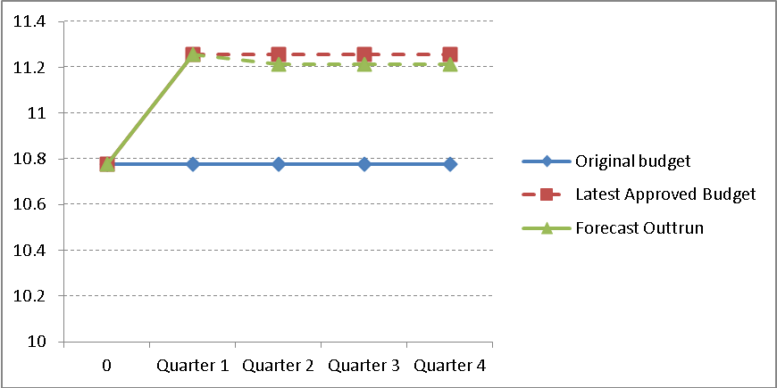

2.8 The effect of the variances on the Council’s (surplus)/deficit for the year and the general fund balance over the medium term is shown in the table below.

|  |  |  |  |  |  |
| --- | --- | --- | --- | --- | --- |
| **Movement on General Fund** | **2016/17** | **2016/17** | **2016/17** | **2017/18** | **2018/19** |
| **Original Budget** | **Latest Approved** | **Outturn Forecast** | **Outturn Forecast** | **Outturn Forecast** |
| **£000** | **£000** | **£000** | **£000** | **£000** |
| Balance B/F at 1 April | (4,727) | (4,396) | (4,396) | (3,965) | (3,990) |
| (Surplus)/deficit for year | (5) | 477 | 432 | (25) | 28 |
| Balance at 31 March | **(4,732)** | **(3,919)** | **(3,965)** | **(3,990)** | **(3,962)** |

A minimum prudent general fund balance of not less than £2 million is considered appropriate.

2.9 **Appendix 1** shows the medium term revenue budget by cost centre by committee.

2.10 **Appendix 2** shows the explanations of revenue variances reported since the last report.

2.11 **Appendix 3** shows the previous revenue variances up to period 3 (June) which have been reported to and agreed by this committee. This is shown to reconcile the movements from the original budget agreed by Council in February 2016.

2.12 **Appendix 4** shows the Council’s key budget indicators for service income.

2.13 **Appendix 5** shows the Council’s key budgetary & financial risks.

***Capital***

2.14 The original budget for 2016/17 (as approved by Council in February 2016) was **£6.656 million**. The latest budget is **£9.478 million** which includes rephasing of **£0.482 million** as approved by Council at its meeting in May and additional rephasing of **£2.340 million** that was included in the outturn report presented to Policy & Resources Committee in June and recommended for approval to Council.

2.15 Services have identified **£1.410 million** to be rephased to later years in the programme. This has reduced the 2016/17 budget **to £8.068 million**. In addition services have also identified a project to the value of **£0.150 million** to be removed from the programme and also additions to the programme totalling **£0.149 million** (which are funded from external contributions.

2.16 The two main re-phasings identified are:

* Bury Lake Young Mariners (BLYM) – **£0.750 million** rephased to 2017/18 due to the delay in BLYM confirming their VAT status for the construction project.
* Waste Services Depot - **£0.494 million** rephased to 2017/18 as awaiting a decision on location of new depot

2.17 Capital spend up to 31 July was **£0.988 million** which represents 12.2% of the latest budget following re-phasings. Service accountants have met with budget holders, who have confirmed that budgets will be spent by the end of the financial year; this will be monitored at future budget reports and any additional re-phasings will be identified as they are known.

2.18 **Appendix 6** shows the Council’s medium term capital investment programme 2016 -2019 by cost centre by Committee.

2.19 **Appendix 7** shows theexplanations of capital variances reported this period

2.20 **Appendix 8** shows the funding of the capital programme.

3. **Options/Reasons for Recommendation**

3.1 The recommendations below enable the Committee to make recommendations to Council concerning their budget.

4. **Policy / Budget Reference and Implications**

4.1 In accordance with the Council’s financial procedure rules, if the recommendations are accepted, this will amend the Council’s budgets.

4.2 There are no substantial changes to Council policy resulting from this report.

5. **Legal, Equal Opportunities, Staffing, Environmental, Community Safety, Public Health, Customer Services Centre, Communications & Website, and Health & Safety Implications**

5.1 None specific.

6. **Financial Implications**

6.1The following revenue and capital variations have been identified for all Service Committees for Period 4 (end of July).

|  |  |  |  |
| --- | --- | --- | --- |
| Variance | 2016/17  £ | 2017/18  £ | 2018/19  £ |
| **Revenue** - (Favourable )/ Unfavourable | (45,130) | (38,870) | 65,310 |
| **Capital** - Increase / (Decrease) | (1,411,120) | 1,257,800 | 317,320 |

6.2 The revenue budget shows a net favourable variance of **£0.019 million** over the three years 2016/17 to 2018/19, this primarily due to the increase in income from the number of participants using the garden waste collection service which has been offset against the commercial income targets over the medium term .

6.3 The capital programme has increased by **£0.164 million** over the three years to 2016/17 to 2018/19. This is due to the following:

* The refurbishment of play and leisure areas in the district at Eastbury, Ebury and Skidmore Way, funded by Section 106 (£63,500), Manor House and Bedmond, funded by Abbot Langley Parish Council (£135,500), Croxley Green Skate Park, subject to external funding (£115,000).
* The removal of the £150,000 budget for the investment in the council’s own Recycling facility due to the lack of space at Batchworth depot. The council is currently working with three other district councils (Welwyn & Hatfield, Watford and Dacorum) to procure a new contract for this service. This service is currently provided by Herts CC at Waterdale and is funded from revenue.

7. **Risk Management Implications**

7.1 There are no risks to the Council in agreeing the recommendations.

7.2 *The following table gives the risks if the recommendations are rejected, together with a scored assessment of their impact and likelihood:*

|  |  |  |  |
| --- | --- | --- | --- |
| *Description of Risk* | | *Impact* | *Likelihood* |
| *1* | *The Council’s Medium-Term Financial Plan would be out of date and officers would not have accurate budgets to work to.* | *III* | *A* |

7.3 The Council has determined its aversion to risk and is prepared to tolerate risks where the combination of impact and likelihood are plotted in the shaded area of the matrix. The remaining risks require a treatment plan. The risk is managed within the Finance services service plan.

|  |  |  |  |  |  |  |  |  |
| --- | --- | --- | --- | --- | --- | --- | --- | --- |
| **Likelihood** | A |  |  | 1 |  |  | Impact | Likelihood |
| B |  |  |  |  |  | V = Catastrophic | A = >98% |
| C |  |  |  |  |  | IV = Critical | B = 75% - 97% |
| D |  |  |  |  |  | III = Significant | C = 50% - 74% |
| E |  |  |  |  |  | II = Marginal | D = 25% - 49% |
| F |  |  |  |  |  | I = Negligible | E = 3% - 24% |
|  | I | II | III | IV | V |  | F = <2% |
| **Impact** | | | | | |  |  |

8. **Recommendation**

To Council:

8.1 That the following revenue and capital budget variations be approved and incorporated into the three-year medium-term financial plan:-

|  |  |  |  |
| --- | --- | --- | --- |
| Variance | 2016/17  £ | 2017/18  £ | 2018/19  £ |
| **Revenue** - (Favourable )/ Unfavourable | (45,130) | (38,870) | 65,310 |
| **Capital** - Increase / (Decrease) | (1,411,120) | 1,257,800 | 317,320 |

Report prepared by: Stephen Exton – Finance Manager (Accountancy)

Checked by: Nigel Pollard – Section Head (Accountancy)

**Background Papers**

2016/17 Budget Monitoring Quarter 1 (April to June) report

2016/17 Policy and Resources (12 September 2016) report

**APPENDICES**

Appendix 1 Medium term revenue budget by cost centre by Committee (2016-19)

Appendix 2 Explanations of revenue variances reported this Period

Appendix 3 Variances previously reported

Appendix 4 Key budget indicators – Income streams

Appendix 5 Budgetary risks.

Appendix 6 Medium term capital investment programme (2016 -2019)

Appendix 7 Explanations of capital variances reported this Period

Appendix 8 Funding the capital programme (2016-2019)

**APPENDIX 1**



**APPENDIX 2**



**APPENDIX 3**



**APPENDIX 4**



**APPENDIX 5**



Note: The serial numbers relate to the Council’s risk register and serials 1-6 do not relate to finance or budget risks.



**APPENDIX 6**



**APPENDIX 7**



**APPENDIX 8**

