EXECUTIVE COMMITTEE – 29 OCTOBER 2007
HOUSING AND ENVIRONMENT POLICY PANEL – 23 OCTOBER 2007
APPENDICES 1 TO 8

07 10 23 HE i – (15) disabled parking bays-app 1

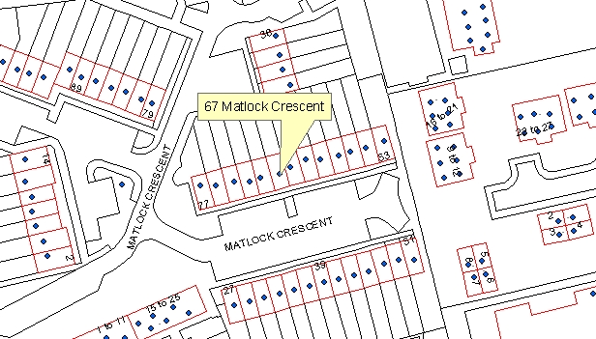

07 10 23 HE i – (15) disabled parking bays-app 2

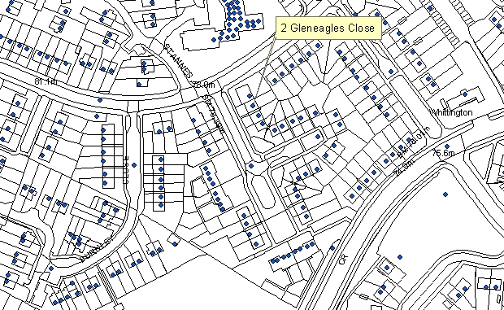

07 10 23 HE i – (15) disabled parking bays-app 3

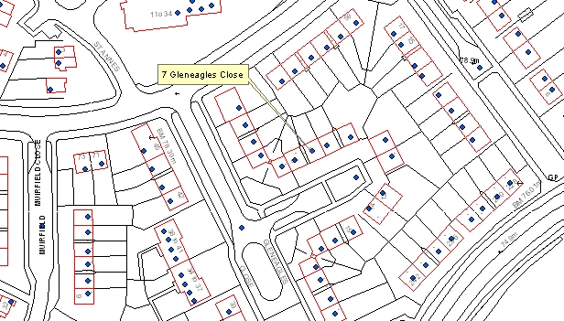

07 10 23 HE i – (15) disabled parking bays-app 4

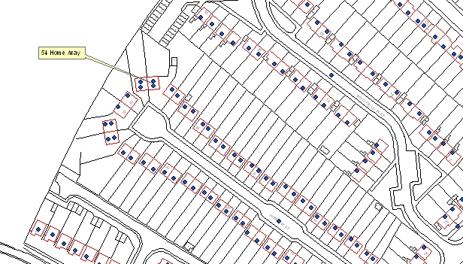

07 10 23 HE i – (15) disabled parking bays-app 5

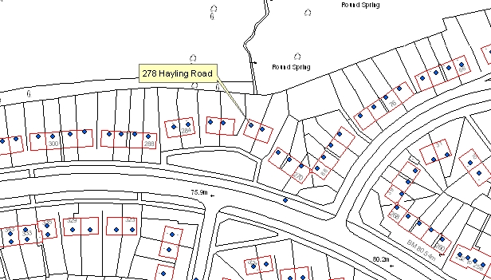

07 10 23 HE i – (15) disabled parking bays-app 6

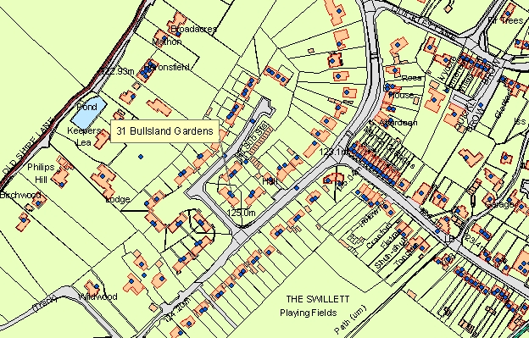

07 10 23 HE i – (15) disabled parking bays-app 7

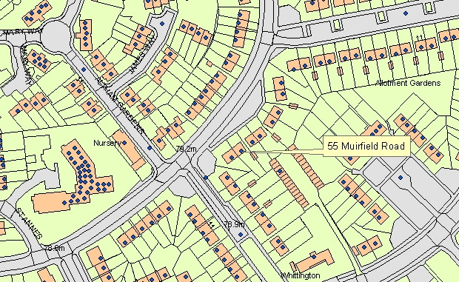

07 10 23 HE i – (15) disabled parking bays-app 8



