EXECUTIVE COMMITTEE – 3 JULY 2006

PUBLIC SERVICES AND HEALTH POLICY PANEL – 6 JUNE 2006.

5b. ANNUAL REVIEW OF THE FOOD LAW AND HEALTH AND SAFETY LAW ENFORCEMENT SERVICE PLANS
(DHH)

1. Summary

  - To consider the review of the Food Law and Health and Safety Law Enforcement Service Plans and to make recommendations to the Executive Committee.

- Details

  - Council adopted the Food Law Enforcement Service Plan in December 2001 and the Health and Safety Law Enforcement Service Plan in February 2002. Both Plans form part of the Budget and Policy Framework within the Council Constitution. The Food Standards Agency and the Health and Safety Commission require the Plans to be reviewed on an annual basis. The review should identify any weaknesses or under-performance and should specify proposals to address any such issues.

  - This report details the Review of the Enforcement Plans and progress to date against the Action Plan. The Review is required to meet the Food Standards Agency Framework Agreement on Local Authority Food Law Enforcement and mandatory Section 18 guidance from the Health and Safety Commission. It is a requirement of the Council Constitution that these Service Plans are subject to consultation. The Plans have been advertised in the local newspaper and comments invited. To date no comments have been received.

FOOD LAW ENFORCEMENT

  - Last year (2005/06) we met 95.8% of the target for high-risk inspections (23/24) and 100% for other risk (231 / 231).

  - All applicants for Basic Food Hygiene Courses continue to be directed to the Watford courses, which run every month.

  - We are participating in the “Safer Food, Better Business” national initiative which promotes the HACCP (Hazard Analysis Critical Control Points) legislative requirements to small and medium sized businesses. We offer training events on the use of the resource pack, which details all compliance advice and appropriate forms and documents for monitoring safety in the food business. Future compliance inspections will be mainly based around this document to prove compliance.

  - We have continued to participate in national food sampling programmes.

  - The annual licensing of Butchers shops ceased on 31st December 2005. The specific requirements relating to HACCP have been incorporated and rolled out to all food businesses

  - Following consideration of the Environmental Health Service Plan earlier this year the Panel requested a further report on options for providing the statutory inspection programmes to provide members with more confidence in the integrity of the control of high risk food premises within the district. This review identifies an alternative inspection strategy that will bring inspection of these premises back in-house.

  - Currently the contractor undertakes all programmed inspections, determined by risk rating from the previous visit and produces any letters in respect of contraventions to be edited by TRDC staff. Commercial Team officers undertake all revisits and any enforcement action deemed necessary when passed by the contractor. A 10% audit check is also undertaken. There is therefore a certain amount of duplication of resource in undertaking the audit of contractor performance.

  - Members are reminded that the use of contractors was approved at a time when qualified food specialists were in extremely short supply and there had been a dramatic downturn in the number of students entering the profession. The Food Standards Agency also introduced a new qualification standard which required non-EHOs (Technical Officers) to undertake a 2-year course for qualification to carry out high-risk food inspections. The one qualified member of staff (other than the Commercial Standards Manager) was on maternity leave. Panel and Executive agreed to remove a front-line post to fund the use of contractor specialists.

  - Members are also reminded that the Commercial Standards Team undertake statutory duties other than food and health and safety enforcement, including infectious disease control, air quality and pollution complaints, contaminated land, all statutory nuisance complaints in respect of commercial premises and drainage issues in commercial premises. The Commercial Standards Manager also supervises the Licensing Team.

  - The current situation is that the Team now has 2 qualified food inspectors (one part time) following the recent qualification of an EHO. The part-time officer has expressed a wish to increase her hours to 4 days a week and this additional resource (funded by reducing the Contractor budget) will reinforce the proposals that follow. It is suggested that resources can be far more effectively used by removing the duplication of auditing and bringing high-risk inspections back in-house. The planned programme for 2006/2007 has identified 52 inspections within these categories. Officers of the Commercial Team will therefore be involved in inspections and all follow-up visits necessary, beneficial to both business and Council alike in terms of consistency and contact.

  - The contractor will continue to be used to undertake the majority of inspections of category C premises (care homes, schools etc) that are of “medium risk”. They will be required to undertake all revisits to ensure compliance (where appropriate) and will be available to reinforce the high-risk programme in the event of emergencies or existing staff leaving. This category has the highest number of premises at 239. Some category C premises will be inspected in-house if they present the risk of deteriorating standards due to changes in management, staff etc. These include some catering pubs, takeaways and restaurants.

  - It is also proposed to introduce self-assessment for low risk premises (those premises in categories D and below) using a questionnaire to allow business operators to audit their business for compliance. Low-risk premises include shops selling wrapped sweets, off-licences and chemists selling baby food, greengrocers etc. A 10% check visit will be made to premises completing the form and visits will be undertaken to all premises where no return is made.

  - The evaluation and analysis of the questionnaires will be undertaken by the enforcement staff to determine if further action or advice to the business is required.

  - Alternative inspection programmes are fully supported and advocated by the Food Standards Agency and also meet the recommendations of the Hampton Report in reducing administrative burdens on small businesses.

  - Members are advised that by adopting the alternative inspection strategy it will lead to the development of a “scores on the doors” initiative for food businesses within the district. An enhanced level of confidence in the inspections and risk scores will be such that an award scheme to be displayed in food businesses will be an option for the future. Such a scheme would bring food safety to the forefront of commercial competition and should lead to an even greater level of food safety compliance. Low performing businesses would be at a distinct disadvantage to those advertising a high star rating.

HEALTH AND SAFETY LAW ENFORCEMENT.

  - Last year (2005/06) we met 100% of the target for high-risk inspections (2/2) and96.5% for other risk (140 / 145). The “self-assessment” questionnaire has continued to be used for very low-risk premises. This form allows the owner of such a business to consider his health and safety responsibility and compliance in an easy format. It also reduces the Councils inspection requirements for the programme. Last year 19 self-assessments have been used in this way.

  - The Chief EHO chaired a Consortium of District and County Councils in Herts and Beds, along with the HSE, NHS organisations and the private sector in the European Health and Safety Week on “Noise at Work”. Over 313,000 newspaper inserts were distributed through local papers, a resource pack was created and sent to all junior and secondary schools in Herts and Beds. In addition a Trade Fair and Seminar was organised for the opening of the week and was attended by 170 delegates.

2.20 The Health and Safety Commission have introduced a “FIT3” programme to improve health and safety. It is based on “fit for work, fit for life and fit for tomorrow” and aims to see a reduction in injuries, days lost and ill-health across a number of targeted areas:

- Slips and trips
- Falls from height
- Disease reduction (dermatitis, asthma and cancer)
- Work related stress
- Bad backs
- Workplace transport
- Moving goods safely.

2.21 Across the HSE region (Herts, Cambridgeshire and Beds) a programme of priorities has been adopted which aims to see

- 3% reduction in work related fatal and major injuries
- 6% reduction in work related ill-health, and
- 9% reduction in days lost due to work related injuries

against the 2004/05 baseline figures.

2.22 The Council’s inspection programme will reflect these priorities. We will examine all accident notifications and the database to determine whether any other premises should be added to the inspection programme where significant improvements could be delivered to meet the regional aims.

Customer Satisfaction

  - Customer Satisfaction for both these services remains extremely high.

3. Options/Reasons for Recommendation

3.1 To comply with the requirements of the Council Constitution and of Food Standards Agency Framework Agreement on Local Authority Food Law Enforcement and the Health and Safety Commission’s Mandatory Section 18 Guidance.

4. Policy/Budget Implications

4.1 The recommendations in this report are not within the Council’s agreed policy and budgets.

5 Financial Implications

  - There are no revenue or capital implications as a result of this report.

  - The scheme will be cost neutral. The same resource is required to deliver the statutory inspection programme whether by the existing contractor route (with its inherent concerns) or by the proposals which will deliver consistency, confidence and the opportunity to deliver a future “scores on the doors” programme.

  - The cost of the proposed increase in hours for the part-time Environment Officer will be funded by the concomitant reduction in the Private Sector Partners budget

6 Legal, Equal Opportunities, Staffing, Environmental, Customer Services Centre and Website Implications

6.1 none specific as a result of this report. Staffing issues are detailed within the Plans themselves.

7 Community Safety Implications

7.1 The food and health & safety enforcement functions contribute to Community Safety by ensuring, as far as possible, that all food premises and Council-enforced commercial premises within the district are legally compliant.

8. Risk Management Implications

8.1 The following table shows the risks that have been identified and gives an assessment of their impact and likelihood in accordance with the Council’s Risk Management Strategy:-

Description of Risk |  | Impact | Likelihood
1 | Failure to deliver the inspection programmes required by the Food Standards Agency or the Health and Safety Commission | III | E
2 | Failure to adopt alternative inspection strategy | D | II

Note:
1. For the meaning of the assessment score see the key to the matrix in paragraph 13.2 below.
2. For the definitions of ‘catastrophic’, ‘almost certain’, etc, see the extract from the ‘Risk Management Strategy Statement’ at the end of the agenda.

8.2 The above risks have been prioritised in the matrix below. The Council has determined its aversion to risk. It is prepared to tolerate risks where the combination of impact and likelihood are shaded in the bottom left in the table below. The remaining risks require management and monitoring. Those combinations of impact and risk shaded centrally below are less time critical but those shaded to the right require immediate management and monitoring.

Likelihood | A |  |  |  |  |  | Impact | Likelihood
Likelihood | B |  |  |  |  |  | V = Catastrophic | A = Almost Certain
Likelihood | C |  |  |  |  |  | IV = Critical | B = Very High
Likelihood | D |  | 2 |  |  |  | III = Significant | C = High
Likelihood | E |  |  |  |  |  | II = Marginal | D = Low
Likelihood | F |  |  | 1 |  |  | I = Negligible | E = Very Low
Likelihood |  | I | II | III | IV | V |  | F = Almost Impossible
Likelihood | Impact

  - In view of this assessment no action plan is required at this time.

8.4 However, by not adopting the recommendations in this report the current concerns of the Panel relating to the dependence on contractors to deliver our inspection programme, and to progress national food safety initiatives, will not be addressed.

9. Recommendations

to Executive Committee

9.1 That the Panel endorse the proposed new alternative inspection strategy to deliver the Council’s statutory requirements in relation to food and health & safety enforcement duties;

9.2 That the proposed increase in hours for the Environment Officer be approved on a cost-neutral basis with a corresponding reduction in the Private Sector Partner budget;

9.3 That the Panel makes any comments on the draft Food Law Enforcement Service Plan and the Health and Safety Law Enforcement Service Plan; and

9.4 That a detailed report on a “scores on the doors” policy be submitted to a future meeting of the Panel.

Background Papers
Food Standards Agency Framework Agreement on Local Authority Food Enforcement.
Mandatory Section 18 Guidance from the health and Safety Commission.
Council Constitution

Report prepared by: John Scott, Commercial Standards Manager.
Ted Massey, Chief Environmental Health Officer.
APPENDICES / ATTACHMENTS
Appendix 1 – Food Law Enforcement Service Plan 2006/07
Appendix 2 – Health and Safety Law Enforcement Service Plan 2006/07

APPENDIX 1



THREE RIVERS DISTRICT COUNCIL

FOOD LAW ENFORCEMENT SERVICE PLAN

2006/07

Drawn up in accordance with the Food Standards Agency Framework Agreement, March 2003

Introduction

This is the fifth annual review of the Food Law Enforcement Service Plan functions carried out by the Environmental Health Section under the provisions of the Food Safety Act 1990 and the Food Standards Act 1999. The Food Service Plan is an expression of the authority’s commitment to the development of the food service and is now required by the Food Standards Agency (FSA), the body that monitors and audits local authorities activities on food enforcement. The scope of the food service plan covers the following specific areas:

- Food safety and hygiene enforcement
- Infectious disease investigations

The FSA Framework Agreement issued in September 2000 (revised in March 2001, again in April 2002 and March 2006) provides service planning guidance and promotes the importance of service planning in ensuring that national priorities and standards are addressed and delivered locally.

The Three Rivers District Council Food Service Plan has been drawn up in accordance with the guidance in the Framework Agreement. This is to enable the FSA to assess our delivery of the service and to allow local authorities to compare service plans written in the common format in preparation for a fundamental performance review under the local government Best Value agenda.

The FSA in the Framework Agreement require that the Food Service Plan is submitted (at least annually) to the relevant member forum for approval to ensure local transparency and accountability. Council first approved this Plan in December 2001, and it has been revised annually since then.

1. Environmental Health Service
Aims and Objectives for Food Law Enforcement

The Aims in relation to Food Law Enforcement

- Appoint staff and contractors who are able to deliver high quality, efficient and cost effective service delivery
- manage the service to ensure environmental and statutory standards are maintained and the council receives good value for money
- become a leader in achieving high percentage of customer high levels of satisfaction amongst service users
- work as a team and with others to achieve our aims
- ensure that our customers can access the service easily through a range of media, including the Councils website
- ensure customers can contribute to the service and feedback views
- commit to quality action planning and target setting in line with the Council’s comprehensive equality plan once confirmed.

The Objectives in relation to Food Law Enforcement

- Undertake food premises inspections on risk-assessed timetable; detain and seize foodstuffs if appropriate; take enforcement action and revisit as necessary.
- Undertake Home Authority liaison.
- Liaise with businesses to provide advice.
- Undertake food sampling.
- Investigate food related infectious diseases; refer complainants to GPs; take enforcement action against food handlers causing food poisoning
- Maintain systems to receive food hazard warnings and ensure appropriate action follows.
- Promote food safety through press releases, talks, information on web sites etc.
- Promote food hygiene courses.
- Ensure premises are licensed as necessary.
- To complete training required following the restructuring of the Environmental Health Section, to maximise the productivity of the remaining in house staff and to trial and implement cost effective enforcement via external service providers.

2. Background

  - Profile of the Local Authority

Three Rivers is situated in the South West of Hertfordshire. The district includes large rural areas with 12 small villages and towns. It borders Watford to the east and the London Borough of Hillingdon to the south.

The district serves a population of about 89,300 (Registrar General’s estimate for mid – 1999). 4.7% of the population is estimated to be from black and ethnic minority backgrounds of which a large percentage live in the affluent Moor Park area of the district.

There are 34,120 dwellings in the district of which 75% are owner occupied; 13% are owned by the Council; 4% by others (including Registered Social Landlords) and 8% by Private Sector Landlords.

The unemployment figures are well below the Great Britain's average. However, there are pockets of deprivation characterised by single parent families, low-income households and a high incidence of long term health problems.

Three Rivers is an attractive place in which to live on the inner fringe of London. It benefits from having excellent road and rail links to London and elsewhere, including the M25, M1, the West Coast Main line and the Metropolitan Line into Central London. Heathrow and Luton Airports are nearby.

  - Organisational Structure

The Structure Charts at Appendices A, B and C show how the food service fits into the Council's services and Committees. The food service is within the Environmental Health Section and is currently provided within a specialist team also undertaking the health and safety enforcement function, infectious disease control and a limited amount of health education work. This team also deals with industrial pollution control, contaminated land and air quality management

Overall co-ordination of the Section's food enforcement is the responsibility of the Chief Environmental Health Officer. The Commercial Standards Manger is the Lead Officer with specialist responsibility for food hygiene/safety.

Specialist services for the food function are provided by external bodies, namely the Public Health Laboratory Service (PHLS) as the food examiner and Eurofin Scientific as the public analyst nominated by Hertfordshire County Council Trading Standards Section.

Committee Structure

The Council has adopted the Leader and Cabinet structure, supported by a number of Policy Panels. There is a Scrutiny Committee.

The majority party forming the Cabinet has decided that there ought to be cross party political representation on the decision-making Committee and we therefore have an Executive Committee comprising 7 Cabinet Members and 3 Members from the minority parties. Both minority parties have opted not to be represented on Executive Committee.

The Executive Committee makes all decisions on behalf of the Council except those delegated to Council. There is a Leader and Deputy Leader and 6 Portfolio holders from the majority party (the Deputy Leader holding a portfolio). Currently the Portfolios are Housing; Public Services and Health; Leisure and Community Development; Resources; Physical Environment and Community Safety. There is a corresponding Policy Panel for each of the Portfolios. The food service comes under the remit of the Public Services and Health Policy Panel and the Portfolio holder for Public Services and Health.

  - Scope of the Food Service

The food service covers the following specific areas: -

- Food safety and hygiene enforcement.
- Infectious disease investigations.
- Investigation of food complaints
- Food Safety promotion.
- Food Sampling

The food service is currently provided through the specialist Commercial Standards Team.

The Council also has a regulatory responsibility under the Health and Safety at Work etc Act 1974 in all food premises (except for school canteens, which are enforced by the Health and Safety Executive). Compliance inspections for health and safety are not normally undertaken at the same time as the food inspection unless they are due within 3 months of the food inspection.

Use of Contractors

The Council has agreed to contract out the major part of the routine inspection programme for 2005/6, owing primarily to recruitment difficulties and the national skill shortage in this area. All premises deemed to be high risk would remain in house, as will all enforcement.

We ensure that the external contractors meet the requirements of The Food Safety Act 1990 Code of Practice No. 9 (Food Hygiene Inspections) and 19 (Qualification and Experience of Authorised Officers). The contractor is also subject to the monitoring and auditing regime for inspections and proves satisfactory competence.

  - Demands on the Food Service

As of the 1st April 2006, there are 474 food premises registered with the Authority:

2004/5 |  | 2006/7
Category A | 1 | Category A | 7
Category B | 43 | Category B | 47
Category C | 258 | Category C | 239
Category D | 59 | Category D | 44
Category E | 86 | Category E | 106
Category F | 42 | Category F | 31
Total | 489 | Total | 474

The category to which a food premises is rated is dependent upon a risk assessment. This assessment is made from a “point scoring exercise” taking into account:

- Potential Hazard
- Type of food and method of handling
- Method of processing
- Consumers at risk
- Any vulnerable groups (children or the elderly)

- Compliance
- Food hygiene and safety
- Structural matters

- Confidence in Management / Control systems

- Significance of Risk
A significant risk of the food being contaminated with bacteria.

Points are defined within statutory guidance. The lower the risk and the greater the compliance / confidence in management the lower the score and category resulting in less frequent inspections. Conversely the greater the risk and non- compliance allied with little or no confidence in management gives a higher score and category resulting in far more frequent inspections.

The majority of the premises are restaurant and catering type and the district has very few manufacturing or specialist/complex processes. The main manufacturing plant in the district closed in May 2002.

Licences

No product specific premises are licensed within the district.
A total of 9 premises were previously licensed under the Food Safety (General Food Hygiene) (Butchers' Shops) Amendment Regulations 2000.

Access to the Food Service

The food service is located at Three Rivers House, Northway, Rickmansworth, Herts, WD3 1RL. Customers of our service can contact the Section by the following means:

- In person, at the One Stop Shop reception, Monday - Thursday 8.00am - 5.30pm and Friday 8.00 am - 5.00pm.
- By telephone to the Commercial Team during the times stated above.
- By e-mail (officer’s name).@threerivers.gov.uk
- For emergencies, i.e. a food poisoning outbreak or notification of a category A Food Hazard Warning, the Out of Hours Emergency Number.

External Factors impacting on the Service

This Council has, in recent years, found the recruitment and retention of staff (particularly in the Commercial Standards Team) extremely difficult. Until December 2003 this Team carried 1 long-term vacancy. Executive Committee has agreed to the deletion of this post, with the funds released used to employ agency staff to supplement the routine inspection programme.

  - Enforcement Policy

The Council’s Corporate Enforcement Policy received Member approval in December 2000 at the Executive Committee. The Corporate Policy fully reflects the Local / Central Government Concordat on Good Enforcement. The Food Enforcement Policy has been revised to reflect the Enforcement Concordat and changes in national guidance. It is available from the office or on the Council’s website at www.threerivers.gov.uk

3. Service Delivery

There is a general requirement across the following sections to estimate the staff resource required to undertake each of the identified areas. There is also a requirement to identify the level of “competency” available within the authorised officers. For ease of reading these have been collated at Appendices and F.

3.1 Food Premises Inspections

It is the Council's policy to ensure that:
- all food premises receive an inspection at the frequency determined by the approved Code of Practice (currently being revised).
- Inspections are carried out in accordance with the Food Safety Act Codes of Practice (CoP), in particular CoP No. 9 Food Inspections and other national guidance from recognised bodies.
- No prior warning is given to the food business in relation to programmed inspections and, that wherever possible, inspections are timed at peak activity for the business in order that compliance can be checked against peak operating conditions.
- Inspections are not time-limited. They take as long as is necessary to thoroughly audit the business from a food safety point of view

In addition the Council’s procedures in relation to the inspection of food premises require that the inspecting officer:

- Announces him / herself to the person in control of the business
- Advises of the reason for the visit (full inspection / revisit / food complaint etc)
- Invites the person in control to accompany the officer during inspection
- Discusses contravention’s in detail
- Advises of the next action to be taken (none / informal letter / Notice etc)
- Obtains the signature of the person in control on the inspection record
- Advises of the right to make representations to the Line Manager in respect of any issues relating to the inspection.

The estimated number of inspections programmed for 2006/07 is 234. See Appendix D for the inspection programme. This estimated figure does not include new premises which will register and require inspection and also those premises which become Category A rated requiring a 6 monthly inspection and therefore 2 inspections in the year. Conversely it does not include Category A premises which become a lower Category and thus require less inspections.

The Section is committed to increasing and improving compliance with nationally driven outcomes. In particular it will seek to ensure improved compliance with the requirement to have (a) a food safety management control system in place and (b) the requirement for food handlers to have food hygiene training appropriate to the tasks they undertake

The management control system requirements necessitate a fully documented procedure of all the hazards involved in the business activities; the risk assessment of those hazards and the documented procedures for addressing the risks. In legal terms the responsibility is firmly on the owner of the business but in reality, they need advice and assistance from inspectors. This extends the inspection and monitoring time and this is currently being monitored to determine the effect on resource requirements. The Section has also arranged an evening seminar on this issue which, although only attracting 11 people, proved to be a valuable and successful exercise.

The FSA Code of Practice No. 9 (Food Hygiene Inspections) introduces new guidance on revisits to premises, which is anticipated to increase the number of visits to be made. Currently it is estimated that 40% of inspections require a revisit. It is possible that this may increase to 45% with the new requirements. All authorised officers have the expertise to undertake all the inspection requirements..

  - Food Complaints

Food complaints received by this Section are listed in the following broad categories:

- Foreign body or unfit/mouldy food (Food complaints).
- Complaints concerning food businesses, such as food handling practices, suspected food poisoning, refuse drainage, hygiene, etc.

Investigations of complaints are in accordance with nationally recognised LACORS guidance and Three Rivers District Council procedures. It is the policy of this Section to make an initial response to all complaints within 24 hours. In relation to foreign body/unfit/mouldy food complaints, priority is given to those which relate to safety issues rather than purely a quality issue which do not pose a risk to public health.

All complaints are thoroughly investigated, including obtaining information from the Home or Originating Authority. Where a “due diligence” defence can be established and storage at the retailer complies in terms of temperature, stock rotation and products are within the “best before” and “use by” dates then no action is taken. All other cases are assessed on evidence and whether the offence is so serious as to put health at risk. Action taken varies from an informal warning to prosecution, in accordance with the adopted Food Enforcement Policy.

In relation to complaints concerning food businesses, priority is focused upon those posing a high-risk to public health. Where the assessment shows a serious risk then an immediate visit is made. Where a programmed inspection is due within the next 4 weeks and the assessment is that there is no imminent risk then the complaint will be investigated at this time.

In all cases the complainant is advised of our proposed course of action and is updated on the progress of the investigation, particularly where information is required from third parties.

  - Home Authority Principle

The Section complies with the Home Authority Principle of liaising with the Home or Originating Authority on issues that have national implications to ensure consistency of approach and implementation of good practice. The Home or Originating authority take responsibility for ensuring that food manufacturing premises within their area comply in all respects with food hygiene and standards requirements and have all appropriate procedural documentation in place to be able to demonstrate a “due diligence” defence in law.

The Section has no formal agreements with the following organisations but acts as Home Authority for:

- Ferrero UK Ltd
- Perrier
- Trebor Bassett

3.4 Advice to Businesses

In line with the principles of the Enforcement Concordat, the Section is committed to working with businesses to help them comply with the law and to encourage the use of good practice. This is achieved through a range of mechanisms: -

- Advice given during the course of inspections and other visits.
- Provision of advisory leaflets, including those in other languages.
- Response to business requests for advice and assistance.
- The provision of the Basic Food Hygiene Course for training of staff
- The provision of specialist training seminars on specific food issues.

3.5 Food Inspection and Sampling

The food service will target its food sampling for microbiological examination and analysis on the following criteria: -

- High-risk processors / Manufacturers within the Borough.
- Businesses identified for sampling as part of a national, regional or local programme.

In devising the programme the Section will take into account the sampling initiatives co-ordinated by the following bodies: -

- Local Authority Co-ordinators of Regulatory Services (LACORS)
- Public Health Laboratory Service
- Herts and Beds Chief Officers Food Study Group

The service, when participating in these surveys, will aim to undertake at least the minimum number of samples requested by each local authority. So far this year the service has undertaken the sampling of ready-to-eat salads; stir fry vegetables and ice from ice-machines.

All samples are taken in compliance with the Three Rivers DC Sampling procedure and any formal samples taken in line also with the Food Safety (Sampling and Qualification) Regulations 1990 and the FSA Code of Practice No.7.The sampling budget for 2006/2007 is:

Sampling Budget | 2006/2007
Microbiological | (Allocation Credits awaited from the PHLS )
Analysis | £640.00 (Allocation within Sectional budget)

Sampling in respect of complaints concerning food premises will be undertaken following an inspection and determination of risk at the time of inspection.

3.6 Control and Investigation of Outbreaks and Food Related Infectious Diseases

The Section investigates food related infectious disease notifications in accordance with procedures agreed with the Hertfordshire Health Authority. Investigations of outbreaks are undertaken in accordance with the Joint Plan for the Control of Communicable Diseases in Hertfordshire.

Notifications of food poisoning in persons in high-risk groups (food handlers, those working in health care, children 5 or under and older children and adults who may find it difficult to implement good standards of personal hygiene) will be responded to within 24 hours. This is to ensure that appropriate advice is given, and action is taken, to prevent an incident turning into an outbreak. Where appropriate, food handlers are excluded from work until 3 negative samples for the organism are received.

In 2005/06, 163 cases of infectious disease (suspected food poisoning) were notified. It is not possible to estimate the resource demand for this function but it is unlikely that there will be a reduction on last year’s number of cases.

There is an increasing trend for complainants to contact the Section directly alleging food poisoning from meals at restaurants or from consuming unsound food. In all cases these customers are referred to their GP for proper diagnosis and treatment.

3.7 Food Safety Incidents

The Food Hazard Warning System is set up to alert local authorities to a serious issue relating to the contamination or mislabelling of food. These will normally require a product recall by the manufacturer. These may have serious public health or national implications. Food Hazard Warnings are transmitted electronically via the EHCNet system, a national network system. During office hours emails alert the Commercial Team to warnings and out of hours via the emergency Out of Hours system and direct access to alerts via text message to mobile telephone..

The Section, on receipt of a warning will respond in accordance with Code of Practice No. 16 (Food Hazard Warnings) and the Three Rivers DC Food Hazard Warning Procedure, which has been developed in line with the FSA Framework Agreement. Action taken will be dependent upon the severity and level of the Food Hazard Warning and will be guided by information provided with the Warning itself.

Due to the responsive nature of Food Hazard Warnings, it is impossible to estimate the likely nature and resource implications. In the year 2005/6, the Commercial Standards Team received 93 food hazard warnings. It would be reasonable to expect the same level of requirement to continue.

3.8 Liaison with Other Organisations

The Section is committed to the principle of consistency as set out in the Enforcement Concordat. This is to ensure that all enforcement action be it verbal warnings, statutory notices or prosecution is consistent with national guidance and other local authorities’ practices. In pursuant of this commitment, the Section currently attends the following forums: -

- Herts & Beds Chief Officers Food Study Group
- Herts & Beds Food Sampling Working Group
- Herts & Beds Inter Authority Auditing Working Party
- District Control of Infection Committee, Hertfordshire Health Authority
- Hertfordshire Environmental Health & Trading Standards Food Co-ordinating Group.

There are close links within the Council with both Planning and Building Control to identify issues (proposed new businesses, alterations/extensions etc) relating to food premises. Early intervention advice is given at this stage to ensure that food hygiene compliance can be met at this stage thus avoiding enforcement action later.

3.9 Food Safety Promotion

Promotional work is to be undertaken in 2004/5 by officers within the Section and in partnership with other agencies and bodies. In particular those projects under consideration include: -
.
- Greater dissemination of food safety information via the Council's website.
- Food Safety Week

Additional promotional work to be undertaken will include regular press releases.

4. Resources

  - Financial Allocation

The overall level of expenditure involved in providing the food safety service is listed below. This is split into staffing and non-fixed costs. It should be noted that the figures cover the cost of many additional activities. These include the management of the licensing section, industrial/commercial pollution control, air quality management, the inspection of contaminated land, the health & safety enforcement function and the Infectious Disease investigation service An analysis of costs between each area has not been carried out, nor have recharges been included.

Cost (£) | 2006/2007
Staffing | 126414
Transport (Travel & Subsistence) | 6712
Supplies and Services | 1849
Direct Income | 4640
Total | 139615

  - Staffing Allocation

From 1st April 2006, Qualified Environmental Health Officers and Food Safety Officers, supported by the Commercial Standards Manager and external contractors will undertake the food law enforcement work within the remit of the FSA and Framework Agreement. Administrative support staff undertakes maintenance of the computer system and computerised records.

The staffing resources per activity are listed at Appendix E and include all service delivery areas in this Section. This Appendix also includes the staffing resources available per designation of staff.

The estimated number of staff having a direct role in food enforcement and support staff is included in Appendix E and relates to levels of competency to be able to undertake the work.

  - Staff Development Plan

The Section ensures that authorised officers undertaking food work are appropriately qualified and receive regular on-going structured training to enable them to effectively carry out food hygiene inspections and enforcement.

The updating/ongoing training of authorised officers on food hygiene/safety will be a minimum of 10 hours in line with the Code of Practice 19 and the principles of Continued Professional Development (CPD) scheme administered by the Chartered Institute of Environmental Health.

This training will take the form of in-house training, formal courses or vocational visits. In particular, the training will be provided by in-house sessions, courses arranged by the Herts & Beds Chief Officers’ Food Study Group in conjunction with the local branch and low cost training by the Food Standards Agency.

Training needs will be identified at Team Meetings and the Staff Development Review process undertaken on a 6 monthly basis and resulting in the formulation of a Personal Development Plan.

5. Quality Assessment

  - Quality Assessment

The Section has established the following monitoring arrangements to assess the quality of the service provided: -

- Review of samples of case paperwork by the Commercial Standards Manager.
- Auditing/Shadowing of food inspections.
- Uniformity / consistency discussions at the monthly Team Meetings.
- Consistency discussions on new advice / guidance and the impact on the inspection protocol at the time of receipt.
- Staff Development Reviews on performance monitoring and appraisal.

6. Review

  - Review against the Service Plan

The review against the service plan will be undertaken on an annual basis. This will be in conjunction with the publication for approval of the following year's draft plan and be subject to Member approval.

Performance indicators affecting the service are listed at Appendix F, including the Audit Commission PI.

  - Identification of any Variation from the Service Plan

Key performance indicators are reviewed on a quarterly basis and the Performance Indicators reported to the Public Services and Health Review Panel. Results are reported in writing and any explanations given for variance against the target. Refer to Appendix F.

Where it can be shown that any additional activities other than direct enforcement action have taken place (i.e. mailshots to businesses with advice on new legislative requirements) which achieve the same outcome as individual visits, these will be identified in the review against the service plan.

  - Areas of Improvement

Any service issues identified during the Quality Review process, performance monitoring or review of the service plan will be recorded in writing and an appropriate action plan formulated to address the issues.

APPENDIX A: CORPORATE STRUCTURE

Council Directorates and their Sections

ENVIRONMENTAL HEALTH
TOWN
SERVICES

 |  |  | Chief Executive
Housing and Health |  | Planning and Environment |  |  | Corporate Resources |  |  | Strategic Services
Housing Services |  | Development Control |  |  | Accountancy Practice |  |  | Democratic Services
Environmental Services |  | Building Control |  |  | Legal Practice |  |  | Support Services
Environmental Health  Policy Team |  | Local Plans and Transportation |  |  | Properties and Facilities Management |  |  | Corporate Development
 |  | Leisure |  |  | Taxation, Rent and Benefits |  |  | Customer Services Centre
 |  |  |  |  | Treasury Services |  |  | ICT

APPENDIX B: Food Service in the Organisational Structure

Chief Executive

Director of Housing and Health

Chief Environmental Health Officer

Residential Standards Manager
Commercial Standards Manager
Technical Support

Corporate Health & Safety
Licensing Officer
2.7 x Environment Officers
Licensing Assistants x 2

APPENDIX C - COMMITTEE STRUCTURE

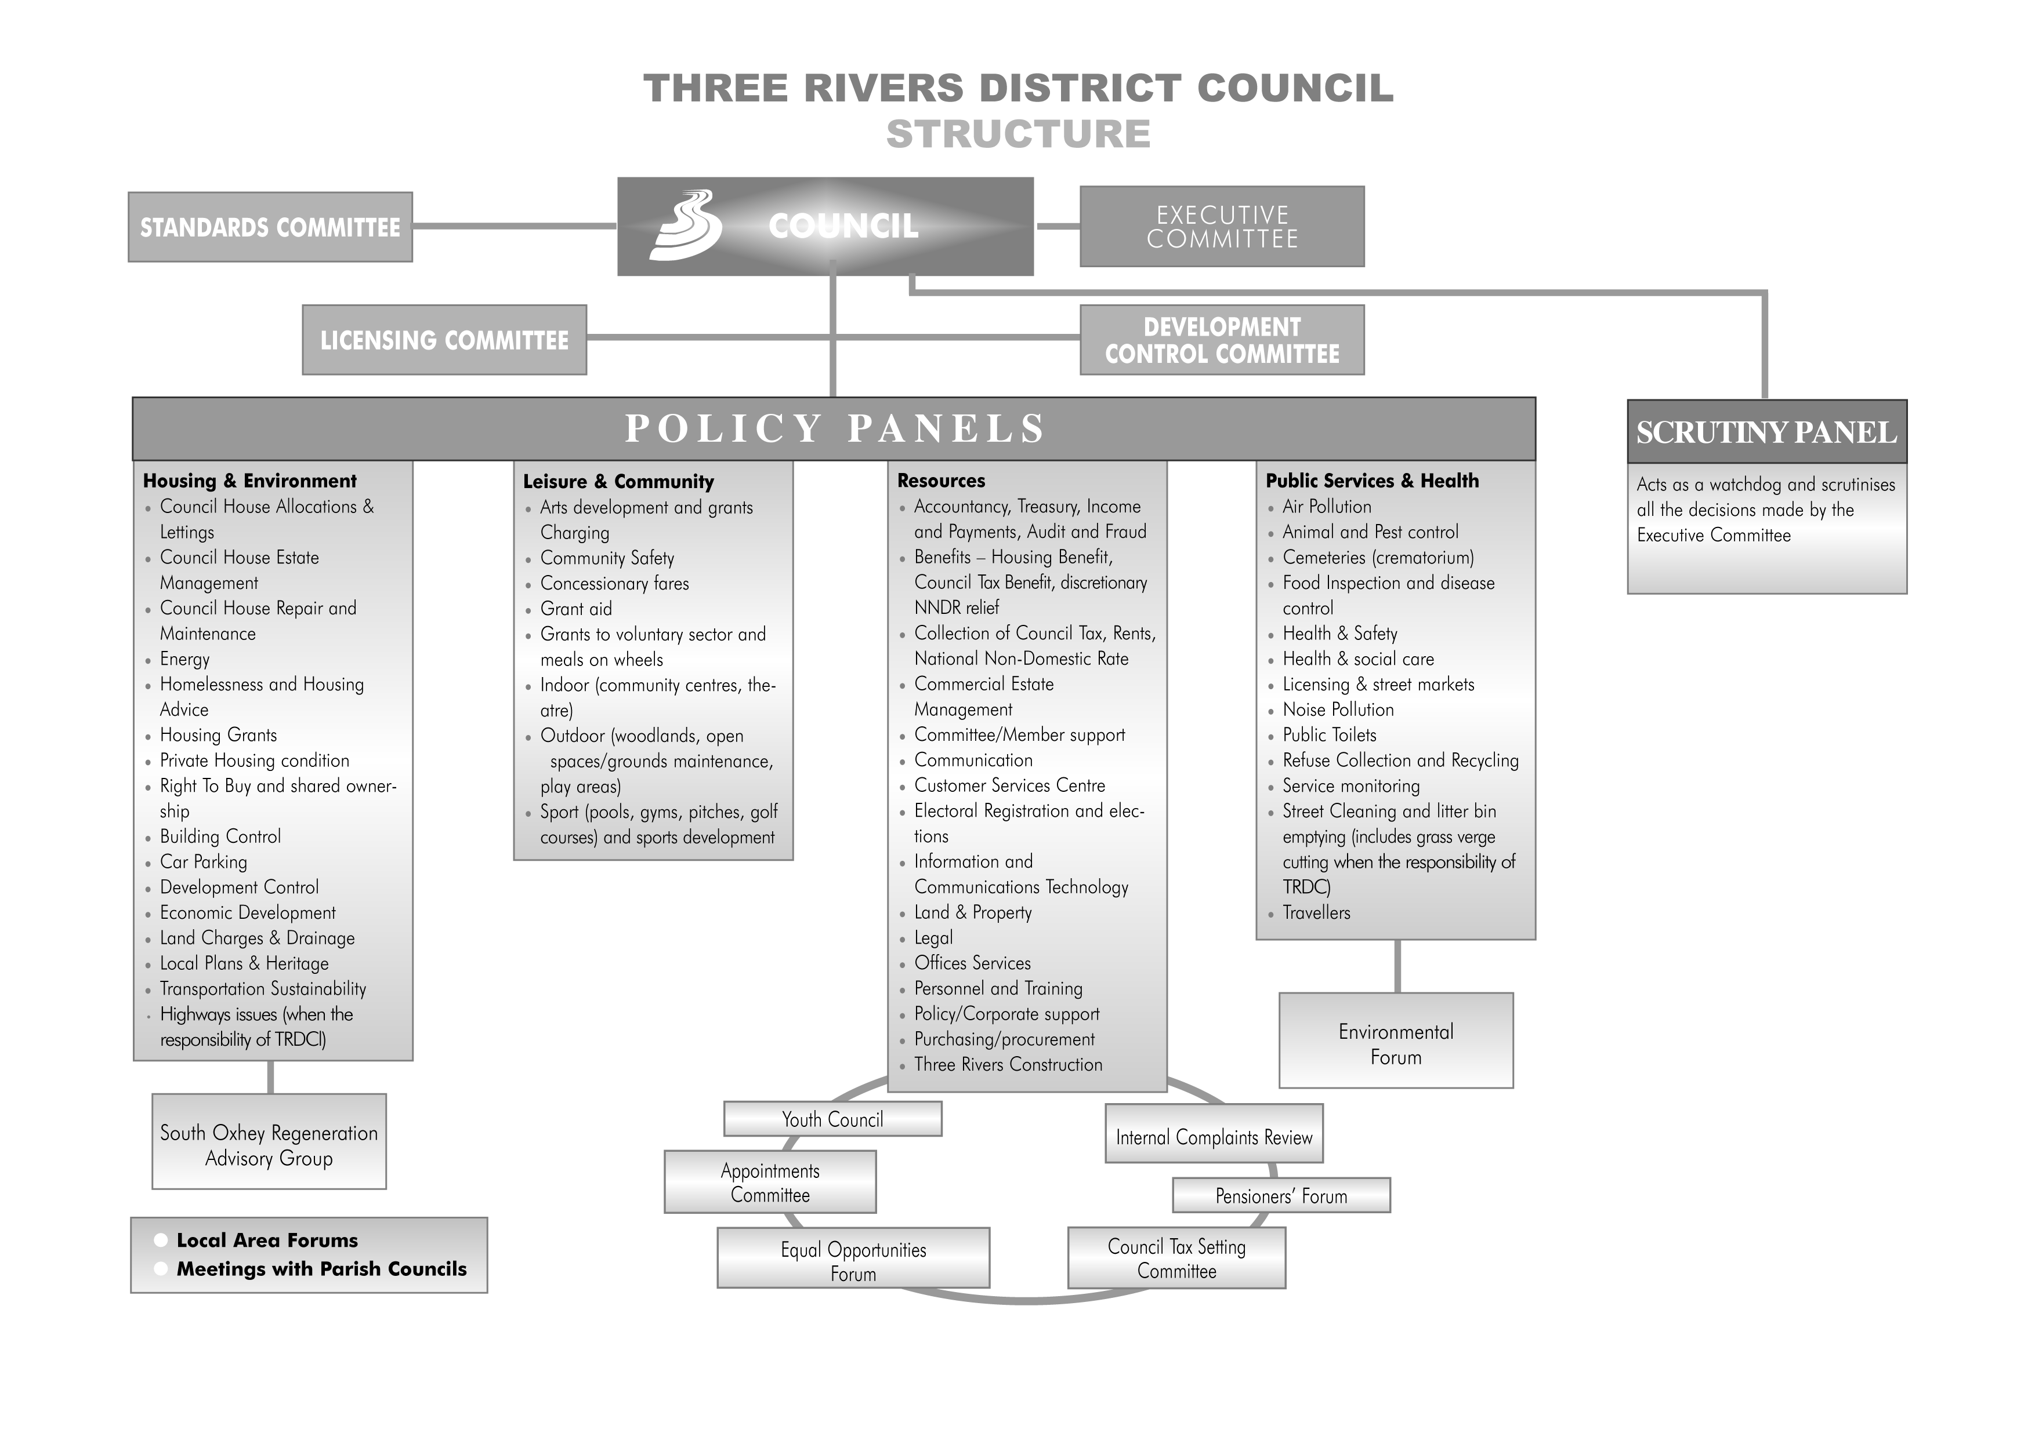

APPENDIX D: PROFILE OF FOOD BUSINESSES IN THREE RIVERS

Risk Category Inspection Interval
A At least every 6 months
B At least every year
C At least every 18 months
D At least every 2 years
E At least every 3 years
F At least every 5 years

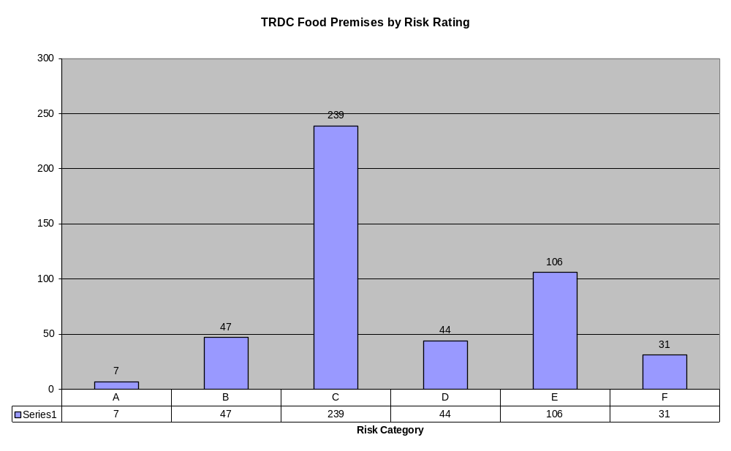

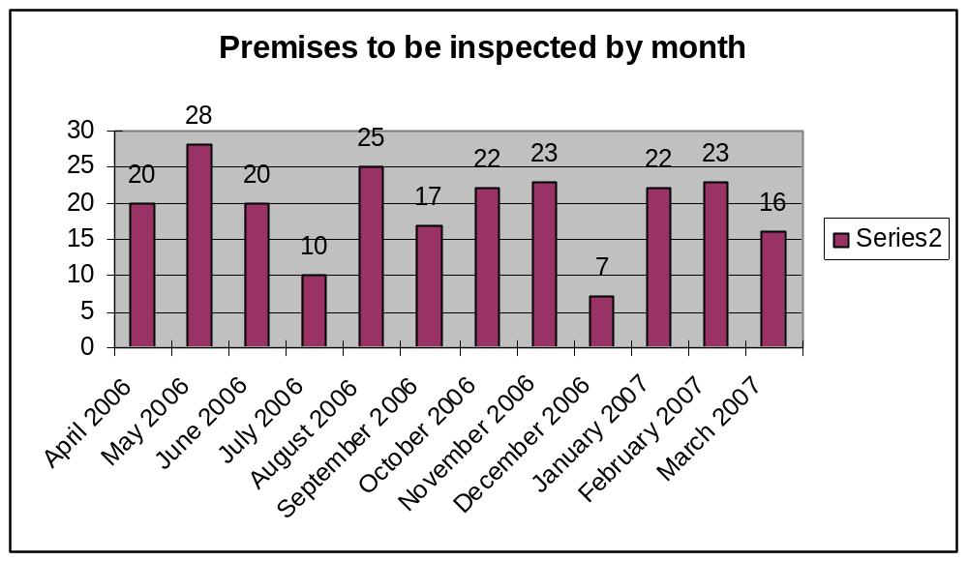

APPENDIX E:

ESTIMATED STAFFING RESOURCES PER ACTIVITY 2006/7

Food Service Delivery | Staffing Resources Required (FTE)
Food Premises Inspections | 0.7
Food Complaints | 0.05
Home Authority Principle | 0.05
Advice to Businesses | 0.15
Food Inspection and Sampling | 0.10
Food Related Infectious Disease | 0.25
Food Safety Incidents | 0.04
Liaison with other Organisations | 0.05
Food Safety promotion | 0.05
Support Officers (computer record maintenance, filing, returns etc) | 0.5

Staffing Resources in Food Service 2006/7

Designation | Staffing Resources Available (FTE)
Environmental Health Officer | 0.75
Food Safety Officer | 0.75
Contractors | Not known as FTE
Support Officers | 0.5
Commercial Standards Manager | 0.2

APPENDIX F: LEVELS OF COMPETENCY

Levels of competencies are expressed with reference to Code of Practice No 19 (Qualifications and Experience of Authorised Officers). Numbers are in terms of number of officers and not FTE's.

Competency Level | No. of officers
Inspection of HACCP based management control systems | 3
Inspection of Category A-C | 3
Inspection of substantial manufacturers | 3
Inspection of Category D-F | 4
Service of Improvement Notices | 3
Service of Emergency Prohibition Notices (EPN) or voluntary agreements | 1
Inspect, detain and seize foodstuff | 2
Taking of informal samples | 3
Taking of formal samples | 3
Support activities | 6

APPENDIX G: KEY PERFORMANCE INDICATORS

Description | Performance Indicator | 2004/05
Score against a list of enforcement best practice for Environmental Health | New Indicator BV 166  Audit Commission | 100%
The percentage of food premises inspections that should have been carried out that were carried out for high-risk premises. | National performance indicator which ceases in March 2001 and is replaced with indicator BV 166. | 100%
The percentage of food premises inspections that should have been carried out that were carried out for other premises. | National performance indicator which ceases in March 2001 and is replaced with indicator BV 166. | 100%

APPENDIX 2 – REQUIREMENTS OF THE FOOD STANDARDS AGENCY FRAMEWORK AGREEMENT ON LOCAL AUTHORITY FOOD ENFORCEMENT.

requirement | Action Date (if applicable) | To address (recommendation including Standard Paragraph) | Achieved? | Comments
1. Draw up, document and implement a Service Delivery Plan that incorporates all elements required by the Framework Agreement Service Planning Guidance. |  | 3.1 of the Standard | 
2. The annual review of performance against the Service Plan should be submitted for appropriate Member approval. | The first cycle of meetings in the new financial year | 3.2 of the Standard. | 
3. Establish a document review process to ensure all documented policies and procedures are reviewed at regular intervals and whenever there are changes to legislation or centrally issued guidance. |  | 4.1 of the Standard |  | Achieved
4. Set up and implement a documented procedure for the authorisation of Officers. |  | 3.3.5 The Authority should set up and implement a documented procedure for the authorisation of officers. [The Standard – 5.1] |  | Use of consultants and non-food staff on out of hours is included. The authorisation documents confirm the delegation of power from the authority and are specific in confirming powers of individual officers. The authorisations are consistent with duties and in accordance with qualifications and experience.
5. Ensure that it has in post an officer with specialist knowledge to have lead responsibility for food hygiene legislation |  | The Standard (5.2) |  | Commercial Standards Manager is designated lead officer for the function
6. Ensure that it has in post a sufficient number of authorised food officers to carry out it’s food hygiene enforcement responsibilities. |  | The Standard (5.3) |  | The Council is satisfied that it has access to the appropriate number of food inspectors.
7. Establish and maintain a documented Training Programme to ensure the training of all Authorised Officers and support staff in the technical and administrative aspects of the work in which they are involved. |  | The Standard (5.4) |  | A training Programme will be identified from a skills appraisal of all Authorised Officers and Support staff. Agency staff will be required to demonstrate on-going training. All training records and certificates are held on a central file.
8.Maintain records of all relevant academic or other qualifications, training and experience for each of it’s Authorised Officers. |  | The Standard (5.5) |  | In place
9. Carry out food hygiene inspections of premises within the district at a frequency which is not less than that determined under the inspection rating system set out in Food Safety Act Code of Practice 9 | On-going – inspection programme is generated from the computer | The Standard (7.1) |  | The Council is satisfied that all inspections will be undertaken in accordance with COP 9
10.Ensure that premises requiring approval by the local authority are inspected in accordance with relevant legislation, Food Safety COPs and centrally issued guidance | On-going taking into account guidance from FSA | The Standard (7.2) |  | One meat cutting plant and 9 Butchers Shops are identified for specific inspection requirements.
11. Ensure that documented procedures for inspections include Approved Premises and Butchers licensing |  | The Standard (7.5) |  | In place
12. Ensure that contemporaneous records of inspections are stored in such a way that they are retrievable. | On-going | The Standard (7.6) |  | In place
13. Review and implement its draft documented policy and procedures in relation to food complaints | On-going taking into account guidance from FSA | The Standard (8.1) |  | Addressed in the Food Enforcement Policy adopted by Council
14. Ensure that its documented procedure relating to maintaining and updating an accurate database includes details on the control of access to, and updating, of the information held |  | The Standard (11.2) |  | In place
15.Ensure that a documented sampling programme is set up and implemented. The programme should take into account the nature of its food establishments. | On-going | The Standard (12.3) |  | Sampling programme to assist national sampling requirements is underway. Local sampling requirements will be identified from the review of the sampling procedure below.
16. Ensure that a documented sampling procedure is set up and implemented for the procurement or purchase of samples to ensure the continuity of evidence and the prevention of deterioration or damage to samples while under the Councils control. |  | The Standard (12.4) |  | Achieved
17. Ensure the availability of documented evidence of appointment of the Public Analyst and Food Examiner |  | The Standard (12.6) |  | In place
18. Ensure the draft procedure for responding to food hazard warnings (received from the FSA) and food safety incidents is reviewed and implemented. |  | The Standard (14.1) |  | In place
19. Ensure that arrangements are made to deal with food hazard warnings received outside of office hours. |  | The Standard (14.2) |  | In place
20. Review and implement the draft Enforcement Policy and procedures for the food enforcement service in accordance with the relevant COPs and other guidance. The Policy or accurate summary should be readily available to the public and food businesses in the area. | On-going taking into account guidance from the FSA | The Standard (15.1) |  | The Corporate Enforcement Policy has been approved and implemented. Procedures have been detailed above.  The Policy will be available to the public and will be distributed to businesses during inspection.
21. Ensure that food law enforcement is carried out in accordance with relevant COPs. |  | The Standard (15.2) |  | Already being done.
22. Consider documenting that the Enforcement Policy has been taken into account in all prosecution files/ | On-going | The Standard (15.3) |  | New procedure to aid in the decision making process for prosecutions has direct referral to Enforcement Policy
23. maintain up-to-date accurate records, in retrievable form, for all Approved Premises in it’s area in accordance with relevant COPs. These records should include full details of all inspections, investigations and visits, the determination of compliance with legal requirements, details of any enforcement action taken and the relevant approval information. |  | The Standard (16.1) |  | Already in place
24. Ensure that it fully implements its documented internal monitoring procedure, to verify its conformance with the Standard, relevant legislation and Food Safety COPs and the authorities own documented policies and procedures. The procedure should cover all staff employed to carry out food hygiene enforcement, including consultants. | On-going | The Standard (19.1) |  | Performance monitoring and review procedure in production.  We are also participating in an Inter-Authority audit scheme implemented by the Herts and Beds CEHO Group.

Ted Massey
Chief Environmental Health Officer
Three Rivers District Council
Three Rivers House
Northway
Rickmansworth
Herts
WD3 1RL

APPENDIX 2

THREE RIVERS DISTRICT COUNCIL

HEALTH AND SAFETY LAW ENFORCEMENT SERVICE PLAN

2005/6

Drawn up in accordance with the Health and Safety Commission Section 18 Guidance - October 2003

HEALTH AND SAFETY SERVICE PLAN – TABLE OF CONTENTS.

INTRODUCTION Page 3

1. ENVIRONMENTAL HEALTH SERVICE AIMS Page 3

The Environmental Health section
Aims of Environmental health
Objectives in relation to Health & Safety Law Enforcement

2. BACKGROUND Page 5

Profile of Three Rivers District Council
Organisational Structure
Committee Structure
Scope of service
Use of Contractors
Demands on the Service
Access to the Service
External Factors impacting on the Service
Enforcement Policy

3. SERVICE DELIVERY Page 9

Inspections
Complaints
Lead Authority Principle
Advice to Business
Investigation of accidents
Liaison with Other Organisations
Health and Safety Promotion

4. RESOURCES Page 13

Financial
Staffing
Staff Development

5. QUALITY ASSESSMENT Page 15

6. REVIEW Page 15

Review of Plan
Identification of Variations
Areas of Improvement

APPENDICES

Appendix A Corporate Structure
Appendix B Health and Safety in the Organisational Structure
Appendix C Committee Structure
Appendix D Profile of Businesses / Inspection Programme
Appendix E Staffing Resources per activity
Appendix F Staffing Resources available as FTEs
Appendix G Levels of Competency
Appendix H Key Performance Indicators

Introduction

This Service Plan is dedicated to the health and safety enforcement functions carried out by the Environmental Health Section under the provisions of the Health and Safety at Work Act 1974. The Health and Safety Law Enforcement Plan is an expression of the authority’s commitment to the development of the enforcement service and is now required by the Health and Safety Commission (HSC), the body that monitors local authorities activities on health and safety enforcement. The scope of the plan covers the following specific areas: -

- Health and safety enforcement
- Accident notification and investigation
- Complaint investigation
- Accident prevention
- Health and safety promotion.

The revised section 18 Guidance from the HSC (October 2003) provides service planning guidance and promotes the importance of service planning in ensuring that national priorities and standards are addressed and delivered locally. The HSC have also produced a Strategic Plan 2001 – 2004 which addresses the key areas of workplace safety which are priorities during this period. This Service Plan takes these priorities into account.

The Three Rivers District Council Health and Safety Service Plan has been drawn up in accordance with the guidance. This is to enable the HSC to assess our delivery of the service and to allow local authorities to compare service plans written in the common format in preparation for a fundamental performance review under the local government Best Value agenda.

The Commission guidance requires that the Health and Safety Service Plan is submitted (at least annually) to the relevant member forum for approval to ensure local transparency and accountability. Council first approved this Plan in December 2001.

1. Environmental Health Service Aims and Objectives for Health & Safety Law Enforcement

  - The Aims of Environmental Health

Our aims are to:

- Appoint staff and contractors who are able to deliver high quality, efficient and cost effective service delivery
- manage the service to ensure environmental and statutory standards are maintained and the council receives good value for money
- become a leader in achieving high percentage of customer high levels of satisfaction amongst service users
- work as a team and with others to achieve our aims
- ensure that our customers can access the service easily through a range of media, including the Councils website
- ensure customers can contribute to the service and feedback views
- commit to quality action planning and target setting in line with the Council’s comprehensive equality plan once confirmed.

  - The Objectives in relation to Health & Safety Law Enforcement

- Undertake Health and Safety inspections of all local authority enforced premises. To investigate complaints. To promote health and safety. To invoke the full range of enforcement options where necessary and to have full regard to the Enforcement Concordat.
- To prepare for new imposed performance targets likely to be set by The Health and Safety Commission by; completing training required following the restructuring of the Environmental Health Section, maximising the productivity of the remaining in house staff and to trial and implement cost effective enforcement via external service providers.
- Promote health and safety through inspections and public relations, press releases, information on the Council’s web site, and by active participation in national events and local awareness raisin initiatives.
- To promptly assess and investigate where appropriate all accident or incident notifications reported via through the national reporting centre.

2. Background

2.1 Profile of the Local Authority

Three Rivers is situated in the South West of Hertfordshire. The district includes large rural areas with 12 small villages and towns. It borders Watford to the east and the London Borough of Hillingdon to the south.

The district serves a population of about 89,900 (Registrar General’s estimate for 2001). 4.7% of the population is estimated to be from black and ethnic minority backgrounds of which a large percentage live in the affluent Moor Park area of the district.

There are 34,120 dwellings in the district of which 75% are owner occupied; 13% are owned by the Council; 4% by others (including Registered Social Landlords) and 8% by Private Sector Landlords.

The unemployment figures are well below the Great Britain's average. However, there are pockets of deprivation characterised by single parent families, low-income households and a high incidence of long term health problems.

Three Rivers is an attractive place in which to live on the inner fringe of London. It benefits from having excellent road and rail links to London and elsewhere, including the M25, M1, the West Coast Main line and the Metropolitan Line into Central London. Heathrow and Luton Airports are nearby.

2.2 Organisational Structure

The Structure Charts at Appendices A, B and C show how the health and safety service fits into the Council's services and Committees. The health and safety service is within the Environmental Health Section and is currently provided within a team undertaking the food enforcement function, infectious disease control, pollution control, contaminated land, licensing and a limited amount of health education work. Other officers are authorised under the Health and Safety at Work etc. Act 1974 for enforcement of health and safety legislation within their field of expertise (e.g. Pest Control, Animal Control, and private sector housing).

Overall co-ordination of the Section's health and safety enforcement is the responsibility of the Chief Environmental Health Officer. The Commercial Standards Manager is the Lead Officer with specialist responsibility for health and safety.

2.3 Committee Structure

The Council has adopted the Leader and Cabinet structure, supported by a number of Policy Panels. There is a Scrutiny Committee.

The majority party forming the Cabinet has decided that there ought to be cross party political representation on the decision-making Committee and we therefore have an Executive Committee comprising 7 Cabinet Members and 3 Members from the minority parties. One party has opted not to be represented on Executive Committee.

The Executive Committee makes all decisions on behalf of the Council except those delegated to Council. There is a Leader and Deputy Leader and 6 Portfolio holders from the majority party (the Deputy Leader holding a portfolio). Currently the Portfolios are Housing; Public Services and Health; Leisure and Community Development; Resources; Physical Environment and Community Safety. There is a corresponding Policy Panel for each of the Portfolios. The food service comes under the remit of the Public Services and Health Policy Panel and the Portfolio holder for Public Services and Health.

2.4 Scope of the Health and Safety Service

The health and safety service covers the following specific areas: -
- Health and safety enforcement
- Investigation of notified accidents
- Investigation of health and safety complaints
- Health and Safety promotion.

The Commercial Standards Manager, supported by one authorised officer on a part time basis currently provides the health and safety service. A longstanding vacant post, which it has not been possible to fill, has been deleted and the funds released used to finance the appointment of external contractors. The contract for this work is currently out to tender.

The Council has a regulatory responsibility under the Health and Safety at Work etc Act 1974 in all health and safety premises as defined under the Health and Safety (Enforcing Authority) Regulations 1989. The Enforcement function is shared with the Health and Safety Executive. Routine compliance inspections for health and safety in food premises are not normally undertaken at the same time as the food safety inspection, as this would result in “over-regulation”.

We ensure that the external contractors meet the requirements of The Health and Safety at Work Act 1974, in terms of their competency to inspect.

2.5 Demands on the Health and Safety Service

As of the 1st April 2006, there are 1,071 health and safety premises registered with the Authority: A comparison with last year’s profile is given below

2005/6 |  | 2006/7
Category A | 29 | Category A | 15
Category B1 | 42 | Category B1 | 29
Category B2 | 56 | Category B2 | 39
Category B3 | 169 | Category B3 | 141
Category B4 | 257 | Category B4 | 245
Category C | 601 | Category C | 602
Total | 1154 | Total | 1071

The category to which a premises is rated is dependent upon a risk assessment. This assessment is made from a “point scoring exercise” taking into account:

- Safety Hazard

The potential of machinery, work activity or work method to cause harm

- Health Hazard

The potential for substance, noise or work method to cause harm

- Safety Risk

The likelihood that the potential for harm is realised

- Health Risk

The likelihood that the potential for health effects is realised

- Welfare

The standards of welfare provision within the organisation

- Public Hazard

The likelihood that the general public will be harmed by the work activity

- Confidence in Management

Confidence in the ability of Management to maintain a low level risk

Scores (points) are defined within each area by statutory guidance. The greater the risk and non-compliance, allied with little or no confidence in management, gives a higher score and category resulting in far more frequent inspections.

Conversely the lower the risk and the greater the compliance / confidence in management the lower the score and category resulting in less frequent inspections.

The majority of the premises are small offices and retail shops. There are a number of small / medium size industrial estates within the district but the enforcing authority for the majority of premises on these lies with the Health and Safety Executive.

2.6 Access to the Health and Safety Service

The health and safety service is located at Three Rivers House, Northway, Rickmansworth, Herts, WD3 1RL. Customers of our service can contact the Section by the following means: -

- In person, at the One Stop Shop reception, Monday - Thursday 8.00am - 5.30pm and Friday 8.00 am - 5.00pm.
- By telephone to the Commercial Team during the times stated above.
- By e-mail (officer’s name).@threerivers.gov.uk
- For emergencies, i.e. a major accident, the Out of Hours Emergency Number.

2.7 External Factors impacting on the Service

This Council has, in recent years, found the recruitment and retention of staff (particularly in the Commercial Standards Team) extremely difficult. The current staffing situation allows us to actively address service delivery in-house.

Recently the planned inspection programme has concentrated on the backlog of missed inspections, with the emphasis placed upon the higher risk premises. From 2001 health and safety compliance inspections had been given lower priority than those for food premises. Due to staffing problems and increasing workload demands on the food safety side there has been insufficient resource to meet the inspection programme for both.

Despite this there has always been an emergency response to notifications of injury, accidents and workplace complaints.

2.8 Enforcement Policy

The Council’s Corporate Enforcement Policy received Member approval in December 2000 at the Executive Committee. The Corporate Policy fully reflects the Local / Central Government Concordat on Good Enforcement Policy.

The Health and Safety Enforcement Policy has been revised to reflect the Enforcement Concordat and changes in national guidance and was first approved by Full Council on 11th February 2002.

3. Service Delivery

The new mandatory section 18 guidance requires the Council to estimate the staff resource required to undertake activities in each of the identified areas. There is also a requirement to identify the level of “competency” available within the authorised officers. For ease of reading these have been collated at Appendices E and F.

3.1 Health and Safety Premises Inspections

It is the Council's policy to ensure that:

- all health and safety premises receive an inspection at the frequency determined by the approved Guidance
- inspections are carried out in accordance with the Health and Safety at Work etc. Act 1974 and Regulations, and Guidance made / issued in association with the Act.
- no prior warning is given to the health and safety business in relation to programmed inspections in order that compliance can be judged during normal working conditions. Prior warning would allow the company to present itself in a more favourable light to the inspecting officer than may normally be the situation for employees.

In addition the Council’s procedures in relation to the inspection of health and safety premises require that the inspecting officer:

- Announces him / herself to the person in control of the business
- Advises of the reason for the visit (full inspection / revisit / health and safety complaint etc)
- Invites the person in control to accompany the officer during inspection
- Discusses contraventions in detail
- Advises of the next action to be taken (none / informal letter / Notice etc)
- Obtains the signature of the person in control on the inspection record
- Advises of the right to make representations to the inspecting Officer’s Line Manager in respect of any issues relating to the inspection.

The calculated number of inspections due for 2005/6 is:

Risk Rating
Category A 2
Category B1 11
Category B2 1
Category B3 17
Category B4 16
Category C a randomly chosen 20% of 57 premises.

The management control system for any company requires a fully documented Health and Safety Policy outlining the company’s general approach to health and safety compliance. This Policy should be supported by detailed procedures of all staff instructions relating to the control of identified hazards within the business following a detailed risk assessment. The risk assessment should identify the hazards involved in the business activities; the risk of those hazards and the documented procedures for addressing the risks. In legal terms the responsibility is firmly on the owner of the business but in reality, they need advice and assistance from inspectors. This extends the inspection and monitoring time and this is currently being monitored to determine the effect on resource requirements.

We have takes steps to ensure that all those premises for which we have an enforcement duty are identified and included on our register and database. The database has been thoroughly audited and compared with other sources of information.

For the lowest risk premises we have introduced with reasonable success a self-assessment questionnaire. This is used instead of carrying out a full inspection. Non returns are visited and a random 20% proportion of those that are completed are checked with a compliance visit.

The Council is also committed to assisting the Health and Safety Commission by the implementation of any specific schemes identified as being priority in reducing accidents or improving health and safety. These have been identified in the Commission’s Strategic Plan and will be incorporated in the annual service plan for health and safety.

  - Health and Safety Complaints

Health and safety complaints received are listed in the following broad categories: -

- Complaints from employees concerning working conditions / practices
- Complaints from the general public concerning unsafe conditions / practices

All complaints are thoroughly investigated, including obtaining information from the Lead Authority (see later section on the Lead Authority Principle). All cases are assessed on evidence and whether the offence is so serious as to put health at risk. Follow–up action varies from an informal warning to prosecution.

In relation to complaints concerning health and safety businesses, priority is focused upon those posing a high-risk to safety (of employees or persons visiting the premises) or to public health. Where the assessment shows a serious risk then an immediate visit is made. Where a programmed inspection is due within the next 4 weeks and the assessment is that there is no imminent risk then the complaint will be investigated at this time.

In all cases the complainant is advised of our proposed course of action and is updated on the progress of the investigation, particularly where information is required from third parties.

In respect of complaints made against the Council itself, or a member of the enforcement staff, the Council’s corporate complaint procedure will be immediately implemented. A named officer (usually the line manager) will be the point of contact and will be responsible for leading the investigation of the complaint and advising the complainant of progress and outcomes. If the complainant is still not satisfied they may complain to the Council’s Quality Officer or to the Ombudsman.

  - Lead Authority Principle

The Section complies with the Lead Authority Principle of liaising with the Lead Authorities on issues that have national implications to ensure consistency of approach and implementation of good practice. The Lead Authority take responsibility for ensuring that safe systems of work, documentation, guidance and instructions are provided from the business’s central headquarters to all other manufacturing / retailing outlets of the company.

The district has few multiple manufacturers or retailers within the area. However, we do take advice / guidance from the Lead Authority for multiple retailers when considering appropriate enforcement action.

The Section will always heed advice and information from the Lead Authority in determining what action, if any, to take in respect of identified contraventions in local premises of a multiple retailer.

3.4 Advice to Businesses

In line with the principles of the Enforcement Concordat, the Section is committed to working with businesses to help them comply with the law and to encourage the use of good practice. This is achieved through a range of mechanisms: -

- Advice given during the course of inspections and other visits.
- Provision of advisory leaflets, including those in other languages.
- Response to business requests for advice and assistance.

In 2001/2, 57 requests were received for advice to businesses (excluding advice given during the course of inspections). In 2002/3 the Commercial Team has dealt with 62 such requests. In 2003/4 77 requests were made so there is no reason to believe that this number will diminish for 2004/5.

3.5. Investigation of Accidents

The Council will allocate sufficient time and resources to review appropriate action in respect of all notifications of accidents, dangerous occurrences and cases of ill health associated with employment. As a rule we are unlikely to investigate all complaints and notifications made to us because of the resource implications and that the notification itself may be so straightforward that further investigation will produce no benefits. Those of a more serious nature which may indicate lack of training / guidance or procedures or a clear disregard for safety issues will be investigated immediately in accordance with the Commission’s objectives and priorities.

We will always follow the advice from the Commission, through training and associated guidance material, when determining appropriate action in respect of complaints and notifications.

  - Liaison with Other Organisations

The Section is committed to the principle of consistency as set out in the Enforcement Concordat. This is to ensure that all enforcement action be it verbal warnings, statutory notices or prosecution is consistent with national guidance and other local authorities practices. In pursuant of this commitment, the Section currently attends the following forums: -

- Herts & Beds Chief Officers Occupational Health Study Group
- Herts & Beds Inter Authority Auditing Working Party
- Health and Safety Executive local authority liaison meetings

There are close links within the Council with both Planning and Building Control to identify issues (proposed new businesses, alterations/extensions etc) relating to health and safety premises. Early intervention advice is given at this stage to ensure that health and safety compliance can be met at this stage thus avoiding enforcement action later.

  - Health and Safety Promotion

Promotional work will be undertaken in 2004/5 by officers within the Section and in partnership with other agencies and bodies. In particular those projects under consideration include: -

- Participation in European Health and Safety week
- Joint enforcement initiatives with the Health & Safety Executive and Watford Council on business parks that straddle our district boundaries.

Additional promotional work to be undertaken will include regular press releases on enforcement action and national campaigns

4. Resources

4.1 Financial Allocation

The overall level of expenditure involved in providing the health and safety service is listed below. This is split into staffing and non-fixed costs. It should be noted that the figures cover the cost of many additional activities. These include the management of the licensing section, industrial/commercial pollution control, air quality management, the inspection of contaminated land, the food safety enforcement function and the Infectious Disease investigation service, as well as health and safety enforcement in the private sector. An analysis of costs between each area has not been carried out.
Cost (£) | 2006/2007
Staffing | 126414
Transport (Travel & Subsistence) | 6712
Supplies and Services | 1849
Direct Income | 4640
Total | 139615

4.2 Staffing Allocation

Qualified Officers undertake the health and safety enforcement work within the remit of the Council (using advice and guidance from the Health and Safety Commission and Section 18 guidance). Dedicated administrative support staff undertake maintenance of the computer system and computerised records.

The staffing resources per activity are listed at Appendix E and include all service delivery areas in this Section. This Appendix also includes the staffing resources available per designation of staff.

The estimated number of staff having a direct role in health and safety enforcement and support staff is included in Appendix E and relates to levels of competency to be able to undertake the work.

4.3 Staff Development Plan

The Section will ensure that authorised officers undertaking health and safety work are appropriately qualified and receive regular on-going structured training to enable them to effectively carry out health and safety, hygiene inspections and enforcement. There are regular officer meetings to discuss enforcement issues to try and achieve consistency and uniformity. The Council is committed to participate in inter-authority auditing where our peers in neighbouring authorities audit our health and safety enforcement service.

The updating/ongoing training of authorised officers on health and safety will be in accordance with specified requirements from the Health and Safety Executive and the Chartered Institute of Environmental Health. This training will take the form of in-house training, formal courses or vocational visits. In particular, the training will be provided by in-house sessions, courses arranged by the Herts & Beds Chief Officers’ Health and Safety Study Group in conjunction with the local branch of the Chartered Institute of Environmental Health and low cost training by the Health and Safety Commission. Training needs are identified at both Team Meetings and during the Staff Development Review (performance appraisal) process. These result in the formulation of an on-going Personal Development Plan.

Training identified as a priority during the year 2006/2007 is: -

- Health and safety inspection and contractor management
- Health and Safety policies and procedures.
- Preparing for prosecution and witness training
- Generic risk assessment

5. Quality Assessment

    - Quality Assessment

The Section has established the following monitoring arrangements to assess the quality of the service provided: -

- Review of samples of case paperwork by the Chief EHO.
- Auditing/Shadowing of health and safety inspections.
- Uniformity / consistency discussions at Team Meetings.
- Consistency discussions on new advice / guidance and the impact on the inspection protocol at the time of receipt.
- Staff Development Reviews on performance monitoring and appraisal.
- Inter-Authority auditing.

6. Review

  - Review against the Service Plan

The review against the service plan will be undertaken on an annual basis. This will be in conjunction with the publication for approval of the following year's draft plan and be subject to Member approval.

Performance indicators affecting the service are listed at Appendix F.

  - Identification of any Variation from the Service Plan

Key Performance Indicators are reviewed on a quarterly basis and the Performance Indicators reported to the Public Services and Health Review Panel. Results are reported in writing and any explanations given for variance against the target. Refer to Appendix F.

Where it can be shown that any additional activities other than direct enforcement action have taken place (i.e. mail shots to businesses with advice on new legislative requirements) which achieve the same outcome as individual visits, these will be identified in the review against the service plan.

  - Areas of Improvement

Any service issues identified during the Quality Review process, performance monitoring or review of the service plan will be recorded in writing and an appropriate action plan formulated to address the issues.

This year the commercial premises database will continue to be audited for accuracy against the National Non Domestic Rate Register.

APPENDIX A: CORPORATE STRUCTURE

Council Directorates and their Sections

 |  |  | Chief Executive
Housing and Health |  | Planning and Environment |  |  | Corporate Resources |  |  | Strategic Services
Housing Services |  | Development Control |  |  | Accountancy Practice |  |  | Democratic Services
Environmental Services |  | Building Control |  |  | Legal Practice |  |  | Support Services
Environmental Health |  | Local Plans and Transportation |  |  | Properties and Facilities Management |  |  | Corporate Development
Policy Team |  | Leisure |  |  | Taxation, Rent and Benefits |  |  | Customer Services Centre
 |  |  |  |  | Treasury Services |  |  | ICT

APPENDIX B:
Health and Safety Service in the Organisational Structure

Chief Executive

Director of Housing and Health

Chief Environmental Health Officer

Residential Standards
Commercial Standards Manager
Technical Support

Licensing Officer
2.7 x Environment Officers
(1 post deleted for external contracts)

Corporate health and safety
Licensing Assistant

APPENDIX C - COMMITTEE STRUCTURE

APPENDIX D:

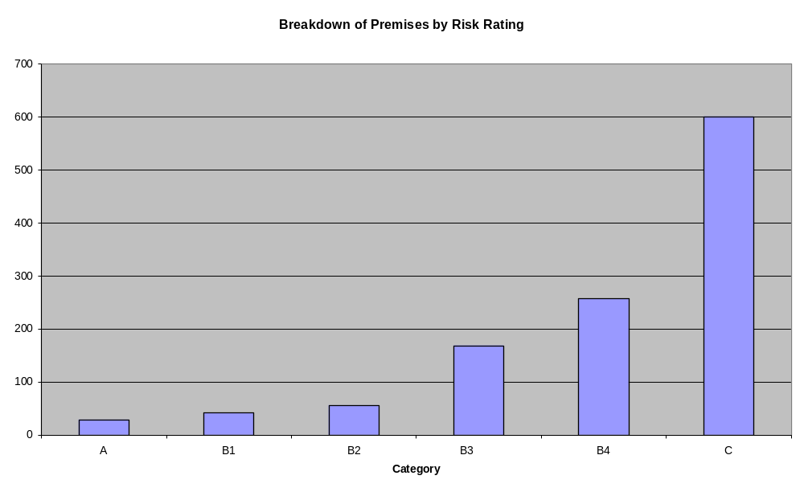PROFILE OF HEALTH AND SAFETY BUSINESSES IN THREE RIVERS

Category Inspection Interval
A At least every year
B1 At least every 2 years
B2 At least every 3 years
B3 At least every 4years
B4 At least every 5 years
C At least every 6 years

APPENDIX E: ESTIMATED STAFFING RESOURCES PER ACTIVITY 2004/5

Health and safety Service Delivery | Staffing Resources Required (FTE)
Health and Safety Premises Inspections | 0.5
Health and Safety Complaints | 0.20
Home Authority Principle | 0.00
Advice to Businesses | 0.05
Health and Safety Sampling | 0.00
Health and Safety Incidents | 0.09
Liaison with other Organisations | 0.05
Health and Safety promotion | 0.25
Support Officers (computer record maintenance, filing, returns etc) | 0.3
Chief Environmental Health Officer | 0.06

APPENDIX F

Staffing Resources in Health and Safety Service 2004/5

Designation | Staffing Resources Available (FTE)
Manager  Enforcement Officers | 0.2  0.9
Support Officers | 0.3
Chief Environmental Health Officer | 0.1

APPENDIX G: LEVELS OF COMPETENCY

Levels of competencies are expressed with reference to Code of Practice No 19 (Qualifications and Experience of Authorised Officers). Numbers are in terms of number of officers and not FTE's.

Competency Level | No. of officers
Inspection of management control systems | 4
Inspection of Category A-B4 | 4
Inspection of Category C | 4
Service of Improvement Notices | 4
Service of Prohibition Notices (EPN) or voluntary agreements | 4
Inspect, detain and seize health and safety articles and equipment | 4
Taking of informal samples | 4
Taking of formal samples | 4
Support activities | 3

APPENDIX H - KEY PERFORMANCE INDICATORS

Description | Performance Indicator | 2000 / 2001 | 2001 / 2002 | 2002 / 2003 | 2003 / 2004 | 2004/ 2005 | 2005/ 2006
Score against a list of enforcement best practice for Environmental Health | New Indicator BV 166  Audit Commission | N/A | 95% | 95% | 95% | 100% | 100%
The percentage of health and safety premises inspections that should have been carried out that were carried out for high-risk premises. | Local PI | 6.25% | 16.7% | 54% | 100% | 100% | 100%
The percentage of health and safety premises inspections that should have been carried out that were carried out for other premises. | Local PI | 6.25% | 16.7% | 98.9% | 25% | 96.6% | 95.67%

