POLICY AND RESOURCES COMMITTEE

7 NOVEMBER 2017

PART I – NOT DELEGATED

6. SHEPHERD SCHOOL PUBLIC SPACES PROTECTION ORDER (CED)

1. Summary

1.1 To receive the consultation findings from the Shepherd School Public Spaces Protection Order (PSPO) and to recommend to full Council the implementation of a PSPO in the area for a period of two years.

2. Details

2.1 At its meeting on 17 July 2017 the Committee agreed to go out to formal consultation on the making of a PSPO relating to anti-social parking and road safety for Shepherd Primary School in Mill End.

2.2 The consultation was undertaken between 18 July and 11 August 2017 using online, and paper version of the survey. The on-line survey was marketed through the Shepherd Primary School parent email and on the Council’s website. The paper version was delivered to local residents and to new parents (for the September 2017 intake) for whom the school did not have email details.

2.3 130 survey responses were received. The summary report of the consultation feedback is in Appendix 1.

2.4 The vast majority of responses agreed to the proposals for the PSPO:

- 88% agreed to the ban in principle (69% strongly agreeing)
- 89% agreed to the weekday morning times for the ban (74% strongly agreeing)
- 89% agreed to the weekday afternoon times for the ban (74% strongly agreeing)
- 87% agreed to the exemption for residents in the marked zone (75% strongly agreeing)
- 93% agreed to the exemption for those requiring disabled access to the school (76% strongly agreeing)
2.5 The proposed PSPO for Shepherd Primary School would:

- Ban dropping off or picking up a school pupil from Shepherd Primary School; in any area within the marked zone

- Operate Monday to Friday, during term time only, between 0800 and 0900 and between 1430 and 1545.

- Make residential parking exempt in the proposed zone

- Not apply to those requiring disabled access to the school.

2.6 To be enforced, designated Council Officers would need to witness a driver stopping in the zone during the active time, to drop-off or pick up a child from the school. In such circumstances a Fixed Penalty Notice (FPN) could be issued. Officers would identify the registered keeper of the vehicle using a single manual request to the Driver and Vehicle Licensing Agency, and issue the FPN by post to the registered keeper. It would potentially be possible to issue a FPN with photographic evidence and a witness statement signed by a third party. Photographic evidence is not essential if the witness gives a clear witness statement including a registration number or identifying the driver by recognition. There is the possibility of issuing body cams to designated officers.

2.7 The proposed zone for the PSPO is shown in the map below:
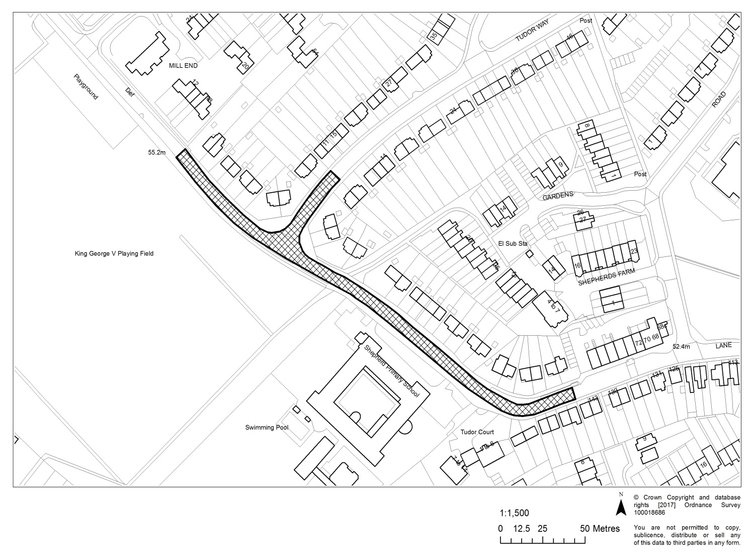

2.8 The Headteacher of Shepherd Primary School and several consultation respondents have raised the need for a direct path to be constructed from William Penn car park across King George V Playing Fields. This would allow for parents to park in the William Penn Car Park and walk their children to the school gate without the need for further road crossing.

2.9 Whilst there is a Park and Stride area in operation at the Mill End Social Club for Shepherd School, this is not easy to access for parents approaching from the eastern side of the school. Providing a pathway across King George V Playing Fields may reduce the impact of any PSPO zone on surrounding road areas.

2.10 Officers have costed the construction of a pathway across King George V Playing Fields. This is estimated to cost £10,000. Officers are seeking feedback from Hertfordshire County Council’s Safer Routes to School team to see if they will commit to contributing to the construction cost of such a path. The proposed route for the path is shown in the diagram in Appendix 2 – in blue.

3. Options/Reasons for Recommendation

3.1 To pilot the use of a PSPO for a period of a year to address the detrimental impact on the quality of life of those in the locality caused by the driving behaviour exhibited whilst parents drop off and pick up children from Shepherd Primary School. Following the pilot the PSPO could continue or be revoked within the two-year period without the need for immediate extension.

3.2 To build a footpath across the King George V Playing Field near to Shepherd Lane to allow parents to park in the William Penn car park and walk their children to the school without causing a nuisance to those in the locality.

3.3 Alternatively, the Council could take no action and rely on the current enforcement of limited parking restrictions in the area.

4. Policy/Budget Reference and Implications

4.1 The recommendations in this report are not within the Council’s agreed policy. The purpose of this proposed policy is to pilot the use of a Public Space Protection Order to address anti-social behaviour related to parents who drive to school at drop-off and pick up times. At the end of the pilot it is anticipated that the policy will have changed the driving behaviour of people dropping off and picking up children from the school.

4.2 The recommendations in this report relate to the achievement of the following objectives of the strategic plan:

    - Maintain high quality local neighbourhoods and streets;

2.3.1 Reduce anti-social behaviour and crime.

4.3 The impact of the recommendations on these objectives would be to increase public satisfaction with the way the Council has addressed the issues surrounding Shepherd School. A Local Authority can make a PSPO for up to three years and, if this pilot is judged a success, this Authority can extend the PSPO on certain grounds for up to a further three years. If however the PSPO is not successful in addressing the concerns of the public it can be discharged.

4.4 A budget has been agreed for the pilot. Should the pilot prove effective then the resource implications for maintaining the PSPO and potentially rolling it out to other areas will be identified.

5. Environmental and Public Health Implications

5.1 None specific.

6. Financial Implications

6.1 All offences under a PSPO can be dealt with by issuing a FPN of up to £100. The current FPN for this Council’s existing PSPO is £75. It is suggested the same level is set for breaching the proposed PSPO for Shepherd School. The maximum fine on summary conviction is level 3 on the standard scale (currently £1,000). FPN payments are retained by the Council; fines ordered at a magistrates’ court are not remitted to the Council but costs can be claimed.

6.2 Implementation costs will include the consultation, signage, road marking, monitoring equipment, software and officer time for processing and monitoring FPNs. Officer time will be from existing budgets. The additional costs will come from the budget allocated to the pilot which totals £30,000.

7. Legal Implications

7.1 The Legal team has been consulted on the proposed prohibitions of the PSPO. It is essential that all the procedural requirements for making the order are followed including publication and consultation to ensure that it cannot be subsequently challenged.

7.3 Human rights aspects of the PSPO have been considered. It was assessed that the negative impact of the proposed PSPO on the Convention rights of those currently stopping in the zone would be proportionate to the interests of public safety and the prevention of disorder or crime, for those whose safety would be improved whilst walking around the approaches to the school. Specific exceptions have been made for those people with disabilities.

7.4 Incidents leading to unpaid FPNs would be referred to the Legal team. The same evidential tests apply to FPNs as prosecution. An FPN is offered as an alternative to prosecution: if it is not paid, prosecution is the next stage.

8. Equal Opportunities Implications

8.1 Relevance Test

Has a relevance test been completed for Equality Impact? | Yes
Did the relevance test conclude a full impact assessment was required? | No

8.2 There is the potential for the PSPO to indirectly discriminate against disabled drivers, dropping off their children, or parents of disabled children dropping them off at school. However, the proposed order would exempt such situations from the ban. No adverse impact on grounds of disability is therefore anticipated.

9. Staffing Implications

9.1 The pilot will be implemented by Officers designated to implement the PSPO. These are officers in the Community Partnerships Unit and Environmental Protection Enforcement Team. Enforcement will be undertaken within existing resources for the period of the pilot.

10. Community Safety Implications

10.1 The piloting of a PSPO will assess its impact on road safety outside the school and its potential to reduce anti-social behaviour associated with parking.

11. Customer Services Centre Implications

11.1 The FPN Payment system is already set up on Firmstep. Should the PSPO go ahead payments for FPNs could be received online and through the call centre.

12. Communications and Website Implications

12.1 The PSPO will need to be published on the Council’s website.

13. Risk Management and Health & Safety Implications

13.1 The following table gives the risks that would exist if the recommendation is rejected, together with a scored assessment of their impact and likelihood:

Description of Risk |  | Impact | Likelihood
1 | Existing measures of parking control will be maintained and existing behaviour and risk to public safety will continue | III | C

13.2 Of the risks detailed above none is already managed within a service plan.

Likelihood | A |  |  |  |  |  | Impact | Likelihood
Likelihood | B |  |  |  |  |  | V = Catastrophic | A = >98%
Likelihood | C |  |  | 1 |  |  | IV = Critical | B = 75% - 97%
Likelihood | D |  |  |  |  |  | III = Significant | C = 50% - 74%
Likelihood | E |  |  |  |  |  | II = Marginal | D = 25% - 49%
Likelihood | F |  |  |  |  |  | I = Negligible | E = 3% - 24%
Likelihood |  | I | II | III | IV | V |  | F = <2%
Likelihood | Impact

13.3 In the officers’ opinion none of the new risks above, were they to come about, would seriously prejudice the achievement of the Strategic Plan and are therefore operational risks. The effectiveness of treatment plans are reviewed by the Audit Committee annually.

14. Recommendation

14.1 That the Committee recommends to full Council that a Public Spaces Protection Order is made for Shepherd Primary School on the grounds outlined in 2.5-2.7 for a period of 2 years starting January 2018.

14.2 The final wording of the Public Spaces Protection Order to be delegated to the Chief Executive in consultation with the Chairman of the Policy and Resources Committee.

14.3 That the Committee recommends to full Council that the following officers are
designated to implement the Public Spaces Protection Order:

Community Safety Intervention Officer
Community Safety Co-ordinator
Performance and Projects Manager
Head of Community Partnerships
Environmental Protection Enforcement Officers

14.4 That the Committee instructs officers to commission the building of the pathway across King George V Playing fields and continue to seek a contribution towards the costs of this from Hertfordshire County Council.

Report prepared by: Andy Stovold, Head of Community Partnerships

Data Quality

Data sources:
Shepherd School PSPOS Consultation Responses

Data checked by: Alison Mirpuri, Consultation Officer

Data rating:

1 | Poor
2 | Sufficient | ✓
3 | High

APPENDICES / ATTACHMENTS

Appendix 1 - Three Rivers District Council Shepherd Primary School PSPO Consultation – Summary Report

Appendix 2 - Proposed Pathway Across King George V Playing Fields

Appendix 1 - Consultation
Three Rivers District Council
Three Rivers District Council Shepherd Primary School PSPO Consultation

SUMMARY REPORT

September 2017

Background

Following complaints and recordings of issues* (detailed below) relating to dropping off and collecting pupils from Shepherd Primary School in Rickmansworth, Three Rivers District Council has been observing and gathering further information on behaviour around Shepherd Primary School at school start and finishing times and investigating the impact this may or may not have on the local community.
*The issues concerned are as follows:
- Hazardous parking causing obstruction and preventing school pupils crossing the road safely
- Vehicles blocking the school crossing point on Shepherds Lane
- Vehicles parked in the bus stop on Shepherds Lane
- Vehicles blocking residents driveways and dropped kerbs
- Vehicles parked on the mini roundabout at Shepherds Lane and Tudor Way causing danger
- Obstruction of the highway causing congestion
As a result of this investigation, the Council launched a formal consideration of a Public Spaces Protection Order (PSPO) relating to parking around Shepherd Primary School. To support this consideration, a public consultation was conducted in order to capture the views of local residents and visitors to the area.

Objectives

The objectives of the research are to:

- Determine the level of public agreement for the introduction of a PSPO relating to the following proposals:

  - A ban on stopping in any area within the marked zone for the purposes of dropping off or picking up from Shepherd Primary School
  - The ban to operate from Monday to Friday between 0800 to 0900, during term time only
  - The ban to operate from Monday to Friday between 1430 to 1545, during term time only
  - The ban would make residential parking exempt in the proposed zone
  - The ban would not apply to those requiring disabled access to the school

- Determine the level of public agreement and gather feedback regarding the proposed marked zone, which incorporates parts of Shepherds Lane, Tudor Way and Church Lane.

Methodology

A ‘Survey Monkey’ on-line survey was launched on Tuesday 18th July 2017 and closed at 5pm on Friday 11th August 2017.

The on-line survey was marketed via Shepherd Primary School parent email and on the Three Rivers District Council website. A paper version of the survey was also delivered (with freepost envelope) to local residents and to new parents to Shepherd Primary School.

In total, 130 survey entries were completed, of which 31 were paper survey returns.

Respondent Profile

- Residents - From those surveyed, the following percentages were residents on the roads affected by the proposed marked zone:

  - Shepherds Lane: 8%
  - Tudor Way: 19%
  - Church Lane: 12%

- Parent/carer of child at Shepherd Primary School – Just over a third (36%) of respondents were parents/carers of a child at Shepherd Primary School.

- One response was on behalf of an organisation: Hertfordshire Constabulary

Results

The Public Spaces Protection Order proposals
The vast majority of respondents agreed to the proposals for the PSPO.
- 88% agreed to the ban in principle (69% strongly agreeing)
- 89% agreed to the weekday morning times for the ban (74% strongly agreeing)
- 89% agreed to the weekday afternoon times for the ban (74% strongly agreeing)
- 87% agreed to the exemption for residents in the marked zone (75% strongly agreeing)
- 93% agreed to the exemption for those requiring disabled access to the school (76% strongly agreeing)

Q1: It is proposed that the Public Spaces Protection Order (PSPO) will impose the following requirements and restrictions. Please state how strongly you agree or disagree with the following proposals:
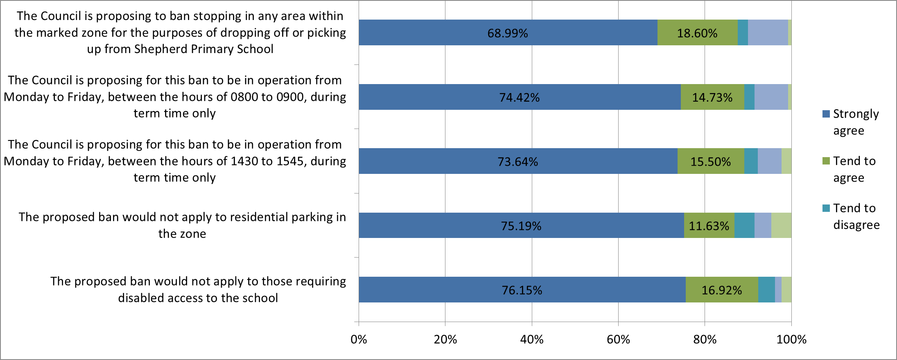

Respondent comments
SUPPORT
Dangerous conditions
Current dangerous conditions resulting from parking issues around Shepherd Primary School was the main concern for respondents to the survey (17 mentions), who highlighted issues of speed, visibility, mini-roundabout violations, concern for children being taken out of cars on the road side and cycling safety.
“The reasons for my strong ratings are for the safety of the children, elderly, disabled and emergency services”
“This is a constant source of problem and has resulted in a child being knocked over previously”
“As a parent of a small child with hearing difficulties, on more than one occasion a car has ridden the kerb to park on the pavement on a corner and my son has not heard the car, so I have had to drag him out of the way. It should not have to be so dangerous for children to walk to school”
“Speeding is an issue on this road at all times. It is supposed to be 20mph limit”
“The curve in the road presents a loss of vision to the oncoming vehicles”
“A number of drivers heading south along Shepherds Lane take the opportunity to avoid being slowed down by the roundabout. Instead, they go the wrong way round the mini-roundabout and reach the school crossing point on Shepherds Lane at a speed somewhat above the 20mph limit. I believe that the recommended way of dealing with this behaviour is to add a traffic island at the entrance to the mini-roundabout”
“The PSPO will reduce the amount of traffic in Shepherds Lane and so will make it more suitable for Reach Free School pupils to cycle from homes in western parts of the Bury Lane Estate to the new site of their school in Long Lane”
Car park availability and access
Some respondents (4 mentions) proactively suggested alternative parking for school users (e.g. William Penn and the social clubs) and some requested a direct path to be constructed from William Penn car park (7 mentions). However, some respondents were unclear on alternative parking and wanted assurances on this (5 mentions).
“Shepherds school has sent letters out regarding parking up William Penn and Sports and Social. Why aren’t the parents and some teachers parking there instead?”
“It would be useful to have a direct pathway to the school gate, although there is a path going around the park, this is quite far for the smaller children, especially when it is raining, which is when the traffic to the school increases”
“I do think you need to back this up with a viable path from William Penn Car Park to the school as it’s not great walking across wet, mud, dew.

Bus access
Concern was raised that the current parking was restricting appropriate access for buses (4 mentions)
“Buses have an awful job getting up and down Church Lane/Shepherds Lane”
“I use the bus during these times and they struggle to get through. On occasions if the driver has struggled to get up to Mill End then he will by-pass the school on his return journey by going straight down Berry Lane thus missing out my stop completely”
Inconsiderate parking
Residents raised issues they had faced regarding school users parking across their driveways, inhibiting them from leaving (8 mentions). One disabled resident also raised concern that taxis could not reach her house to pick up. One resident stated that car parkers damaged their gate post performing 3-point turns.
“As a resident whose house is within the marked area, I think this is a great idea as I regularly catch parents parking across my driveway”
“If I was getting into my car as somebody pulled up, regardless of whether I asked them to move, they would insist on it being more important to drop their children than allow me to leave my driveway”
FINER DETAIL QUERIES/CONCERNS
Resident permits
Two residents queried how their cars would be exempt from the PSPO. Would they need a permit and would this cost?
“How will you tell the difference between a residents’ cars and a parent dropping off their child?”
Concern that car parking will extend further along the road at the end of the zone.
A significant minority of comments (8 mentions) came from respondents concerned that the zone would push car parking further up the road.
“I generally agree with the proposal, but am worried cars will be pushed further along the roads at the end of the zones”
“This may well create a knock-on effect. Motorists will be inclined to park on pavements, particularly at roundabout large pavement areas at corners of Shepherds Lane and Tudor Way, thereby blocking access for prams, mobility cars and blind people with walking sticks. Also, there is a stretch of grass verge area between the King George V playing field and Shepherds Lane, which is well used as a footpath. This no doubt, will be churned up into mud and troughs”
Overlap of double yellow lines and new proposed zone at Church Lane
A resident voiced concern that the proposed zone and double yellow lines were not matched on Church Lane, which may cause confusion regarding the rules to be followed by car drivers.

OPPOSITION COMMENTS/ALTERNATIVE SOLUTIONS
Current road traffic legislation
A resident commented that if current road traffic law was upheld, that a PSPO would not be required.
Fewer cars parked might mean higher car speed
One respondent voiced concern that reducing the number of cars parked on the road might encourage higher car speeds.
“Whatever you do, don’t help Tudor Way. It is a rat run”
Small/ill children
A respondent commented that small children or babies would find parking restrictions more of a challenge (e.g. if using the Daybreak nursery). There was also some concern that children would be late for school if they had to walk from car parks/across fields (1 mention).
“If you have to pick up a child from school that is not well, then what?”
“This will certainly provide a convenient excuse for being ‘only’ fifteen minutes late for the School Playground Assembly at 850am. We would suggest 815 to 930am”
“Would these rules apply to parents dropping off and collecting their children who attend Daybreak Nursery? I collect my daughter at 2.30pm from Daybreak when there is no school traffic!”
Request for a layby to be cut by the school
Some respondents suggested that a layby for short drop offs by the school would ease the congestion (3 mentions).
“The ideal solution would be a lay by outside the school”
Disabled bay
A disabled bay near the school was requested by two respondents.

The proposed parking zone
The vast majority (87%) of respondents agreed to the marked zone proposed for the PSPO (as detailed in the consultation and shown below) - with 63 % strongly agreeing.
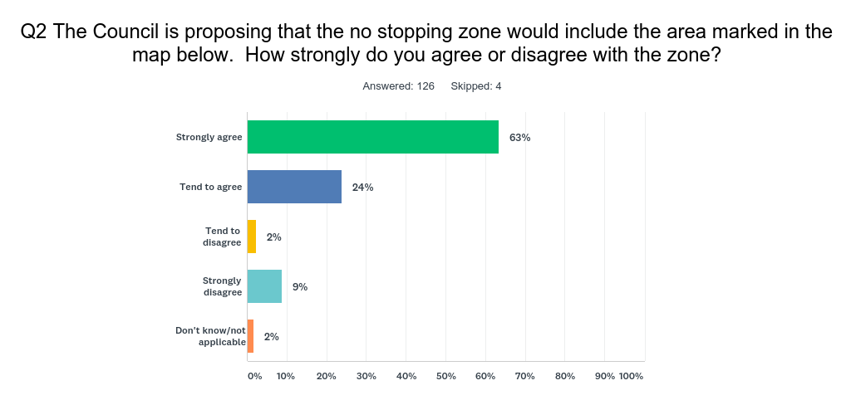

Respondent comments
Enforcement requirements
Respondents were keen to know how the PSPO would be enforced (7 mentions).
“Of course, this is a moot unless it is enforced. There are yellow lines already in place in some of the designated zone on which people are already parking without impunity because the parking restrictions are not enforced”
Extension of zone requested
Extension of the zone was requested by residents living on Church Lane (1 mention), Mill Way (1 mention) and Tudor Way (7 mentions).
“Think the ban should be made longer down Tudor Way, as they already park over our driveway”
“This is a good idea but needs to extend further along Tudor Way towards the Green. This is a curved road that is a bus route. When cars are parked on both sides of the road during school drop off time, it’s difficult to see what’s coming along the road and if the bus needs to get along it’s near impossible”
“It is more likely that they will use Beauchamp Gardens/Middleton Road/Hall Close (which is already the unofficial park and stride). Please would you also look at including these with the Public Spaces Protection Order?”
Tudor Court
Concern was raised that Tudor Court, already felt to be used for school parking, would become more congested as a result of the PSPO.
“Every day we have parents parking in our private car park [Tudor Court]. We do try and stop but face abuse. These bans will cause extra pressure”
Further comments
- Request for lights at the pelican crossing
- Request for a pedestrian crossing

Appendix 2 – Proposed pathway aross King George V Playing Fields.



