Outer Loudwater Conservation Area
APPENDIX 1

Conservation Area Appraisal

Contents

- Introduction

- Planning History

- Geology and Geography

- History

- Character and Appearance of the Area

- Sub-Areas

7. Bibliography

Appendices

A. Loudwater Map 1777 Andrews and Drury to be provided by TRDC?
B. Loudwater Map 2006
C. Draft Schedule for Article 4(1) Direction

1 Introduction and Executive Summary

  - Three Rivers District Council has a duty under the Planning (Listed Building and Conservation Areas) Act 1990 (The Act) to designate as conservation areas any “areas of special architectural or historic interest, the character or appearance of which it is desirable to preserve or enhance.” The designation of a conservation area brings additional protection of trees, control over demolition and development as well as a requirement for a decision-maker, in exercising planning powers, to pay “special attention to the desirability of preserving and enhancing the character and appearance of the conservation area”.

  - This is reflected in the Three Rivers District Council Local Plan 1996-2011, which reaffirms the tests and considerations set out in PPG 15. Policies C1 relates to development within conservation areas, and C6 relates to demolition in conservation areas.

  - The Council is additionally required by The 1990 Act to keep conservation areas under review and to formulate and publish from time to time proposals for their preservation and enhancement.

  - Outer Loudwater Conservation Area has been designated because it forms the attractive and distinctive setting for Loudwater based on the well-wooded valley bordering the River Chess and incorporating low density residential development.

  - The Conservation Area includes sub-areas of individual character which include some distinctive pre- and post-war homes (a number of which are thatched) and other significant buildings. Details are given in this appraisal.

  - Some areas are characterised by pavement-free roadways, wide grass verges and maturely landscaped frontages which contribute to Loudwater’s rural and individual character.

  - This appraisal has been prepared to help safeguard and enhance the character of the area. It will be complemented by a management plan of practical measures. One of the most important recommendations in the management plan will be to apply an Article 4(1) Direction to Outer Loudwater Conservation Area, which will help safeguard the special characteristics described in this document.

Purpose of the Statement

1.4 Government policy guidance, provided in ‘PPG15: Planning and the Historic Environment’ (PPG15, 1994) expresses the need for local authorities to assess the special interest, character and appearance of conservation areas to assist in setting out planning policy and to inform development control. English Heritage has published guidance on undertaking Conservation Area Assessments (1997) and this appraisal of the Loudwater Outer Conservation Area (“The Area”) has been undertaken in accordance with their advocated approach.

1.5 PPG15 sets out a presumption in favour of preserving buildings that make a positive contribution to the character and appearance of conservation areas. In addition the guidance recognises the contribution of traditional surfacing and street furniture to the character of an area.

1.6 The aims of this appraisal are therefore to:

- set out the special architectural and historic interest of the “The Area” and to describe the special character and appearance that it is desirable to preserve or enhance;
- identify through an audit of the built heritage of the area, buildings and other elements that positively contribute to the character;
- identify elements and buildings that detract from the character of the area and any sites where an opportunity to enhance the character of an area may exist;
- examine the existing boundaries of “The Area” and consider the potential for other areas to be included and, if appropriate, where existing areas should be excluded; and
- identify areas subject to pressure for change that would be adverse to the character and appearance of “The Area” as a result of permitted development and identify any areas where the removal of permitted development rights would safeguard the essential character and appearance of the area.

  - It should be noted that the appraisal does not represent an exhaustive record of every building, feature or space within “The Area” and an omission should not be taken to imply that an element is of no interest.

  - The Council is required to draw up and publish proposals for addressing and implementing recommendations for action contained in the Appraisal. This includes: -

- policy guidance to enable planning applications to be processed
- consideration of resources needed to sustain historic environment
- mechanisms for monitoring change
- enforcement strategy to address unauthorised development
- use of Article 4 powers
- action to ensure repairs of buildings at risk
- Enhancement/regeneration schemes if appropriate
- strategy for management and protection of important trees, greenery and open spaces
- The resource implications for the Council
- community consultation on the draft Appraisal and the Management Strategy

  - In line with the Guidance on the Management of Conservation Areas published by English Heritage in conjunction with the Planning Advisory Service, it is considered that the development of the Management Strategy should be based on the character appraisal that is provided by this document. The strategy will be prepared once consultation has taken place on the Appraisal with the local community and a finalised document has been approved by the Executive Committee of Three Rivers District Council.

2 Planning History

  - An earlier designation “Loudwater Conservation Area” was made by Three Rivers District Council on 12 November 1998. This area, the boundary of which abuts the “Outer” designation, comprises parts of Loudwater between Chorleywood Road and Sarratt Lane and includes land and buildings at Troutstream Way, Kingfisher Lure, Overstream, Trout Rise, Whisper Wood, Cherry Hill, Loudwater Heights, Farm Lane, Violet Way, Loudwater House and Loudwater Drive. The designation was made following the preparation of a planning appraisal which concluded that the area contained features of “special interest” and was under threat from development following planning permission and the exercise of permitted development rights.

  - A Direction under Article 4(1) of the General Permitted Development Order 1995 restricting permitted development in the original Loudwater Conservation Area was made by Three Rivers District Council on 11 October 2002, and approved by the Secretary of State on 6 December 2002. This Direction relates to thatched roofs, windows and chimneys, hard surfaces and means of enclosure in respect of schedules of properties.

  - On 30 July 2004 the Council confirmed a further direction under Article 4(1) relating to land at Trout Rise Farm, Loudwater in respect of means of enclosure. It was made in response to proposals for the subdivision of open land into small plots which threatened to harm the appearance of the area. This Direction was confirmed by the Secretary of State on 25 January 2005. The area it covers lies in the Loudwater Outer Conservation Area.

  - Designation of the Loudwater Outer Conservation Area was made by Three Rivers District Council on 6 February 2006, following requests for consideration by the local community. The Council resolved to designate the Loudwater Outer Conservation Area because the defined area forms the attractive and distinctive setting for Loudwater based on the well-wooded valley bordering the River Chess and incorporating low density residential development. Conservation Area designation will assist the Council to safeguard the area’s special character.

  - When a Conservation Area is designated it is necessary to consider whether an Article 4 direction should apply, since the special character of the area must not be damaged by minor “permitted development” works. The special character is of crucial importance to the qualities of the Conservation Area.

  - Article 4 Directions, relating to the removal of dwelling house permitted development rights, are made pursuant either to Article 4(1) or Article 4(2) of the Town and Country Planning (General Development) Order 1995, depending on whether the works would front a public highway or a private road. The Loudwater Outer Conservation Area is a mix of private and public roads and a designation under Article 4(1) would apply. Article 4 (1) Directions relating to Parts 1 to 4 of Schedule 2 of the Town and Country Planning (General Development) Order 1995 do not require prior approval of the Secretary of State but do require approval to remain in force after the initial six month period.

  - A photographic survey has been undertaken of all properties in Loudwater Outer Conservation Area and an assessment made of special characteristics (including thatched houses, pre- and post-war properties and features such as windows, chimneys, hard standings, means of enclosure and gates). Appendix C contains a schedule of properties considered to contribute to the special character of the area, where additional controls are considered justified. This will form the basis for an Article 4(1) Direction.

  - This appraisal describes the special character of the area in detail.

3 Geology and Geography

3.1 Geology

3.1.1 Loudwater is underlain by Cretaceous chalk, a relatively soft rock, initially deposited in a warm tropical sea some 90 - 80 million years ago.

Loudwater may well have got its name from the sound of the water tumbling over natural weirs in the river at the western end of the area adjacent to Trout Rise. Here the chalk, called misleadingly the Chalk Rock, was of a much harder consistency and had resisted erosion thus forming a natural step in the river. Water mills on the river in the past may have used this natural feature.

Overlying the chalk on the slopes above the river are thin, (<1metre) clays and flint gravelly clays deposited originally by the River Thames as it ran north-eastwards past St Albans, Ware, etc, to the North Sea off the Norfolk coast some 250,000 years ago. Ice approaching from the north as far as Bricket Wood, blocked this river forming a lake stretching through Rickmansworth to Uxbridge, and eventually diverted it into its present course through Maidenhead, Staines and London.

Below Loudwater Drive the chalk is covered by silty, river alluvium deposited by the more recently developed (<180,000 years), River Chess.

The chalk is the principal aquifer in southern Britain and until recently was able to maintain the water flows within the River Chess and the other Chiltern rivers at higher levels than at present. Over-abstraction and lower rainfall in recent years has seriously affected these flows. It is likely that when the water mills were operating in centuries past water flows averaged several times those found at present.

Geography

Loudwater is a hamlet lying to the north of the Chorleywood Road, the east of the M25 from J18 to Solesbridge Lane, along to the junction with Sarratt Lane, along Sarratt Lane to Loudwater Lane- Long Ridge and then southwards across the fields to the junction of Loudwater Lane and the Chorleywood Road.

Loudwater lies to the east of the Chilterns Area of outstanding Natural Beauty, part of which is within the Outer Loudwater Conservation Area

Part of this area comprises the Loudwater Conservation Area which was designated in October 1998.

History

Roman

Located across the River Chess at the bottom of Clearburn, Trout Rise is the remains of a Roman Villa, the earliest proof of homesteads in the area although stone and flint tools indicate Stone Age Man lived in or visited the area. This area has been designated a Site of Archaeological interest and lies within the Outer Loudwater Conservation Area.

There is evidence of a brewery alongside the River Chess with a large corn- drying oven which was probably used for malting grain for beer. There was a carefully designed system of sluices to regulate the flow of water from the River Chess to the mill.

Medieval

Although Rickmansworth was an important area throughout the middle ages (mentioned in the Domesday survey of 1086) there is no significant record of Loudwater until the Andrews and Drury map of 1777.

18th Century Loudwater

The Andrews and Drury map of 1777 clearly shows Solesbridge Lane, Sarratt Lane and Loudwater Lane with a turnpike where the Chorleywood Road is now. Thus we can be sure that three of the lanes bordering Loudwater have not changed much in 250 years.

The area was mainly farm land with a few large copses, and an orchard, with mill cottages at either end. These mill buildings remain as Grade II Listed Buildings today.

Character and appearance of the area

General

Loudwater is a wooded, undulating part of the Chess Valley with narrow lanes and leafy tracks. The original settlement of large detached houses in spacious plots developed along the banks of the river, taking advantage of the breathtaking views across the valley..

    - In some parts, very large Edwardian houses, each with many acres of land, have been replaced by several large detached houses of character still on generous plots with trees and gardens all around them.
    - Since the 1970’s there has been a tendency for extending houses towards the boundaries, putting the rural and sylvan feel of the properties at risk. In most cases this has been controlled effectively, but there are some examples of over-development of plots that detract from the overall impression of Loudwater.

    - There are properties which, due to their particular architectural merit, should be subject to further protection through Article 4 direction. These would be separately identified by TRDC.

5.1.5 Equally, there are a number of small developments built since the 1970s of modern design which, although not out of place in their respective cul-de-sac settings, do not warrant further protection.

  - Sarratt Lane and Loudwater Lane

    - The single track nature of both these lanes with leafy canopies throughout, will not have changed much in the last three hundred years. Unfortunately, heavy traffic has eroded the verges causing undesirable widening of the lanes. Attempts to slow traffic to prevent damaging verges are becoming more urgently required and any applications by property owners to convert verges to wider access points are being opposed.

    - Loudwater Lane c1900
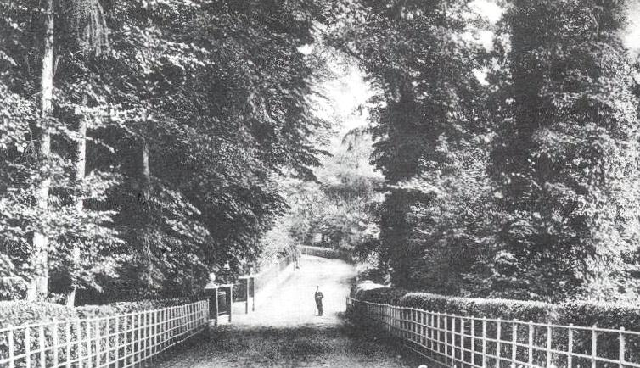

    - Loudwater Lane 2006
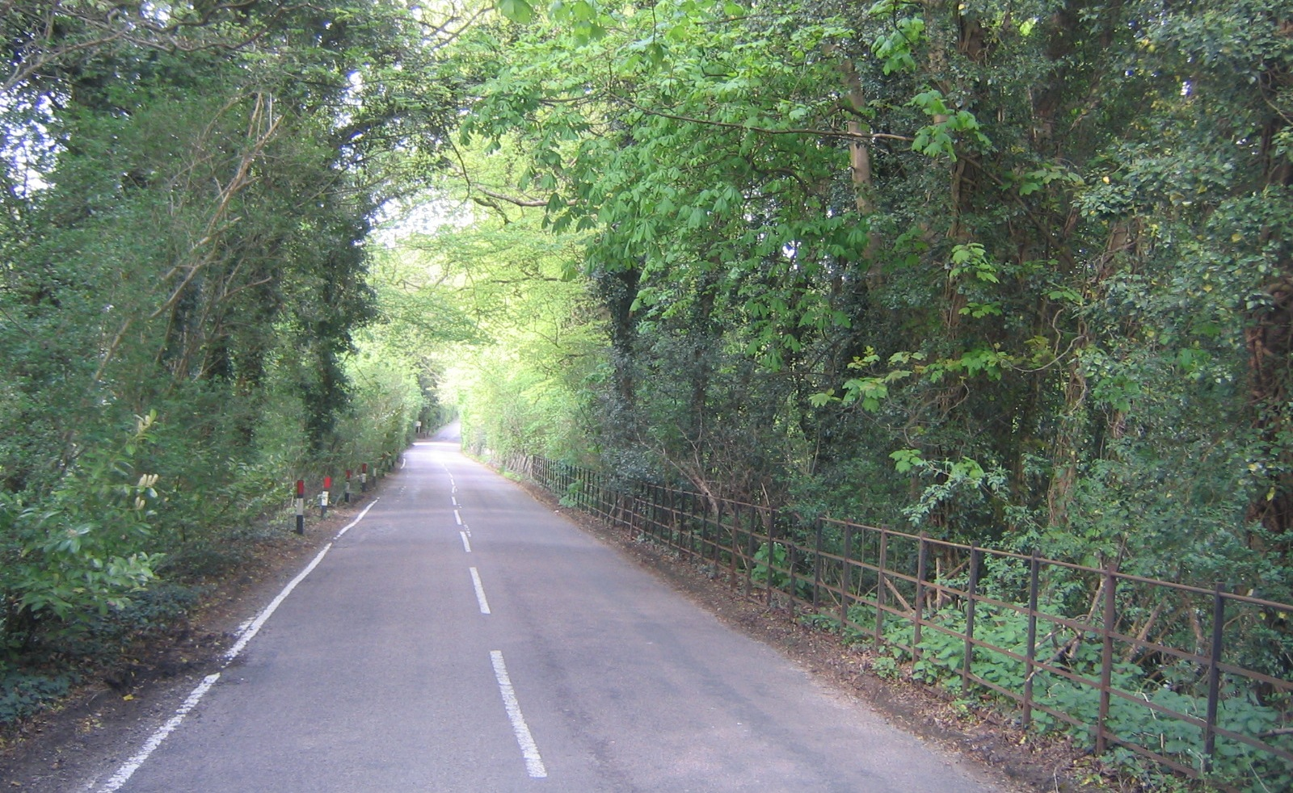

    - Sarratt Lane 2006

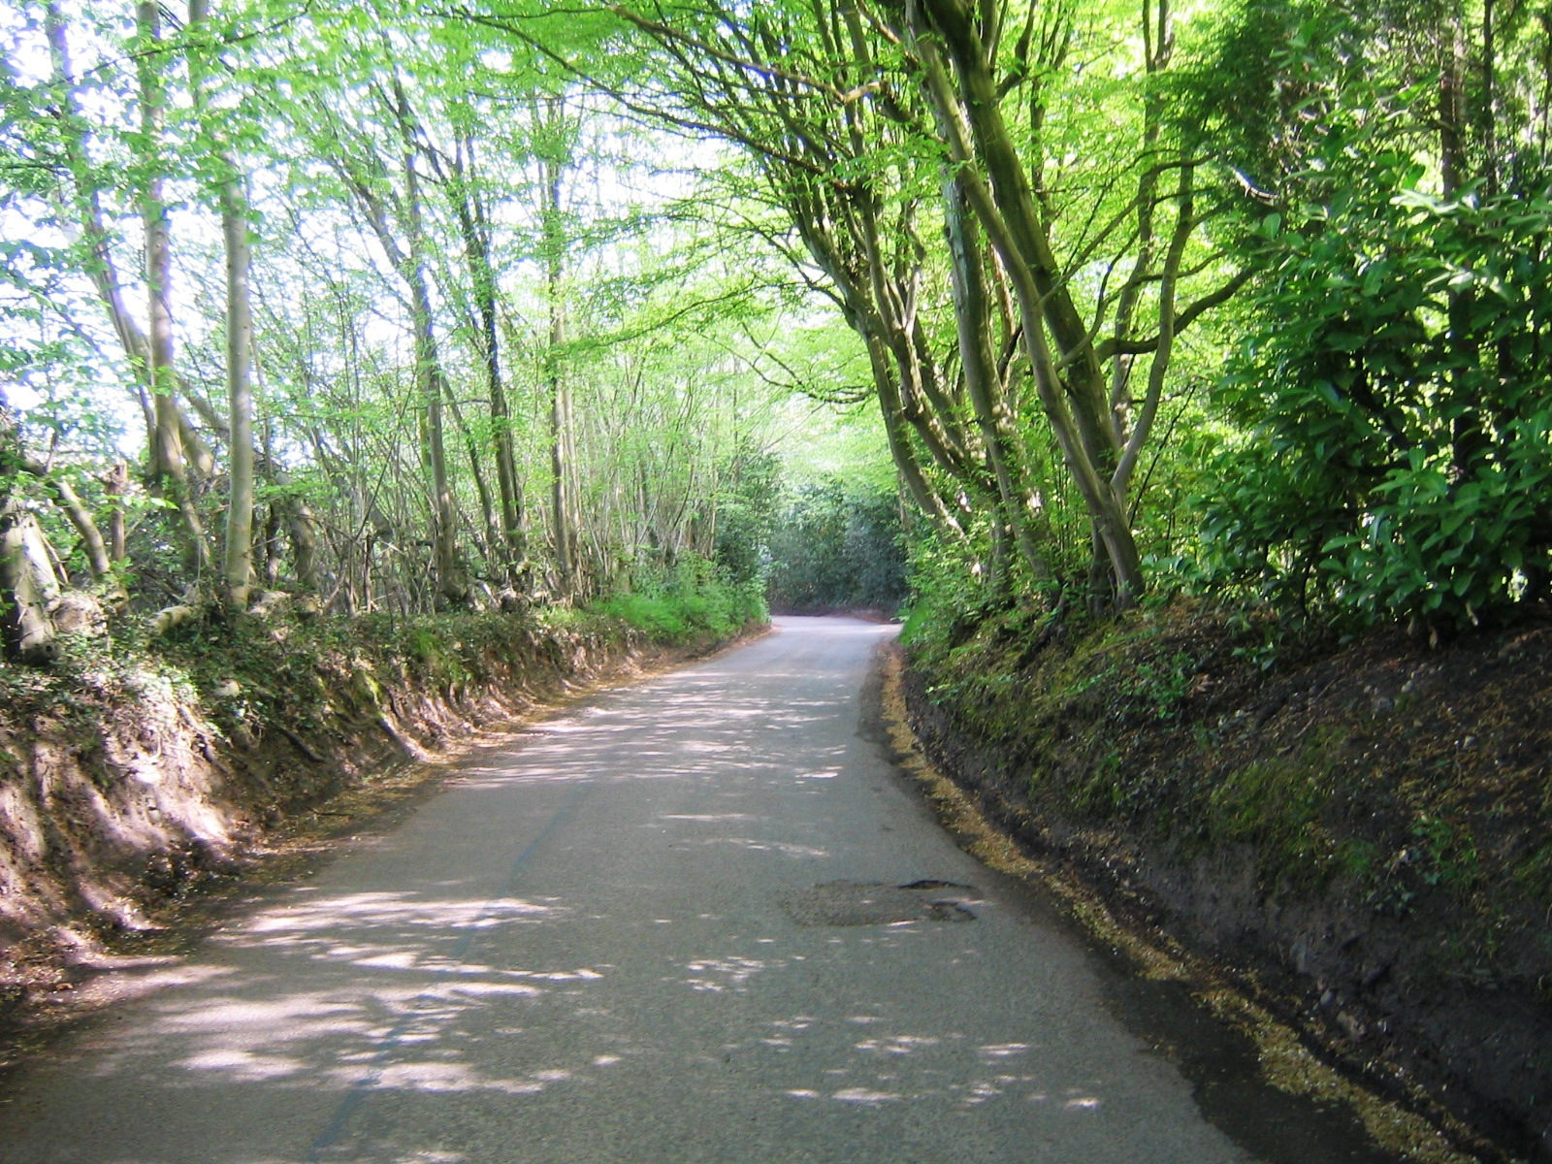

  - Chorleywood Road

    - Residents of Chorleywood Road, including Harewood and Rasehill Close have to contend with fast flowing traffic at most times of the day. Access to the road is with difficulty as there are blind spots. It is an advantage that there are few houses between Loudwater Lane and the M25 Motorway.

6 Sub-Areas

Roads within “The Area” have been examined individually and carefully for their particular characteristics and they have been identified and are shown on the Plan as Appendix 3. The character and appearance are defined in detail in the subsequent text. The sub-areas are:

- Loudwater Lane North
- Bridle Lane
- Sarratt Lane East
- Sarratt Lane West
- Lower Plantation
- Chorleywood Road
- Loudwater Lane South
- Loudwater Farm and environs

Sub-Area 1: Loudwater Lane North
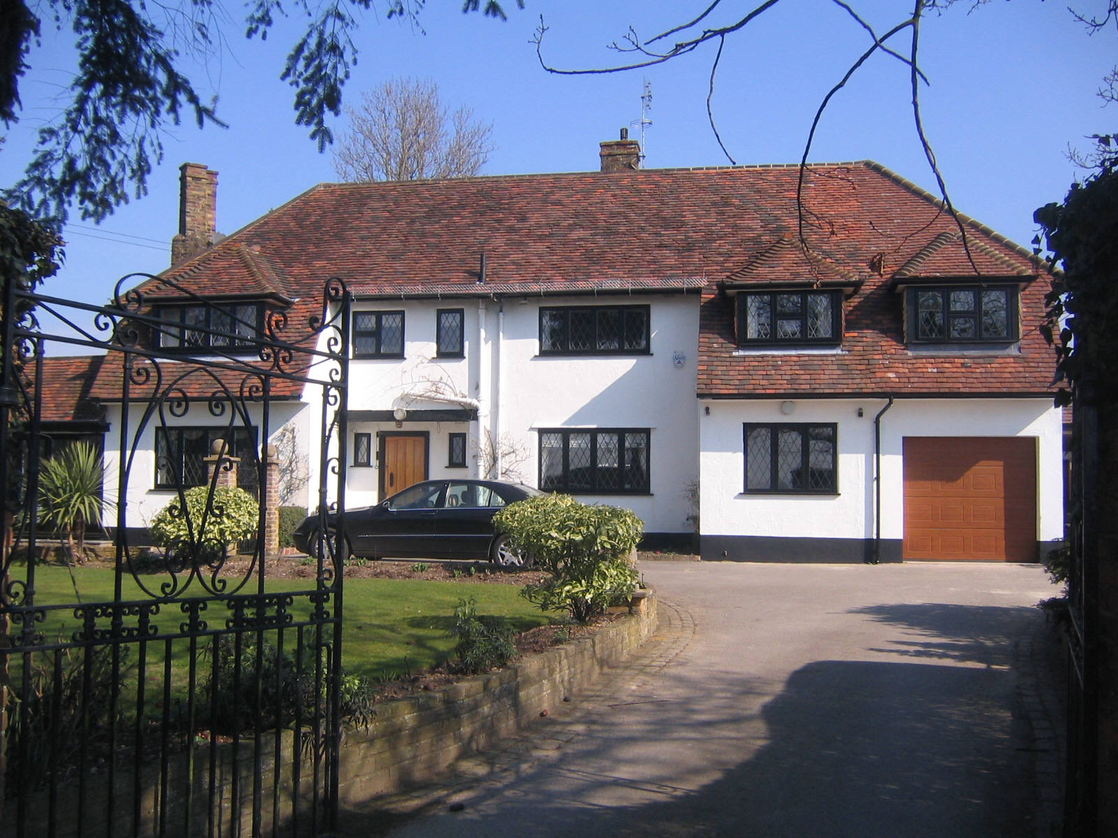
The predominant feature of this sub-area is the rolling arable farming land covering many acres. The few houses within this farmland area are positioned mainly within substantial plots and look across extensive pastoral views. Lightly wooded areas shield Loudwater Lane from the traffic noise of the distant M25 motorway.

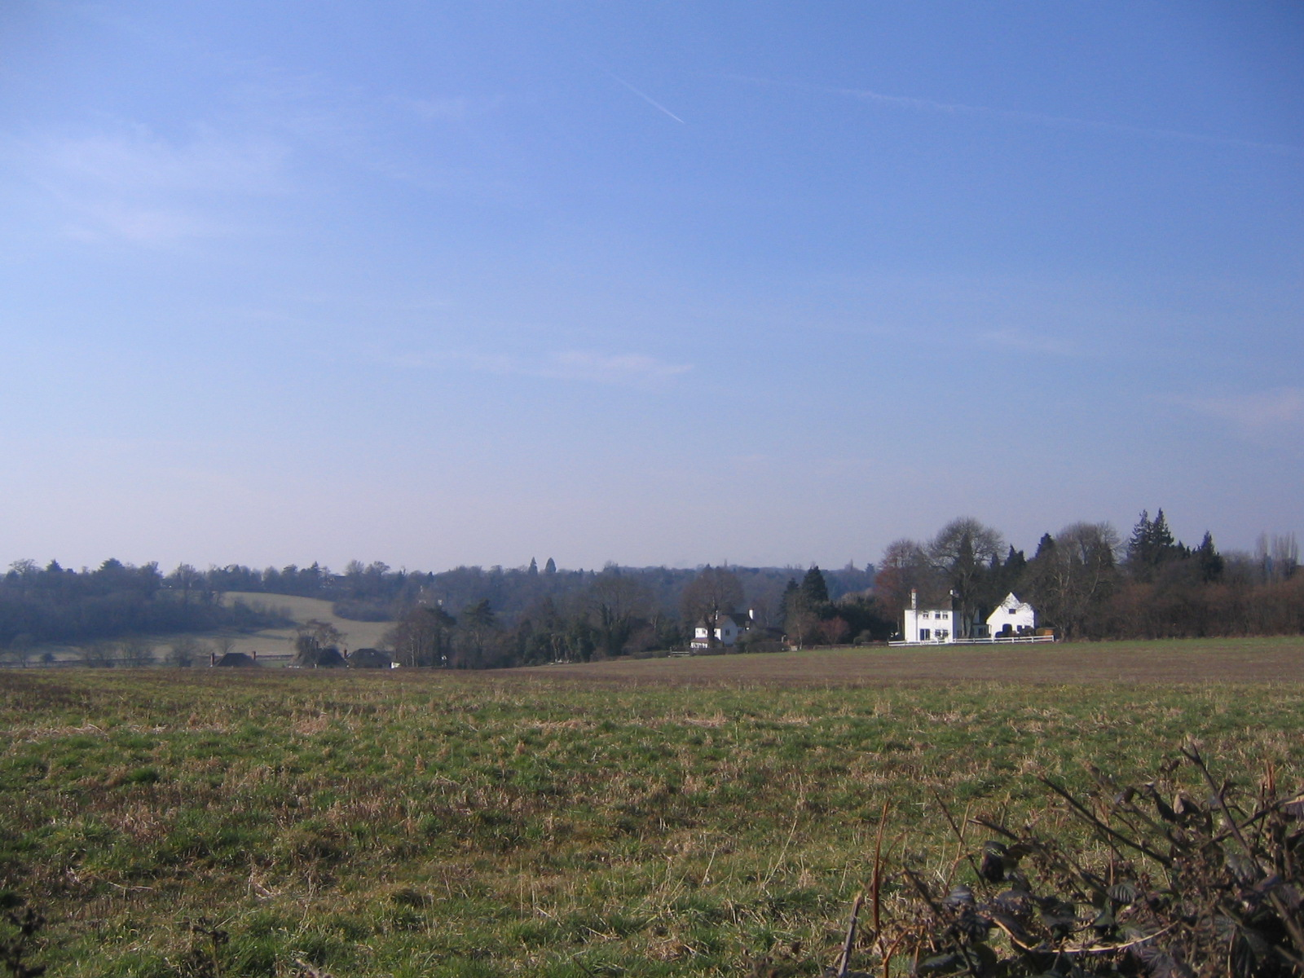
The double fronted substantial Oak House fronting Loudwater Lane, looking across arable farmland

Sweeping views from both sides of this section of Loudwater Lane are across wide, open fields allowing the visitor to enter the Area to enjoy the rural atmosphere afforded. The route of this level part of Loudwater Lane occasionally meanders so that glimpses of farms and their environs can be savoured from various vantage points. The view
towards the Royal Masonic Girls School is a particularly fine feature of this road.
Southerly views across farmland from Oak House

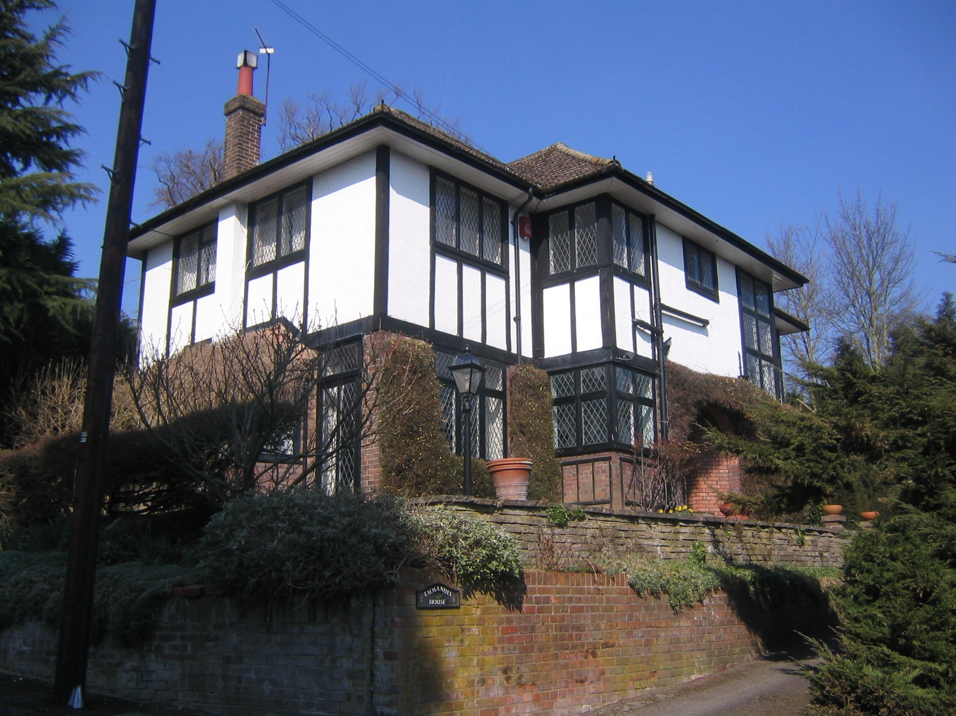
Rooflines of several stucco rendered and brick fronted houses, for example Emmanuel House in Timberidge and Oak House in Loudwater Lane, are most striking against the skyline. Tall chimney stacks are a feature of houses in this area.

Armitage Close and Timberidge have more recent housing stock but are all on lightly wooded, spacious plots.

The splendid views eastwards from Timberidge are across rooftops of some houses in Loudwater Lane and a particularly fine example of a Mansard roofed house (see Sub-Area 8).
Emmanuel House in Timberidge, facing impressively eastwards

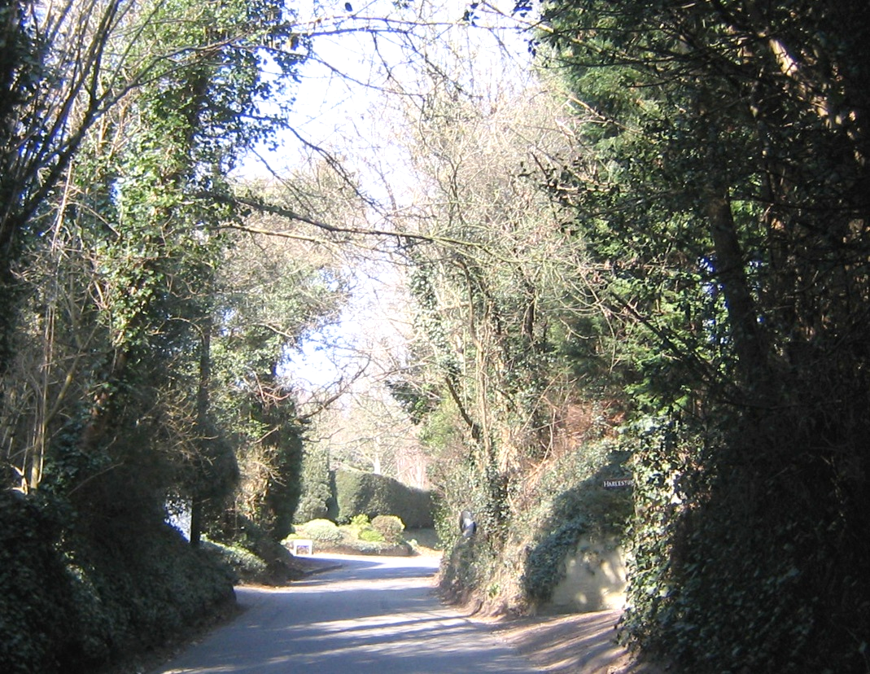
A view from under its famous canopy of trees, looking northwards in Loudwater Lane

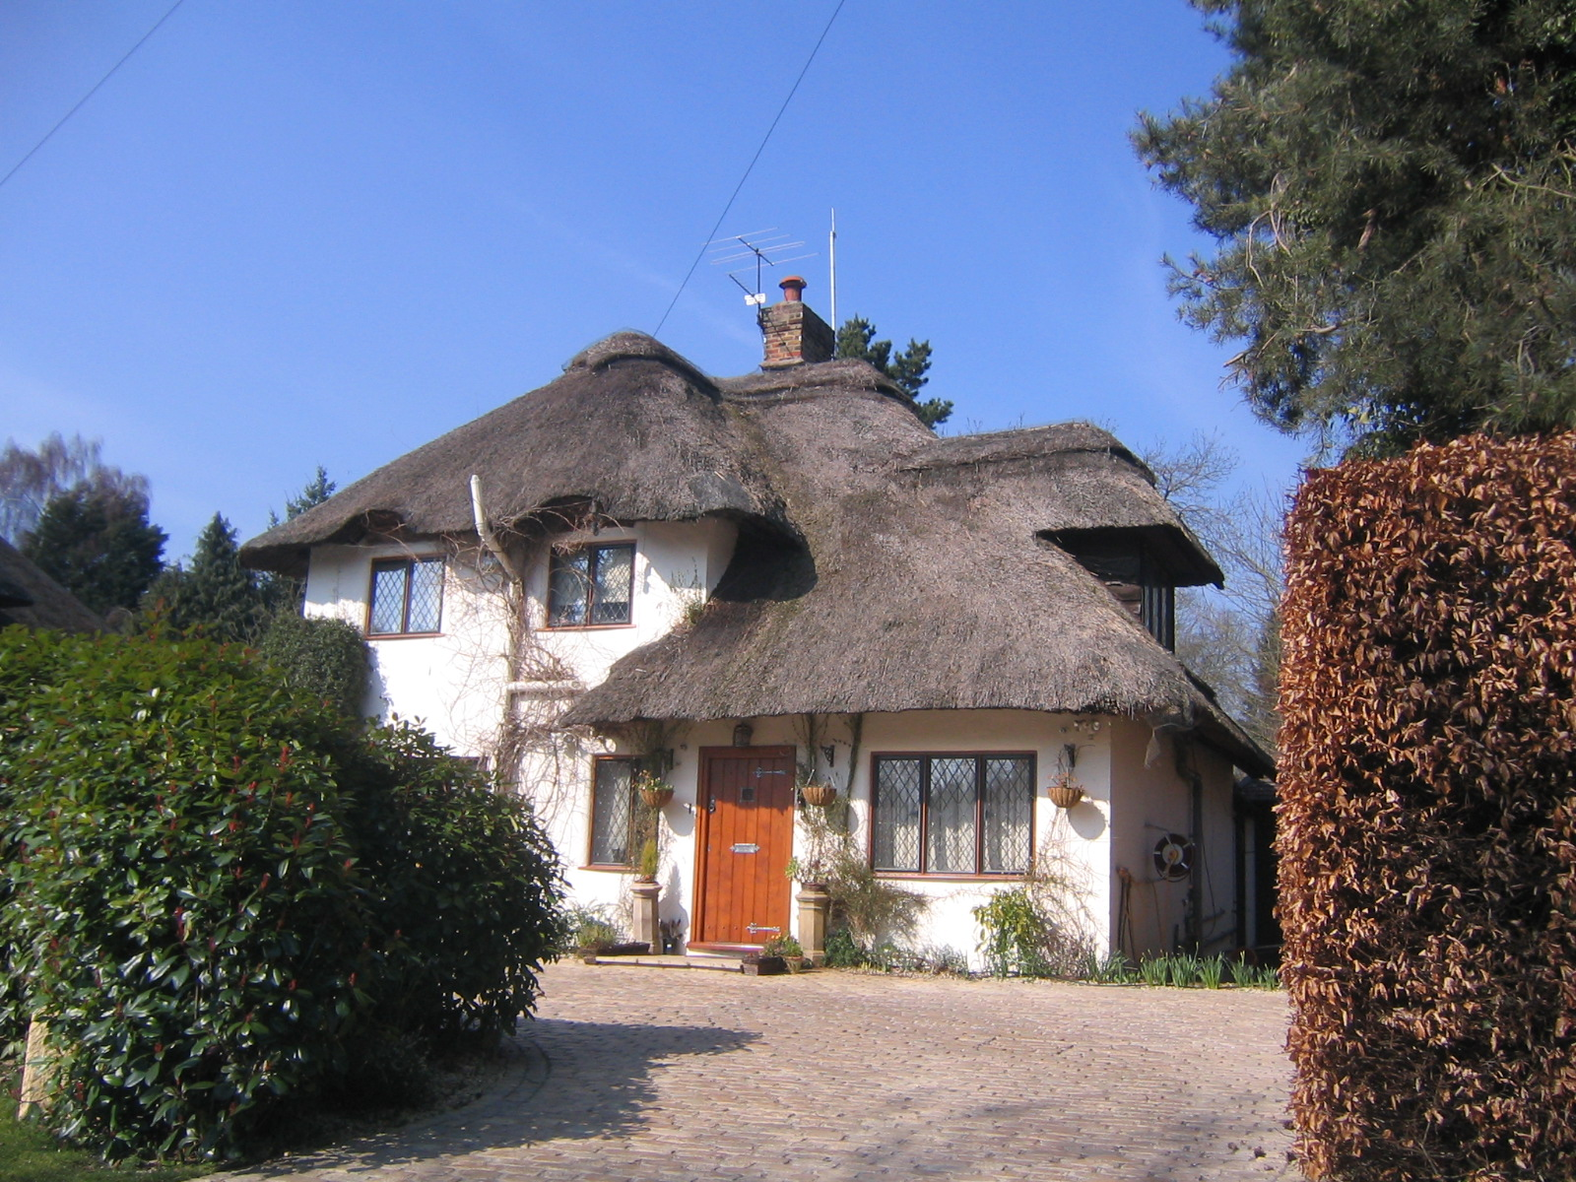
Sub-Area 2: Bridle Lane

Bridle Lane is a private gated estate with only one entrance resulting in an absence of through-traffic.

All the detached houses are large and substantial and sit well on generously sized plots. The wide spacing between nearly every house is emphasised by plot boundaries being well away from each house. All houses have been individually architect-designed and built during the first half of the twentieth century. Many are thatched roofed and are splendid examples of the renowned builder, McNamara.
McNamara built Chenies Cottage

The pavement-free roadway, with wide grass verges on both sides, is a feature of Bridle Lane. The total sub-area has several fine specimen trees, some dating back to early Victorian times.

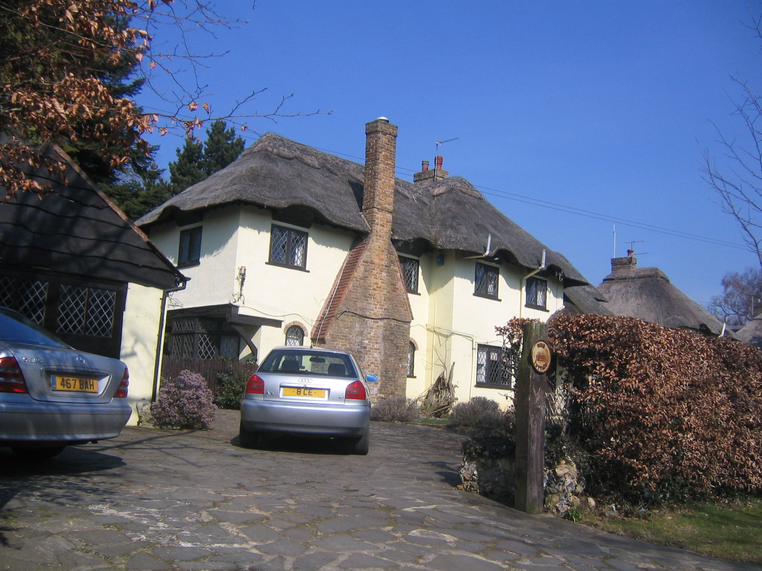

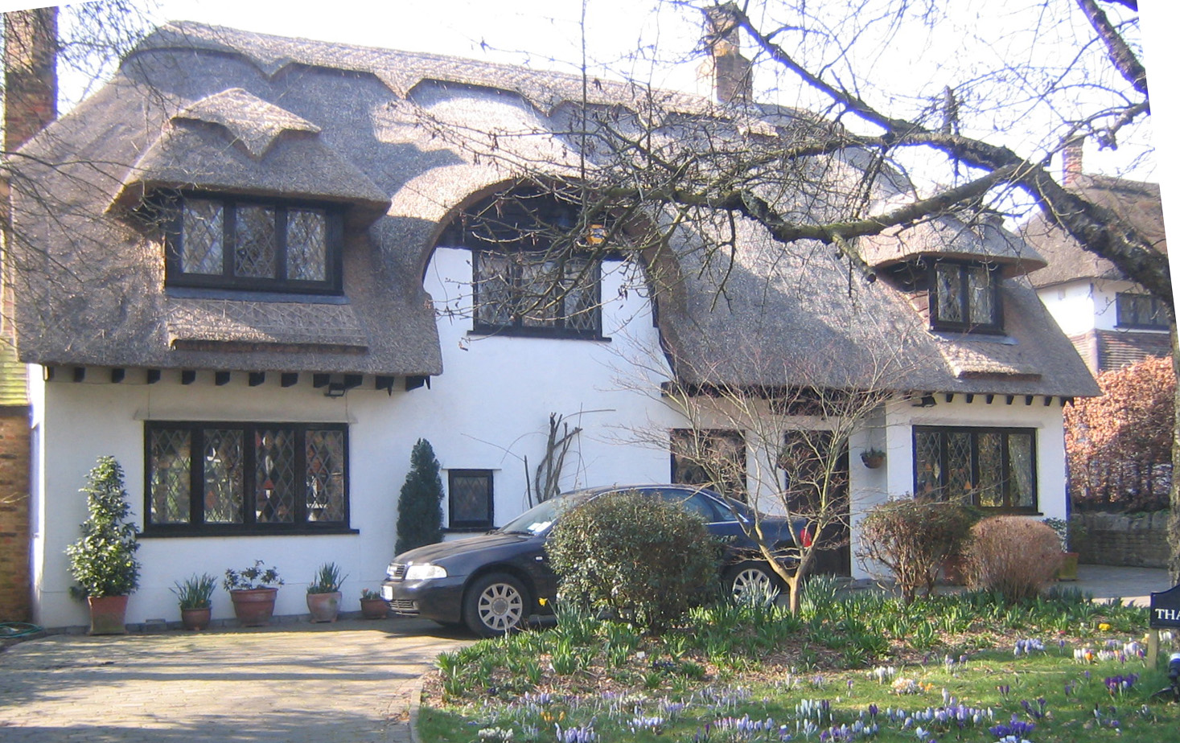

A fine example of thatching at Bois Cottage

The appropriately named Thatchways

Sub-Area 3: Sarratt Lane

From its junction with Loudwater Lane, Sarratt Lane rises gently westwards, winding gently through densely wooded
countryside and gardens.

This sub-area comprises two sections both with similar properties, either side of the northern boundary of the existing Loudwater Conservation Area.

The wooded and canopied Sarratt Lane

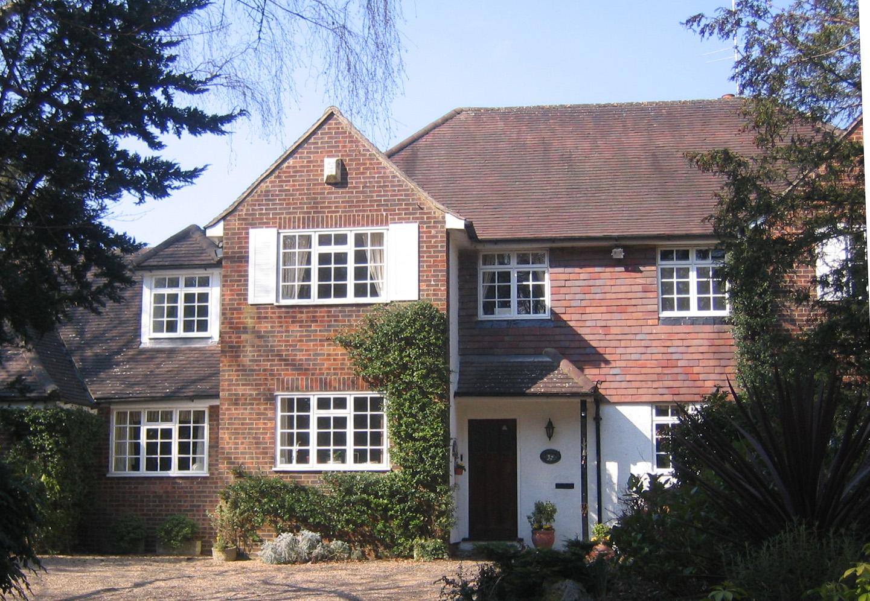
The few houses along this part of Sarratt Lane are set on large plots and are fine examples of Edwardian and middle-twentieth century homes.

Thorpelands, typical of houses along Sarratt Lane, each with their own wooded verges
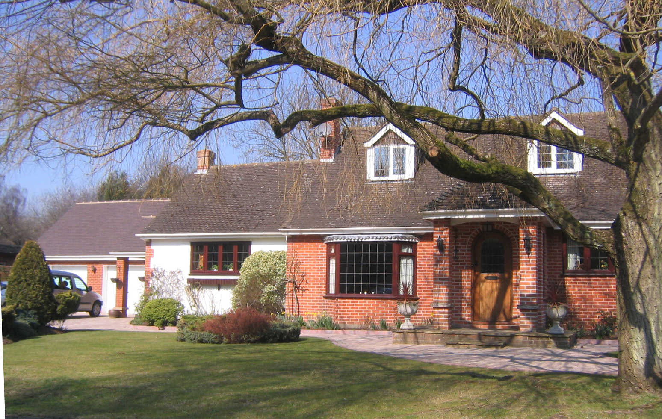

9 Ladywood Close, typical of houses in cul de sacs off Loudwater Lane

Sub-Area 4: Sarratt Lane West

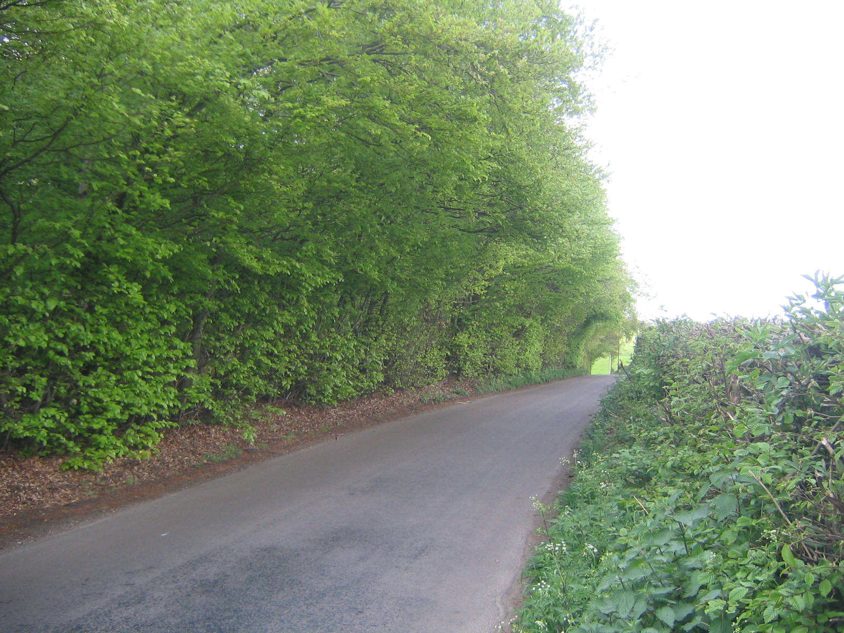

Looking westwards along rural Sarratt Lane

Towards the western end of Sarratt Lane the road moves between the ancient coppiced trees of Beechengrove Wood and large arable fields. Extensive, unhindered views are available which continue when one turns north at its junction with Solesbridge Lane.

Leaving Beechen Hill House on the left, which is set in far-reaching wooded grounds, Solesbridge Lane goes south and downhill towards the River Chess. Arguably the finest sweeping views of rolling Hertfordshire hills available locally are now in sight, none of which appear to be spoilt by the imposition of the M25 motorway

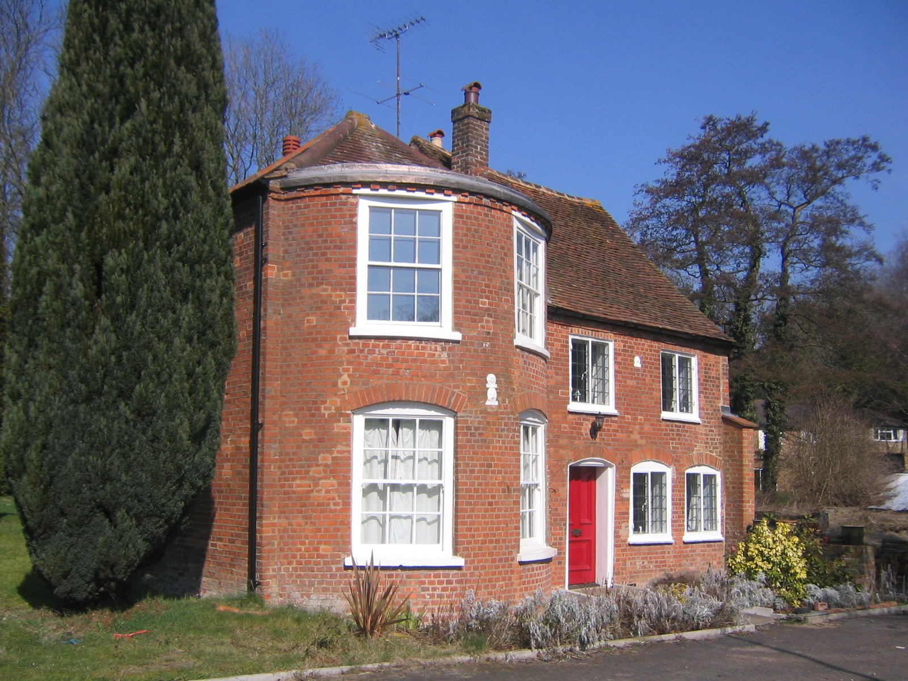
At the foot of this descending roadway, on the left, is an area bisected by the River Chess. Uniquely, there are no less than five weirs in this part of the river. Both brown and rainbow trout are found here and sometimes even pike.

Recent diggings have revealed remains of a Roman barley mill used here in the production of beer .

The Mill House, Solesbridge Lane – a Grade II Listed Building

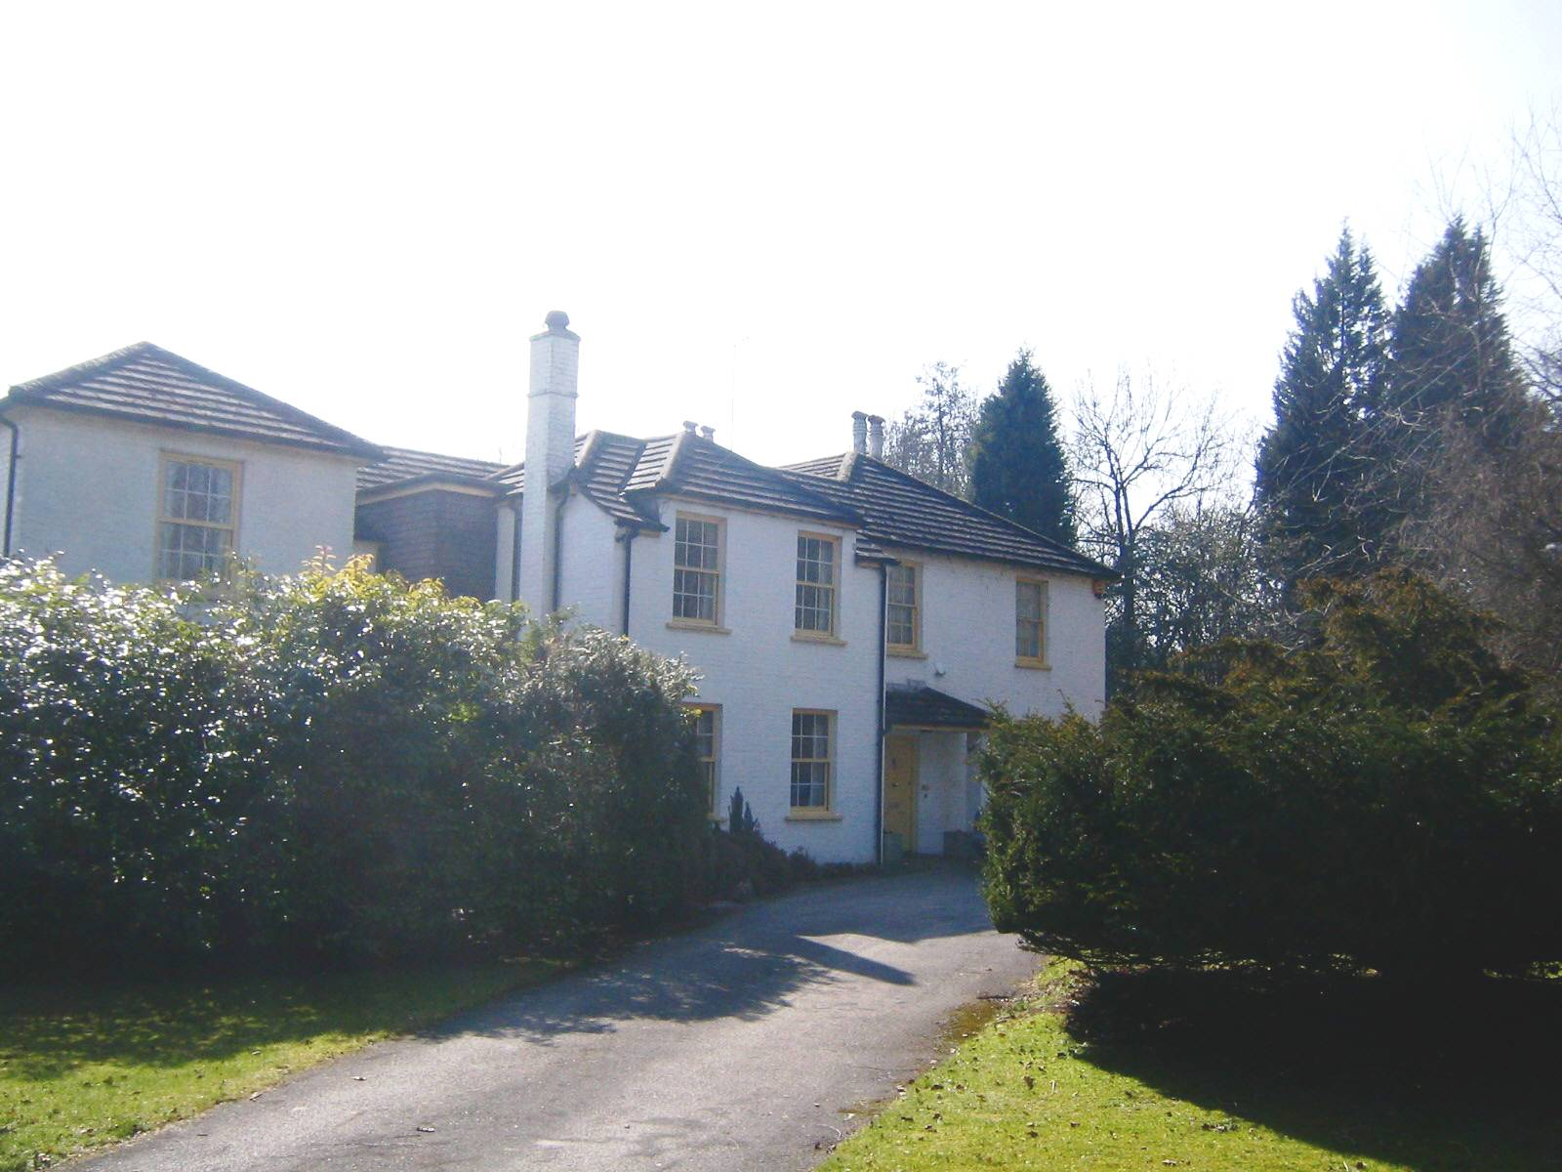
Development has been minimal with only five houses to accompany The Mill House and neighbouring barn. They are both Grade II listed buildings and date from the 17th century. Interestingly the Mill House has two fine Fire Mark plates.

A commercial water garden company has extensive sales areas which are close to the M25 motorway.

The White House. Solesbridge Lane

Sub-Area 5: Lower Plantation

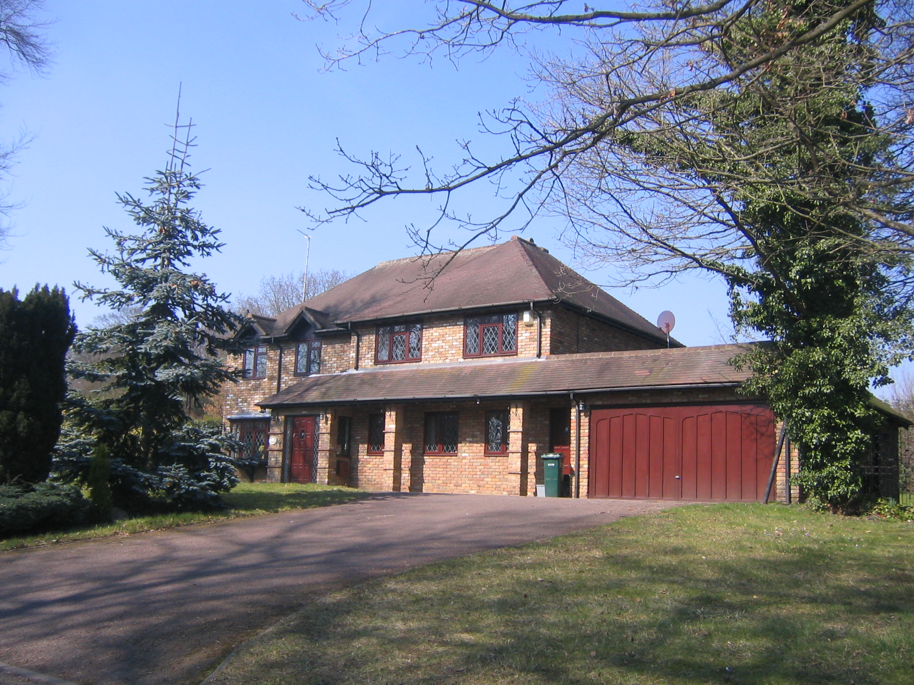
A relatively modern development of substantial, individual detached houses, set in large plots with plenty of space between each of them.

1, Lower Plantation

Sub-Area 6: Chorleywood Road.

These properties border or are accessed from the A404, between Loudwater Lane and the existing Loudwater Conservation Area. There are several original Edwardian properties, characterised by white rendering with wooden facings. Similar large properties on plots of many acres have been either replaced by modern developments (Harewood) or, in the case of Rasehill Close, some of the grounds have been used to build modern properties.

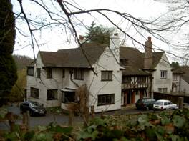
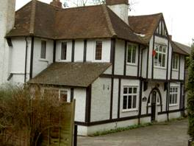

Dykewood, a typical Edwardian property Rasehill, a distinctive Edwardian property
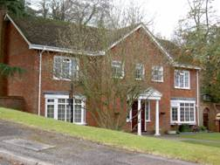

All properties in this area are substantial. There are no bungalows or flats. They are on good sized plots, with space between the properties. There is significant tree planting, which is typical of the Conservation Area as a whole.

These properties lie on a steep gradient. The land to their rear slopes sharply down to the Chess Valley. This affords many properties an excellent view across the valley. Equally, looking back, southwards from the valley floor these properties are barely visible through the heavily wooded hillside.
Harewood,: a substantial modern home

Sub-Area 7: Loudwater Lane South.
This area includes two Grade II listed buildings: Glen Chess and Old Mill House.
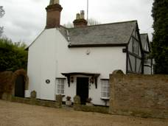
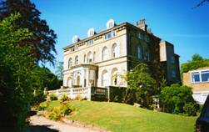

. Glen Chess: A Grade II listed building
Old Mill House: A Grade II listed building

Glen Chess was built in the mid 1850s by Herbert Ingram. He was a printer and also owned Loudwater Mill (now demolished). The mill produced paper to wrap the medicines produced by Ingram’s drug company. He also started a magazine called “The Illustrated London News.” In the twentieth century Glen Chess was converted into flats. It stands in spacious grounds, which include a lake.
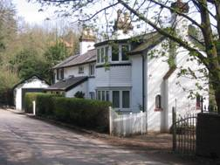
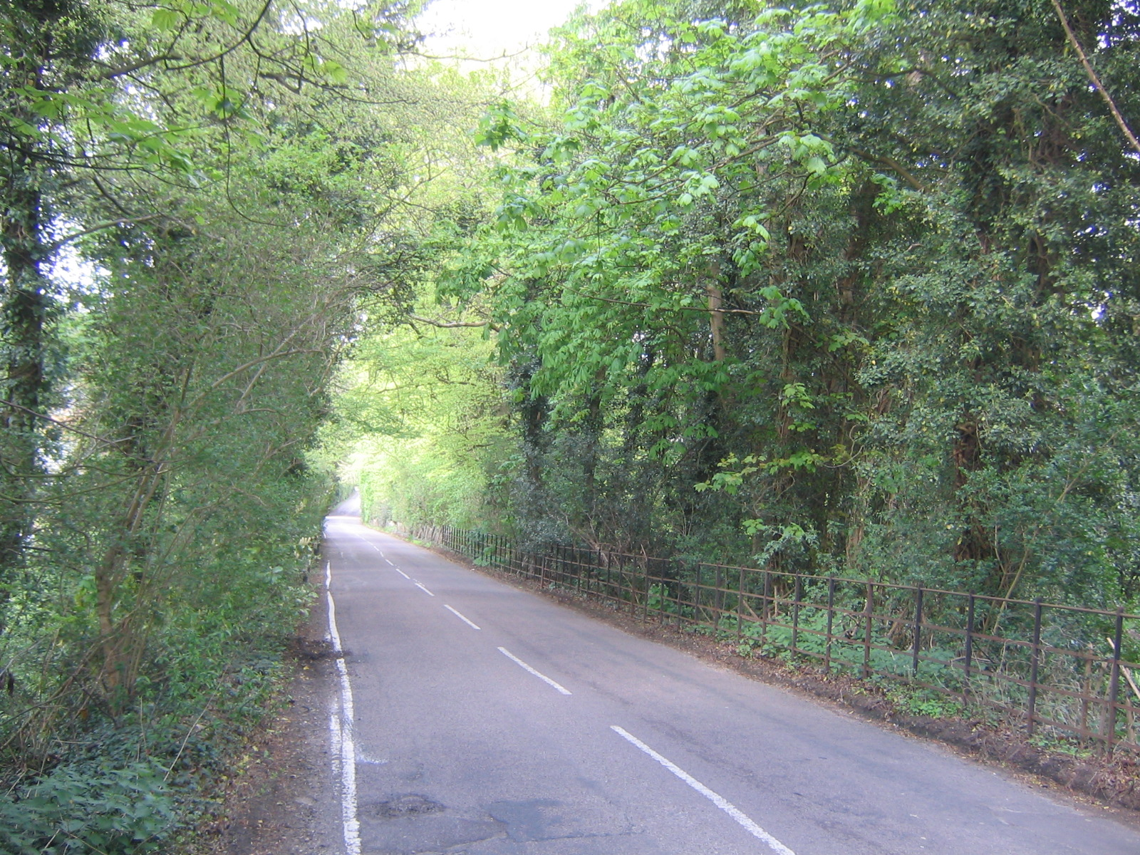
The unique Chess Cottage nestling alongside the River Chess Densely wooded Loudwater Lane as it meanders lazily through meadowland

The River Chess is greatly in evidence in this sub area. It conveys a tranquil, rural ambience to the area. There is much open space here, with views across the fields as one travels north along Loudwater Lane. The area is richly planted with trees. All properties are individual and stand in large plots

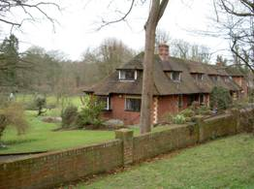

Mont au Source- a substantial property with grounds leading to the River Chess. Its elevations are designed to harmonise with the surroundings.
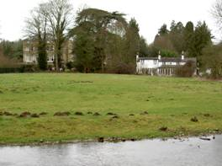

View of Glen Chess and Chess Cottage from Loudwater Farm

Sub-Area 8: Loudwater Farm and environs.

Loudwater Farm includes a wooden barn which is 450 years old and is Grade II listed. There are further buildings on this site which are constructed of brick and flint.

The River Chess flows through the farm, contributing to the peaceful, rural aura. Across the River and fields, properties in Loudwater Lane can be viewed. From the farm the valley rises gently to the north, giving extensive vistas of farmland and lightly wooded areas, with very little evidence of development.

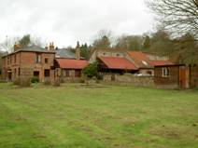
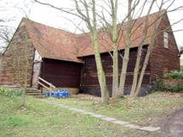
The barn at Loudwater Farm Loudwater Farm

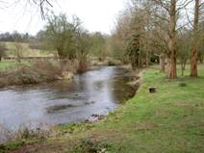
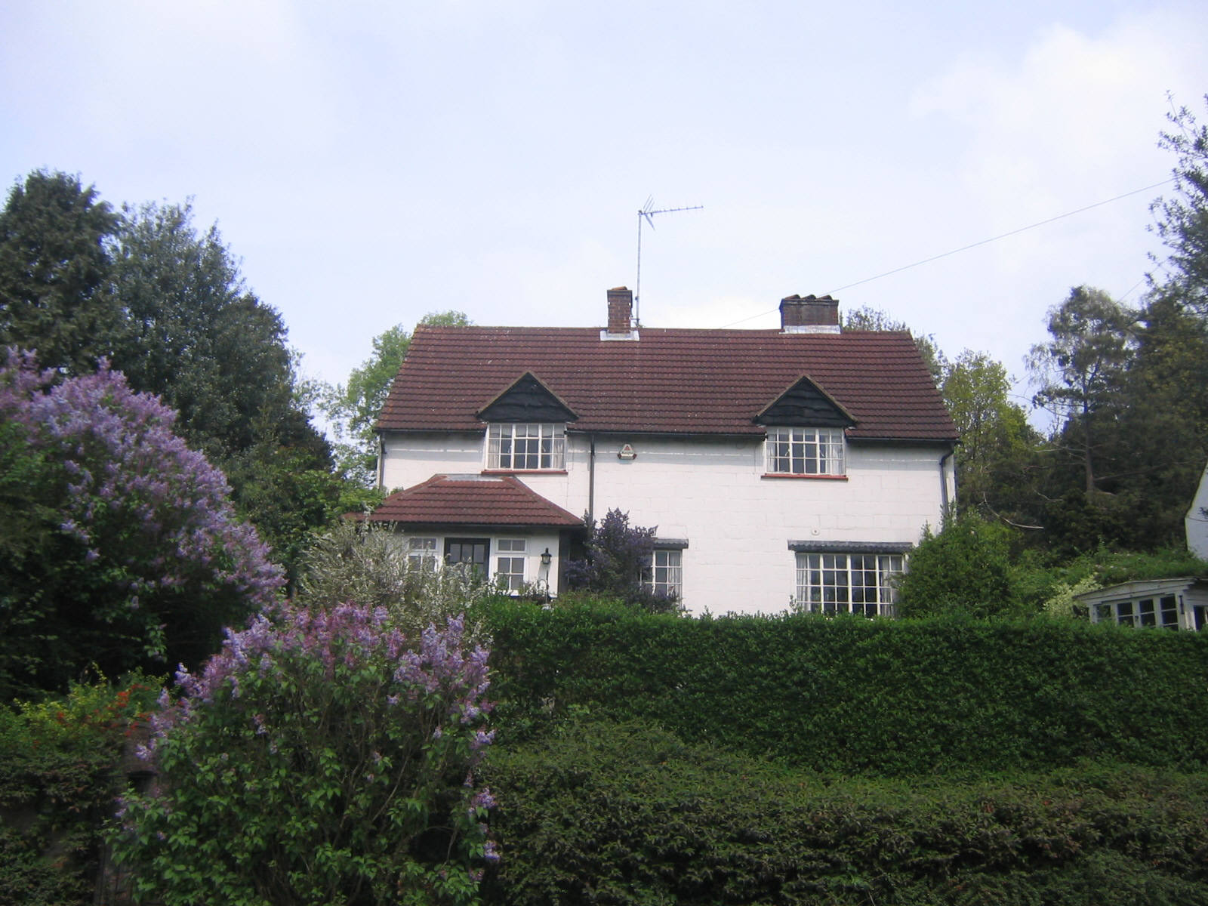
Loudwater Cottage, Loudwater Lane, looks out over the View of the River Chess through
River Chess from its elevated position Loudwater Farm

The Chess Lane, Hill and Close area consists of individual properties, built on good sized plots with significantly wide garden areas between the properties. Those in Chess Lane have excellent views of the countryside and River Chess. The area is quite steeply sloping which is in keeping with the topography of the Conservation Area.

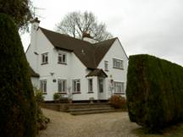
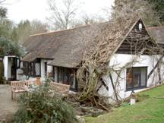
Willow End Willow Cottage

The area is devoid of pavements and there are only two street lights in the immediate area, which contributes to the rural feeling.

Properties in this section of Loudwater Lane, including Rooks Hill with its McNamara houses, are substantial, individual detached residences, on generous plots with space between the properties. They are set well back from the road, many having steep driveways consistent with having being built on the side of a valley.

An abundant planting of trees shields many of the houses from view. Those in the proximity of Loudwater Farm have excellent views of the valley and surrounding countryside. There are no flats in this area.

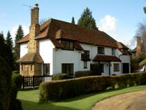
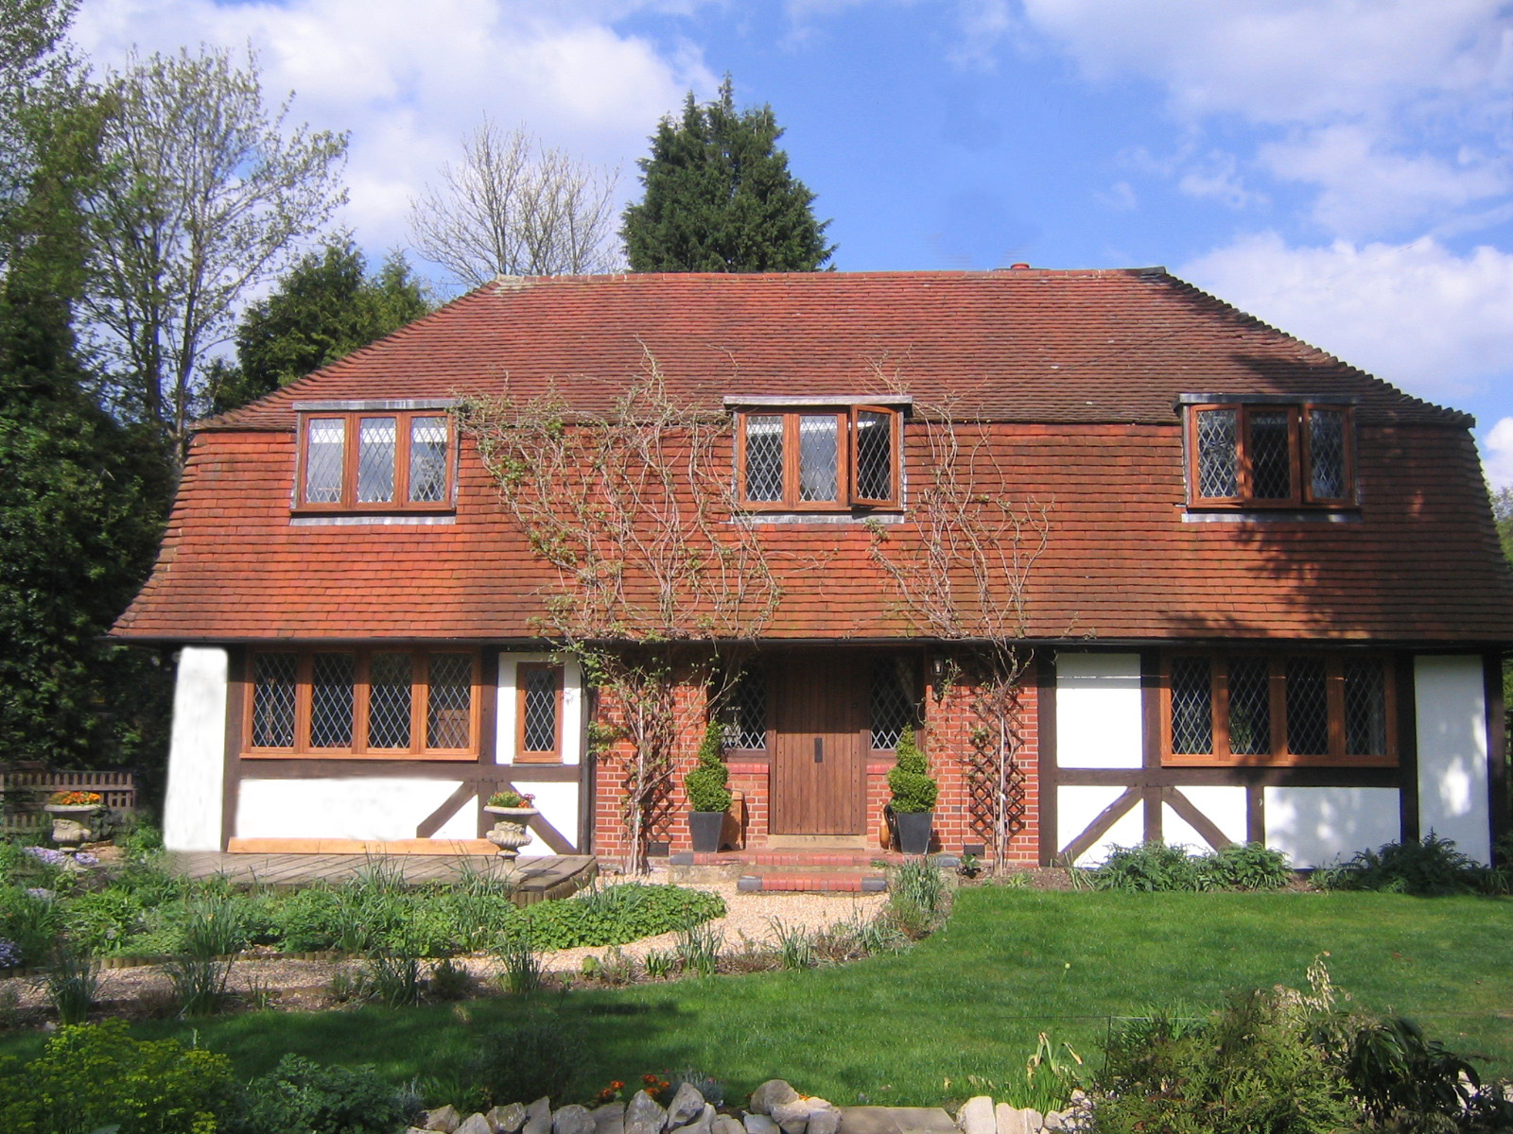
Cobblers, Rooks Hill Mansard Cottage, Loudwater Lane

7 Bibliography

The Book of Chorleywood and Chenies (1983) by George E. Ray
B. D’Olier B.Sc., Ph.D., G.G.S., C.Geol
Three Rivers District Council
Andrews and Drury Map 1777



