FINANCIAL POSITION STATEMENT
& BUDGET MONITORING REPORT



JUNE 2008 (MONTH 3)

PLEASE NOTE THIS REPORT SHOULD BE BROUGHT

TO THE MEETINGS LISTED OVERLEAF

EXECUTIVE COMMITTEE – 21 JULY 2008

LEISURE & COMMUNITY SAFETY POLICY & SCRUTINY COMMITTEE – 22 JULY 2008

PUBLIC SERVICES AND HEALTH POLICY & SCRUTINY COMMITTEE - 24 JULY 2008

SUSTAINABLE ENVIRONMENT POLICY & SCRUTINY COMMITTEE – 5 AUGUST 2008

RESOURCES POLICY & SCRUTINY COMMITTEE – 14 AUGUST 2008

AUDIT COMMITTEE – 3 SEPTEMBER 2008

PART 1 – NOT DELEGATED

5. FINANCIAL POSITION STATEMENT & BUDGET MONITORING REPORT – JUNE 2008 (MONTH 3)
(DCR)

1 Summary

1.1 This report gives an update of the three-year medium-term financial plan and the position on the current year’s budget for the period ending on 29 June 2008 and comments on the outturn for 2007/08.

2 Details

2.1 Members are welcome to raise questions on the figures prior to any discussion at the meetings listed above. Indeed, it would be helpful if questions could be notified in advance to ensure that comprehensive responses are available to members at the meetings. Queries should be addressed in the first instance to the Accountancy Practice (accountancy.practice@threerivers.gov.uk) who will ensure an answer is provided by the responsible budget holder.

3. Options/Reasons for Recommendations

  - The recommendations below enable the Executive Committee to make recommendations to Council concerning the Council’s budget.

4. Policy/Budget

4.1 There are no substantial changes to Council policy resulting from this report. Increases in budgets requiring the use of the Council’s balances must be approved by the Council. Virements between services (at cost centre level) may be approved by the Executive Committee along with proposals for the use of ‘windfall’ income.

4.2 The figures in this report take account of the transfer of the housing stock to Thrive Homes. Statute orders that the HRA should be retained for one year following transfer. At transfer, 22 dwellings at Clitheroe Gardens were retained by the Council pending transfer to a social landlord for development. Interim arrangements have been made with Thrive Homes for the management and maintenance of the properties whereby Thrive retain the rental income. Any housing subsidy implications will be reported when the position is known. A report to members seeking appropriation of retained housing land to the General Fund will be presented in due course. The Secretary of State’s permission to close the HRA will then be sought. The HRA can be closed if it contains less than 50 properties. It is intended that the balance on the HRA will transfer to the General Fund at 31 March 2009.

5. Financial Implications

Revenue Out-turn 2007/08

5.1 The Audit Committee approved the Council’s Statement of Accounts for 2007/08 on 30 June and requested the Resources Policy and Scrutiny Committee to consider the reasons for the late variations to the out-turn budget at its next meeting (Minute No. AC15/08 refers).

  - Included in appendices 3 (General Fund) and 5 (Housing Revenue Account - HRA) are explanations for the variations between the latest approved estimate and the out-turn included in the Statement of Accounts. These 2007/08 variances impact on the balances brought forward into the current year and are now included in the balance brought forward figures in appendices 1, 2 and 4. Where the variances impact on this and future years they are now included in forward projections.

  - The significance of the variances reported on closing the accounts is that, along with those reported in Month 11 (February), they would not have been taken into account in setting the revised budget for 2007/08 and the original budgets for this and subsequent years.

  - In the General Fund, a decrease in expenditure £217,340 was identified in the period 11 budget monitoring report and a reduction in expenditure of £45,448 resulted on finally closing the accounts. These post budget variances represent 0.5% of gross expenditure.

  - The HRA variances resulting in an increase of expenditure of £242,910 in period 11 budget monitoring report and a reduction in expenditure of £669,298 resulted on finally closing the accounts.

  - Capital schemes valued at £5.354m have been re-phased into 2008/09. £4.929m of this has already been reported to Members through budgetary control. Details of £0.425m of re- phasing to be approved are shown in Appendix 6.

Three-Year Medium-Term Financial Plan

Income & Expenditure Account (I&E)

  - A summary of the I&E is shown at Appendix 1. It takes into account the transfer of housing stock to Thrive Homes.

General Fund Three Year Medium-Term Financial Plan

5.8 Projected variations to the General Fund identified this month are shown in detail at Appendix 3, and summarised below:-

Overspend / (Underspend) | 2007/2008  £ | 2008/2009  £ | 2009/10  £ | 2010/11  £
General Fund | (45,448) | (528,288) | 125,560 | 117,900

  - Since the last budget monitoring report (February 2008 - month 11) the Executive Committee approved the restructuring of the Council’s workforce following LSVT (Minute No. Ex182/07 refers) which identified savings as detailed below. These amounts have been included in the efficiency table shown at paragraph 5.24.

 | 2007/2008  £ | 2008/2009  £ | 2009/10  £ | 2010/11  £
Staff savings | 0 | (83,380) | (85,660) | (88,010)

5.10 These figures are included in the projected year end balances in the table below.

5.11 The General Fund Three-Year Medium-Term Financial Plan including accumulative variances and balances is shown at Appendix 2. Anticipated balances are shown in summary below:

Balance at Year End (31 March) | 2007/2008  £ | 2008/2009  £ | 2009/10  £ | 2010/11  £
General Fund | 4.056,242 | 7,833,093 | 7,831,722 | 7,983,591

Housing Revenue Account (HRA)

5.12 The HRA Financial Plan is shown at Appendix 4.

HRA Budgeted Expenditure

5.13 The following projected variations to the HRA have been identified this month (Appendix 5):

Overspend / (Underspend) | 2007/2008  £ | 2008/2009  £ | 2009/10  £ | 2010/11  £
Housing Revenue Account | (669,298) | 0 | 0 | 0

HRA Balance

5.14 Accumulative variances and balances are shown at Appendix 4. Anticipated balances are shown in summary below:

Balance at Year End  (31 March) | 2007/2008 | 2008/2009  £ | 2009/10  £ | 2010/11  £
Housing Revenue Account | 4,129,811 | 0 | 0 | 0

5.15 The variations identified will be incorporated into the latest estimate.

Capital Investment Programme

Capital Expenditure

5.16 Appendix 6 shows each scheme in the current year’s capital investment programme.

5.17 The following variations to the Capital Investment Programme have been identified this month. Explanations are provided at Appendix 7. The variations between the latest approved estimate and the outturn for 2007/08 are also included in this appendix and these have been reported in the Statement of Accounts. These variances impact on the funding brought forward into the current year and are included in the brought forward figures in appendix 9:-

Overspend / (Underspend) | 2007/2008  £ | 2008/2009  £ | 2009/2010  £ | 2010/11  £
Additions / (Savings)  Re-phasing | (486,557)  (424,460) | (350,000)  384,460 | 0  40,000 | 0  0
Total | (911,021) | 34,460 | 40,000 | 0

Capital Funding

5.18 Appendix 8 shows the funding available for capital purposes.

5.19 The impact of changes in expenditure and funding are shown at Appendix 9. The balances held at the end of each financial year are estimated to be:-

Funding available for:- | 2007/2008  £ | 2008/2009  £ | 2009/2010  £ | 2010/2011  £
Regeneration  General Fund Schemes  Housing Stock or General Fund Schemes | 544,509  193,415  27,515,241 | 525,000  193,415  25,131,869 | 525,000  0  23,504,053 | 525,000  0  21,896,292
Total | 28,253,165 | 25,850,284 | 24,029,053 | 22,421,292

Efficiency Gains

  - The Government Spending Review (SR04) required councils to achieve 2.5% per annum efficiency improvements on their 2004/05 ‘baseline’, of which at least half should be cashable. By the end of 2007/08, efficiency gains equivalent to 7.5% of the 2004/05 baseline should be achieved.

  - The 2007/08 backward look Annual Efficiency Statement (AES) has been signed off by the Leader of the Council, the Chief Executive and the Director of Corporate Resources and Governance. Future years’ budgets incorporate the cashable efficiency gains achieved.

  - The tables below shows the efficiencies made against the target set by Department for Communities and Local Government (DCLG).

Targets as advised by DCLG
Description | 2005/6 | 2006/7 | 2007/8
Description | £000s | £000s | £000s
Cashable Efficiencies (at least 50% of total efficiencies) | 194 | 339 | 508
Non-Cashable Efficiencies (balance of total efficiencies) | 193 | 338 | 508
Total Efficiency Gains - Target from DCLG | 387 | 677 | 1016

Efficiencies made and to be made by TRDC
Description | 2005/6 | 2006/7 | 2007/8
Description | £000s | £000s | £000s
Cashable Efficiencies
From backward looking AES for 2004/5 (Actual) | 41 | 41 | 42
From backward looking AES for 2005/6 (Actual) | 453 | 460 | 467
From backward looking AES for 2006/07 (Actual) | 0 | 54 | 46
From backward looking AES for 2007/08 (Actual) | 0 | 0 | 218
Sub-Total Cashable Efficiencies | 494 | 555 | 773
Non-Cashable Efficiencies
From backward looking AES for 2005/6 (Actual) | 16 | 17 | 17
From backward looking AES for 2006/07 (Actual) | 0 | 166 | 166
From backward looking AES for 2007/08 (Actual) | 0 | 0 | 264
Sub-Total Non-Cashable Efficiencies | 16 | 183 | 447
Total Efficiency Gains – Identified by TRDC | 510 | 738 | 1220

This table shows that the Council has more than achieved the required efficiency gains for the 2004 Spending Review period (SR04) 2004 /05 to 2007/08.

  - The Comprehensive Spending Review (CSR07) requires Local Government to make efficiency savings of 3% per annum effective from April 2008 and 9.3% cumulative by the end of 2010/11. Only cashable efficiency gains can be counted towards the target. Targets for individual councils have not been set by the DCLG; however there is an expectation that cash releasing savings should be equivalent to 3% year on year of the Total Net Service expenditure measured from the 2007/08 base budget.

  - The Hertfordshire Pathfinder Project has undertaken to increase these efficiency gains to 3.5% per annum.

  - Service planning for the period 2008 -2011 includes cashable efficiencies identified as part of the budget monitoring process during 2007/08 and new items found in preparing forward projections. These are detailed below:

Efficiency Gains Identified | 2008/09  £ | 2009/10  £ | 2010/11  £
Performance Management & Scrutiny | 202,570 | 212,170 | 217,710
Customer Services Centre | 0 | 0 | 173,590
ICT | 76,640 | 78,740 | 80,890
Personnel Practice | 43,190 | 44,650 | 46,230
Democratic Services | 33,440 | 35,320 | 37,240
Legal | 6,440 | 12,310 | 12,620
Total | 362,280 | 383,190 | 568,280

5.25. The amounts in the table above have been included in the 2008/09 and future years budgets. The budget process will monitor the achievement of the cashable efficiencies and variations to the AES will be reported to the Executive.

6. Legal, Equal Opportunities, Staffing, Environmental, Community Safety, Customer Services Centre and Website

  - None specific

7. Risk Management Implications

7.1 The Council has agreed its risk management strategy which can be found on the website at http://www.threerivers.gov.uk. The risk management implications of this report are detailed below.

7.2 There are no risks to the Council in agreeing the recommendations.

The following table gives the risks that would exist if the recommendations are rejected, together with a scored assessment of their impact and likelihood:

Description of Risk |  | Impact | Likelihood
1 | The Council’s Medium-Term Financial Plan would be out of date and officers would not have accurate budgets to work to. | II | E

7.3 The subject of this report is covered by the Accountancy Practice Service Plan. Any risks resulting from this report will be included in the risk register and, if necessary, managed within this plan.

7.4 The Accountancy Practice Service Plan already includes the financial and budgetary risks which were set out in the report entitled ‘Strategic, Service and Financial Planning 2008-2011’ presented to the Executive Committee on 4 February 2008.

The table below shows the operational risks.

Description of Risk |  | Impact | Likelihood
4 | Inaccurate cash flow forecasts resulting in significant variations in estimated interest income | III | D
5 | Inaccurate estimates of fees and charges income | III | B
9 | The Council is faced with an increasing number of employment tribunals | II | C
10 | That the estimated savings from the proposed shared services are not achieved | III | E
11 | The Council is faced with potential litigation and other employment related risks | III | E
12 | Stock transfer receipt and adverse variation in the investment interest rate | III | D

7.5 The above risks are plotted on the matrix below depending on the scored assessments of impact and likelihood, detailed definitions of which are included in the risk management strategy. The Council has determined its aversion to risk and is prepared to tolerate risks where the combination of impact and likelihood are plotted in the shaded area of the matrix. The remaining risks have a treatment plan included in the Accountancy Practice Service Plan.
Likelihood | A |  |  |  |  |  | Impact | Likelihood
Likelihood | B |  |  | 5 |  |  | V = Catastrophic | A = >98%
Likelihood | C |  | 9 |  |  |  | IV = Critical | B = 75% - 98%
Likelihood | D |  |  | 4, 12 |  |  | III = Significant | C = 50% - 75%
Likelihood | E |  |  | 10,11 |  |  | II = Marginal | D = 25% - 50%
Likelihood | F |  |  |  |  |  | I = Negligible | E = 2% - 25%
Likelihood |  | I | II | III | IV | V |  | F = <2%
Likelihood | Impact

7.6 In the officers’ opinion none of the risks above, were they to come about, would seriously prejudice the achievement of the Strategic Plan and are therefore operational risks. The effectiveness of treatment plans are reviewed by the Audit Committee annually.

7.7 The treatment plan for these risks shows:-
Existing Control | The risk assessment is used to calculate sums to be held within balances should the risks materialise. These are included in the three-year medium-term financial plan and reported to members when the budget is set.
Adequacy of Control | Balances have not reduced below the prudent minimum agreed by members
Action Required | Monitor risks during the year
Critical Success Factor | Balances will not drop below the prudent minimum agreed when setting the budget

7.8 Appendix 10 and 11 report the current position on the risks identified.

7.9 The Council’s policy for reserves and balances should be based on a thorough understanding of its needs and risks, and should be properly and clearly reported to members. Existing controls relate specifically to revenue balances. Appendix 12 details the Council’s policy on other reserves and balances and the current position on each.

8. Recommendation

8.1 To Council:

That the following revenue variations to the General Fund and Housing Revenue Account be noted and incorporated into the latest estimate:-

Overspend / (Underspend) | 2007/2008  £ | 2008/2009  £ | 2009/10  £ | 2010/11  £
General Fund  Housing Revenue Account | (45,448)  (669,298) | (528,288)  0 | 125,560  0 | 117,900  0

8.2 That the following variations to capital expenditure be noted and incorporated into the latest estimate.

Overspend / (Underspend) | 2007/2008  £ | 2008/2009  £ | 2009/10  £ | 2010/11  £
Additions / (Savings)  Re-phasing | (486,557)  (424,460) | (350,000)  384,460 | 0  40,000 | 0  0
Total | (911,021) | 34,460 | 40,000 | 0

8.3 To the Policy & Scrutiny Committees:

That this report be noted.

Report prepared by: Alan Power – Accountancy Manager

Nigel Pollard – Finance Manager

Stephen Exton – Finance Manager

Background Papers: None

Appendices:

Appendix | Content
1 | Summary Consolidated Revenue Account
2 | Three Year Medium Term Financial Plan – General Fund
3 | Explanation of Variances – General Fund
4 | Three Year Medium Term Financial Plan – Housing Revenue Account
5 | Explanation of Variances – Housing Revenue Account
6 | Capital Investment Programme
7 | Detailed Explanations of Capital Variances
8 | Funding Available for Capital
9 | Three Year Medium Term Financial Plan –  Capital Investment Programme
10 | Position on Financial & Budgetary Risks
11 | Position on Fees & Charges
12 | Position on Reserves & Balances

APPENDIX 1

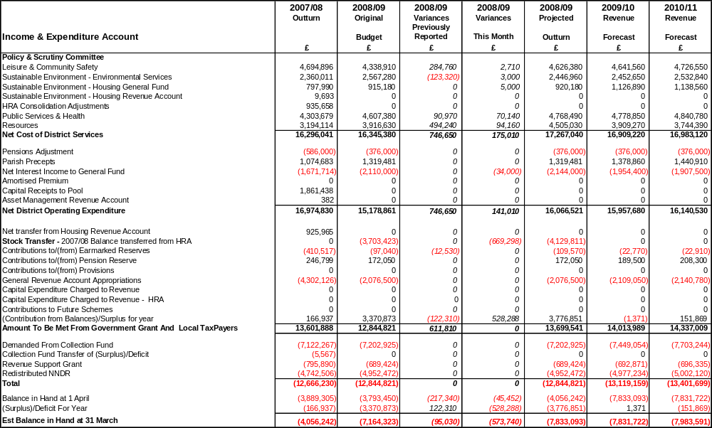
APPENDIX 2

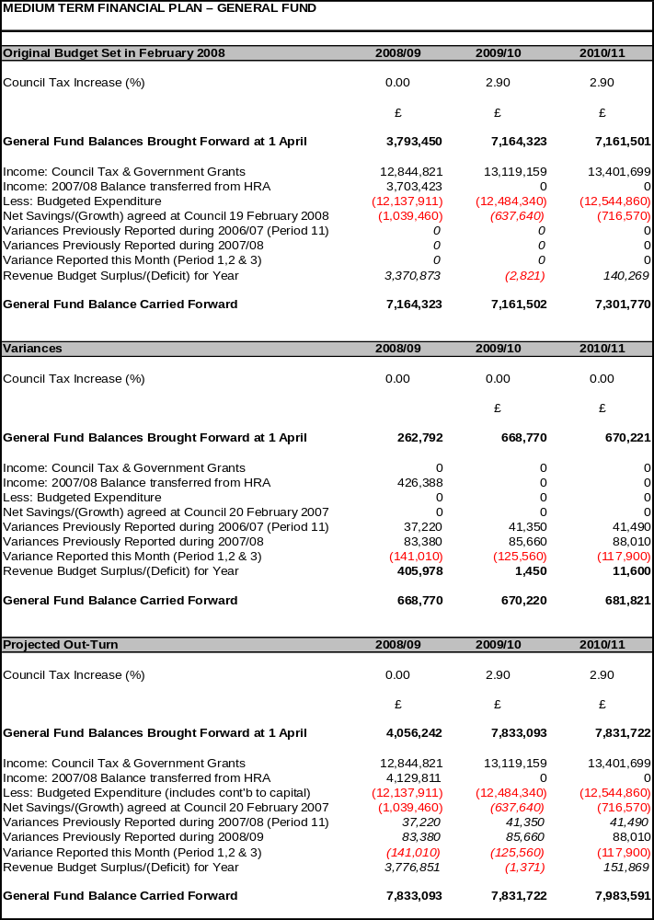
APPENDIX 3

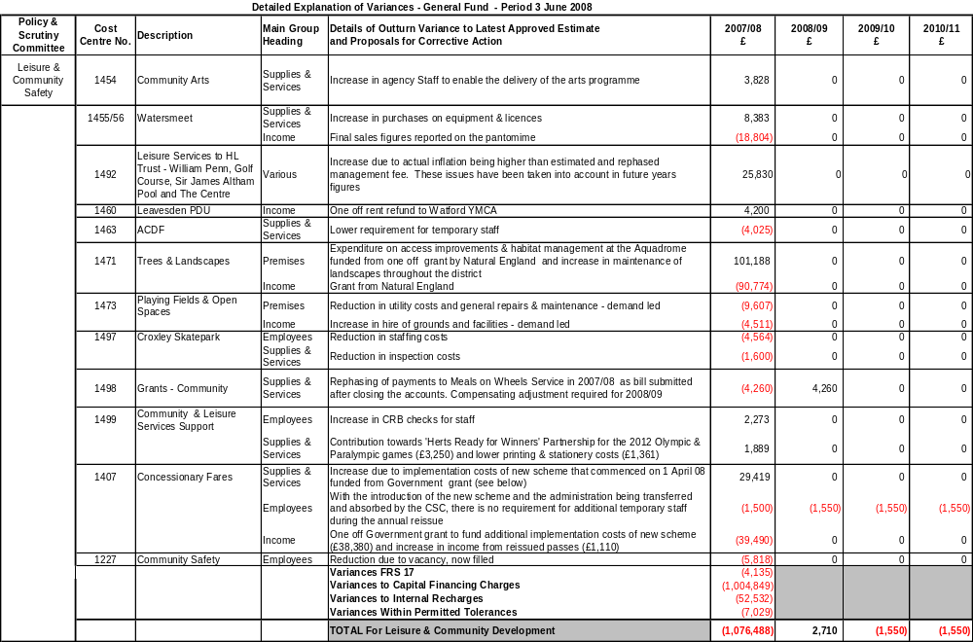

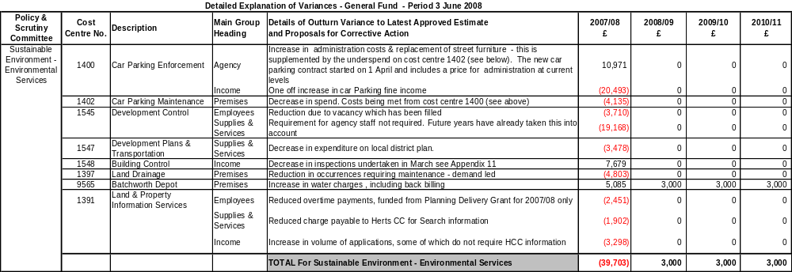

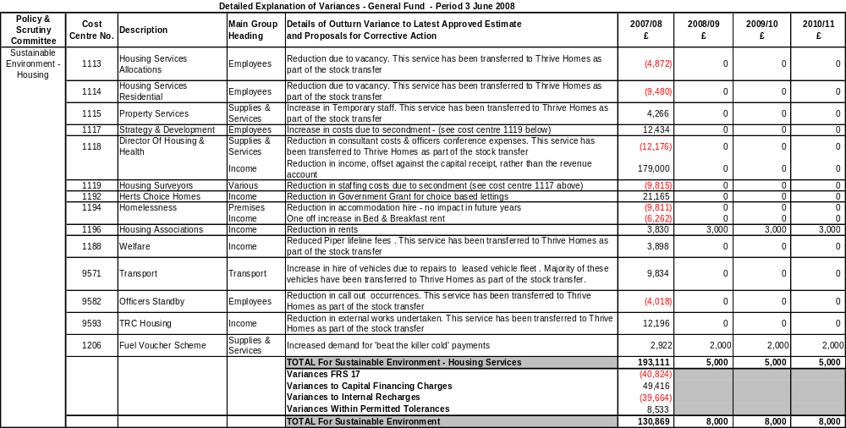

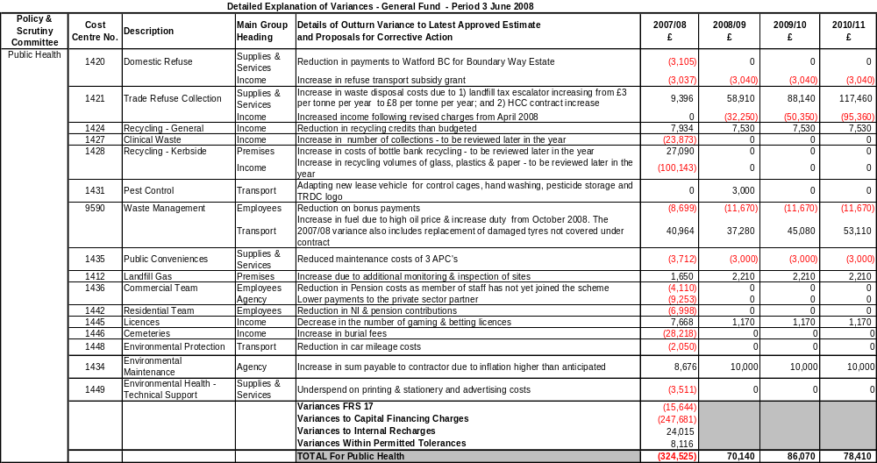

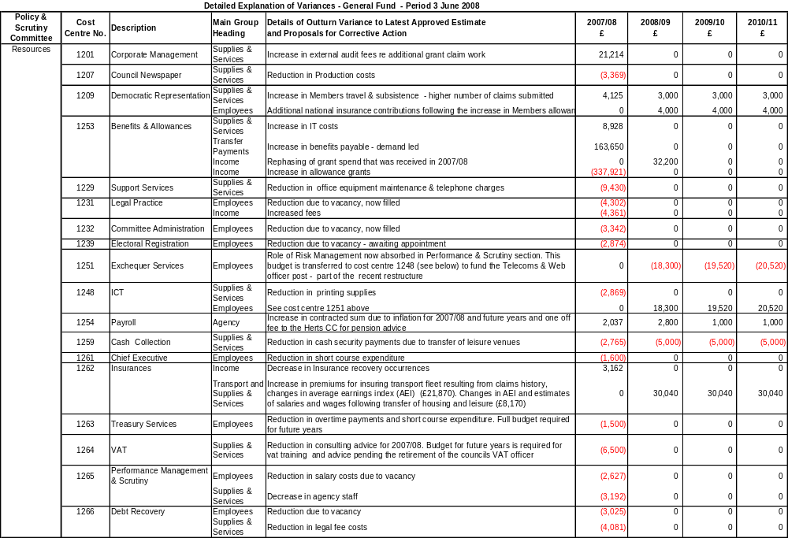
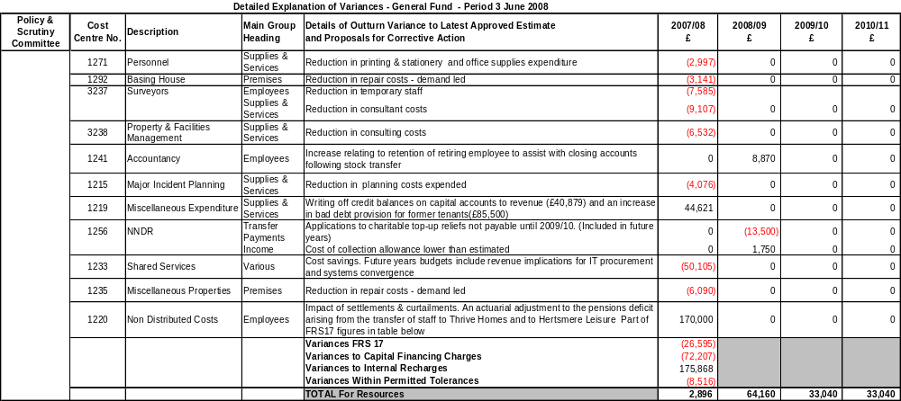

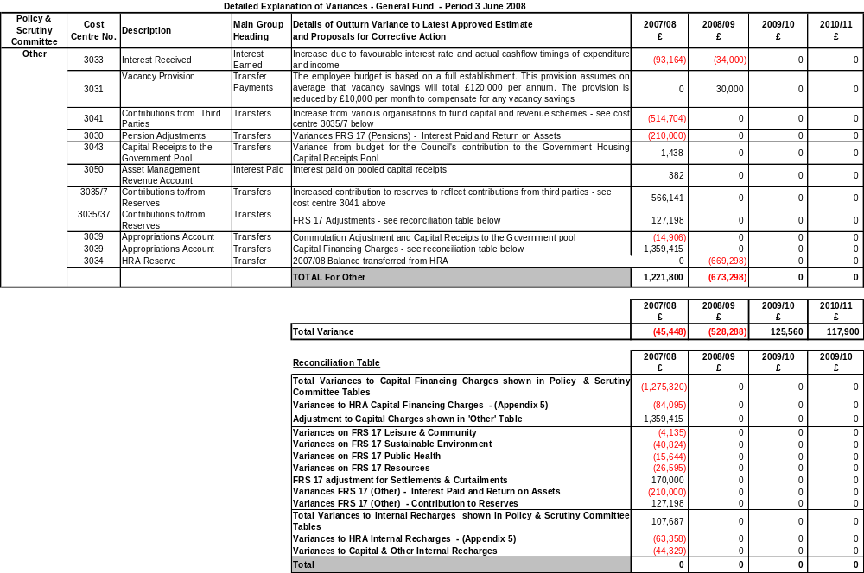

APPENDIX 4
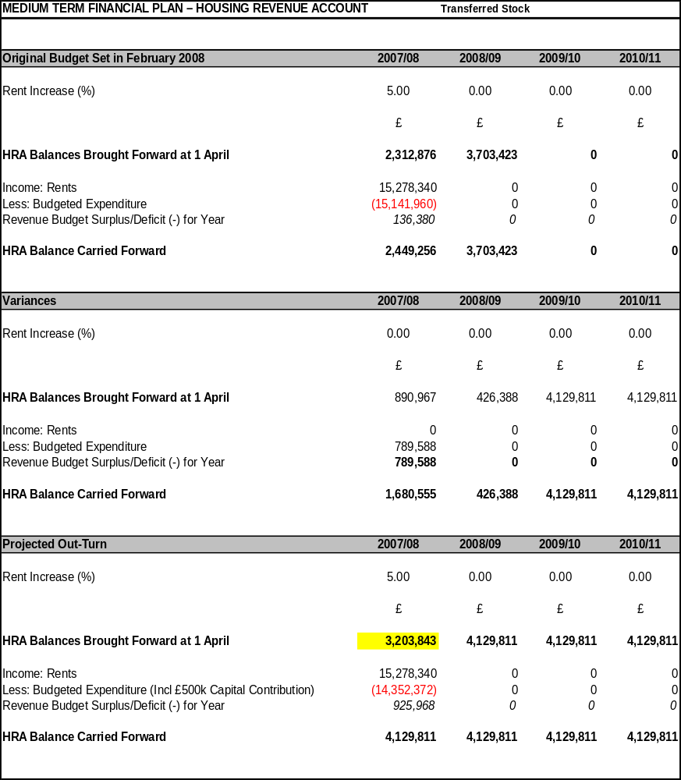

APPENDIX 5
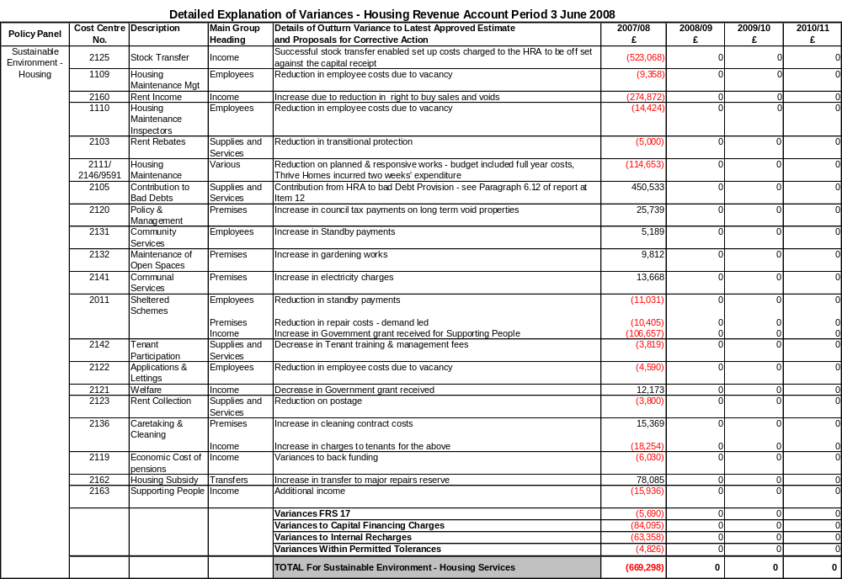

APPENDIX 6

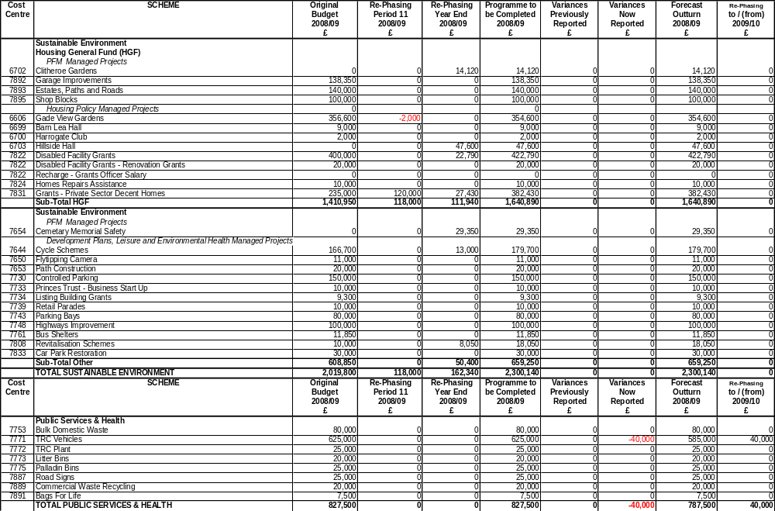

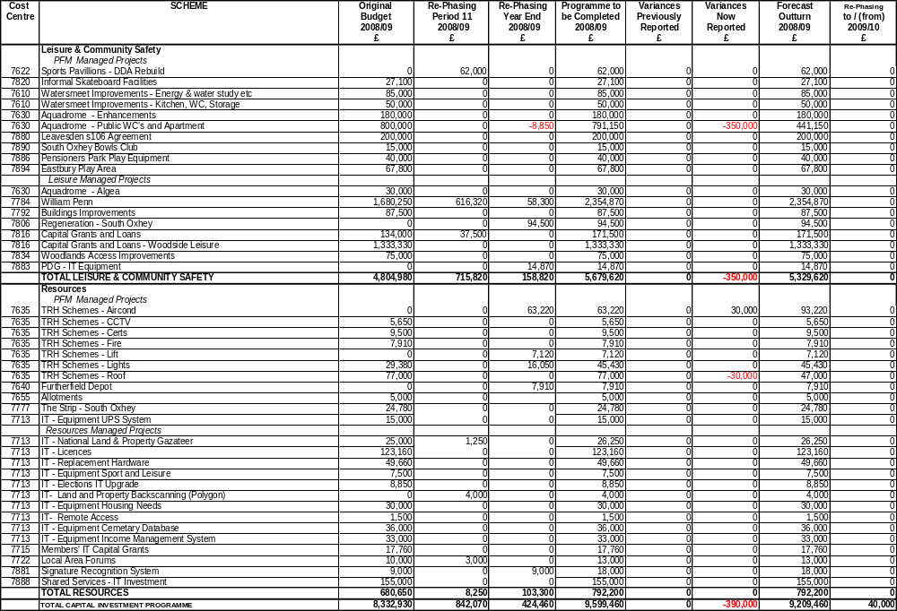
APPENDIX 7

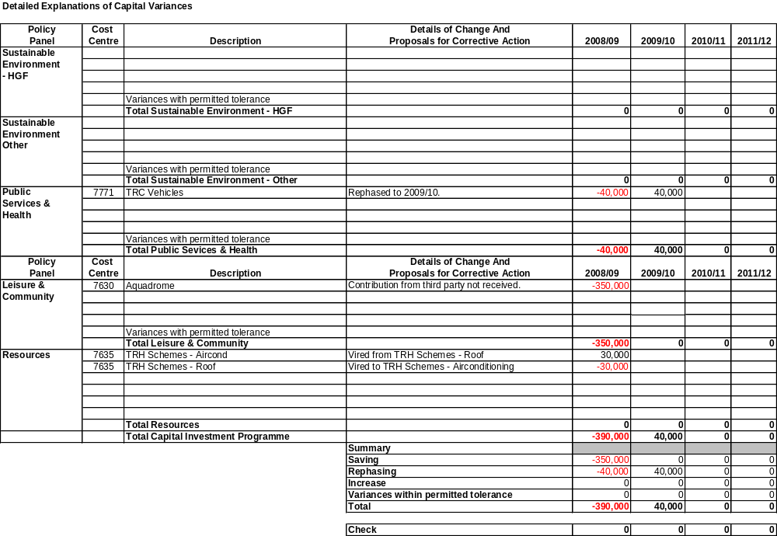

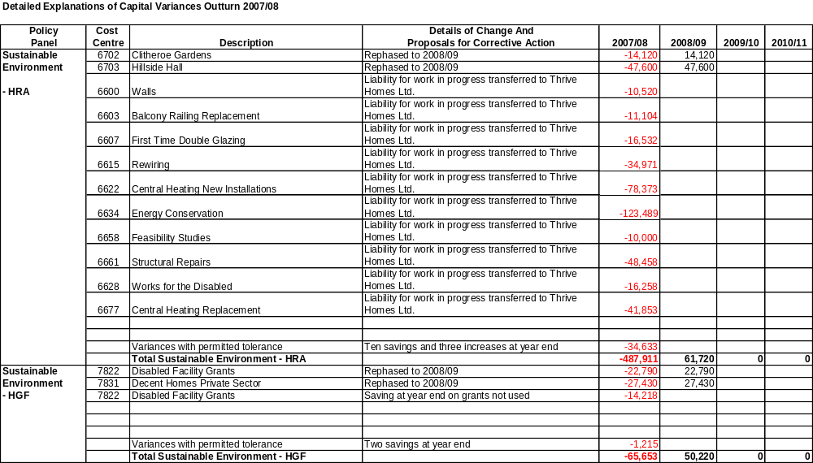
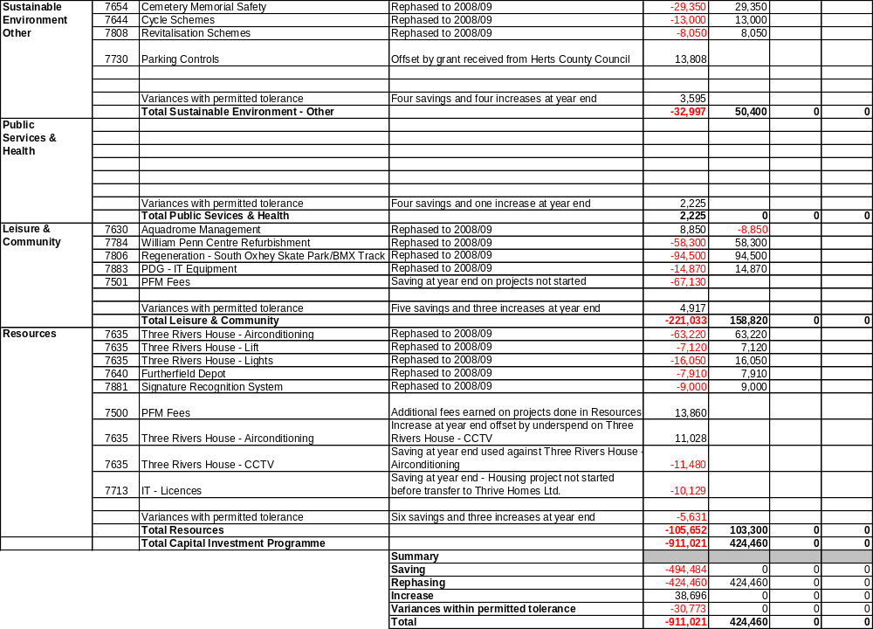

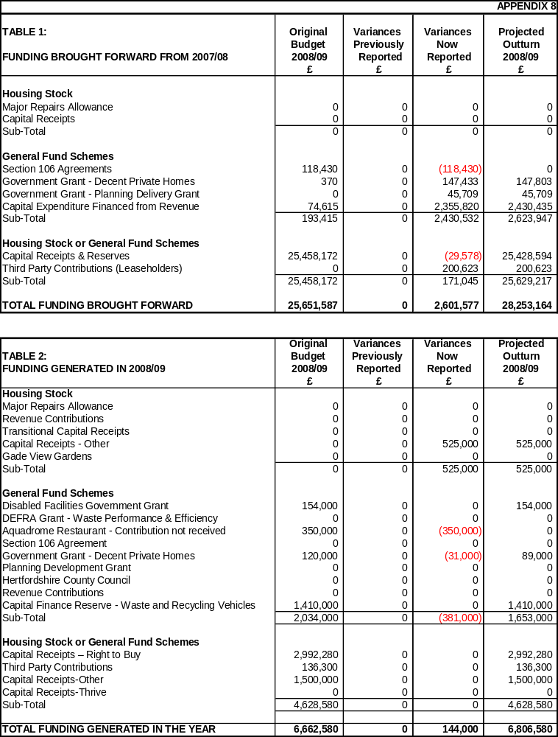
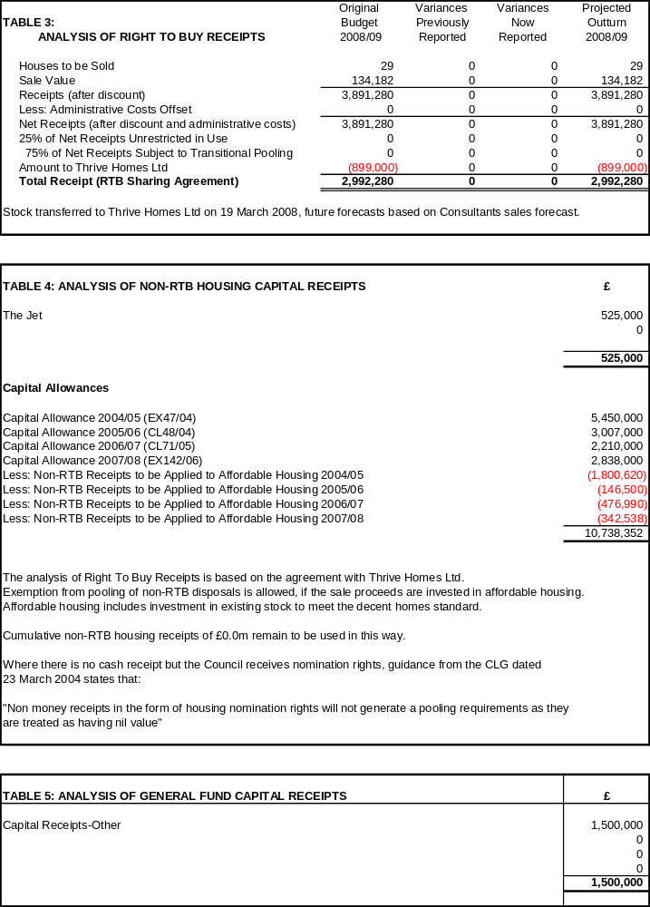

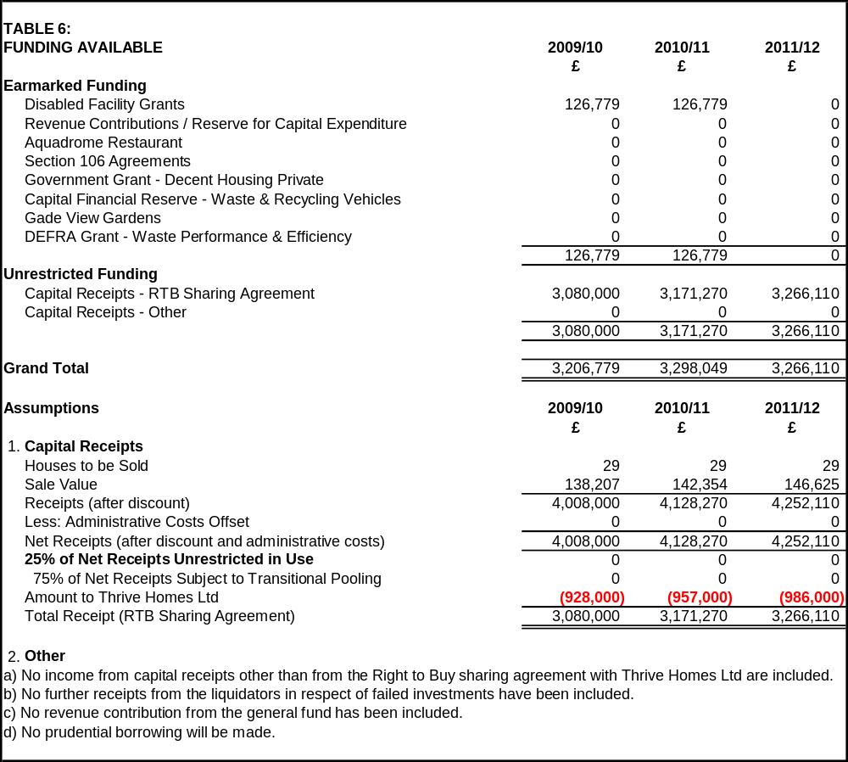

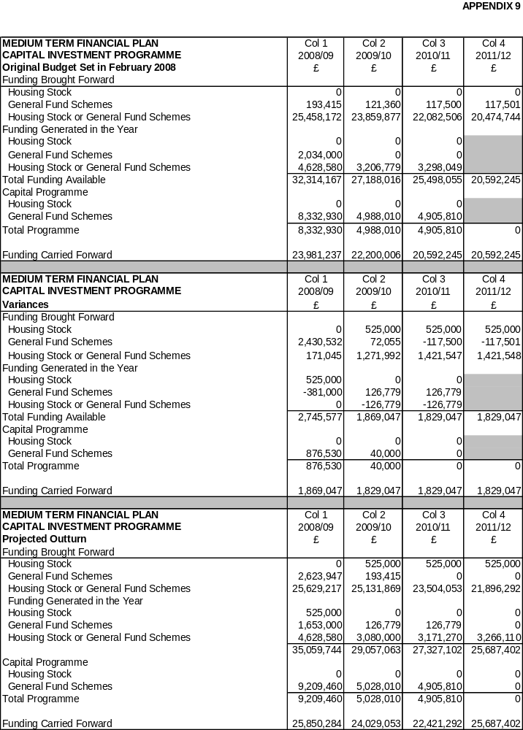
APPENDIX 10

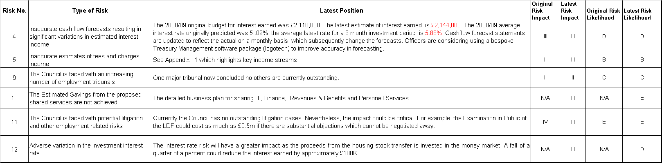

APPENDIX 11

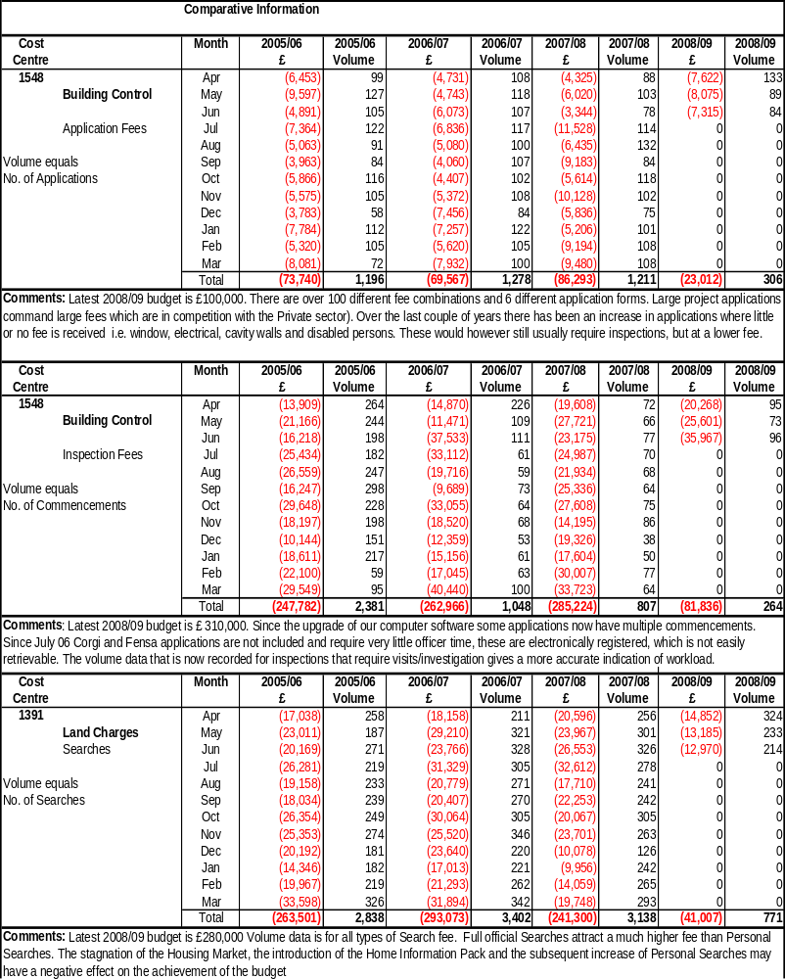
APPENDIX 12

COUNCIL’S POLICY ON OTHER RESERVES AND BALANCES

The Council is required to monitor and maintain its levels of reserves and balances within the range determined by its agreed policy.

The Policy for reserves and balances should be based on a thorough understanding of its needs and risks, and should be properly and clearly reported to members.

Below is a summary of the Balance Sheet as at 31 March 2008 (and comparatives at 31 March 2007). An understanding of the balance sheet will identify which balances need to be reviewed as part of budget monitoring. The annual statement of accounts was approved by the Audit Committee on 30 June 2008.

 |  |  | 31 March 2007 |  | 31 March 2008
 |  |  | £000 | £000 | £000 | £000
Total Fixed Assets |  |  |  | 357,581 |  | 46,278
Long-Term Debtors (Mortgages) |  |  |  | 400 |  | 357
Total Long-Term Assets |  |  |  | 357,981 |  | 46,635
Current Assets
 | Stocks and Work in Progress |  | 27 |  | 17
 | Debtors |  | 4,175 |  | 16,375
 | Investments |  | 22,316 |  | 46,851
 |  |  |  | 26,518 |  | 63,243
Total Assets |  |  |  | 384,499 |  | 109,877
Current Liabilities
 | Creditors |  | (4,842) |  | (23,381)
 | Cash Overdrawn |  | (1,091) |  | (207)
 |  |  |  | (5,933) |  | (23,588)
Total Assets less Current Liabilities |  |  |  | 378,566 |  | 86,289
Long-Term Liabilities
Pensions Liability |  |  |  | (8,846) |  | (5,530)
Grants & Contributions Deferred Account |  |  |  | (4,232) |  | (3,679)
Total Assets Less Liabilities |  |  |  | 365,488 |  | 77,080
Capital Adjustment Account |  |  |  | (3.55,156) |  | (1,706)
Usable Capital Receipts Reserve |  |  |  | (7,483) |  | (25,428)
Pensions Reserve |  |  |  | 8,846 |  | 5,530
Earmarked Reserves |  |  |  | (4,564) |  | (4,775)
General Reserves
- | General Fund |  |  | (3,889) |  | (4,056)
- | Housing Revenue Account |  |  | (3,204) |  | (4,130)
- | Collection Fund |  |  | (60) |  | 37
- | Other Reserves |  |  | 22 |  | 0
Total Equity |  |  |  | (365,488) |  | (77,080)

The following balances are reviewed on a regular basis:

Fixed Assets

Under the Valuers’ Conditions of Engagement, the Council has a five year rolling programme of valuations for all land and buildings, which is carried out throughout the year. In addition to the five year valuations, interim valuations are undertaken where major capital works are carried out and annual assessments for impairment are carried out.

Long-Term Debtors (Mortgages)

The management of the Mortgage portfolio is out-sourced to Gemini Consultants Ltd, who monitor all accounts and report to the Council on a monthly basis. No new mortgages have been granted in over 16 years, there are no significant arrears and balances are reducing in line with expectation.

Current Assets and Liabilities

Debtors

The Exchequer Services and Housing Services Service Plans include BV and TRC Performance Indicators to monitor the collection rates and level of outstanding debts on Sundry Debtors, Council Tax and NNDR payments and rental arrears. These are reported quarterly to Policy Panels.

A significant proportion of Debtors on the Balance Sheet at the year end is represented by Government Departments and other public bodies. These balances are difficult to monitor on a daily basis as the year end balances result from timing differences between claims to these departments and payment of the claims. Often the payments made by Government departments in the year are based on an estimate at the start of the year and the debtor at the year end is only paid after the final claim has been audited. Where, however, payments are made monthly, and interim claims can be submitted during the year, the base data to these claims can be monitored during the year. Such data includes:

The debit raised on NNDR (The total amount collected from NNDR Payers)

The debit affects the net amount payable to the Government NNDR pool. An estimate of the debit is made at the start of the Financial Year and a schedule of payments to the pool is issued based on this estimate. The NNDR debit is monitored weekly after receipt of valuation schedules from the Valuation Office Agency and also each month when BV10 (NNDR collected in year) is calculated. Any major changes in Total Rateable Value can be reported quarterly by means of an amended Government return (NNDR2) but the lower threshold set by Government for reporting such changes is approximately £125,000 in quarters one and two and £250,000 in quarters three and four for this Council. If the changes are above the threshold, an amended schedule of payments will be issued and this will also be monitored via the Treasury Management monthly cash flow.

Housing and Council Tax Benefit Subsidy

Housing and Council Tax Benefit Subsidy, together with gross salaries, pension payments, rents, interest earned, government grants and certain fees and charges are key budget indicators monitored monthly by the relevant Cost Centre Managers as part of the budget monitoring process. Major variances are reported in the monitoring reports.

Investments

Investment criteria are set in the Council’s Treasury Management Strategy reported to the Executive Committee twice a year. They are reviewed daily as part of the Treasury Management function and reported monthly to Members through the Members’ Information Bulletin.
Creditors

The overall Sundry Creditors figure at the year end also includes all accrued expenditure reflected in the accounts where goods or services have been received before the year end, but invoices have not been received from the suppliers in time to pay before the year end.

As with Debtors, the balance at the year end does not necessarily reflect this level of monitoring during the year because of timing differences between the collection of monies for third parties, such as Income Tax, Pension Contributions and VAT and the final payments to those third parties.

Members should note that where balances arise as a timing difference between final claim and payment based on estimates (either to of from the Government), the resultant year end balance can be either a Debtor or a Creditor, depending on whether the estimate was higher or lower than the final claim or payment.

Cash Overdrawn

Bank Balances are monitored daily as part of the Treasury Management function to ensure that excess balances are invested and debit balances avoided. The bank balances reconciled to the Council’s accounts monthly as part of the income function.

The Cash Overdrawn that appears on the balance sheet at the year end includes accruals and prepayments included in Debtors and Creditors and do not imply an actual cash overdraft.

Stock & Work In Progress

The Council does not hold any material stocks as it works on a ‘Just In Time’ ordering system.

Balance Sheet – Total Equity:

Executive Committee 4 February 2008 received a report entitled ‘Strategic, Service and Financial Planning 2007-2010’ which included an analysis of cash-backed balances and how they are used, and which are earmarked for specific purposes. This report is reproduced in the Council’s Medium Term Financial Plan.

The General Fund and HRA balances are monitored as part of the Budget Monitoring Report (See Appendix 2 and 4).

The policy for the use of capital receipts, and other Earmarked reserves which fund the Capital Investment Programme was set at Council on 19 February 2008. These balances are reviewed during the year to reflect changes in the Capital Investment Programme and the level of Capital Receipts (Asset sales) and reported as part of capital funding in budget monitoring reports (see Appendix 8).

The cash-backed elements of total equity are monitored as part of the Monthly Treasury Management Cash Flow reconciliation.

For certain balances and reserves (The Chairman’s Charity, Payroll Deductions – union payments, Court Orders, AVCs etc) there is not expected to be any significant movement during the financial year, and the overall balance is not material. The Balance Sheet is produced annually and reported in the statement of accounts. In the Foreword to the accounts, the Chief Financial Officer comments on uses and level of balances.

Monitoring Reserves and Balances – Council Policy

The majority of reserves and balances are monitored regularly as part of normal Council departmental activities or well established budget monitoring procedures as detailed above.

A positive decision has been made not to monitor non-material balances, or those on which there is very little movement during the year, but they are reviewed as part of the Council’s closing of accounts procedures, and commented on both at budget setting and in the foreword to the Statement of Accounts.

Larger Debtors and Creditors are, in general, beyond the Council’s control, but where additional claims and returns can be completed to closer match claims to payments during the year this is included in departmental procedures.

