EXECUTIVE COMMITTEE – 21 JULY 2008

LEISURE AND COMMUNITY SAFETY POLICY AND SCRUTINY COMMITTEE –

3 JUNE 2008

PART I - DELEGATED

7b. OLDER PERSONS’ PLAY PARK – LOCATION AND EQUIPMENT RECOMMENDATIONS
(DCES)

1. Summary

1.1 The purpose of this report is to detail equipment options for an older persons’ play park as well as options for the location of the proposed facility.

- Details

Background

  - Following the agreed capital budget on 19th February 2008 at the Full Council meeting to install outdoor play equipment for adults, Officers have met with a number of play equipment companies to establish what equipment is available on the market for adults.

  - ‘Play’ equipment for adults is restricted to either traditional trim trails, grouped pieces of exercise equipment or the newly introduced outdoor gym equipment, as seen recently in Manchester (see Appendix 1).

Equipment Options

  - Trim trails are designed to improve overall fitness levels and are mainly used by men and women with a reasonable level of fitness.

  - Trim trails tend to consist of monkey bars and other pieces of equipment (see Appendix 2 for illustrations), which are spread out in a trail through a park or woodland area.

  - Across Europe, trim trails or groups of equipment (Appendix 3 for illustrations) tend to be used in rehabilitation areas and supported housing, whereby a personal physiotherapist is on hand to ensure the equipment is being used correctly as part of a rehabilitation programme.

  - The other alternative is an outdoor gym. These have recently been developed and installed in a small number of locations across the country, including Manchester and London.

  - Outdoor gym equipment is very similar to the equipment found in a standard gym, however they do not require electricity or weights to operate and are made from the same robust material as children’s play equipment.

  - Specific gym equipment can be installed to target a particular fitness level or age group. For example, older people are more likely to use the tai chi wheels, massagers, space walkers and cross trainers (see Appendix 4 for illustrations).

  - This type of equipment is installed with clear, detailed signage to instruct people on how to use the equipment correctly. Advice is provided to consult with a doctor if the person is unsure of their own physical fitness.

  - Many of the companies do not stipulate the need for safety surfacing, due to a low free fall height (maximum level of height a user can fall from whilst on the equipment). However, some advise using either grass rubber matting or wet pour to prevent the area around the equipment from becoming muddy.

2.11 Due to the outdoor-open access nature of the equipment it would be advisable to follow the Manchester example and install the more gym orientated equipment. This would reach a far wider number of residents; those who regularly exercise, together with older, less confident members of the community.

2.12 Indicative quotes detailing costs for the proposed equipment, including specific equipment items, safety surfacing and signage are attached as an Appendix (Appendix 5).

Location Options

2.13 Officers have reviewed all the parks and open spaces to identify where the best location for the ‘older persons’ play park’ would be.

2.14 Factors which were considered when assessing the locations include space to site the park, accessibility, ancillary facilities, informal supervision, trained and proactive staff to offer inductions if need be, refreshment facilities, and the opportunity to enhance community usage and Green Flag applications.

2.15 After this assessment, three main open spaces were identified as potentially meeting the criteria: Leavesden Country Park, King George V Playing Fields and the Aquadrome Local Nature Reserve (LNR).

2.16 The Aquadrome LNR has space to site the park, close to the Café in the Park, next to Bury Lake. The development of facilities also means it will benefit from new public toilets and a new refreshment area. With the application for Green Flag being submitted in 2009, the installation of a older persons’ park will also enhance the community usage and strengthen the application. However, from June 2009 there will no longer be a requirement for a grounds person to be based on site at all times, which means there will potentially be periods when there is no guarantee of informal supervision of the park. On the other hand, the new toilets will have a flat above the facility which will be occupied by someone to provide a presence on site to mitigate vandalism.

2.17 The second location is King George V Playing Fields, which, with its close location to William Penn Leisure Centre, could provide trained staff in which to deliver inductions and provide support if need be. William Penn could also offer refreshment and toilet facilities for users of the park. On the other hand, there is not a lot of space to site the park, due to the installation of the teenage equipment and the football pitches on the playing fields. Secondly, older people may find it intimidating to use the facility in an area with high numbers of young people; this will therefore affect the usage.

2.18 The third location is Leavesden Country Park, which has space to site the park, either next to the existing children’s play equipment or in the area adjacent to the car park. The appointment of a Park Ranger will also offer the opportunity for informal supervision as well as the ability to communicate and consult with the users. YMCA Woodlands have ancillary facilities as well as a refreshment area. There is also the opportunity to partnership with the YMCA Woodlands to provide trained staff who can deliver induction sessions to less confident older people as well as a staff presence year round.

2.19 On balance, Leavesden Country Park along with the strong partnership of YMCA Woodlands and the appointment of a Park Ranger, will provide the best opportunity to maximise the usage of the ‘older persons’ play park’, whilst providing the necessary facilities and space to site the park. Many older people will feel nervous about using the facilities for the first time and with the presence of trained staff and a Park Ranger, their confidence levels should increase over time.

3. Options/Reasons for Recommendation

3.1 The purpose of this report is to detail equipment options for an older persons’ play park as well as options for the location of the proposed facility.

4. Policy Implications

4.1 The recommendations in this report are within the Council’s agreed policy as identified in the 2008-2011 Strategic Plan.

4.2 The facility will provide equal access to leisure activities, increase play opportunities for the local community, and meet the needs and expectations of customers.

5. Financial Implications

  - A capital budget of £40,000 for a ‘pensioner’s play park’ was agreed at Full Council for the 2008/2009 financial year on 19th February 2008.

  - To date the annual revenue costs have not been included in this new project.

  - Some companies offer a maintenance charge of 7.5% per year of the cost of the equipment (e.g. equipment costing £28,000 will have a revenue implication of £2,100 per year) to guarantee the equipment for 5 years. Therefore on a scheme costing £40,000, a budget of £3,000 is required for ongoing maintenance of the equipment, with a further £1,000 for incidental vandalism, graffiti and rubbish collection.

CASH IMPLICATION | Current Year 2008/09  £ | 2009/10  £ | 2010/11  £ | Future Years per annum  £
Capital Expenditure | 40,000 | 0 | 0 | 0
Revenue Consequences
Expenditure | 2,000* | 4,000 | 4,000 | 4,000
Income/Savings
Net Revenue Commitment | 2,000 | 4,000 | 4,000 | 4,000

* Full year maintenance will not be required for this financial year as the ‘older persons’ play park’ will not be installed until towards the end of the financial year.

6. Legal Implications

6.1 The works for the installation of the equipment will be tendered under the Council’s procedures and managed by the Property and Facilities Management team.

7. Equal Opportunities Implications

7.1 Relevance Test

Has a relevance test been completed for Equality Impact? | Yes
Did the relevance test conclude a full impact assessment was required? | No

See Appendix 5 for the Relevance Test

8. Staffing Implications

8.1 The project will require the time of the Active Communities Officer and a Building Surveyor to oversee project management, consultation and installation of the new facility, with advice from the Principal Landscape Officer and the Leisure Development Manager.

9. Environmental Implications

9.1 The installation of a new older persons’ play park will increase the provision of community facilities in the public open space.

9.2 It will contribute to an increase in the levels of different age groups using a local public space.

10. Community Safety Implications, Customer Services Centre Implications, Communications and Website Implications

10.1 None specific

11. Risk Management Implications

11.1 The Council has agreed its risk management strategy which can be found on the website at http://www.threerivers.gov.uk. The risk management implications of this report are detailed below.

11.2 The subject of this report is covered by the Leisure service plan. Any risks resulting from this report will be included in the risk register and, if necessary, managed within this plan.

11.3 The following table gives the risks if the recommendations are agreed, together with a scored assessment of their impact and likelihood:

Description of Risk |  | Impact | Likelihood
1 | Incidents of accident and injury | II | D
2 | Surveillance of the area to minimise the opportunity for inappropriate activity | II | E
3 | Incidents of graffiti | II | D
4 | Incidents of vandalism | II | D

11.4 The following table gives the risks that would exist if the recommendation is rejected, together with a scored assessment of their impact and:

Description of Risk |  | Impact | Likelihood
5 | Incidents of accident and injury | III | B
6 | Reduced surveillance of the area to minimise the opportunity for inappropriate activity | III | B
7 | Incidents of graffiti | III | B
8 | Incidents of vandalism | III | B

11.5 The above risks are plotted on the matrix below depending on the scored assessments of impact and likelihood, detailed definitions of which are included in the risk management strategy. The Council has determined its aversion to risk and is prepared to tolerate risks where the combination of impact and likelihood are plotted in the shaded area of the matrix. The remaining risks require a treatment plan.

Likelihood | A |  |  |  |  |  | Impact | Likelihood
Likelihood | B |  |  | 5, 6, 7, 8, |  |  | V = Catastrophic | A = >98%
Likelihood | C |  |  |  |  |  | IV = Critical | B = 75% - 98%
Likelihood | D |  | 1, 3, 4 |  |  |  | III = Significant | C = 50% - 75%
Likelihood | E |  | 2 |  |  |  | II = Marginal | D = 25% - 50%
Likelihood | F |  |  |  |  |  | I = Negligible | E = 2% - 25%
Likelihood |  | I | II | III | IV | V |  | F = <2%
Likelihood | Impact

11.6 In the officers’ opinion none of the new risks above, were they to come about, would seriously prejudice the achievement of the Strategic Plan and are therefore operational risks. The effectiveness of treatment plans are reviewed by the Audit Committee annually.

12. Recommendation

12.1 That the ‘older persons’ play park’ will consist of outdoor gym equipment, rather than a trim trail, because it is specifically designed for the less active older person.

12.2 That the ‘older persons’ play park’ will be located in Leavesden Country Park

12.3 That the Committee recommend to the Executive Committee a revenue growth of £2,000 for 2008/2009 financial year and £4,000 for 2009/2010 onwards for the annual maintenance of the new facility

Report prepared by: Charlotte Masters, Active Communities Officer

Background Papers

None

Appendices/Attachments

Appendix 1 – Press Cutting for Manchester Outdoor Gym
Appendix 2 – Trim Trail Equipment
Appendix 3 – Grouped Equipment
Appendix 4 – Outdoor Gym Equipment
Appendix 5 – Quotes for Older Persons’ Park
Appendix 6 – Relevance Test

APPENDIX 1 – PRESS CUTTING FOR MANCHESTER’S OUTDOOR GYM

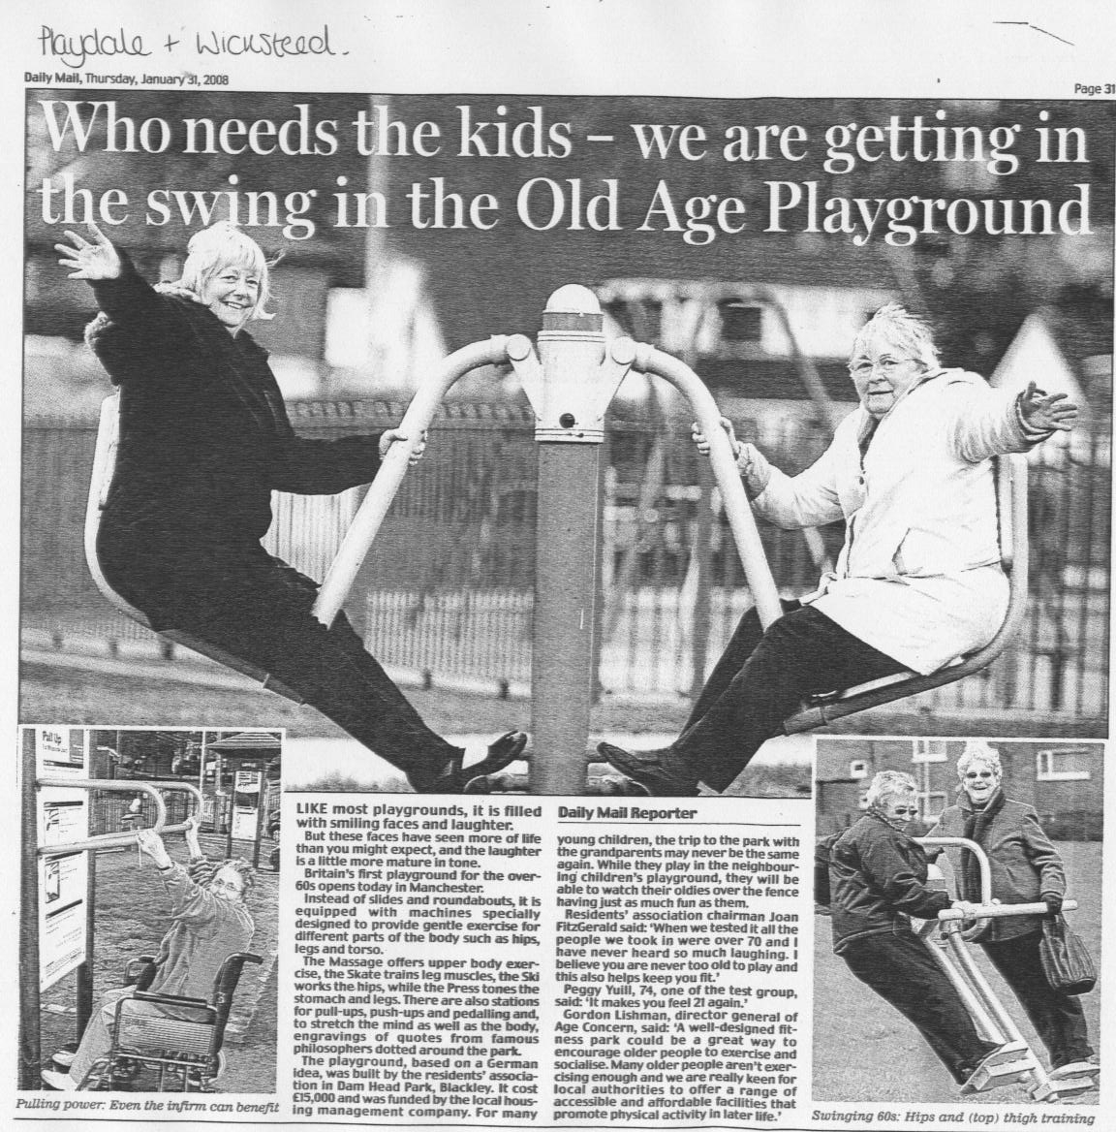
APPENDIX 2 – TRIM TRAIL EQUIPMENT
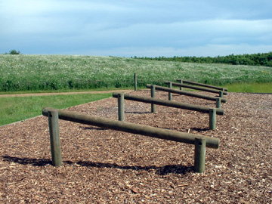
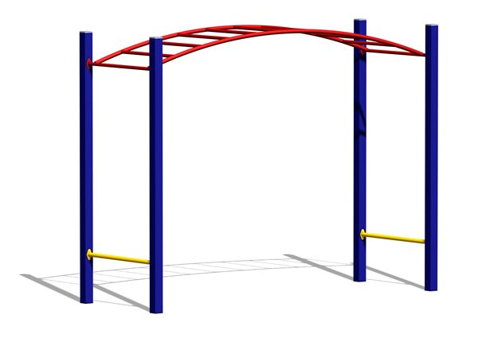
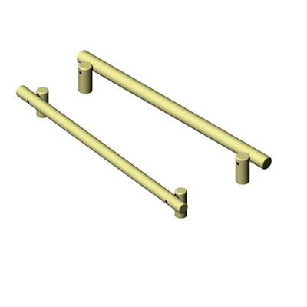

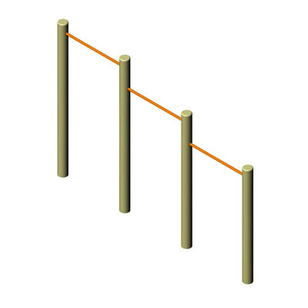

APPENDIX 3 – GROUPED EQUIPMENT
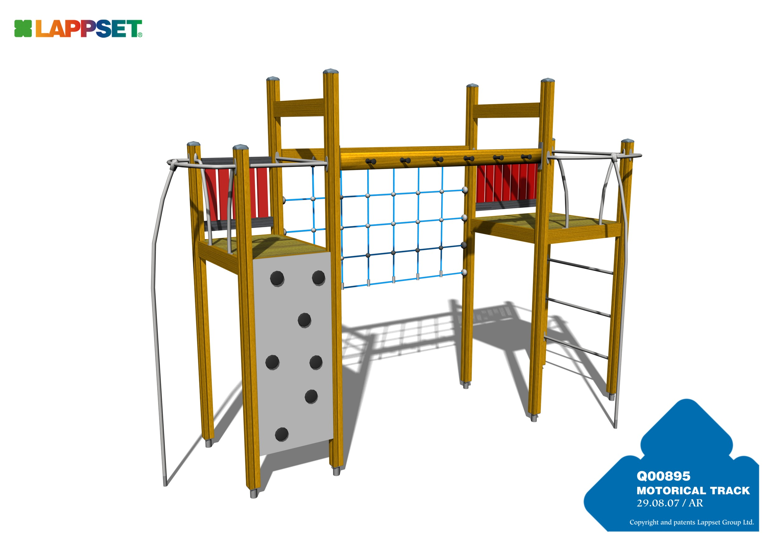
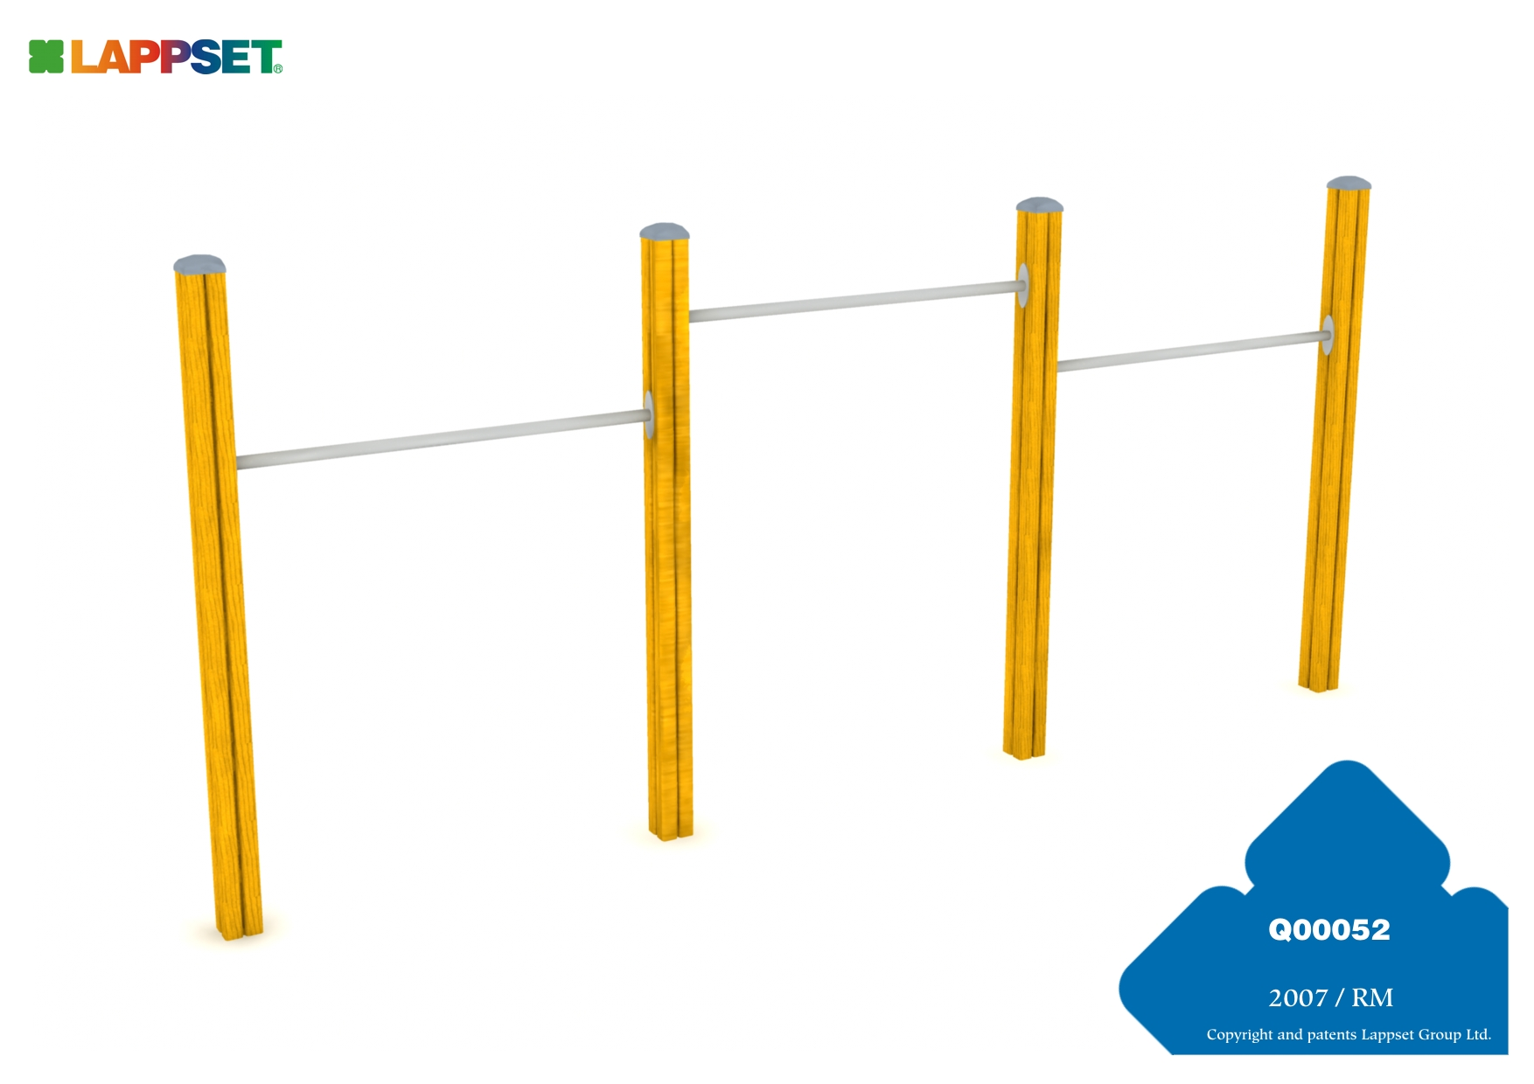
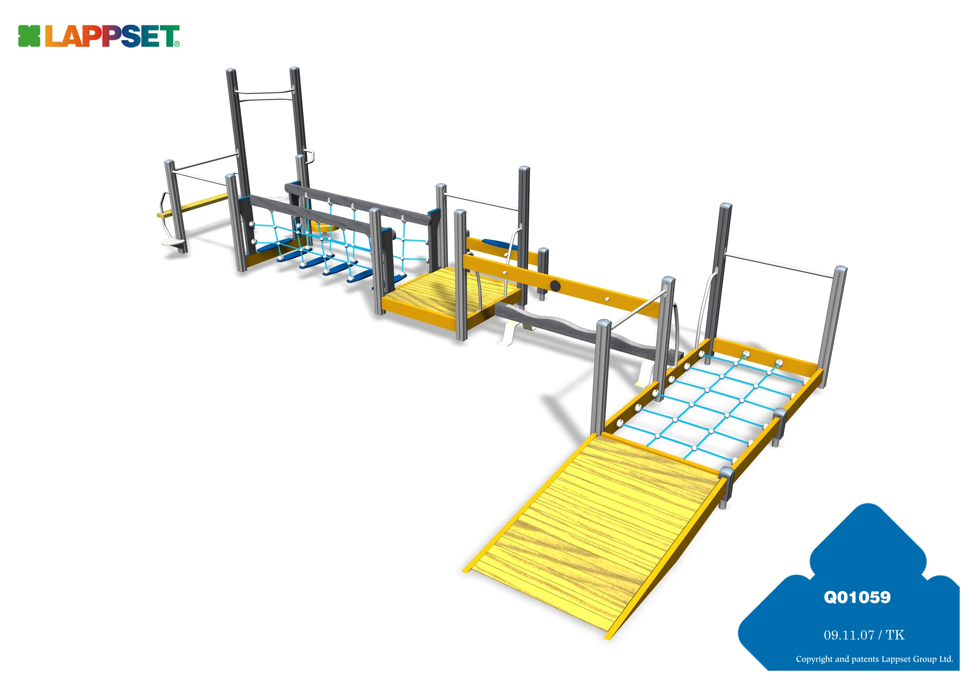
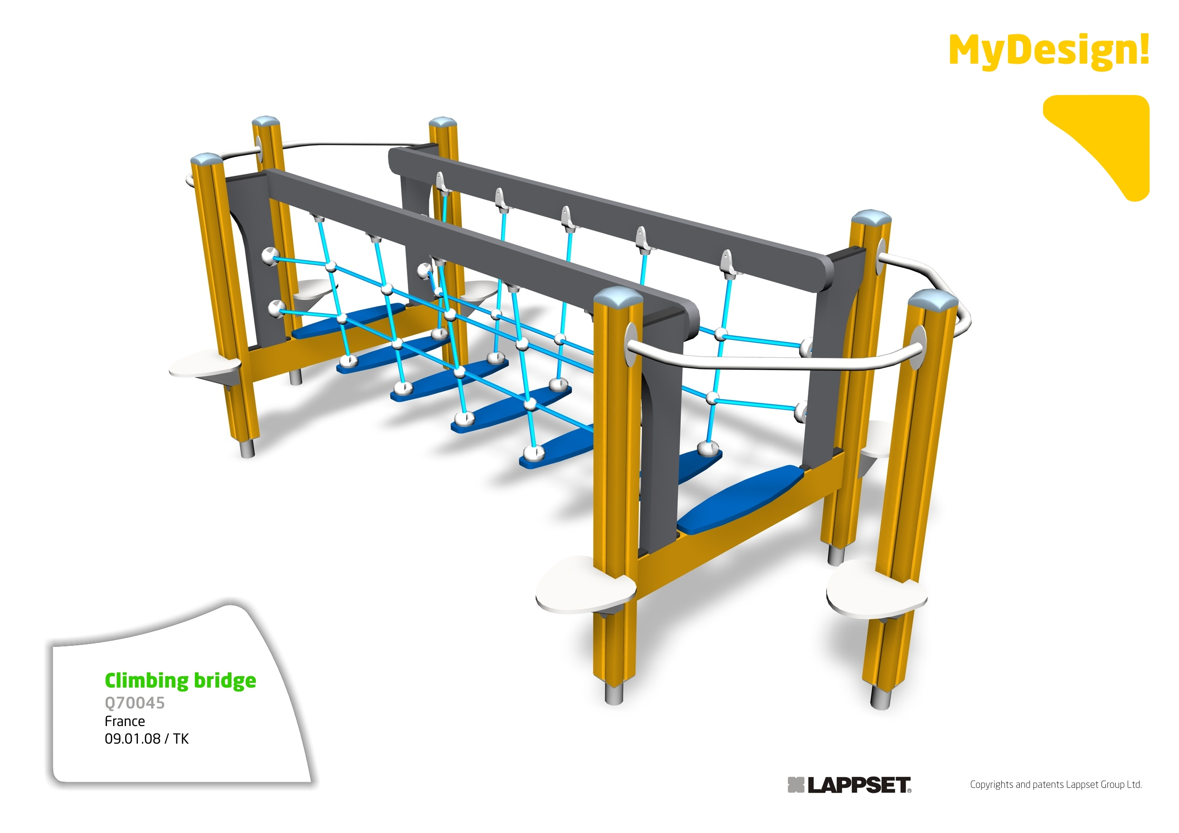
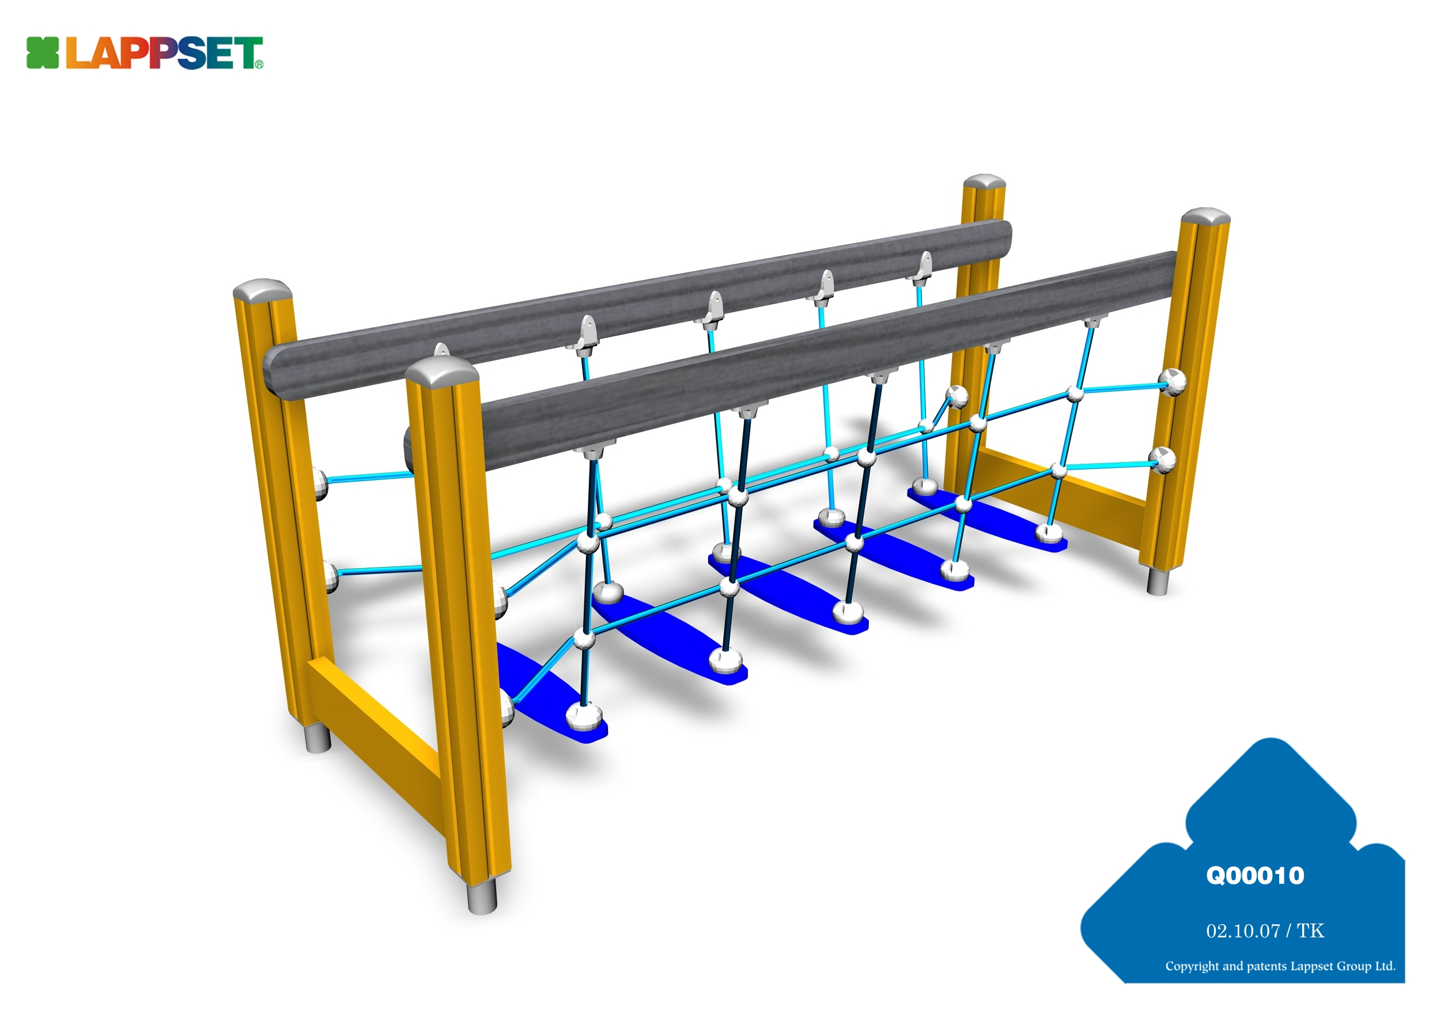
APPENDIX 4 – OUTDOOR GYM EQUIPMENT
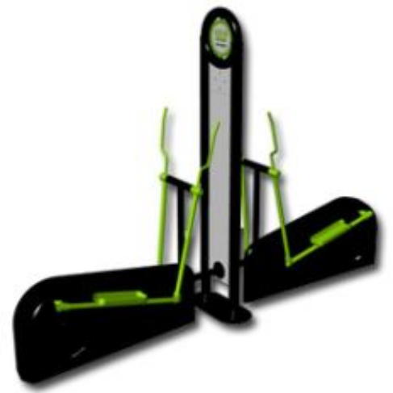
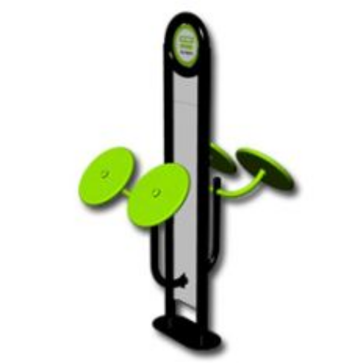
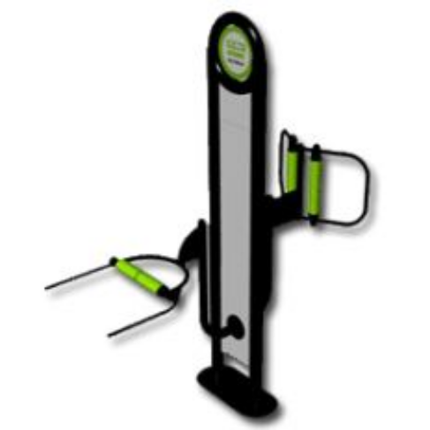
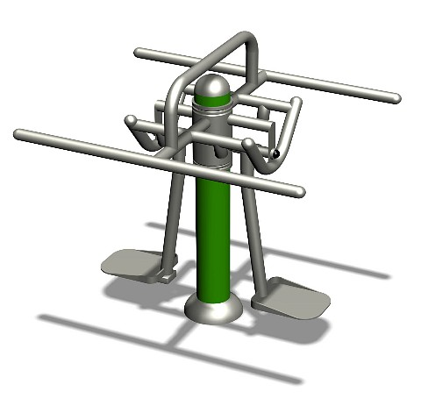
CROSS TRAINER
MASSAGER
TAI CHI WHEELS
SPACE WALKER
SURFER

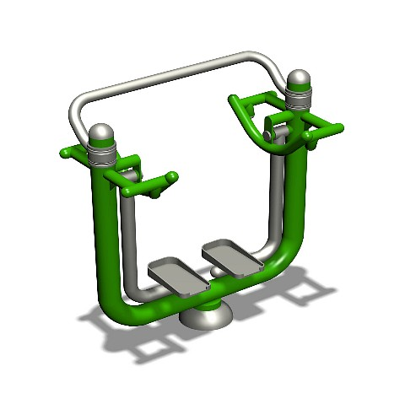
APPENDIX 5 – QUOTES FOR OLDER PERSON’S PARK

Please note these are indicative quotes only and are subject to the formal tendering process.

One site only

Company 1

Items | Cost
10 stations, including all ground works, installation, safety surfacing (coloured wetpour), signage and delivery:  - Fitness Bike  - Double Station Cross Trainer  - Double Station Cross Trainer  - Double Station Tai Chi  - Double Station Tai Chi  - Double Station Massager  - Double Station Massager  - Combination Stepper and Oblique  - Combination Chest Press  - Combination Lats Pull Down | £28,000
Fees @ 13% | £3,640
TOTAL | £31,640

Company 2

Items | Cost
10 Stations and installation:  - Skier  - Surfer  - Space Walker  - Body Twister  - Horseback Rider  - 4 Wheel Spinner  - Agility Bench  - Roller Back Massager  - Pull Down Exerciser  - Leg Press | £16, 536
Safety Surfacing (Black Wetpour) and provide base into existing grass | £2,277
Sign for the equipment and installation of the sign x 3 | £2,388
Security Fencing and warning signs to be erected prior to installation and removed once installation is complete | £350
Provision of secure storage either on site, close to site, or mobile as necessary | £350
Delivery of equipment | £819
Sub Total | £22,720
Fees at 13% | £2,953.60
TOTAL | 25,673.60

Company 3

Items | Cost
12 Stations:  - Ski Stepper  - Ski Stepper  - Sit Up  - Waist Twister  - Leg Stretch  - Power Push  - Mini Ski  - Pull Down Challenger  - Health Walker  - Parallel Rails  - Push Hands  - Handle boat | £14,511
Installation of the equipment | £1,800
Ground Fixings for HAGS gym | £1,068
Safety Surfacing – Black Wetpour | £4,069
Groundwork’s for Wetpour (machine hire, labour and cart spoil) | £3,308
Concrete kerb edging | £2,218
Storage Facility | £450
Security Fencing | £550
Sub Total | £27,974
Fees @ 13% | £3,636.62
TOTAL | £31,610.62

Quotes for Leavesden Country Park and the Aquadrome LNR

Company 2 (Estimates based on the cost of 10 items)

Items | Cost
7 Stations and installation:  - Skier  - Surfer  - Space Walker  - Horseback Rider  - 4 Wheel Spinner  - Roller Back Massager  - Pull Down Exerciser | £11,575.20
Safety Surfacing (Black Wetpour) and provide base into existing grass | £1,539.90
Sign for the equipment and installation of the sign x 3 | £2,388
Security Fencing and warning signs to be erected prior to installation and removed once installation is complete | £350
Provision of secure storage either on site, close to site, or mobile as necessary | £350
Delivery of equipment | £573.30
Sub Total | £16,776.40
Fees at 13% | £2,180.93
TOTAL | £18,957.33
TOTAL FOR 2 SITES | £37,914.66

Company 3 (Estimates based on 12 items)

Items | Cost
7 Stations:  - Ski Stepper  - Waist Twister  - Mini Ski  - Pull Down Challenger  - Health Walker  - Push Hands  - Handle boat | £8,464.75
Installation of the equipment | £1,050
Ground Fixings for HAGS gym | £623
Safety Surfacing – Black Wetpour | £2,373.58
Groundwork’s for Wetpour (machine hire, labour and cart spoil) | £3,308
Concrete kerb edging | £1,293.83
Storage Facility | £450
Security Fencing | £550
Sub Total | £18,113.16
Fees @ 13% | £2,354.71
TOTAL | £20,467.87
TOTAL FOR 2 SITES | £40,935.74

APPENDIX 6 – RELEVANCE TEST
Form A – Relevance Test

Function/Service Being Assessed:
1. Populations served/affected:
Universal (service covering all residents)?

Targeted (service aimed at a section of the community –please indicate which) ?

2. Is it relevant to the general duty? (see Q and A for definition of ‘general duty’)
Which of these three aspects does the function relate to (if any)?:

1 – Eliminating Discrimination
2 – Promoting Equality of Opportunity
3 – Promoting good relations

Is there any evidence or reason to believe that some groups could be differently affected?
Yes
No

Which equality categories are affected?
Race
Age
Sexual Orientation
Disability
Gender
Religion

3. What is the degree of relevance?
In your view, is the information you have on each category adequate to make a decision about relevance?
Yes (Yes it is open to all and is free of charge)

No (specify which categories)

Are there any triggers for this review (for example is there any public concern that functions/services are being operated in a discriminatory manner?) If yes please indicate which:
Yes

No

4. Conclusion
On the basis of the relevance test would you say that there is evidence that a medium or high detrimental impact is likely? (See below for definition)
Yes
No

Note: if a medium or high detrimental impact has been identified then a full impact assessment must be undertaken using Form B.
Completed forms should attached as an appendix to the relevant report and a copy sent to the Community Partnerships Unit in Corporate Development, Strategic Services.

Definition of Low, Medium or High detrimental impact.
For any one (or more) equality group the following evidence is found:

Evidence may come from one or more of the following sources:
- Local service data
- Data from a similar authority (including their EIA)
- Customer feedback
- Stakeholder feedback
- National or regional research
High Relevance | There evidence shows a clear disparity between different sections of the community in one or more of:  - levels of service access;  - quality of service received; or  - outcomes of service.
Medium Relevance | The evidence is unclear (or there is no evidence) if there is any disparity in terms of:  - levels of service access;  - quality of service received; or  - outcomes of service.
Low Relevance | The evidence shows clearly there is no disparity in terms of:  - levels of service access;  - quality of service received; or  - outcomes of service.

