EXECUTIVE COMMITTEE – 6 APRIL 2009

LEISURE & COMMUNITY SAFETY POLICY & SCRUTINY COMMITTEE 9 JUNE 2009

PUBLIC SERVICES AND HEALTH POLICY & SCRUTINY COMMITTEE – 11 JUNE 2009

SUSTAINABLE ENVIRONMENT POLICY & SCRUTINY COMMITTEE – 23 JUNE 2009

RESOURCES POLICY & SCRUTINY COMMITTEE - 25 JUNE 2009

AUDIT COMMITTEE – 15 APRIL 2009

PART 1 – NOT DELEGATED

5. BUDGET MONITORING REPORT – FEBRUARY 2009 (MONTH 11)
(DCRG)

1. Summary

1.1 This report seeks approval to changes in the approved medium-term financial plan based on information contained in the Financial Position Statement for the period ending on 25 February (Month 11).

2. Details

  - Members are welcome to raise questions on the figures prior to any discussion at the meetings listed above. Indeed, it would be helpful if questions could be notified in advance to ensure that comprehensive responses are available to members at the meetings. Queries should be addressed in the first instance to the Accountancy Practice (accountancy.practice@threerivers.gov.uk) who will ensure an answer is provided by the responsible budget holder.

3. Options/Reasons for Recommendations

  - The recommendations below enable the Executive Committee to make recommendations to Council concerning the Council’s budget.

4. Policy/Budget

4.1 There are no substantial changes to Council policy resulting from this report. Increases in budgets requiring the use of the Council’s balances must be approved by the Council. Virements between services (at cost centre level) may be approved by the Executive Committee along with proposals for the use of ‘windfall’ income.

5. Financial Implications

5.1 The Council’s activities are funded either from the council tax – these are (General Fund) revenue accounts that include the day to day income and expenditure of the council – or from capital sources which are used to create assets benefitting the community over the longer term. The Council’s budget monitoring concentrates on these two key accounts each of which has a three-year medium term financial plan associated with it. These financial plans are updated with monthly variations on a rolling basis.

Revenue Income & Expenditure Account

5.2 A summary of the Revenue Medium-Term Financial Plan including cumulative variances and balances is shown below:-

 | 2008/09  £ | 2009/10  £ | 2010/11  £ | 2011/12  £
Year End Balance – Original Budget | 7,164,323 | 7,161,502 | 7,301,770 | 7,301,770
Variances During the Year
- Change to Opening Balance | 262,792 | 2,065,900 | 114,837 | -823,713
- Previously Approved to Date | 1,650,018 | -1,878,493 | -942,780 | -408,653
- This Month | 153,090 | -72,570 | 4,230 | 4,230
Sub-Total Variances to Date | 2,065,900 | 114,837 | -823,713 | -1,228,136
Year End Balance – Out-turn Forecast | 9,230,223 | 7,276,339 | 6,478,057 | 6,073,634

Capital Investment Programme and its Funding

  - A summary of the changes to capital expenditure and its funding during the year is shown below:-

 | 2008/09 | 2009/10 | 2010/11 | 2011/12
 | £ | £ | £ | £
Year End Balance – Original Budget | 23,981,237 | 22,200,006 | 20,592,245 | 20,592,245
Variances to Funding During the Year
- Change to Opening Balance | 2,601,577 | (1,682,018) | (3,647,497) | (4,934,106)
- Previously Approved to Date | (3,852,646) | (1,965,479) | (1,286,609) | 2,958,770
- This Month | (430,949) | 0 | 0 | 0
Sub-Total Funding Variances to Date | (1,682,018) | (3,647,497) | (4,934,106) | (1,975,336)
Variances to Programme During Year
- Change to Original Budget | 0 | (407,780) | (1,227,330) | 886,180
- Previously Approved to Date | (857,300) | (666,240) | 2,113,510 | (2,469,340)
- This Month | 449,520 | (153,310) | 0 | 0
Sub-Total Programe Variances to Date | (407,780) | (1,227,330) | 886,180 | (1,583,160)
Year End Balance – Out-turn Forecast | 21,891,439 | 17,325,179 | 16,544,319 | 17,033,749

5.4 The key changes to the capital programme and its funding are:-

- The Private Sector Decent Homes Grants awarded by TRDC shows a variance of £300k due to applications not meeting grant criteria.

- The receipt from the sale of Gade View Gardens has been removed from 2008/09 and no receipt is shown in future years until position resolved.

- The number and amount received for Right To Buy Sales for 2008/09 are shown in the table below;

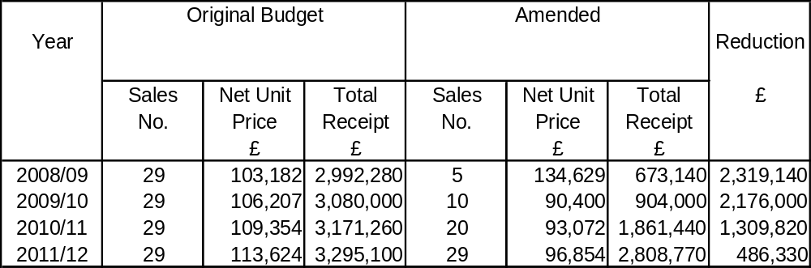

6. Legal, Equal Opportunities, Staffing, Environmental, Community Safety, Customer Services Centre and Website

6.1 None specific.

7. Risk Management Implications

7.1 The Council has agreed its risk management strategy which can be found on the website at http://www.threerivers.gov.uk .

7.2 There are no risks to the Council in agreeing the recommendations in this report.

7.3 The following table gives the risks that would exist if the recommendations are rejected, together with a scored assessment of their impact and likelihood:

Description of Risk |  | Impact | Likelihood
1 | The Council’s Medium-Term Financial Plan would be out of date and officers would not have accurate budgets to work to. | III | A

7.4 The above risk is plotted on the matrix below depending on the scored assessments of impact and likelihood, detailed definitions of which are included in the risk management strategy. The Council has determined its aversion to risk and is prepared to tolerate risks where the combination of impact and likelihood are plotted in the shaded area of the matrix. This risk would require a treatment plan and be included in the Accountancy Practice Service Plan.

Likelihood | A |  |  | 1 |  |  | Impact | Likelihood
Likelihood | B |  |  |  |  |  | V = Catastrophic | A = >98%
Likelihood | C |  |  |  |  |  | IV = Critical | B = 75% - 98%
Likelihood | D |  |  |  |  |  | III = Significant | C = 50% - 75%
Likelihood | E |  |  |  |  |  | II = Marginal | D = 25% - 50%
Likelihood | F |  |  |  |  |  | I = Negligible | E = 2% - 25%
Likelihood |  | I | II | III | IV | V |  | F = <2%
Likelihood | Impact

7.5 In the officers’ opinion the risk above, were it to come about, would seriously prejudice the achievement of the Strategic Plan and would therefore be a strategic risk to be monitored quarterly by the executive Committee. The effectiveness of all treatment plans are reviewed by the Audit Committee annually.

7.6 The Accountancy Practice Service Plan also includes financial and budgetary risks details of which are included in the Financial Position Statement.

8. Recommendation

To Council:-

  - That the following revenue variations be approved and incorporated into the three-year medium-term financial plan:-

 | 2008/09  £ | 2009/10  £ | 2010/11  £ | 2011/12  £
Overspend / (Underspend) | (153,090) | 72,570 | (4,230) | (4,230)

  - That the following capital variations be approved and incorporated into the three-year medium-term financial plan:-

 | 2008/09  £ | 2009/10  £ | 2010/11  £ | 2011/12  £
Increase / Decrease in Capital Funding Increase / Decrease in Capital Investment Programme | (430,949)  449,520  21,891,439 | 0  (153,310)  17,325,179 | 0  0  16,544,319 | 0  0  17,033,749

8.3 To the Policy & Scrutiny Committees:

That this report be noted.

Report prepared by: Alan Power – Accountancy Manager

Nigel Pollard – Finance Manager

Stephen Exton – Finance Manager

Dot Reynolds – Finance Manager

Background Papers: Financial Position Statement

FINANCIAL POSITION STATEMENT



FEBRUARY 2009 (MONTH 11)

CONTENTS

Page Page
1 |  | Introduction
2 |  | Revenue – Summary Income & Expenditure Account  This statement summarises the revenue account which includes the council’s day to day income and expenditure and which is met from council tax.
3 |  | Revenue – Three-Year Medium-Term Financial Plan  This statement shows in summary the three-year medium-term financial plan for the revenue account as it was when budgets were set in February 2008, variations to that budget since February, and the out-turn that is now projected.
4 |  | Revenue – Explanation of Variances  This section gives the changes to budgets that have occurred since the last Financial Position Statement.
7 |  | Capital Investment Programme  This table shows changes to the Capital Investment Programme for the current year that have occurred since setting the original budget in February 2008
9 |  | Capital Investment Programme – Variances  This table gives detailed explanations of the changes to the capital investment programme that have occurred since the last Financial Position Statement
10 |  | Capital – Funding Available  This series of tables gives the funding available for capital expenditure brought forward into the current financial year, the funding generated during the year, funding anticipated in future years and variances to the amounts since the original budget was set in February 2008.
12 |  | Capital – Three-Year Medium-Term Financial Plan  This statement shows in summary the three-year medium-term financial plan for capital expenditure and its funding as it was when budgets were set in February 2008, variations to that budget since February, and the out-turn that is now projected.
13 |  | Financial & Budgetary Risks  This statement shows how the Council is monitoring its financial and budgetary risks.
15 |  | Income from Fees & Charges  Significant budget variations on fees and charges is one of the budgetary risks. This series of tables shows quantitative and monetary trends in key income budgets.
16 |  | Reserves & Balances  The statement explains how the Council monitors and maintains its levels of reserves and balances within the range determined by its agreed policy.
20 |  | Efficiency Gains  This statement shows how the Council is achieving efficiency gains

1 Introduction

1.1 This Financial Position Statement gives an update of the medium-term financial plan as at 25 February 2009.

1.2 Members are welcome to raise questions on the figures prior to any discussion at committee meetings. Indeed, it would be helpful if questions could be notified in advance to ensure that comprehensive responses are available to members at the meetings. Queries should be addressed in the first instance to the Accountancy Practice. (accountancy.practice@threerivers.gov.uk) who will ensure an answer is provided by the responsible budget holder.

SUMMARY INCOME AND EXPENDITURE ACCOUNT
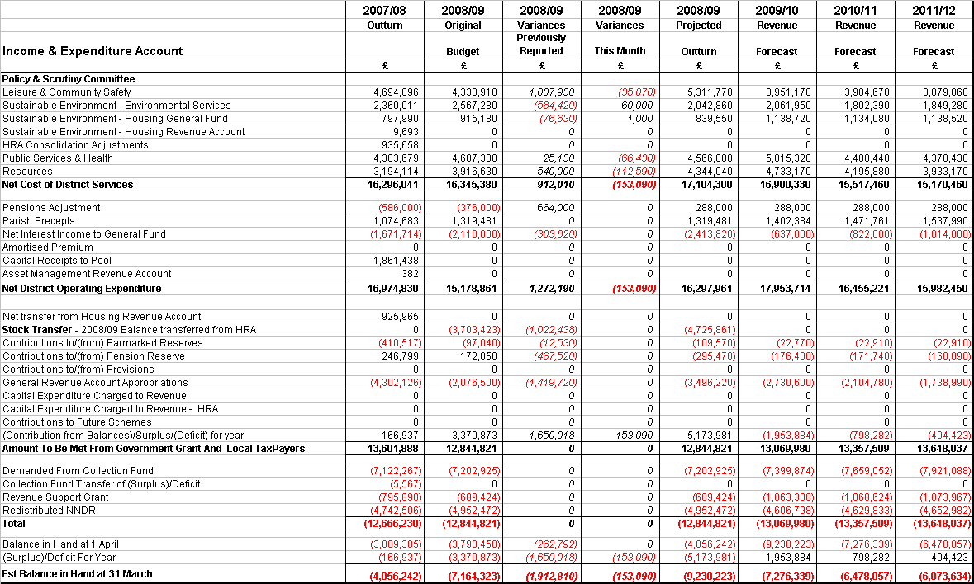

THREE-YEAR MEDIUM-TERM FINANCIAL PLAN – REVENUE ACCOUNT

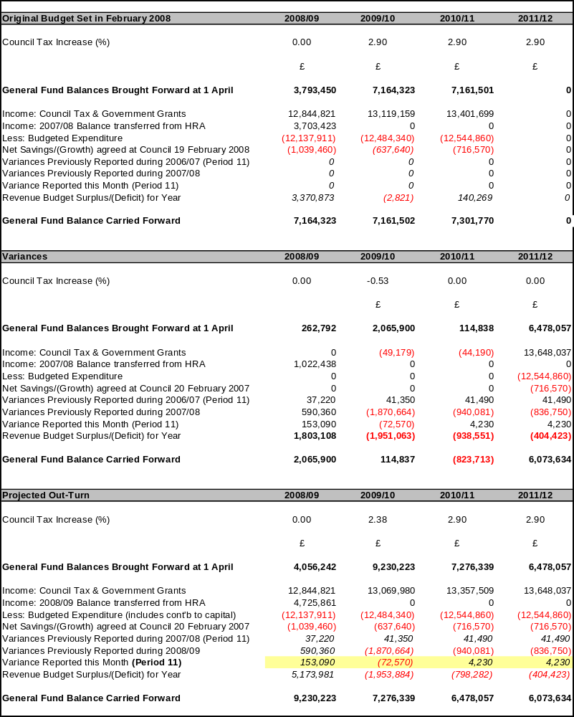
REVENUE – EXPLANATION OF VARIANCES
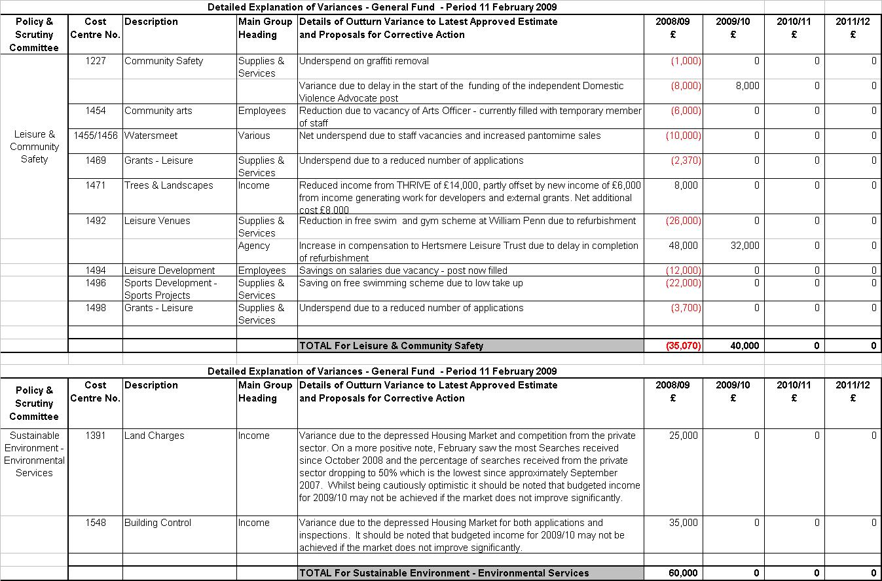

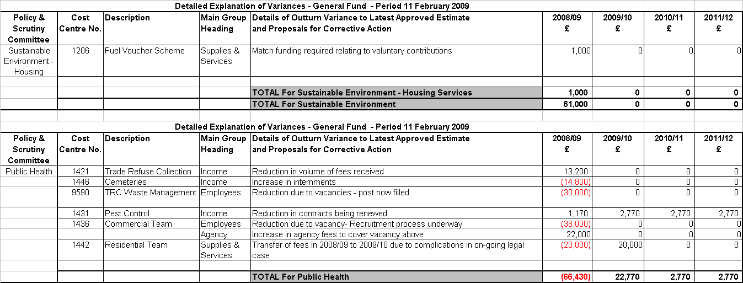

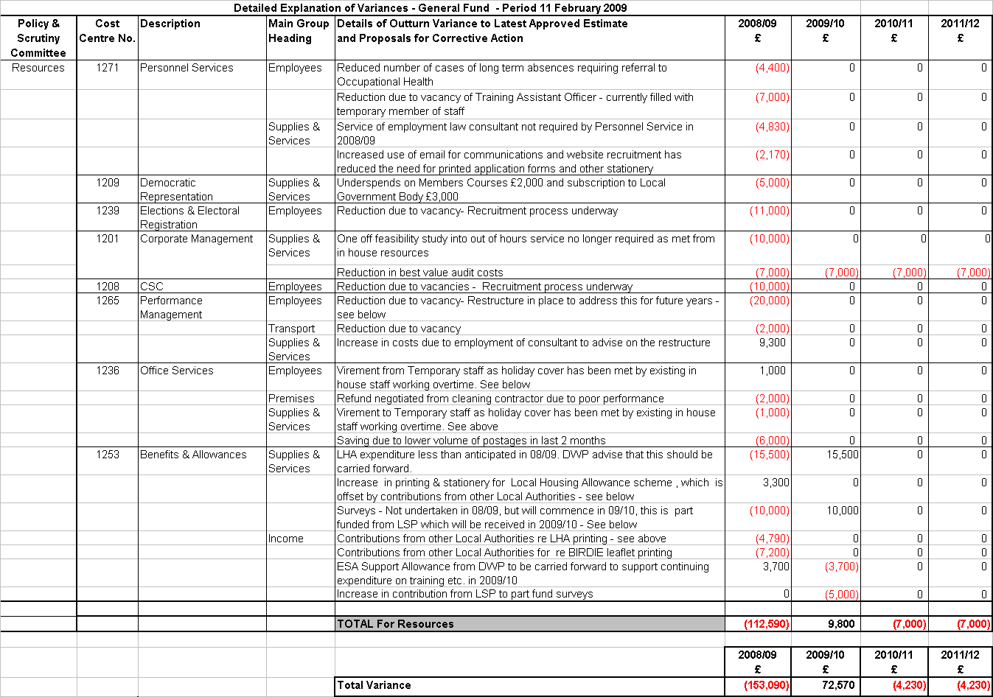
CAPITAL INVESTMENT PROGRAMME
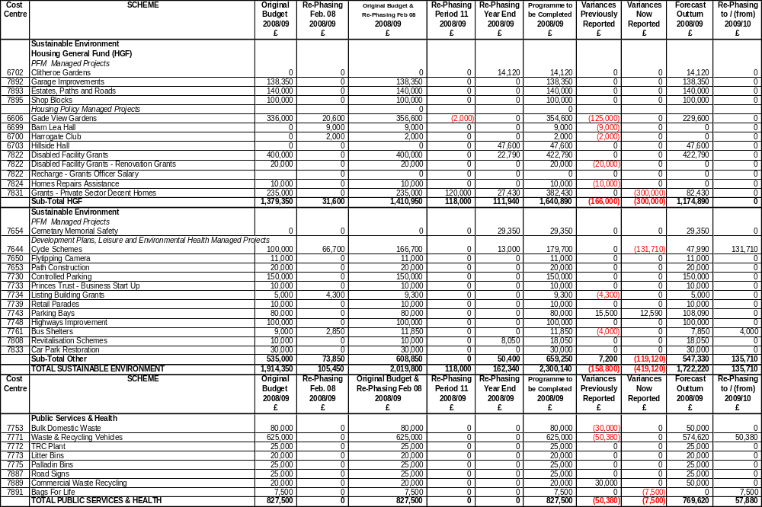
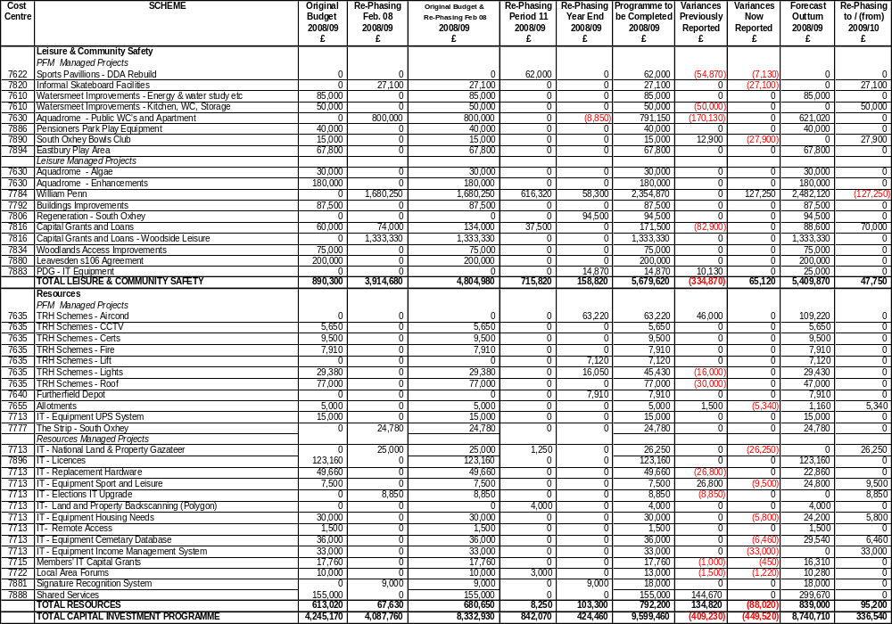
CAPITAL INVESTMENT PROGRAMME VARIANCES

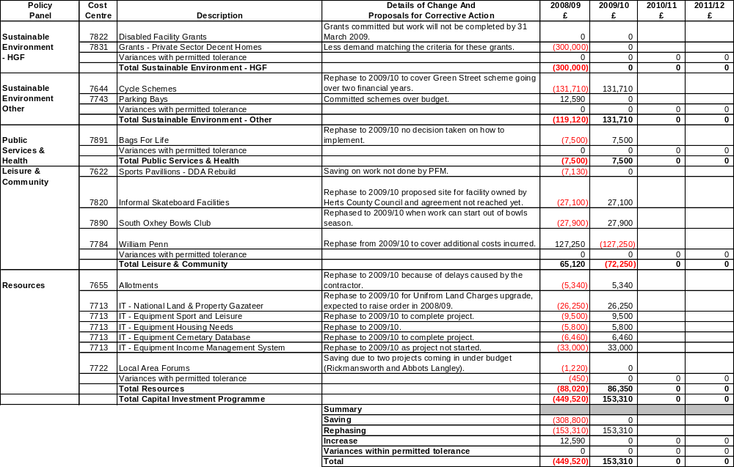
FUNDING AVAILABLE FOR CAPITAL

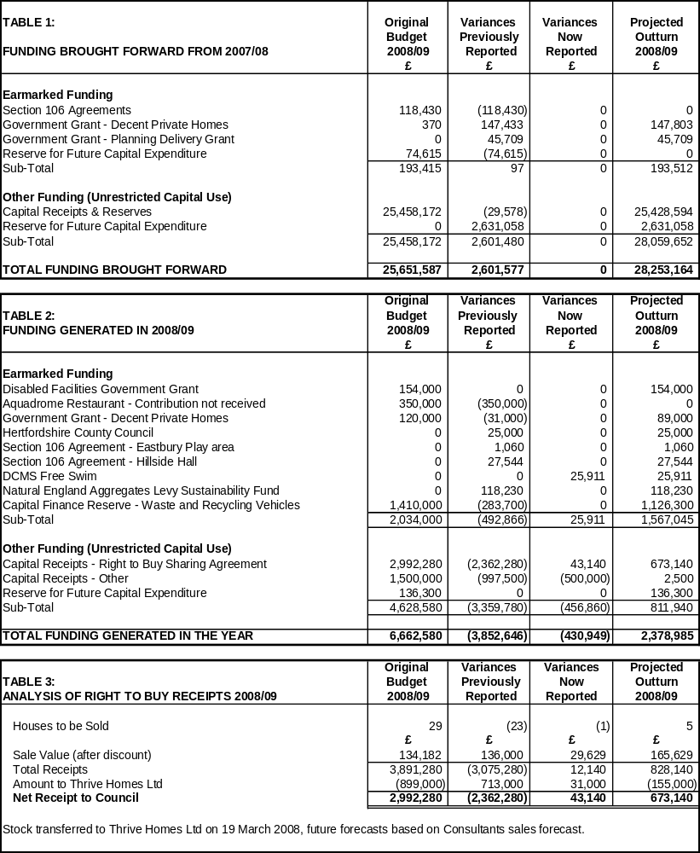

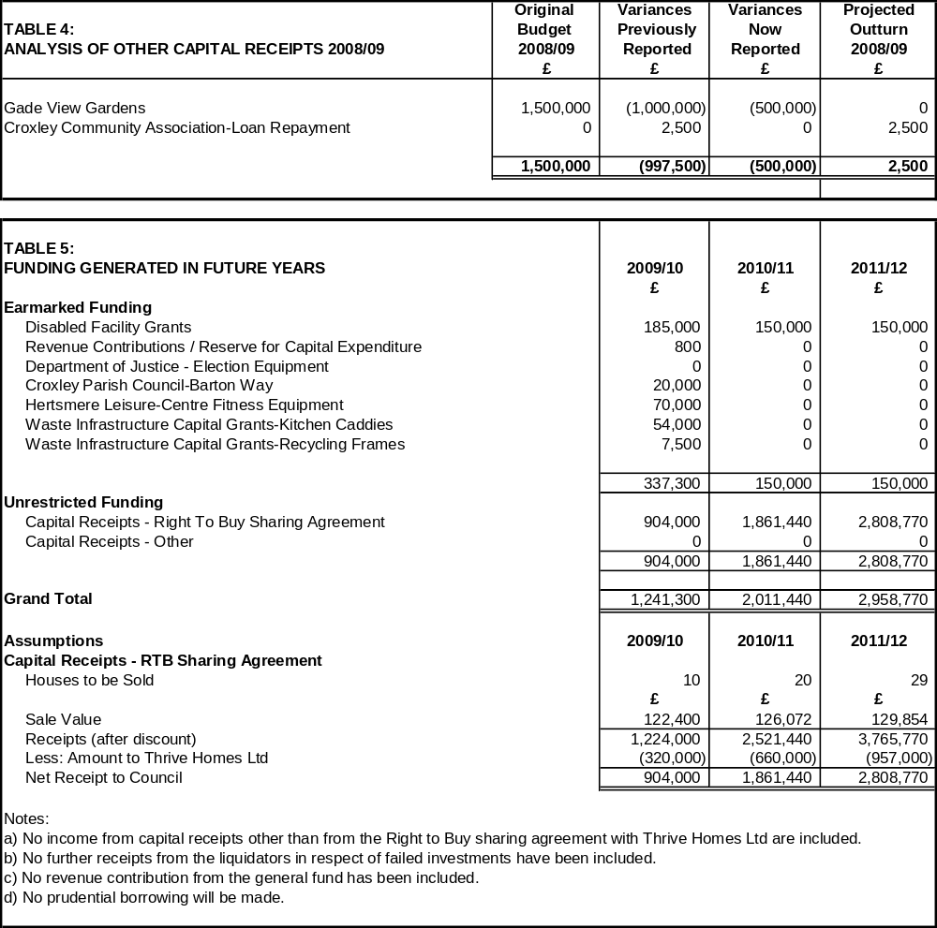
THREE-YEAR MEDIUM-TERM FINANCIAL PLAN – CAPITAL INVESTMENT PROGRAMME
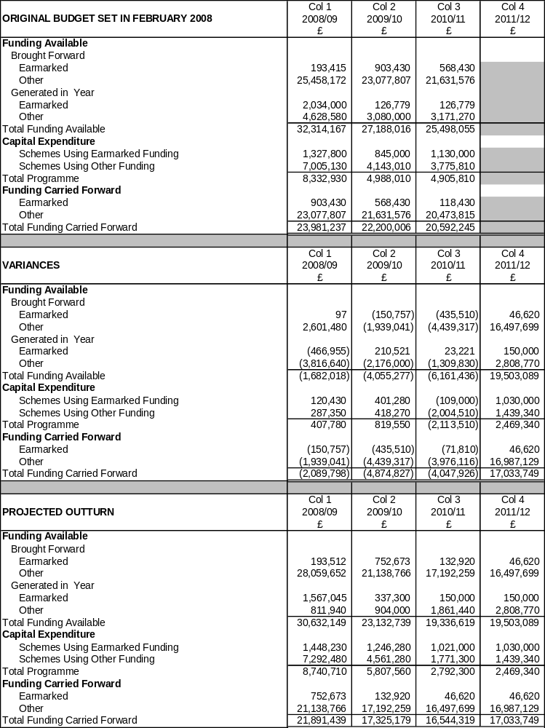

FINANCIAL AND BUDGETARY RISKS

1. The Council has agreed its risk management strategy which can be found on the website at http://www.threerivers.gov.uk.

2. The Accountancy Practice Service Plan includes the financial and budgetary risks which were set out in the report entitled ‘Strategic, Service and Financial Planning 2009-12’ presented to the Executive Committee on 26 January 2009. These are shown below, together with the latest position and latest assessment of impact and likelihood:-

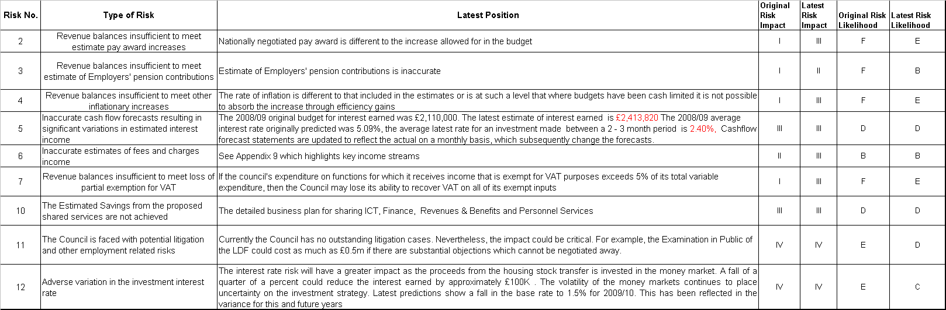

3. The above risks are plotted on the matrix below depending on the scored assessments of impact and likelihood, detailed definitions of which are included in the risk management strategy. The Council has determined its aversion to risk and is prepared to tolerate risks where the combination of impact and likelihood are plotted in the shaded area of the matrix. The remaining risks have a treatment plan included in the Accountancy Practice Service Plan.

Likelihood | A |  |  |  |  |  | Impact | Likelihood
Likelihood | B |  | 3 | 6 |  |  | V = Catastrophic | A = >98%
Likelihood | C |  |  |  | 12 |  | IV = Critical | B = 75% - 98%
Likelihood | D |  |  | 5,10 | 11 |  | III = Significant | C = 50% - 75%
Likelihood | E |  |  | 2, 4, 7 |  |  | II = Marginal | D = 25% - 50%
Likelihood | F |  |  |  |  |  | I = Negligible | E = 2% - 25%
Likelihood |  | I | II | III | IV | V |  | F = <2%
Likelihood | Impact

4. In the officers’ opinion none of the risks above, were they to come about, would seriously prejudice the achievement of the Strategic Plan and are therefore operational risks. The effectiveness of treatment plans are reviewed by the Audit Committee annually.

5. The treatment plan for these risks shows:-

Existing Control | The risk assessment is used to calculate sums to be held within balances should the risks materialise. These are included in the three-year medium-term financial plan and reported to members when the budget is set.
Adequacy of Control | Balances have not reduced below the prudent minimum agreed by members
Action Required | Monitor risks during the year
Critical Success Factor | Balances will not drop below the prudent minimum agreed when setting the budget

INCOME FROM FEES AND CHARGES

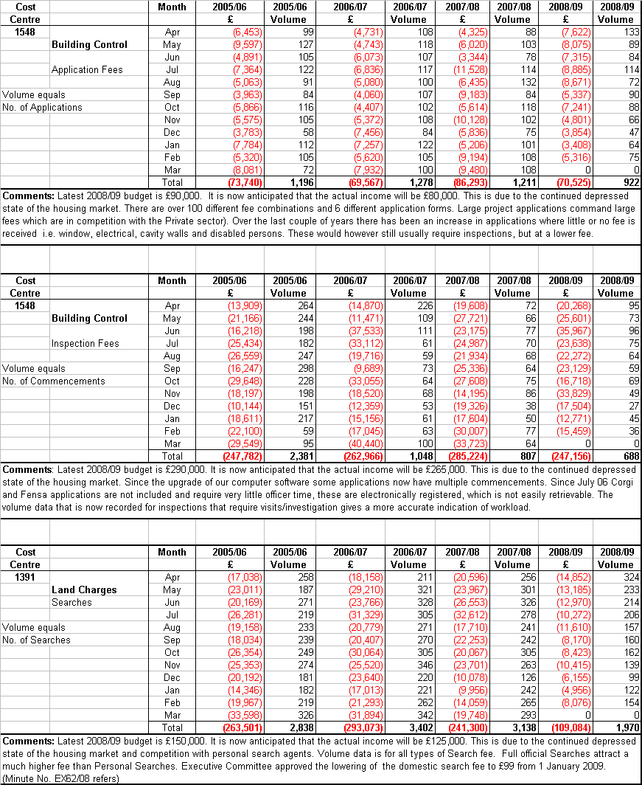
COUNCIL’S POLICY ON OTHER RESERVES AND BALANCES

The Council is required to monitor and maintain its levels of reserves and balances within the range determined by its agreed policy.

The Council’s policy for reserves and balances should be based on a thorough understanding of its needs and risks, and should be properly and clearly reported to members. Existing controls relate specifically to revenue balances. The Council’s policy on other reserves and balances and the current position on each is shown below.

Below is a summary of the Balance Sheet as at 31 March 2008 (and comparatives at 31 March 2007). An understanding of the balance sheet will identify which balances need to be reviewed as part of budget monitoring. The annual statement of accounts was approved by the Audit Committee on 30 June 2008.

 |  |  | 31 March 2007 |  | 31 March 2008
 |  |  | £000 | £000 | £000 | £000
Total Fixed Assets |  |  |  | 357,581 |  | 46,278
Long-Term Debtors (Mortgages) |  |  |  | 400 |  | 357
Total Long-Term Assets |  |  |  | 357,981 |  | 46,635
Current Assets
 | Stocks and Work in Progress |  | 27 |  | 17
 | Debtors |  | 4,175 |  | 16,375
 | Investments |  | 22,316 |  | 46,851
 |  |  |  | 26,518 |  | 63,243
Total Assets |  |  |  | 384,499 |  | 109,877
Current Liabilities
 | Creditors |  | (4,842) |  | (23,381)
 | Cash Overdrawn |  | (1,091) |  | (207)
 |  |  |  | (5,933) |  | (23,588)
Total Assets less Current Liabilities |  |  |  | 378,566 |  | 86,289
Long-Term Liabilities
Pensions Liability |  |  |  | (8,846) |  | (5,530)
Grants & Contributions Deferred Account |  |  |  | (4,232) |  | (3,679)
Total Assets Less Liabilities |  |  |  | 365,488 |  | 77,080
Capital Adjustment Account |  |  |  | (3.55,156) |  | (1,706)
Usable Capital Receipts Reserve |  |  |  | (7,483) |  | (25,428)
Pensions Reserve |  |  |  | 8,846 |  | 5,530
Earmarked Reserves |  |  |  | (4,564) |  | (4,775)
General Reserves
 | -General Fund |  |  | (3,889) |  | (4,056)
 | -Housing Revenue Account |  |  | (3,204) |  | (4,130)
 | -Collection Fund |  |  | (60) |  | 37
 | -Other Reserves |  |  | 22 |  | 0
Total Equity |  |  |  | (365,488) |  | (77,080)

The following balances are reviewed on a regular basis:

Fixed Assets

Under the Valuers’ Conditions of Engagement, the Council has a five year rolling programme of valuations for all land and buildings, which is carried out throughout the year. In addition to the five year valuations, interim valuations are undertaken where major capital works are carried out and annual assessments for impairment are carried out.

Long-Term Debtors (Mortgages)

The management of the Mortgage portfolio is out-sourced to Gemini Consultants Ltd, who monitor all accounts and report to the Council on a monthly basis. No new mortgages have been granted in over 16 years, there are no significant arrears and balances are reducing in line with expectation.

Current Assets and Liabilities

Debtors

The Exchequer Services and Housing Services Service Plans include BV and TRC Performance Indicators to monitor the collection rates and level of outstanding debts on Sundry Debtors, Council Tax and NNDR payments and rental arrears. These are reported quarterly to Policy Panels.

A significant proportion of Debtors on the Balance Sheet at the year end is represented by Government Departments and other public bodies. These balances are difficult to monitor on a daily basis as the year end balances result from timing differences between claims to these departments and payment of the claims. Often the payments made by Government departments in the year are based on an estimate at the start of the year and the debtor at the year end is only paid after the final claim has been audited. Where, however, payments are made monthly, and interim claims can be submitted during the year, the base data to these claims can be monitored during the year. Such data includes:

The debit raised on NNDR (The total amount collected from NNDR Payers)

The debit affects the net amount payable to the Government NNDR pool. An estimate of the debit is made at the start of the Financial Year and a schedule of payments to the pool is issued based on this estimate. The NNDR debit is monitored weekly after receipt of valuation schedules from the Valuation Office Agency and also each month when BV10 (NNDR collected in year) is calculated. Any major changes in Total Rateable Value can be reported quarterly by means of an amended Government return (NNDR2) but the lower threshold set by Government for reporting such changes is approximately £125,000 in quarters one and two and £250,000 in quarters three and four for this Council. If the changes are above the threshold, an amended schedule of payments will be issued and this will also be monitored via the Treasury Management monthly cash flow.

Housing and Council Tax Benefit Subsidy

Housing and Council Tax Benefit Subsidy, together with gross salaries, pension payments, rents, interest earned, government grants and certain fees and charges are key budget indicators monitored monthly by the relevant Cost Centre Managers as part of the budget monitoring process. Major variances are reported in the monitoring reports.

Investments

Investment criteria are set in the Council’s Treasury Management Strategy reported to the Executive Committee twice a year. They are reviewed daily as part of the Treasury Management function and reported monthly to Members through the Members’ Information Bulletin.
Creditors

The overall Sundry Creditors figure at the year end also includes all accrued expenditure reflected in the accounts where goods or services have been received before the year end, but invoices have not been received from the suppliers in time to pay before the year end.

As with Debtors, the balance at the year end does not necessarily reflect this level of monitoring during the year because of timing differences between the collection of monies for third parties, such as Income Tax, Pension Contributions and VAT and the final payments to those third parties.

Members should note that where balances arise as a timing difference between final claim and payment based on estimates (either to of from the Government), the resultant year end balance can be either a Debtor or a Creditor, depending on whether the estimate was higher or lower than the final claim or payment.

Cash Overdrawn

Bank Balances are monitored daily as part of the Treasury Management function to ensure that excess balances are invested and debit balances avoided. The bank balances reconciled to the Council’s accounts monthly as part of the income function.

The Cash Overdrawn that appears on the balance sheet at the year end includes accruals and prepayments included in Debtors and Creditors and do not imply an actual cash overdraft.

Stock & Work In Progress

The Council does not hold any material stocks as it works on a ‘Just In Time’ ordering system.

Balance Sheet – Total Equity:

Executive Committee 4 February 2008 received a report entitled ‘Strategic, Service and Financial Planning 2007-2010’ which included an analysis of cash-backed balances and how they are used, and which are earmarked for specific purposes. This report is reproduced in the Council’s Medium Term Financial Plan.

The General Fund balance is monitored as part of the Budget Monitoring Report (See Appendix 2).

The policy for the use of capital receipts, and other Earmarked reserves which fund the Capital Investment Programme was set at Council on 19 February 2008. These balances are reviewed during the year to reflect changes in the Capital Investment Programme and the level of Capital Receipts (Asset sales) and reported as part of capital funding in budget monitoring reports (see Appendix 6).

The cash-backed elements of total equity are monitored as part of the Monthly Treasury Management Cash Flow reconciliation.

For certain balances and reserves (The Chairman’s Charity, Payroll Deductions – union payments, Court Orders, AVCs etc) there is not expected to be any significant movement during the financial year, and the overall balance is not material. The Balance Sheet is produced annually and reported in the statement of accounts. In the Foreword to the accounts, the Chief Financial Officer comments on uses and level of balances.

Monitoring Reserves and Balances – Council Policy

The majority of reserves and balances are monitored regularly as part of normal Council departmental activities or well established budget monitoring procedures as detailed above.

A positive decision has been made not to monitor non-material balances, or those on which there is very little movement during the year, but they are reviewed as part of the Council’s closing of accounts procedures, and commented on both at budget setting and in the foreword to the Statement of Accounts.

Larger Debtors and Creditors are, in general, beyond the Council’s control, but where additional claims and returns can be completed to closer match claims to payments during the year this is included in departmental procedures.

EFFICIENCY GAINS

1. The Comprehensive Spending Review (CSR07) requires Local Government to make efficiency savings of 3% per annum effective from April 2008 and 9.3% cumulative by the end of 2010/11. Only cashable efficiency gains can be counted towards the target. Targets for individual councils have not been set by the DCLG; however there is an expectation that cash releasing savings should be equivalent to 3% year on year of the Total Net Service expenditure measured from the 2007/08 base budget.

2. The Hertfordshire Pathfinder Project has undertaken to increase these efficiency gains to 3.5% per annum. The Councils target for 2008/09 as reported to the DCLG through National Indicator 179 (Value for Money) is £490,000.

3. The Service planning process and budget monitoring during the year has identified the cashable efficiencies against the target. These are detailed below:

Efficiency Gains Identified | 2008/09  £ | 2009/10  £ | 2010/11  £
Accountancy Practice | 5,000 | 196,000 | 216,000
Building Control | 2,620 | 2,560 | 2,520
Community Services | 5,000 | 5,000 | 5,000
CSC | 0 | 15,150 | 15,530
Democratic Services | 34,790 | 36,670 | 38,590
Development Control | 1,410 | 11,360 | 11,290
Development Plans | 550 | 3,660 | 3,660
Environmental Health | 25,000 | 26,000 | 32,620
Environmental Protection | 11,670 | 268,560 | 392,850
ICT | 76,640 | 90,020 | 92,170
Legal Practice | 6,440 | 12,310 | 12,620
Housing | 0 | 22,100 | 22,100
Performance Management & Scrutiny | 228,860 | 288,570 | 295,150
Personnel Practice | 43,190 | 51,650 | 53,230
Shared Services | 0 | 26,610 | 460,400
Sustainability | 1,500 | 106,730 | 133,710
Total | 442,670 | 1,162,950 | 1,787,440

4. The amounts in the table above have been included in the 2008/09 and future years budgets. The budget process will monitor the achievement of the cashable efficiencies and variations will be reported to the Executive.

